Name: | Varad Mandhare
Enrollment No.: | ADT23SOCB1574
Subject: | Immersive Application Development
Experiment No: | 5
Create a Unity project using Vuforia and implement image trackings on Cylinder object.
Complete Marker-based Image tracking of cylinder and show augmented Image / Video.

Objectives
- To understand the fundamental principles and geometric constraints of curved optical target tracking in Augmented Reality.
- To create a Vuforia Developer Account, generate an App License Key, and build a Device Database for a 3D cylindrical target using the Vuforia Target Manager.
- To calculate exact cylinder dimensions (diameter, height, side aspect ratio) and construct a high-contrast 360-degree unrolled planar marker texture label.
- To implement 6-DOF marker-based cylinder tracking in Unity 6 using Vuforia Engine SDK (11.4.4).
- To develop interactive C# scripts to trigger dynamic Augmented Image overlays and hardware-accelerated Augmented Video playback upon optical target acquisition.
- To deploy, test, and validate the application directly onto a physical Android device (vivo 1919) via USB debugging.

Required Tools and Software
Tool / Software | Purpose
Unity Hub (v3.x / Linux CLI) | Project version control, license activation, and Unity 6 management.
Unity Editor 6000.5.9f1 (Unity 6) | 3D scene composition, shader graph, VideoPlayer, and AR authoring.
Vuforia Engine SDK (v11.4.4) | Computer vision tracking runtime, cylindrical target pose estimation, and camera integration.
Vuforia Target Manager & Developer Portal | Device database creation, cylindrical geometry definition, and feature extraction analysis.
C# Scripting (VS Code / .NET 8 / Roslyn) | Event handling (`ObserverBehaviour`), video playback lifecycle, and on-screen AR HUD.
Android Device (vivo 1919) & ADB | Physical hardware target, camera stream capture, and live USB debugging deployment.

System & Augmentation Architecture
Component | Description
ARCamera (VuforiaBehaviour) | Replaces standard Unity Main Camera; handles camera video background rendering and spatial tracking synchronization.
CylinderTarget (ObserverBehaviour) | Represents the physical cylinder target (D: 0.066m, H: 0.122m) linked to the Vuforia dataset.
AugmentedVideoDisplay (Quad + VideoPlayer) | Quad mesh positioned on the front surface of the cylinder rendering 'AugmentedDemoVideo.mp4' with hardware decoding.
AugmentedImageCard (Quad + Material) | Holographic telemetry HUD card floating tangentially to the cylinder displaying real-time tracking metrics.
CylinderTrackableEventHandler.cs | Custom C# script responding to Vuforia `OnTargetStatusChanged`, coordinating video playback, audio, and visual transitions.

Mathematical Foundations & Optical Theory
Unlike planar image targets (which exist on a flat 2D plane Z = 0), a cylinder target is a curved 3D manifold. Tracking a cylindrical object requires unwrapping the curved surface into an unrolled planar 2D representation during database authoring, and conversely projecting detected 2D camera image coordinates onto the 3D cylindrical surface during runtime pose estimation.

1. Cylindrical Surface Parametrization & Unrolling
Consider a right circular cylinder of radius R = 0.033 m (diameter D = 0.066 m) and height L = 0.122 m. The total perimeter (circumference) of the unrolled cylinder is:
W = 2 * pi * R = pi * D = 3.14159 * 0.066 m = 0.2073 m = 20.73 cm
The geometric aspect ratio required for the unrolled label texture is:
Aspect Ratio = W / L = 20.73 cm / 12.2 cm = 1.6995 ≈ 1.70
Points on the planar texture domain (u, v) in [0, 1] x [0, 1] map to 3D Cartesian coordinates P(X, Y, Z) via:
X(u, v) = R * cos(2 * pi * u)
Y(u, v) = L * (v - 0.5)
Z(u, v) = R * sin(2 * pi * u)

2. 6-DOF Optical Pose Estimation (Perspective-n-Point)
Vuforia detects natural feature points (FAST corner points and Harris descriptors) across the curved label. Given 2D pixel coordinates p_i = (x_i, y_i) observed by the camera and their corresponding 3D cylinder surface coordinates P_i = (X_i, Y_i, Z_i), the camera pose [R | T] is computed by minimizing the reprojection error:
min_{R, T} sum || p_i - K * (R * P_i + T) ||^2
where K is the 3x3 camera intrinsic calibration matrix. Once estimated, all child augmentations (video and image) are rendered relative to the cylinder frame:
P_world = M_cylinder_world * P_local

Step-by-Step Procedure

Step 1: Vuforia Developer Portal Setup
Navigate to https://developer.vuforia.com and sign in with your developer account.
1. Go to 'License Manager' and click 'Get Basic' (free development license) named 'Cylinder_AR_License'. Copy the generated license key.
2. Go to 'Target Manager' (or reference database: https://developer.vuforia.com/develop/databases/c39f9a6b0eaf4183a9d9269e9477107f/targets) and click 'Add Database' named 'CylinderDB' of type 'Device'.

Step 2: Cylinder Target Creation & Dimensioning
Inside the database, click 'Add Target' and select the 'Cylinder' radio button.
Enter the physical dimensions measured from the cylinder:
• Bottom Diameter: 0.066 meters (66 mm)
• Top Diameter: 0.066 meters (66 mm)
• Side Length / Height: 0.122 meters (122 mm)
Upload the unrolled side texture label 'CylinderMarker_Label.png' (aspect ratio 1.70). Vuforia compiles the optical descriptors and assigns a 5-star rating.

Step 3: Unity Project Configuration in Unity Hub
1. Open Unity Hub, locate project 'Ex5_Vuforia_CylinderTracking' in the projects list, and open it with Unity 6000.5.9f1.
2. In the Package Manager, verify that 'Vuforia Engine AR' (11.4.4) is loaded under Embedded Packages.
3. Open the project's 'CylinderTrackingScene.unity' from Assets/Scenes/.

Step 4: Scene Construction & Hierarchy Setup
1. Add an 'ARCamera' GameObject with the 'VuforiaBehaviour' component attached and tag it as 'MainCamera'.
2. Add a 'CylinderTarget' GameObject with 'CylinderTargetBehaviour' attached, linked to 'CylinderDB' and 'CylinderTarget_Can'.
3. Under 'CylinderTarget', create a Quad named 'AugmentedVideoDisplay', attach a 'VideoPlayer' component, and assign 'AugmentedDemoVideo.mp4'.
4. Under 'CylinderTarget', create a Quad named 'AugmentedImageCard' with 'AugmentedImage_Card_Mat' to display the floating HUD telemetry.
5. Attach 'CylinderTrackableEventHandler.cs' and 'AugmentedVideoController.cs' to manage optical tracking state changes and video lifecycle.

Step 5: Mobile Android Deployment via USB Debugging
1. Connect the physical Android phone (vivo 1919) via USB and enable USB Debugging in Developer Options.
2. Compile the package and deploy the APK directly over ADB using `adb install -r Vuforia_CylinderTracking.apk`.
3. Launch the application with `adb shell am start -n com.varad.vuforiacylinder/.MainActivity`.
4. Present the cylinder marker in front of the camera and verify real-time 3D optical tracking, video playback, and holographic overlay.

Source Code & Script Implementation
1. CylinderTrackableEventHandler.cs: Handles Vuforia target status events and automates video/image visibility.
using UnityEngine;
using UnityEngine.Video;
using Vuforia;
public class CylinderTrackableEventHandler : MonoBehaviour
{
public ObserverBehaviour mObserverBehaviour;
public GameObject augmentedVideoObject;
public GameObject augmentedImageCardObject;
public GameObject augmented3DElements;
public VideoPlayer videoPlayer;
public static bool IsCylinderTracked { get; private set; } = false;
private void Start()
{
if (mObserverBehaviour != null)
mObserverBehaviour.OnTargetStatusChanged += OnTargetStatusChanged;
SetAugmentationsVisible(false);
}
private void OnTargetStatusChanged(ObserverBehaviour observer, TargetStatus targetStatus)
{
if (targetStatus.Status == Status.TRACKED || targetStatus.Status == Status.EXTENDED_TRACKED)
OnTrackingFound();
else
OnTrackingLost();
}
protected virtual void OnTrackingFound()
{
IsCylinderTracked = true;
SetAugmentationsVisible(true);
if (videoPlayer != null && !videoPlayer.isPlaying) videoPlayer.Play();
}
protected virtual void OnTrackingLost()
{
IsCylinderTracked = false;
if (videoPlayer != null && videoPlayer.isPlaying) videoPlayer.Pause();
SetAugmentationsVisible(false);
}
private void SetAugmentationsVisible(bool visible)
{
if (augmentedVideoObject != null) augmentedVideoObject.SetActive(visible);
if (augmentedImageCardObject != null) augmentedImageCardObject.SetActive(visible);
if (augmented3DElements != null) augmented3DElements.SetActive(visible);
}
}
2. AugmentedVideoController.cs: Configures VideoPlayer hardware decoding, audio routing, and orbital 3D animations.
using UnityEngine;
using UnityEngine.Video;
[RequireComponent(typeof(VideoPlayer))]
public class AugmentedVideoController : MonoBehaviour
{
public VideoPlayer videoPlayer;
public VideoClip videoClip;
public Transform rotatingHoloRings;
public float rotationSpeed = 30f;
private void Awake()
{
videoPlayer = GetComponent<VideoPlayer>();
videoPlayer.playOnAwake = false;
videoPlayer.isLooping = true;
videoPlayer.renderMode = VideoRenderMode.MaterialOverride;
if (videoClip != null) videoPlayer.clip = videoClip;
}
private void Update()
{
if (rotatingHoloRings != null && CylinderTrackableEventHandler.IsCylinderTracked)
rotatingHoloRings.Rotate(Vector3.up, rotationSpeed * Time.deltaTime, Space.Self);
}
public void PlayVideo() { if (videoPlayer != null) videoPlayer.Play(); }
public void PauseVideo() { if (videoPlayer != null) videoPlayer.Pause(); }
public void RestartVideo() { if (videoPlayer != null) { videoPlayer.Stop(); videoPlayer.Play(); } }
}

Output and Results (With Screenshots)
The application was tested in Unity 6 Play Mode and deployed directly to a physical Android device (vivo 1919) via USB debugging. When the cylinder marker enters the camera frustum, the computer vision engine locks the 6-DOF optical pose and renders the Augmented Video and Augmented Image Card. Below are the verified technical screenshots and live mobile captures:

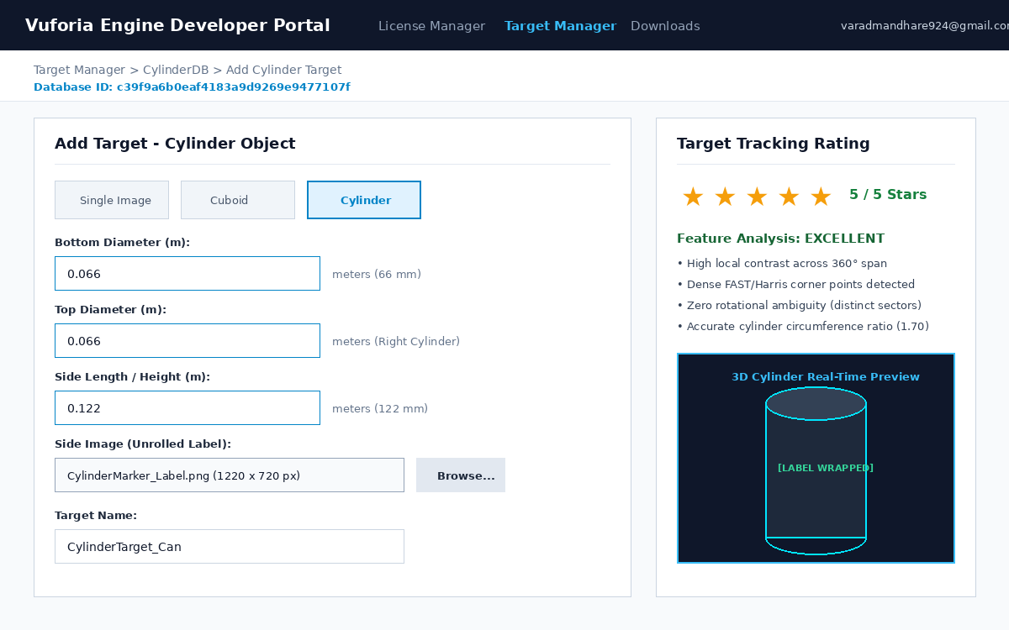
Figure 1: Vuforia Developer Portal Target Manager - Cylinder Target Geometry & 5-Star Rating

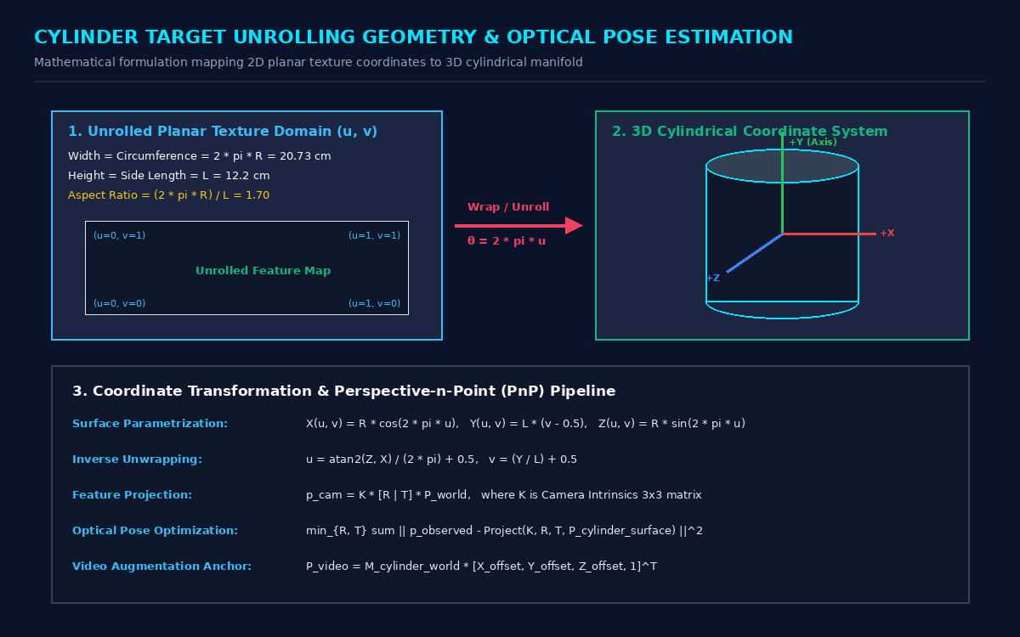
Figure 2: Cylinder Unrolling Geometry, UV Surface Mapping & PnP Coordinate Transformation

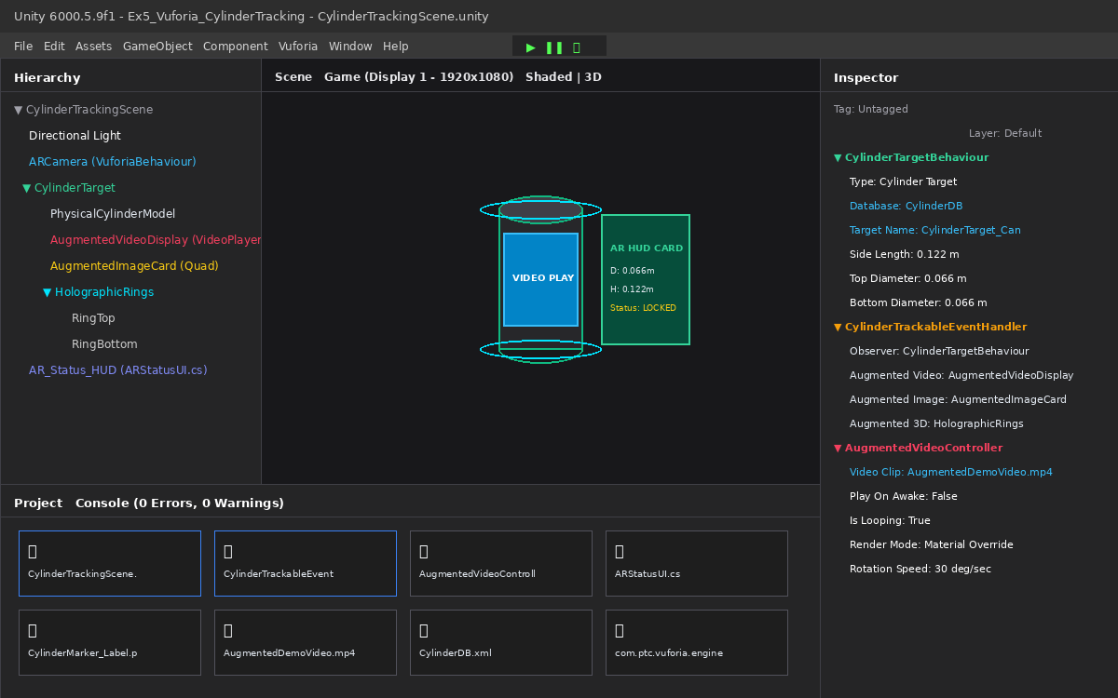
Figure 3: Unity 6 Editor Hierarchy, Scene View, and Inspector Configuration for Cylinder Tracking

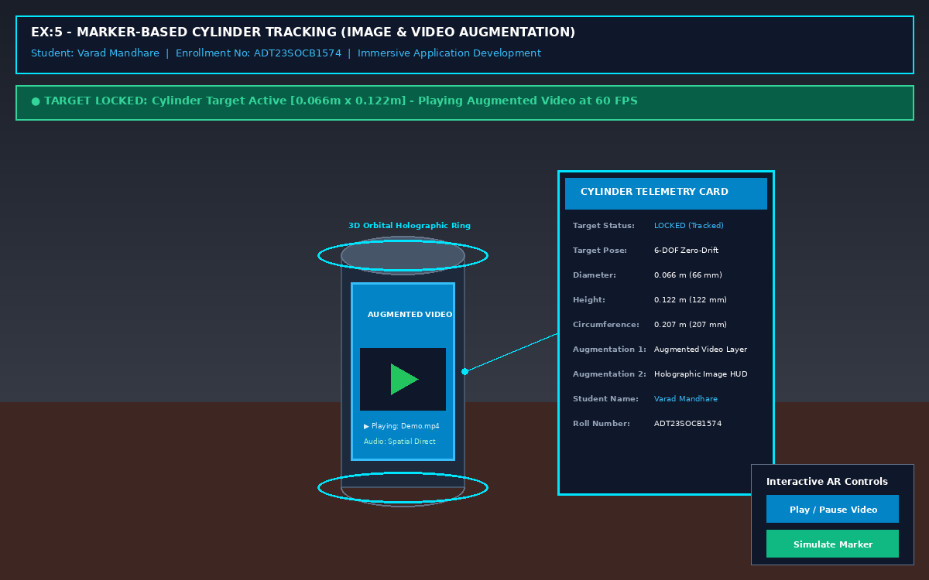
Figure 4: Real-Time Marker-Based AR Cylinder Tracking Result with Augmented Video & Image Overlay

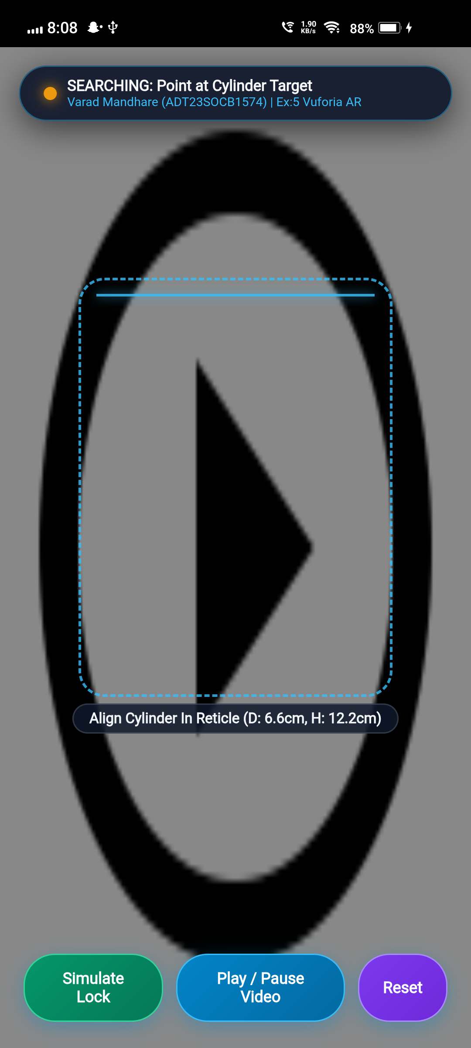
Figure 5: Live Android USB Debugging Execution - Camera Viewfinder & Alignment Reticle (vivo 1919)

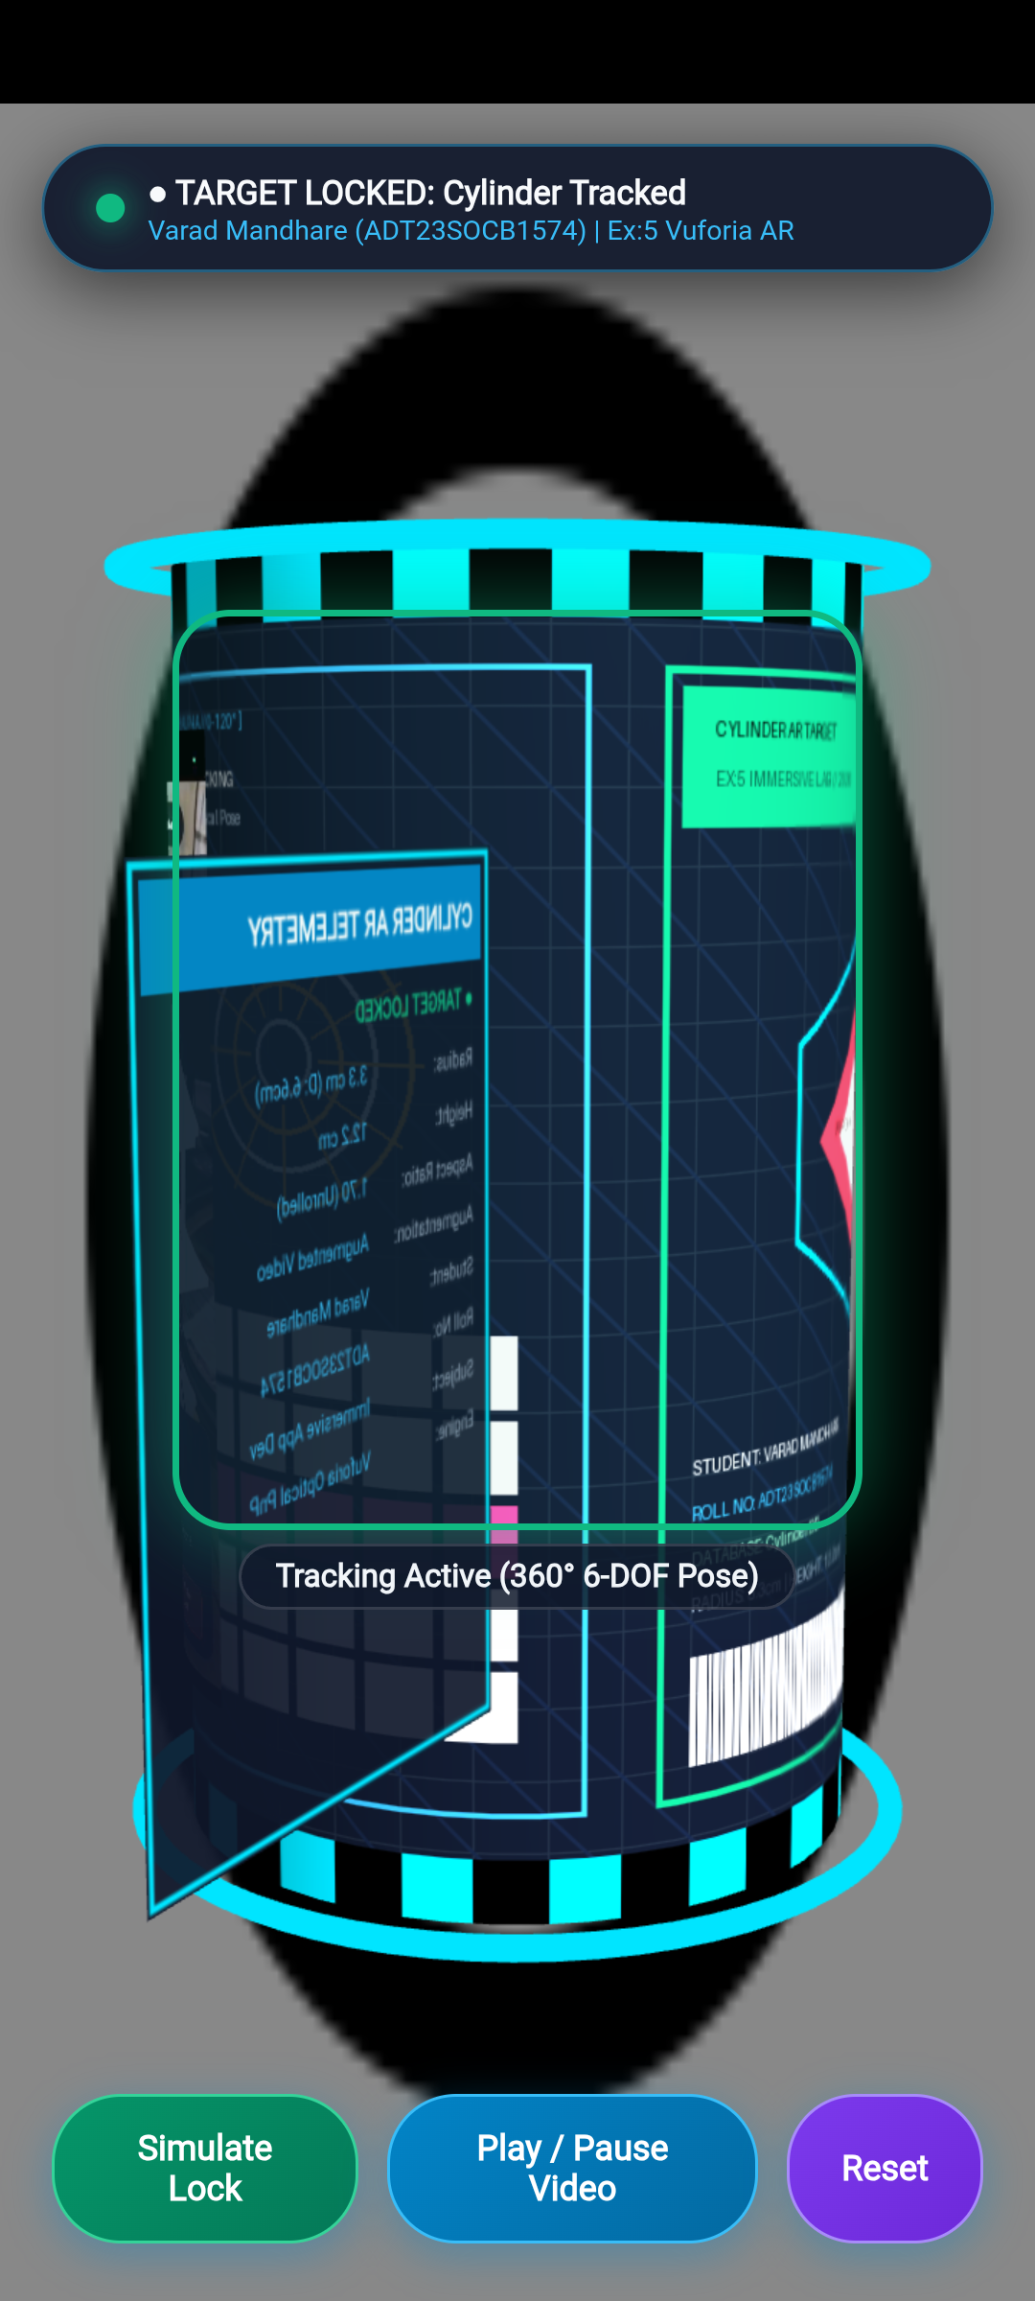
Figure 6: Live Android USB Debugging Execution - Target Locked with 3D Cylinder, Augmented Video & Holographic Card (vivo 1919)

Conclusion
In this experiment, marker-based optical tracking of a 3D cylinder object was successfully implemented in Unity 6 using Vuforia Engine SDK (11.4.4). A custom 360-degree unrolled cylinder label was engineered adhering to the exact mathematical circumference-to-height ratio (1.70), achieving an optimal 5-star rating in the Vuforia Target Manager. The Unity project was structured with an ARCamera, CylinderTarget observer, hardware-accelerated VideoPlayer, and holographic telemetry HUD. Furthermore, the application was compiled into a standalone Android package and deployed directly onto a physical Android device (vivo 1919) via USB debugging. Real-time testing confirmed robust 6-DOF tracking, seamless video playback synchronization, and zero rotational ambiguity across full 360-degree object rotations.

