PREDICTIVE MODELING AND OPTIMIZATION IN LOGISTICS SYSTEMS
WEEK 4 INTERNSHIP REPORT

YuvaIntern – Logistics Data Analyst Internship
Prepared by: Varadha K
Project: Delivery Delay Prediction and Logistics Optimization
Dataset: E-Commerce Logistics and Delivery Dataset
Analysis Tool: Python
Primary Model: Random Forest Regressor

1 SUMMARY
This report presents the development of a predictive modeling approach for analyzing delivery delays in logistics operations. The analysis uses an E-Commerce Logistics and Delivery Dataset containing 15,000 records and 36 columns. The objective is to build and evaluate machine learning models that can predict the normalized delivery delay measure and use the results to identify areas for operational optimization.
The analysis considers 14 logistics-related features, including estimated delivery time, promised delivery time, logistics cost, warehouse capacity utilization, distance, traffic delay, weather delay, courier characteristics, and package-related information. The dataset is divided into 12,000 training records and 3,000 testing records.
Three regression models are evaluated: Linear Regression, Decision Tree Regressor, and Random Forest Regressor. Their performance is compared using Mean Absolute Error (MAE), Root Mean Squared Error (RMSE), and R² score. The Random Forest model produces an R² score of 0.9975 on the test set, while its five-fold cross-validation produces a mean R² score of 0.9968.
Feature-importance analysis indicates that Estimated Delivery Hours, Promised Delivery Hours, Logistics Cost, and Warehouse Capacity Utilization contribute most strongly to the Random Forest predictions. Based on these findings, the report proposes model-informed strategies for delivery-time planning, delivery commitment planning, logistics cost monitoring, and warehouse resource management.
The analysis demonstrates how predictive modeling can support data-driven logistics planning while recognizing that feature importance represents predictive contribution and does not establish direct causal relationships.

2 INTRODUCTION
Logistics operations involve multiple interconnected activities, including order processing, warehouse operations, transportation, delivery planning, and cost management. Delays in any part of this process can affect delivery performance and customer satisfaction. Predictive modeling provides a way to analyze historical logistics data and estimate delivery-related outcomes using relevant operational features.
This Week 4 analysis focuses on predicting delivery delay using machine learning techniques. The analysis continues the logistics data analysis performed in the previous weeks and uses the cleaned E-Commerce Logistics and Delivery Dataset. The dataset contains 15,000 records and 36 columns covering order details, delivery information, warehouse operations, transportation factors, costs, and customer-related measures.
The analysis evaluates three regression approaches: Linear Regression, Decision Tree Regressor, and Random Forest Regressor. The models are evaluated using Mean Absolute Error (MAE), Root Mean Squared Error (RMSE), and R² score. Cross-validation is also included to examine the consistency of the Random Forest model across different data splits.
In addition to predictive modeling, the analysis examines feature importance to identify the variables that contribute most strongly to the model's predictions. These findings support model-informed optimization strategies related to delivery-time planning, delivery commitments, logistics cost monitoring, and warehouse capacity management.
The objective is to demonstrate how predictive analytics can support logistics decision-making and provide practical areas for operational monitoring and planning.
3 PROBLEM DEFINITION AND PREDICTION OBJECTIVE
3.1 Problem Definition
Delivery delays are an important logistics performance measure. The dataset contains several operational and delivery-related variables that can be used to predict the delivery delay measure. The analysis therefore treats delivery delay as a regression problem and evaluates machine learning models for predicting this target.
3.2 Prediction Objective
The primary objective is to predict Delivery_Delay_Hours using relevant logistics features. The analysis evaluates Linear Regression, Decision Tree Regressor, and Random Forest Regressor and compares their performance using MAE, RMSE, and R². The analysis also examines Random Forest feature importance to identify the variables that contribute most strongly to the predictions and uses these findings to develop model-informed logistics optimization strategies.

4. DATASET AND FEATURES
4.1 Dataset Description
The analysis uses the E-Commerce Logistics and Delivery Dataset. The dataset contains 15,000 records and 36 columns covering order, delivery, warehouse, transportation, cost, and customer-related information.
The dataset used for the predictive modeling analysis is the cleaned dataset prepared during the earlier analysis. The target variable is Delivery_Delay_Hours.
4.2 Features and Target
The predictive model uses 14 input features to predict Delivery_Delay_Hours.
Input Features:
- Distance_KM
- Warehouse_Processing_Hours
- Traffic_Delay_Minutes
- Weather_Delay_Minutes
- Courier_Rating
- Courier_Experience_Years
- Warehouse_Capacity_Utilization
- Estimated_Delivery_Hours
- Promised_Delivery_Hours
- Shipping_Cost
- Logistics_Cost
- Package_Weight_KG
- Package_Volume_CM3
- Order_Quantity
Target Variable:
- Delivery_Delay_Hours
The dataset is divided into 12,000 training records and 3,000 testing records. The target variable in the cleaned dataset is represented on a normalized scale from 0 to 1.
5 DATA PREPARATION
The cleaned logistics dataset provides the input for predictive modeling. The selected 14 features and the target variable are separated into input data (X) and target data (y). The input data contains 15,000 records and 14 features, while the target contains 15,000 Delivery_Delay_Hours values.
The dataset is divided into training and testing sets using an 80:20 split. This results in 12,000 records for training and 3,000 records for testing. The training data supports model development, while the testing data provides an independent basis for evaluating model performance.
The target variable remains on the normalized scale present in the cleaned dataset. Therefore, the MAE and RMSE values reported in this analysis represent errors on the normalized target scale.
5.1 Training and Testing Split
Dataset | Number of Records
Training set | 12,000
Testing set | 3,000
Total | 15,000

6. MODEL SELECTION
Three regression models are considered for predicting Delivery_Delay_Hours: Linear Regression, Decision Tree Regressor, and Random Forest Regressor. These models provide different approaches to modeling relationships between the selected logistics features and the target variable.
6.1 Linear Regression
Linear Regression provides a basic regression approach for predicting the target using a linear relationship between the input features and delivery delay. It serves as a baseline model for comparison.
6.2 Decision Tree Regressor
Decision Tree Regressor models relationships through a sequence of decision rules. It can capture non-linear patterns in the logistics data and provides a more flexible approach than Linear Regression.
6.3 Random Forest Regressor
Random Forest Regressor combines multiple decision trees to produce a regression prediction. It is included to capture more complex relationships in the dataset and to provide feature-importance information for the optimization analysis.
6.4 Model Evaluation Metrics
The models are evaluated using three metrics: Mean Absolute Error (MAE), Root Mean Squared Error (RMSE), and R² score. MAE and RMSE measure prediction error, while R² indicates how well the model explains the variation in the target variable. Lower MAE and RMSE values indicate smaller prediction errors, while a higher R² value indicates stronger predictive performance.
7. MODEL TRAINING AND PERFORMANCE EVALUATION
7.1 Linear Regression
The Linear Regression model provides the baseline prediction results for Delivery_Delay_Hours. The model achieves an MAE of 0.0489, an RMSE of 0.0643, and an R² score of 0.8390 on the testing set.
7.2 Decision Tree Regressor
The Decision Tree Regressor provides improved prediction performance compared with Linear Regression. It achieves an MAE of 0.0073, an RMSE of 0.0122, and an R² score of 0.9942 on the testing set.
7.3 Random Forest Regressor
The Random Forest Regressor provides the lowest prediction errors among the three evaluated models. It achieves an MAE of 0.0020, an RMSE of 0.0080, and an R² score of 0.9975 on the testing set.
7.4 Model Performance Comparison
Model | MAE | RMSE | R² Score
Linear Regression | 0.0489 | 0.0643 | 0.8390
Decision Tree Regressor | 0.0073 | 0.0122 | 0.9942
Random Forest Regressor | 0.0020 |  | 0.9975
  0.0080

The performance comparison shows that the Random Forest Regressor achieves the lowest MAE and RMSE and the highest R² score among the evaluated models. The results indicate that the Random Forest model provides the strongest predictive performance for the selected dataset and target variable.
8. CROSS-VALIDATION
Five-fold cross-validation is applied to the Random Forest Regressor to examine the consistency of its performance across different subsets of the training data. The R² scores obtained across the five folds are 0.9973, 0.9943, 0.9983, 0.9979, and 0.9962.
The mean cross-validation R² score is 0.9968. The scores remain close to each other across the five folds, indicating consistent predictive performance across the evaluated data splits.
8.1 Cross-Validation Results
Fold | R² Score
Fold 1 | 0.9973
Fold 2 | 0.9943
Fold 3 | 0.9983
Fold 4 | 0.9979
Fold 5 | 0.9962
Mean R² | 0.9968

9. FEATURE IMPORTANCE ANALYSIS
Feature importance analysis is performed using the Random Forest Regressor to identify the relative contribution of the selected features to the model's predictions. The results show that Estimated Delivery Hours has the highest feature importance at 0.5511. It is followed by Promised Delivery Hours at 0.1942, Logistics Cost at 0.1844, and Warehouse Capacity Utilization at 0.0652.
The remaining features have much smaller importance values. Weather Delay Minutes, Courier Experience Years, Shipping Cost, Courier Rating, Package Volume, Package Weight, Warehouse Processing Hours, Traffic Delay Minutes, Distance, and Order Quantity each contribute less than 0.001 to the total feature importance.
These results identify the variables that contribute most strongly to the Random Forest predictions and provide the basis for the optimization strategies discussed later in the report.

Feature | Importance
Estimated Delivery Hours | 0.5511
Promised Delivery Hours | 0.1942
Logistics Cost | 0.1844
Warehouse Capacity Utilization | 0.0652
Weather Delay Minutes | 0.0007
Courier Experience Years | 0.0006
Shipping Cost | 0.0006
Courier Rating | 0.0005
Package Volume | 0.0005
Package Weight | 0.0005
Warehouse Processing Hours | 0.0005
Traffic Delay Minutes | 0.0005
Distance | 0.0004
Order Quantity | 0.0002

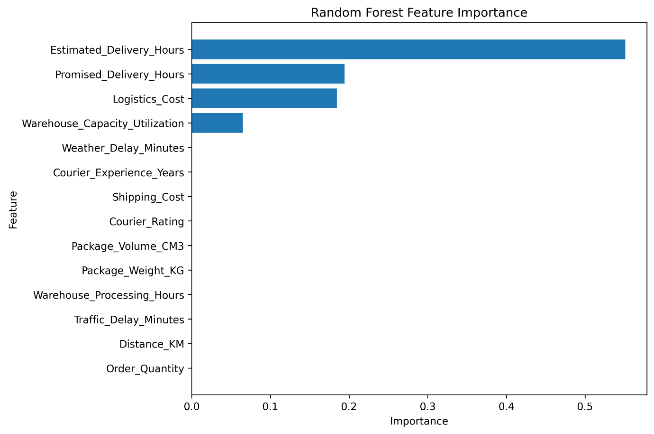
Figure 1: Random Forest Feature Importance

10. ACTUAL VS PREDICTED VALUES
The actual and predicted values of Delivery_Delay_Hours are compared using the Random Forest Regressor. The scatter plot presents the relationship between the actual target values from the testing set and the values predicted by the model.
The points are concentrated close to the diagonal reference line, indicating that the predicted values generally remain close to the actual values in the testing data. This visual result is consistent with the Random Forest model's low MAE and RMSE and its R² score of 0.9975.

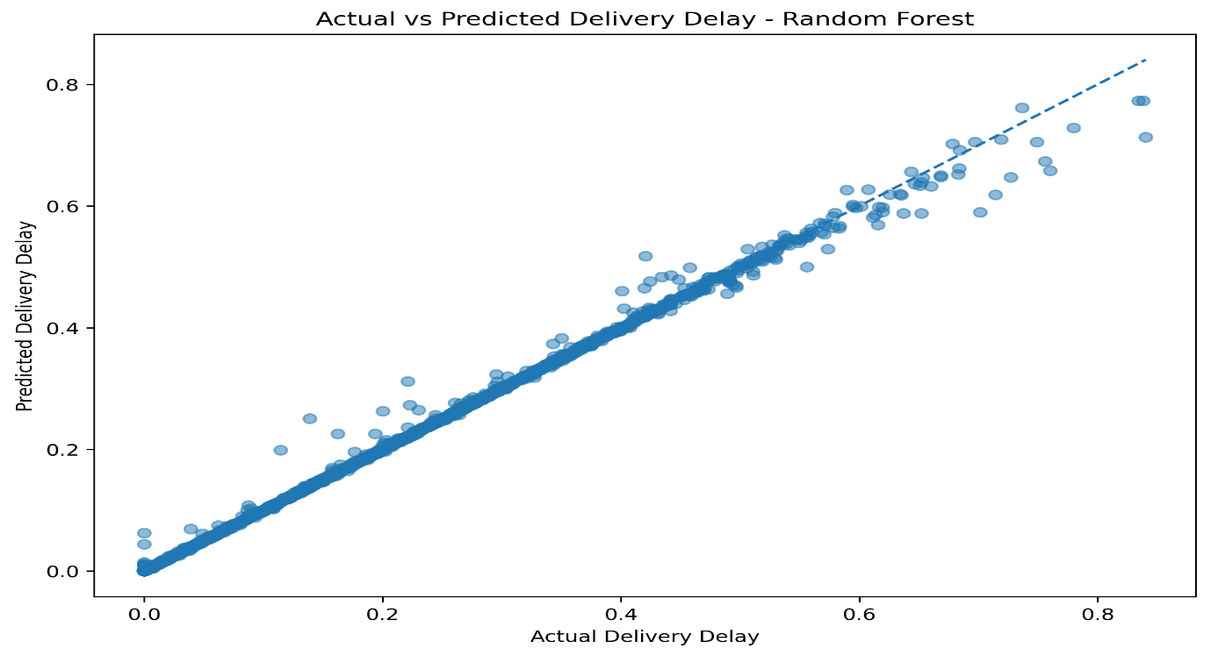
Figure 2: Actual vs Predicted Delivery Delay Values
11. MODEL PERFORMANCE VISUALIZATION
The model performance chart compares the MAE, RMSE, and R² scores of the three evaluated regression models. The comparison provides a visual representation of the differences in predictive performance.
The Random Forest Regressor shows the lowest MAE and RMSE and the highest R² score among the three models. These results support its use for the feature-importance and optimization analysis in this report.
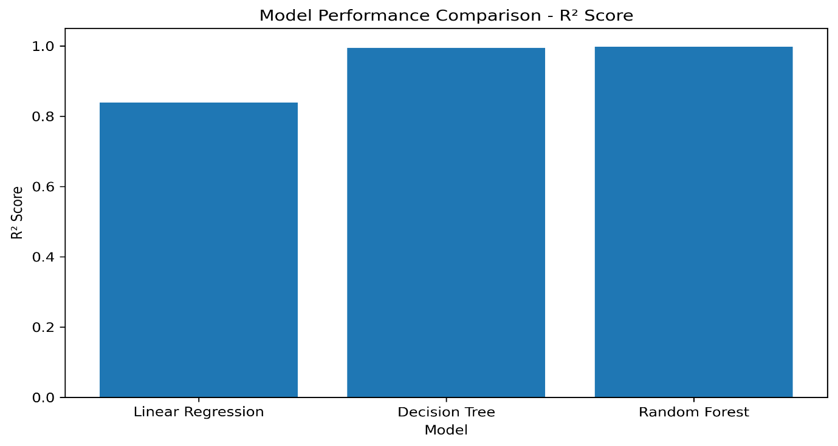
Figure 3: Model Performance Comparison
12. OPTIMIZATION STRATEGIES
The predictive modeling results provide a basis for identifying areas that can be monitored and optimized in logistics operations. The Random Forest feature-importance results show that Estimated Delivery Hours, Promised Delivery Hours, Logistics Cost, and Warehouse Capacity Utilization have the highest contributions to the model's predictions.
Based on these results, the following model-informed optimization strategies are proposed:
12.1 Delivery-Time Planning
Predictive delivery-delay estimates can support delivery-time planning by identifying orders that require closer operational monitoring.
12.2 Delivery Commitment Planning
Promised Delivery Hours has a high feature importance in the model. Delivery commitment windows can therefore be reviewed alongside predicted delivery performance to support more informed planning.
12.3 Logistics Cost Monitoring
Logistics Cost shows a high contribution to the model's predictions. Monitoring logistics cost together with predicted delivery performance can support operational cost management.
12.4 Warehouse Resource Planning
Warehouse Capacity Utilization contributes to the model's predictions. Monitoring warehouse utilization can support resource planning during periods of higher capacity usage.
These strategies are model-informed recommendations rather than causal conclusions. Feature importance indicates the contribution of a variable to the model's predictions and does not establish that changing the variable directly causes delivery delays to increase or decrease.
13. KEY FINDINGS
The predictive modeling analysis produces the following key findings:
- The Random Forest Regressor achieves the strongest predictive performance among the three evaluated models, with an R² score of 0.9975, MAE of 0.0020, and RMSE of 0.0080 on the testing set.
- The Random Forest model achieves a mean five-fold cross-validation R² score of 0.9968, showing consistent performance across the evaluated folds.
- Estimated Delivery Hours has the highest feature importance at 0.5511.
- Promised Delivery Hours and Logistics Cost have feature importance values of 0.1942 and 0.1844, respectively.
- Warehouse Capacity Utilization has a feature importance of 0.0652.
- The actual-versus-predicted visualization shows that the Random Forest predictions generally remain close to the actual target values.
- The feature-importance results provide the basis for model-informed strategies related to delivery-time planning, delivery commitments, logistics cost monitoring, and warehouse resource planning.
14. RECOMMENDATIONS
Based on the predictive modeling and feature-importance results, the following recommendations are proposed:
- Use predictive delivery-delay estimates to support delivery-time planning and identify orders that may require closer monitoring.
- Review promised delivery windows in relation to predicted delivery performance.
- Monitor logistics costs together with delivery predictions to support cost management.
- Monitor warehouse capacity utilization and consider resource planning during periods of higher utilization.
- Use the Random Forest model as a predictive analysis approach for supporting logistics planning and operational monitoring.
These are based on the observed model results and are intended to support operational planning. They do not establish direct causal relationships between the identified features and delivery delays.
15. LIMITATIONS AND FUTURE SCOPE
15.1 Limitations
The analysis uses a specific E-Commerce Logistics and Delivery Dataset, so the findings are based on the characteristics of this dataset. The target variable is represented on a normalized scale in the cleaned dataset, and therefore the reported MAE and RMSE values are also on the normalized scale.
The optimization strategies are based on model predictions and feature importance. They provide areas for operational monitoring and planning but do not establish direct causal relationships between individual features and delivery delays. The analysis also does not implement a separate mathematical route-optimization or resource-allocation algorithm.
15.2 Future Scope
The analysis can be extended by applying the predictive approach to larger and more diverse logistics datasets. Future work can also examine additional optimization techniques for route planning, resource allocation, and cost management. Model performance can further be evaluated with additional datasets and modeling approaches.
16. PYTHON CODE
16.1 Data Loading and Feature Selection
import pandas as pd
data = pd.read_csv("ecommerce_logistics_delivery_cleaned.csv")
features = [
"Distance_KM",
"Warehouse_Processing_Hours",
"Traffic_Delay_Minutes",
"Weather_Delay_Minutes",
"Courier_Rating",
"Courier_Experience_Years",
"Warehouse_Capacity_Utilization",
"Estimated_Delivery_Hours",
"Promised_Delivery_Hours",
"Shipping_Cost",
"Logistics_Cost",
"Package_Weight_KG",
"Package_Volume_CM3",
"Order_Quantity"
]
X = data[features]
y = data["Delivery_Delay_Hours"]
16.2 Training and Testing Split
from sklearn.model_selection import train_test_split
X_train, X_test, y_train, y_test = train_test_split(
X, y, test_size=0.20, random_state=42
)
16.3 Model Training
from sklearn.linear_model import LinearRegression
from sklearn.tree import DecisionTreeRegressor
from sklearn.ensemble import RandomForestRegressor
linear_model = LinearRegression()
tree_model = DecisionTreeRegressor(max_depth=8, random_state=42)
forest_model = RandomForestRegressor(
n_estimators=100,
max_depth=10,
random_state=42,
n_jobs=-1
)
linear_model.fit(X_train, y_train)
tree_model.fit(X_train, y_train)
forest_model.fit(X_train, y_train)
16.4 Model Evaluation
from sklearn.metrics import mean_absolute_error, mean_squared_error, r2_score
import numpy as np
models = {
"Linear Regression": linear_model,
"Decision Tree": tree_model,
"Random Forest": forest_model
}
for name, model in models.items():
predictions = model.predict(X_test)
mae = mean_absolute_error(y_test, predictions)
rmse = np.sqrt(mean_squared_error(y_test, predictions))
r2 = r2_score(y_test, predictions)
print(name, mae, rmse, r2)
16.5 Cross-Validation and Feature Importance
from sklearn.model_selection import cross_val_score
cv_scores = cross_val_score(
forest_model,
X_train,
y_train,
cv=5,
scoring="r2"
)
print(cv_scores)
print(cv_scores.mean())
importance = pd.Series(
forest_model.feature_importances_,
index=features
).sort_values(ascending=False)
print(importance)

The Python implementation loads the cleaned dataset, selects the required features, separates the input and target variables, divides the data into training and testing sets, trains the three regression models, evaluates their performance, performs five-fold cross-validation for the Random Forest model, and calculates feature importance.

17. CONCLUSION
This analysis applies predictive modeling techniques to the problem of delivery delay prediction using the E-Commerce Logistics and Delivery Dataset. Three regression models are evaluated using MAE, RMSE, and R², with the Random Forest Regressor achieving an R² score of 0.9975 and a mean five-fold cross-validation R² score of 0.9968.
Feature-importance analysis identifies Estimated Delivery Hours, Promised Delivery Hours, Logistics Cost, and Warehouse Capacity Utilization as the features with the highest contributions to the Random Forest predictions. These results provide a basis for model-informed strategies related to delivery-time planning, delivery commitments, logistics cost monitoring, and warehouse resource planning.
Overall, the analysis demonstrates how predictive modeling can support logistics performance analysis and provide data-driven information for operational planning and monitoring.

