ADVANCED DATA ANALYSIS AND VISUALIZATION IN LOGISTICS
WEEK 3 INTERNSHIP REPORT
Internship: Logistics Data Analyst Intern
Organization: YuvaIntern
Name: Varadha K
Dataset: E-Commerce Logistics and Delivery Dataset
Tools: Python, Pandas, Matplotlib
Date: September 2026

SUMMARY
This report presents an exploratory data analysis and visualization of an e-commerce logistics and delivery dataset containing 15,000 records and 36 variables. The analysis was conducted using Python, primarily with Pandas for data analysis and Matplotlib for visualization.
The purpose of this analysis was to explore logistics performance indicators, identify relationships between operational variables, compare delivery performance across different shipping methods, examine monthly variations, and understand the relationship between delivery delay and customer satisfaction.
The analysis found that the overall on-time delivery rate in the dataset was approximately 27.93%, while the average delivery delay was approximately 11.52 hours. The average logistics cost was approximately 37.60 and the average customer satisfaction score was approximately 4.01 on the original dataset scale.
Correlation analysis identified several notable relationships. Distance and shipping cost showed a very strong positive correlation of approximately 0.97. Estimated delivery hours and promised delivery hours showed a strong positive correlation of approximately 0.87. Delivery delay and customer satisfaction showed a strong negative correlation of approximately -0.83. These results indicate that delivery performance and cost-related variables are important areas for further investigation.
Comparisons across shipping methods also showed differences in observed delivery performance. Same Day shipping had the highest average normalized delivery delay and the lowest observed on-time delivery rate, while Economy shipping showed the lowest average normalized delay and the highest observed on-time delivery rate. Monthly analysis showed variation in on-time delivery performance across the year.
The analysis provides a practical foundation for identifying operational issues and for further predictive analysis in the next stage of the logistics project.

INTRODUCTION
Data analysis and visualization are important components of logistics management because logistics operations generate large amounts of information related to orders, transportation, delivery times, costs, warehouse operations, and customer experience. Analyzing this information can help identify patterns and relationships that may not be easily observed from raw data.
Following the data collection, cleaning, and preprocessing activities completed during Week 2, this week's task focuses on exploratory data analysis and visualization. The processed logistics dataset was examined using Python to understand its numerical distributions, relationships between variables, delivery performance across categories, and changes in performance over time.
The analysis includes central tendency calculations, distribution analysis, correlation analysis, shipping method comparisons, monthly performance analysis, delivery partner comparisons, and analysis of the relationship between delivery delays and customer satisfaction.
The objective is to convert the available logistics data into meaningful analytical observations that can support further investigation of operational efficiency, cost drivers, potential bottlenecks, and customer experience.
OBJECTIVES
- To perform exploratory data analysis on the processed logistics dataset.
- To calculate central tendency measures for important logistics variables.
- To examine the distributions of delivery delay, logistics cost, and customer satisfaction.
- To identify relationships between important logistics variables using correlation analysis.
- To compare delivery performance across different shipping methods.
- To examine monthly variations in on-time delivery performance.
- To analyze the relationship between delivery delay and customer satisfaction.
- To identify potential operational bottlenecks and cost-related patterns.
- To present findings using appropriate Python visualizations.
- To provide recommendations based on the observed analytical patterns.
DATASET DESCRIPTION
The analysis uses the E-Commerce Logistics and Delivery Dataset used during the previous stage of the project. The dataset contains 15,000 records and 36 columns covering different aspects of e-commerce logistics and delivery operations.
The dataset includes order information, product categories, customer and warehouse regions, shipping methods, delivery partners, order values, order quantities, package characteristics, delivery distance, warehouse processing time, traffic delays, weather delays, courier information, warehouse capacity utilization, delivery time information, delivery delays, delivery status, shipping costs, logistics costs, and customer satisfaction.
The dataset contains both numerical and categorical variables. Examples of numerical variables include Order_Value, Distance_KM, Warehouse_Processing_Hours, Traffic_Delay_Minutes, Delivery_Delay_Hours, Shipping_Cost, and Logistics_Cost. Examples of categorical variables include Product_Category, Shipping_Method, Delivery_Partner, and Delivery_Status.
During Week 2, the dataset is checked for missing values and duplicate records. No missing values and no duplicate records were identified. The Order_Date column was converted into datetime format. Potential outliers were investigated using the IQR method, and selected numerical variables were normalized using Min-Max scaling.
DATASET PROFILE AND DATA QUALITY
Dataset characteristic | Result
Number of records | 15,000
Number of columns | 36
Missing values | 0
Duplicate records | 0
Data types | Numerical and categorical
Date field | Order_Date
Main analysis area | Logistics and delivery performance

The dataset is considered suitable for exploratory analysis after the preprocessing stage. The absence of missing values meant that no imputation was required. Similarly, no duplicate rows were identified, so no duplicate records were removed.
Potential outliers were investigated rather than automatically deleted because unusually high order values, long-distance shipments, traffic delays, or delivery delays may represent genuine logistics situations. This approach preserves potentially meaningful operational observations for further analysis.
TOOLS AND ANALYTICAL METHODOLOGY
Python is used as the main analytical programming language for this task. Pandas is used for loading the dataset, selecting variables, calculating statistics, grouping records, and preparing analytical tables. Matplotlib is used to create the visualizations.
The analysis followed a structured exploratory data analysis process:
Step 1 – Data loading: The processed CSV dataset was loaded into a Pandas DataFrame.
Step 2 – Central tendency: Mean and median values were calculated for selected numerical variables.
Step 3 – Distribution analysis: Histograms were created for delivery delay, logistics cost, and customer satisfaction.
Step 4 – Correlation analysis: Correlation coefficients were calculated for selected operational and performance variables.
Step 5 – Categorical analysis: Shipping methods and delivery partners were compared using grouped statistics.
Step 6 – Time-based analysis: Monthly delivery performance is calculated to identify variations across months.
Step 7 – Relationship analysis: A scatter plot is used to examine the relationship between delivery delay and customer satisfaction.
Step 8 – Interpretation: The analytical results and visualizations were interpreted in terms of logistics performance, operational efficiency, cost, and customer experience.
LOGISTICS KPI SUMMARY
This is one of the sections I strongly recommend adding because it makes the report immediately evidence-based.
KPI | Result | Interpretation
 | 27.93% | Percentage of orders marked as on-time
  On-Time Delivery Rate
 | 11.52 hours | Average delivery delay in the original dataset
  Average Delivery Delay
 |  | Average logistics cost
  Average Logistics Cost
  37.60
Average customer satisfaction | 4.01 / 5 | Average customer satisfaction
Cancellation Rate | 21.79% | Percentage of cancelled orders
Return Rate | 7.55% | Percentage of returned orders

These KPIs provide a high-level view of the logistics dataset before examining individual distributions and relationships. The on-time delivery rate is calculated from the On_Time_Delivery_Flag variable, while delivery delay, logistics cost, and customer satisfaction provide additional indicators of operational and customer-facing performance.
The KPI values are based on the original dataset scale. Later sections also use the normalized dataset for comparative analysis and visualization.
WORKED EXAMPLE — ON-TIME DELIVERY RATE
The On_Time_Delivery_Flag variable is a binary indicator where 1 represents an on-time delivery and 0 represents a delivery that was not marked as on-time.
The mean of a binary 0/1 variable represents the proportion of records with a value of 1.
The calculated mean of On_Time_Delivery_Flag was:
0.279267
Therefore:
On-Time Delivery Rate = 0.279267 × 100
= 27.93%
This means that approximately 27.93% of the delivery records in the dataset were marked as on-time.
This KPI is useful because it provides a direct measure of delivery reliability and can be compared across shipping methods and months.
CENTRAL TENDENCY ANALYSIS
Mean and median values were calculated for selected numerical logistics variables. These measures provide information about the central location of the observations.
Because the analysis uses the normalized dataset for several analytical operations, the values shown in the following table are on a 0–1 normalized scale.
Variable | Mean | Median
Order Value | 0.066 | 0.052
Order Quantity | 0.229 | 0.200
Distance KM | 0.206 | 0.183
Warehouse Processing Hours | 0.192 | 0.163
Traffic Delay Minutes | 0.136 | 0.114
Weather Delay Minutes | 0.097 | 0.059
Delivery Delay Hours | 0.156 | 0.118
Shipping Cost | 0.238 | 0.215
Logistics Cost | 0.308 | 0.292
Customer Satisfaction Score | 0.735 | 0.754

The mean is higher than the median for most of the selected operational variables. For example, normalized Delivery Delay Hours has a mean of 0.156 and a median of 0.118. This difference indicates that some higher-delay observations influence the average.
Logistics Cost has a mean of 0.308 and a median of 0.292, also indicating variation toward higher cost values.
Customer Satisfaction Score has a mean of 0.735 and a median of 0.754. The lower mean compared with the median indicates that some lower satisfaction observations affect the overall average.
These measures provide an initial understanding of the data before examining the detailed distributions.
DISTRIBUTION ANALYSIS
Distribution analysis was conducted for Delivery Delay Hours, Logistics Cost, and Customer Satisfaction Score. Histograms were selected because they provide a visual representation of how observations are distributed across different value ranges.
Distribution analysis helps identify concentration, spread, and potential skewness within the variables.
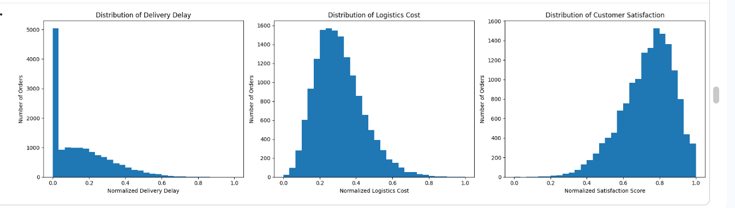
Figure 1: Distribution of Delivery Delay, Logistics Cost, and Customer Satisfaction

The Delivery Delay distribution is concentrated toward the lower end of the normalized range, with fewer observations extending toward higher delay values. This indicates that most observations have relatively lower normalized delays, while a smaller group experiences comparatively higher delays.
The Logistics Cost distribution is concentrated toward the lower-to-middle portion of the normalized range, with observations extending toward higher values. This indicates variation in logistics costs across the dataset.
Customer Satisfaction is concentrated toward the higher portion of the normalized scale, although lower satisfaction observations are also present.
These distributions provide useful background for the correlation and group-level analysis that follows.
Histograms were selected because the three variables are numerical and their distributions need to be examined. A histogram makes it possible to observe where most observations are concentrated and whether a smaller number of observations extend toward higher or lower values.
CORRELATION ANALYSIS
Correlation analysis was performed to examine the strength and direction of relationships between important logistics variables. The selected variables included distance, warehouse processing time, traffic delay, weather delay, estimated delivery time, promised delivery time, delivery delay, shipping cost, logistics cost, and customer satisfaction.
A correlation coefficient ranges from -1 to +1. Positive values indicate that two variables tend to increase together, while negative values indicate an inverse relationship. A value closer to zero indicates a weaker linear relationship.
Correlation should be interpreted as an association rather than proof that one variable causes another.
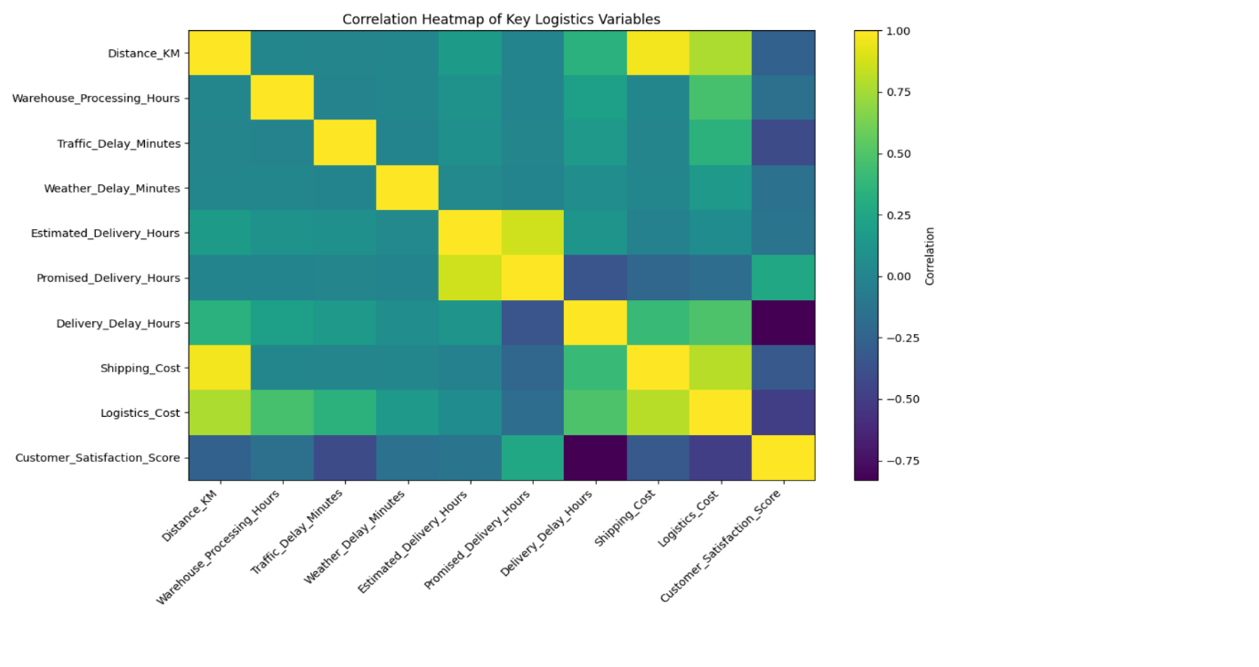
Figure 2: Correlation Heatmap of Key Logistics Variables
Correlation heatmap was selected because multiple relationships can be examined simultaneously. The color intensity provides a quick visual indication of the strength and direction of relationships between the selected logistics variables.
KEY CORRELATION RESULTS
Variable relationship | Correlation | Interpretation
Distance- Shipping Cost | 0.97 | Very strong positive reletionship
Estimated Delivery– Promised Delivery | 0.87 | Strong positive relationship
Delivery Delay–Customer Satisfaction | -0.83 | Strong negative relationship
Shipping cost-Logistics cost | 0.80 | Strong positive relationship
Distance- Logistics Cost | 0.78 | Strong positive relationship
Logistics Cost- Customer Satisfaction | -0.49 | Moderate negative relationship
Traffic Delay- Customer Satisfaction | -0.41 | Moderate negative relationship
Delivery Delay- Logistics Cost | 0.49 | Moderate positive relationship
Distance- Delivery Delay | 0.34 | Positive relationship
Warehouse Processing- Delivery Delay | 0.21 | Weak positive relationship

The strongest positive relationship observed was between Distance and Shipping Cost, with a correlation of approximately 0.97. This indicates that longer delivery distances are strongly associated with higher shipping costs in the dataset.
Estimated Delivery Hours and Promised Delivery Hours also showed a strong positive relationship of approximately 0.87.
Delivery Delay Hours and Customer Satisfaction Score showed a strong negative correlation of approximately -0.83. This indicates that higher delivery delays tend to be associated with lower customer satisfaction.
Shipping Cost and Logistics Cost showed a positive correlation of approximately 0.80, while Distance and Logistics Cost showed a correlation of approximately 0.78.
These relationships identify important areas for further investigation. However, correlation alone does not establish causation.

SHIPPING METHOD ANALYSIS
Delivery performance was compared across four shipping methods: Same Day, Express, Standard, and Economy. The analysis considered order volume, average delivery delay, average logistics cost, average customer satisfaction, and on-time delivery rate.
Grouping the data by shipping method allows different service categories to be compared using the same performance measures.

Shipping Method | Orders | Avg. Delivery Delay | Avg. Logistics Cost | Avg. Satisfaction | On-Time Rate
Same day | 1,489 | 0.275 | 0.364 | 0.651 | 0.036
Express | 4,190 | 0.202 | 0.326 | 0.704 | 0.139
Standard | 6,714 | 0.128 | 0.295 | 0.753 | 0.330
Economy | 2,607 | 0.083 | 0.281 | 0.783 | 0.513

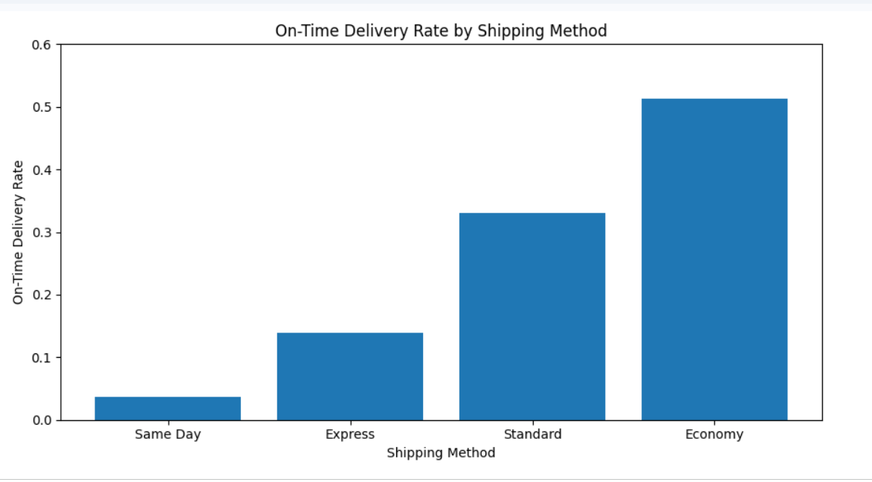
Figure 3: On-Time Delivery Rate by Shipping Method
Same Day shipping shows the highest average normalized delivery delay at 0.275 and the lowest observed on-time delivery rate at 0.036. It also has the highest average normalized logistics cost among the four methods.
Economy shipping shows the lowest average normalized delivery delay at 0.083 and the highest observed on-time delivery rate at 0.513.
Standard shipping has an observed on-time rate of 0.330, while Express has an on-time rate of 0.139.
These differences are observational. The results do not establish that the shipping method itself causes the differences because other operational conditions may influence which shipping method is selected.
A bar chart is selected because shipping method is a categorical variable. A bar chart makes it straightforward to compare the on-time delivery rate across the four service categories.
MONTHLY DELIVERY PERFORMANCE
Monthly analysis was conducted to examine whether delivery performance changed across the twelve months represented in the dataset. The analysis included order volume, average delivery delay, average logistics cost, customer satisfaction, and on-time delivery rate.
Month | Orders | Avg. Delay | Avg. Logistics Cost | Avg. Satisfaction | On-Time Rate
1 | 1,274 | 0.156 | 0.312 | 0.735 | 0.295
2 | 1,161 | 0.164 | 0.312 | 0.728 | 0.275
3 | 1,275 | 0.159 | 0.315 | 0.734 | 0.253
4 | 1, 232 | 0.158 | 0.306 | 0.736 | 0.249
5 | 1,275 | 0.152 | 0.306 | 0.736 | 0.306
6 | 1,232 | 0.161 | 0.308 | 0.732 | 0.276
7 | 1,273 | 0.158 | 0.311 | 0.727 | 0.274
8 | 1,275 | 0.148 | 0.306 | 0.739 | 0.307
9 | 1,233 | 0.158 | 0.306 | 0.736 | 0.248
10 | 1,273 | 0.151 | 0.302 | 0.736 | 0.288
11 | 1,234 | 0.154 | 0.305 | 0.734 | 0.291
12 | 1,263 | 0.148 | 0.306 | 0.741 | 0.287

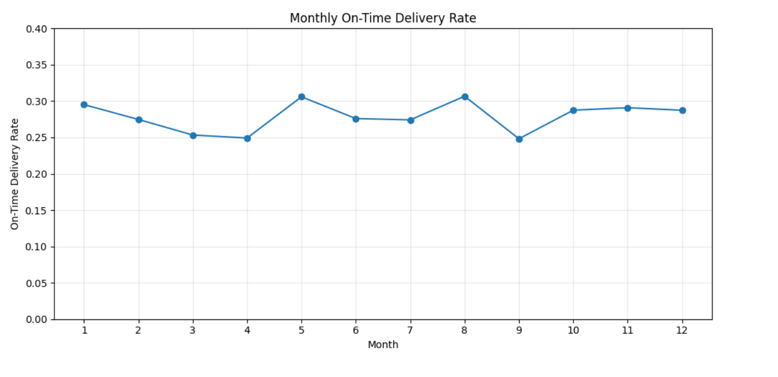 Figure 4: Monthly On-Time Delivery Rate
The monthly on-time delivery rate varies between approximately 0.248 and 0.307. The highest observed rate occurs in August at approximately 0.307, while September shows the lowest at approximately 0.248.
Average delivery delay remains within a relatively narrow range, from approximately 0.148 to 0.164. This indicates that monthly variation in the on-time rate is more noticeable than the variation in average normalized delivery delay.
Monthly monitoring can therefore help identify periods where delivery reliability requires additional investigation.
A line chart is selected because the months have a natural chronological order. A line allows changes in on-time delivery performance to be observed across the year.
DELIVERY PARTNER ANALYSIS
Delivery partner performance was also examined using the same group-level measures. The observed on-time delivery rates were:
- In-House: 0.287
- Partner D: 0.283
- Partner A: 0.282
- Partner B: 0.273
- Partner C: 0.272
The results show relatively similar on-time delivery rates across the delivery partner groups. The difference between the highest and lowest observed rate is comparatively small.
Average delivery delay and logistics cost were also relatively similar across the groups. Therefore, the dataset does not show a large performance separation between delivery partners.
This finding suggests that future analysis should examine other operational variables, such as shipping method, distance, traffic conditions, warehouse processing, and delivery timing, rather than relying only on delivery partner comparisons.

DELIVERY DELAY AND CUSTOMER SATISFACTION
The relationship between delivery delay and customer satisfaction was examined using a scatter plot. This analysis is important because delivery performance can be related to the customer experience.
The correlation analysis produced a correlation coefficient of approximately -0.83 between Delivery_Delay_Hours and Customer_Satisfaction_Score.
A scatter plot is selected because both variables are numerical. The plot allows individual observations to be viewed and makes it possible to visually examine whether higher delivery delays are associated with higher or lower customer satisfaction.

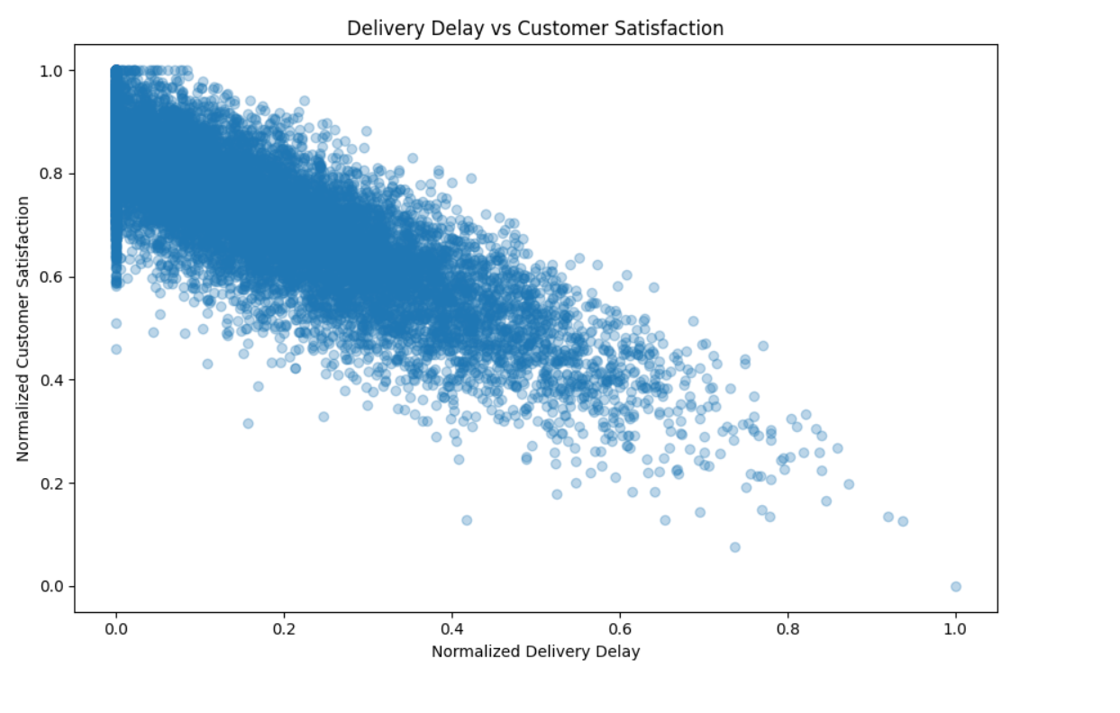
Figure 5: Delivery Delay vs Customer Satisfaction
The scatter plot shows a strong negative relationship between delivery delay and customer satisfaction. This is consistent with the correlation coefficient of approximately -0.83.
The pattern indicates that observations with higher delivery delays generally tend to have lower customer satisfaction scores.
This is an important logistics performance observation because customer satisfaction is an outcome that can be associated with delivery reliability.
However, the relationship should not be interpreted as proof that delivery delay is the only factor influencing customer satisfaction. Other factors such as product, service, cost, and customer expectations may also contribute.
OPERATIONAL EFFICIENCY
Operational efficiency can be examined by considering how consistently orders are processed and delivered within expected timeframes.
The analysis indicates that on-time delivery performance varies across shipping methods and months. This means that overall delivery performance should not be assessed only through a single average value.
The strong relationship between delivery delay and customer satisfaction also indicates that delivery reliability is an important customer-facing performance area.
Warehouse processing time, traffic delay, delivery distance, and shipping method are additional operational variables that can be examined when investigating delivery performance.
These observations can be used to identify areas requiring further investigation rather than being treated as confirmed causal explanations.

COST DRIVERS
Cost-related variables were examined through correlation analysis and shipping-method comparisons.
Distance and Shipping Cost showed a very strong positive correlation of approximately 0.97. This indicates that longer delivery distances are strongly associated with higher shipping costs within the dataset.
Shipping Cost and Logistics Cost also showed a strong positive correlation of approximately 0.80. Distance and Logistics Cost showed a correlation of approximately 0.78.
Shipping method comparisons also showed differences in average logistics cost. Same Day shipping had the highest average normalized logistics cost among the four shipping methods, while Economy had the lowest.
These results suggest that transportation distance and service category are important variables to monitor when examining logistics costs.
POTENTIAL BOTTLENECKS
The exploratory analysis highlights several variables that can be considered potential areas for operational investigation:
Delivery delays: Higher delivery delays are associated with lower customer satisfaction and therefore represent an important performance area.
Traffic delays: Traffic delay shows a negative relationship with customer satisfaction and a positive relationship with delivery delay.
Warehouse processing: Warehouse processing time shows a positive relationship with delivery delay, although the relationship is relatively weak.
Shipping method: Large differences were observed between shipping categories in terms of on-time delivery rate and average delay.
Long-distance deliveries: Distance is strongly associated with shipping cost and also shows a positive relationship with delivery delay.
These are potential bottleneck indicators rather than confirmed causes. Additional analysis would be required to determine the underlying causes.
KEY FINDINGS
Finding 1 — Overall delivery reliability
The overall on-time delivery rate in the dataset is approximately 27.93%.
Finding 2 — Delivery delay and satisfaction
Delivery Delay Hours and Customer Satisfaction Score have a strong negative correlation of approximately -0.83.
Finding 3 — Distance and shipping cost
Distance and Shipping Cost have a very strong positive correlation of approximately 0.97.
Finding 4 — Logistics cost relationships
Shipping Cost and Logistics Cost show a strong positive correlation of approximately 0.80.
Finding 5 — Shipping method variation
Shipping methods show noticeable differences in observed on-time delivery rates, delivery delays, logistics costs, and satisfaction.
Finding 6 — Monthly variation
Monthly on-time delivery performance varies across the year, while average delivery delay remains within a relatively narrow range.
Finding 7 — Delivery partners
Delivery partner performance is relatively similar across the groups in terms of observed on-time delivery rates.
RECOMMENDATIONS
Based on the observations from the exploratory analysis, the following recommendations are proposed:
- Monitor on-time delivery by shipping method: Delivery performance should be monitored separately for each shipping category because the observed performance differs between methods.
- Investigate high-delay orders: Orders with unusually high delivery delays should be examined to determine whether distance, traffic, warehouse processing, or other variables are associated with the delay.
- Monitor long-distance shipments: Since distance has a very strong relationship with shipping cost, long-distance shipments should be monitored for their cost and delivery implications.
- Track customer satisfaction alongside delivery performance: Because delivery delay has a strong negative association with satisfaction, both measures should be monitored together.
- Review monthly performance: Monthly on-time delivery rates should be monitored to identify periods that show relatively lower delivery reliability.
- Continue delivery partner monitoring: Although partner performance is relatively similar, periodic comparison can help identify future changes in performance.
- Use predictive analysis: The variables identified during EDA can be used in subsequent predictive modelling to investigate whether delivery outcomes can be predicted from operational characteristics.
LIMITATIONS
This analysis has several limitations. First, the analysis is based on a single e-commerce logistics dataset, so the findings may not represent every logistics operation.
Second, correlation analysis identifies statistical relationships but does not establish causation. For example, the strong negative relationship between delivery delay and customer satisfaction does not prove that delay is the only reason for lower satisfaction.
Third, several Week 3 visualizations use normalized variables. Normalization places variables on a common 0–1 scale, which is useful for comparison but does not retain the original units in those visualizations.
Finally, this stage focuses primarily on exploratory analysis. Statistical significance testing and predictive modelling would be required for deeper investigation of the observed patterns.
FUTURE ANALYSIS
The findings from this exploratory analysis provide a foundation for further logistics analytics. A future stage can use predictive modelling to investigate whether delivery outcomes can be estimated from operational variables.
Potential predictor variables include delivery distance, traffic delay, weather delay, warehouse processing time, shipping method, package characteristics, courier information, and warehouse conditions.
Predictive models can then be evaluated using appropriate performance metrics. The results can be used to identify important variables and support data-driven logistics planning.
Further analysis could also investigate optimization approaches for delivery performance and logistics costs.
PYTHON CODE
Loading the dataset
import pandas as pd
data = pd.read_csv(
'/content/logistics_data/ecommerce_logistics_delivery_cleaned.csv'
)
print("Dataset shape:", data.shape)
Central tendency
key_columns = [
'Order_Value',
'Order_Quantity',
'Distance_KM',
'Warehouse_Processing_Hours',
'Traffic_Delay_Minutes',
'Weather_Delay_Minutes',
'Delivery_Delay_Hours',
'Shipping_Cost',
'Logistics_Cost',
'Customer_Satisfaction_Score'
]
central_tendency = data[key_columns].agg(['mean', 'median'])
print(central_tendency.round(3))
Correlation
correlation_columns = [
'Distance_KM',
'Warehouse_Processing_Hours',
'Traffic_Delay_Minutes',
'Weather_Delay_Minutes',
'Estimated_Delivery_Hours',
'Promised_Delivery_Hours',
'Delivery_Delay_Hours',
'Shipping_Cost',
'Logistics_Cost',
'Customer_Satisfaction_Score'
]
correlation_matrix = data[correlation_columns].corr()
print(correlation_matrix.round(2))
Shipping method analysis
shipping_analysis = data.groupby('Shipping_Method').agg(
Orders=('Order_ID', 'count'),
Avg_Delivery_Delay=('Delivery_Delay_Hours', 'mean'),
Avg_Logistics_Cost=('Logistics_Cost', 'mean'),
Avg_Satisfaction=('Customer_Satisfaction_Score', 'mean'),
On_Time_Rate=('On_Time_Delivery_Flag', 'mean')
)
print(shipping_analysis.round(3))
Visualization example
plt.figure(figsize=(9, 5))
plt.bar(
shipping_plot['Shipping_Method'],
shipping_plot['On_Time_Rate']
)
plt.title('On-Time Delivery Rate by Shipping Method')
plt.xlabel('Shipping Method')
plt.ylabel('On-Time Delivery Rate')
plt.tight_layout()
plt.show()

CONCLUSION
The task focused on exploratory data analysis and visualization of logistics delivery data using Python. The analysis examined central tendency, distributions, correlations, shipping method performance, monthly delivery performance, delivery partner performance, and the relationship between delivery delay and customer satisfaction.
The analysis produced several meaningful observations. The overall on-time delivery rate was approximately 27.93%. Distance showed a very strong positive relationship with shipping cost, while delivery delay showed a strong negative relationship with customer satisfaction. Differences were also observed across shipping methods and across months in terms of on-time delivery performance.
The visualizations provided a clear way to understand distributions, relationships, categorical comparisons, and changes over time. The analysis also identified potential areas for further investigation, including delivery delays, transportation costs, shipping methods, and customer satisfaction.
Overall, this analysis provides a stronger analytical foundation for the next stage of the logistics project. The findings can be used to support predictive modelling and further investigation of logistics performance.

