Multi-agent network

REFERENCE: <https://langchain-ai.github.io/langgraph/tutorials/multi_agent/multi-agent-collaboration/>

Replacing the below Chart Generator node with Image Generator node

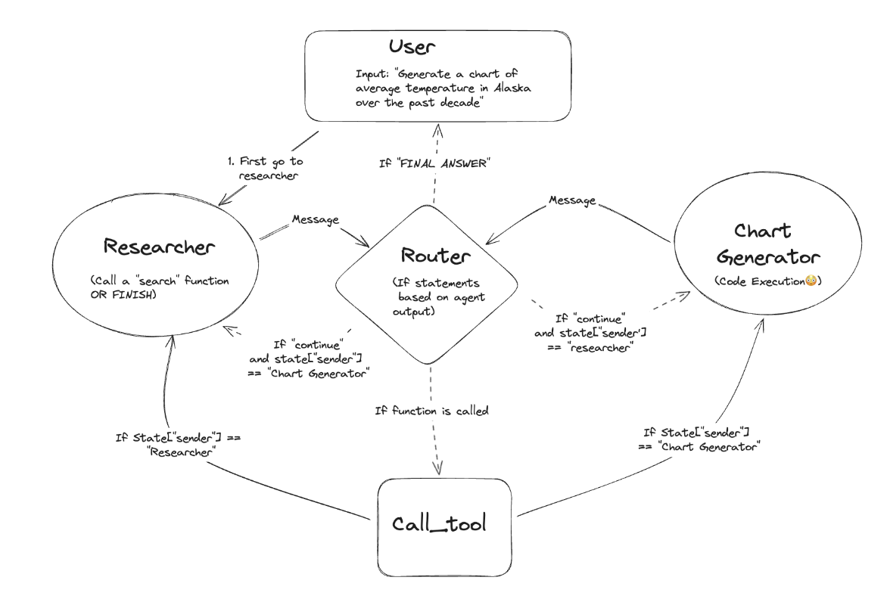

Graph Flow Diagram

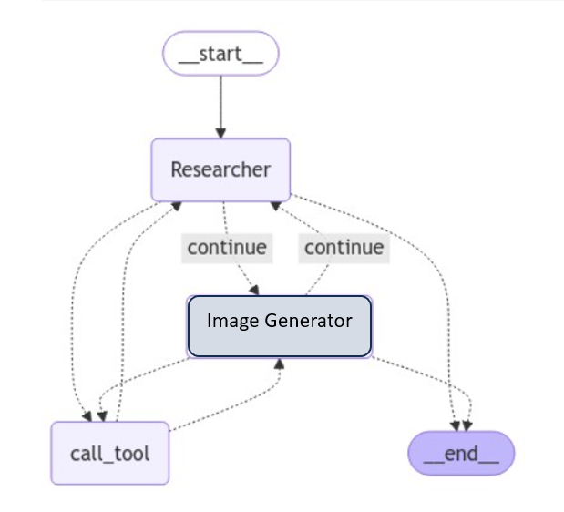

Tool Calls:

Tool calls are not consistent in the some of the LLM as of now,

<https://github.com/langchain-ai/langgraph/issues/720>

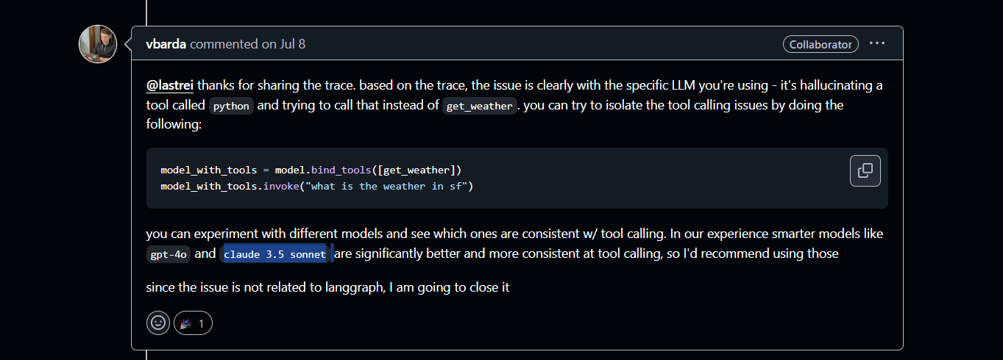

LLM Used:

[llama3-groq-tool-use](https://ollama.com/library/llama3-groq-tool-use)

**A series of models from Groq that represent a significant advancement in open-source AI capabilities for tool use/function calling.**

<https://ollama.com/library/llama3-groq-tool-use>

Reference: <https://youtu.be/Nfk99Fz8H9k?si=kgvrgsBH8pcsZpYP>

Lang Smith Traces:

<https://smith.langchain.com/o/bbb25ee7-d7c5-5e99-8fb3-c25529acb5fc/projects/p/108a8707-35c5-414b-b5a8-1c6d7ba6e981?timeModel=%7B%22duration%22%3A%227d%22%7D&peek=43c4c593-bdf3-482d-9607-f6ccdf5ed309>