**Optimization of Business Logistics: Data driven Analysis of Problem for a grocery firm**

**Final Submission report for the BDM capstone Project**

Submitted by

**Name: Varad Manoj Uttarwar**

**Roll number: 22F2001664**



IITM Online BS Degree Program,

Indian Institute of Technology, Madras, Chennai

Tamil Nadu, India, 600036

**Contents**

|  |  |
| --- | --- |
| **Title** | **Page number** |
| 1. Executive summary and title | 3 |
| 1. Proof of Originality | 4 |
| 1. Problem Statement | 4 |
| 1. Detailed Explanation of Analysis Process | 5 |
| 1. Result and Findings | 8 |
| 1. Interpretation of Results | 14 |
| 1. Recommendations | 15 |

**Declaration Statement**

I am working on a Project titled “Optimization of Business Logistics: Data driven Analysis of Problem for a grocery firm”. I extend my appreciation to Purushottam Paraswar Grocery Store, for providing the necessary resources that enabled me to conduct my project.

I hereby assert that the data presented and assessed in this project report is genuine and precise to the utmost extent of my knowledge and capabilities. The data has been gathered from primary sources and carefully analyzed to assure its reliability.

Additionally, I affirm that all procedures employed for the purpose of data collection and analysis have been duly explained in this report. The outcomes and inferences derived from the data are an accurate depiction of the findings acquired through thorough analytical procedures.

I am dedicated to adhering to the information of academic honesty and integrity, and I am receptive to any additional examination or validation of the data contained in this project report.

I understand that the execution of this project is intended for inwdividual completion and is not to be undertaken collectively. I thus affirm that I am not engaged in any form of collaboration with other individuals, and that all the work undertaken has been solely conducted by me. In the event that plagiarism is detected in the report at any stage of the project's completion, I am fully aware and prepared to accept disciplinary measures imposed by the relevant authority.

I understand that all recommendations made in this project report are within the context of the academic project taken up towards course fulfillment in the BS Degree Program offered by IIT Madras. The institution does not endorse any of the claims or comments.



***Signature of Candidate***

Name: Varad Manoj Uttarwar

Date: 15-March-2024

# Executive Summary

Purushottam Paraswar's grocery store, an establishment with roots dating back to 1963, has consistently upheld a commitment to delivering outstanding customer service and fulfilling the day-to-day needs of its clientele. As part of an ongoing initiative to expand and evolve the business, a recent in-depth examination of the store's operations uncovered a notable challenge, particularly related to bulk ordering procedures during the significant Ekadashi festival and Diwali Festivals.

During a meticulous on-site visit and a thorough review of transactional data, it became evident that the store encounters difficulties with the timing of bulk orders, specifically when these orders need to be sold within a specified timeframe. This challenge, however, presents an opportunity for resolution through the selection of appropriate suppliers. Unfortunately, incomplete supplier information provided by the shop owner has hindered progress in addressing this particular issue.

Moving forward, the analysis shifted focus to a comprehensive examination of items sold during the Ekadashi festival. Various methodologies were employed, complemented by diverse visualization techniques, to discern profitable items and those exhibiting positive performance trajectories. This exploration also involved a critical analysis of persistently underperforming items that, despite their negative impact on the store's profitability, continued to be stocked. Additionally, the study explored innovative strategies to foster the growth and development of the store's business. To perform this analysis, store owner has given useful data which will be helpful in making the analysis.

A subsequent challenge arose concerning the negotiation of price rates with suppliers, this problem could be solved with only conversation with supplier or changing the supplier based on their schemes.

To provide a comprehensive understanding of sales patterns, buying habits, and opportunities for strategic planning, the analysis covered a seven-month period—encompassing the months preceding, during, and following the Ekadashi and Diwali festival. This temporal analysis not only sheds light on sales trends but also serves as a valuable tool for identifying products with a high potential for increased focus and promotional activities.

Finally, the month wise trends have been drawn related to products and transactional analysis is made. Useful suggestions are also given at the end, to enhance the performance of the firm.

# Proof of Originality

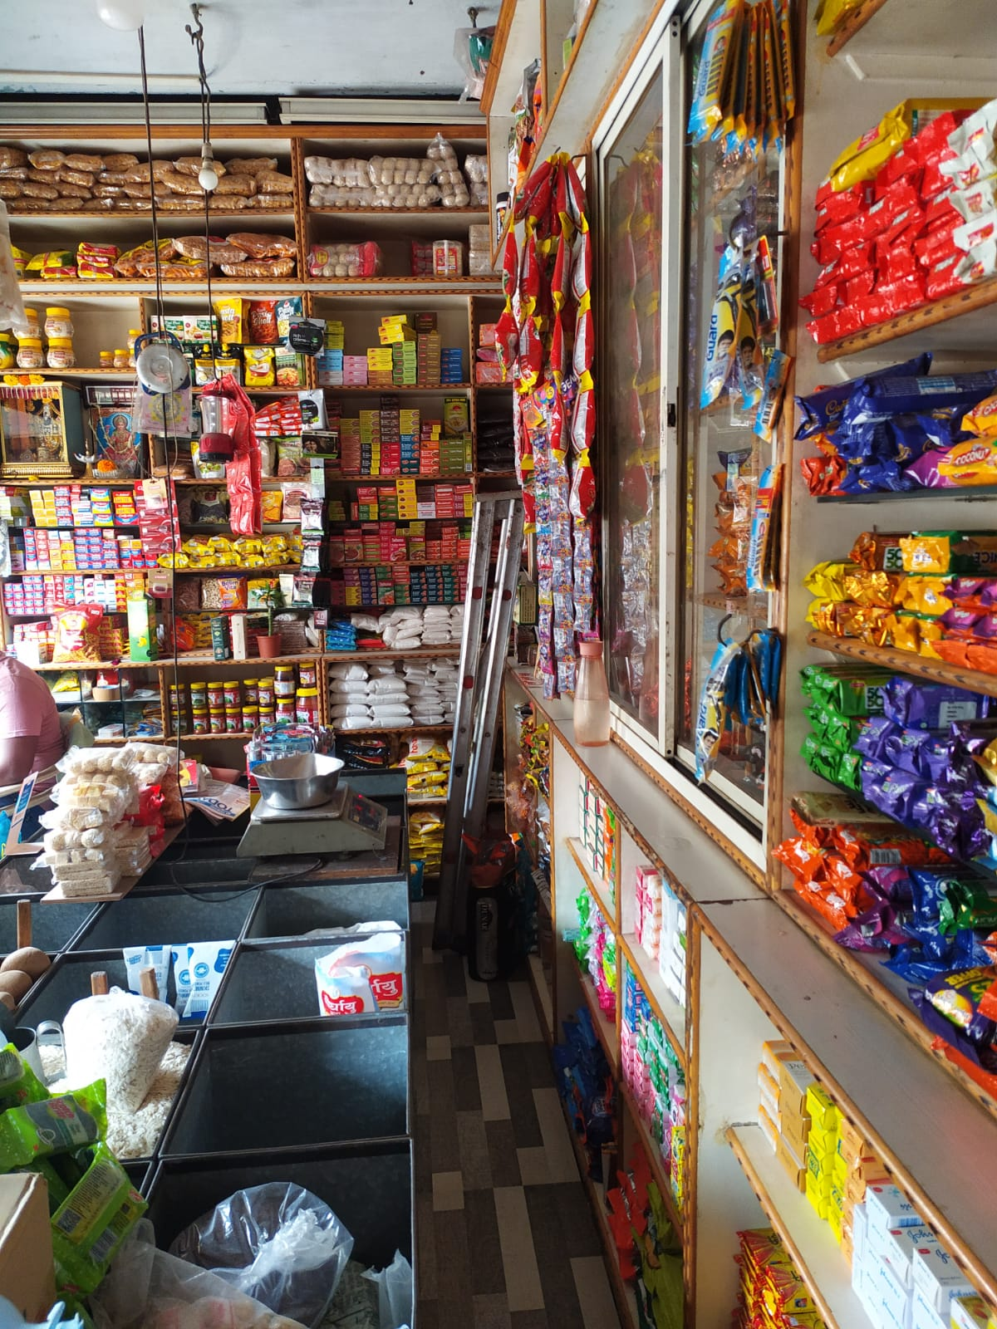

**Fig1: Shop image**

# Problem Statement

* Problem of managing the products in the festivals. This is due to ordering in bulk when there are lot of customers buying from the firm. This could be solved by the analyzing the data from previous month and maintaining the amount so that stock out and overload condition is avoided.
* Mr. Shrikant is facing problem regarding loss in some products, he is adapting to analysis on his stock and transaction so that such losses could be minimized.
* By thorough analysis of stock maintenance and examining the trends, both the problem could be solved and positive insights could be achieved.

1. **Detailed Explanation of Analysis Process**

Mr. Shrikant has cooperated with me and provided with the data of a year. The data was extremely unorganized, but managed by putting entries in sheets and continues communication with him. For analyzing the data, it was important to have structured form of it. Corrections were made on entries which contain spelling mistakes and incorrect input. The firm was buying stock once every 2 month or sometimes somewhere in middle, those discrepancies were solved and data which lied in middle is taken into consideration in earlier month.

After converting the meta data to structured data, I added few important parameters to the structure. As, there was only date present, I converted it to just months so that precision and broader view is maintained regarding the timeline. I’ve added unit, stocks_sold and computed parameter of stocks_remaining in the structure. Earlier, it was difficult to follow up the transaction made by the shop, now after collecting this data, it became easier to have analysis on it. Unit consist of total units of stock bought by the firm in that month. It was assumed to have product unit as kg or singular unit if the product belongs to a company or it is raw.

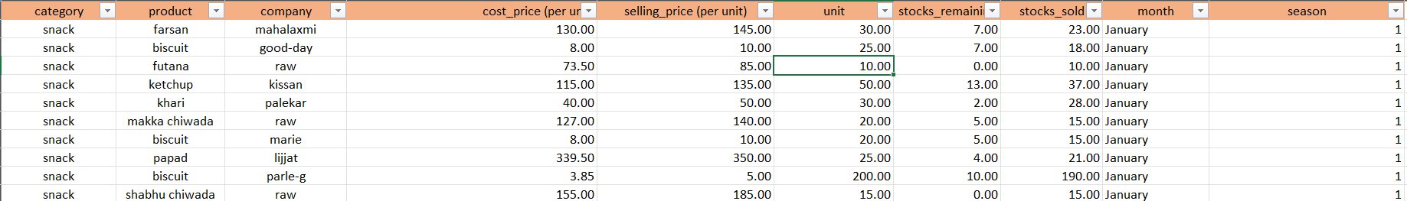

Fig 1: Structure of data

The above structure contains Category to maintain broader aspect of products, Product as the name of product, company for which company does the product belongs or is it a raw, cost_price (per unit) for prices at which the firm buy the product, selling_price (per unit) for prices at which the firm sales the product, unit to know how many units/kg did the show buy from supplier, stocks_sold to know how many units/kg of product were sold, stocks_remaining is computed parameter (unit – stocks_sold), finally season to make seasonal analysis.

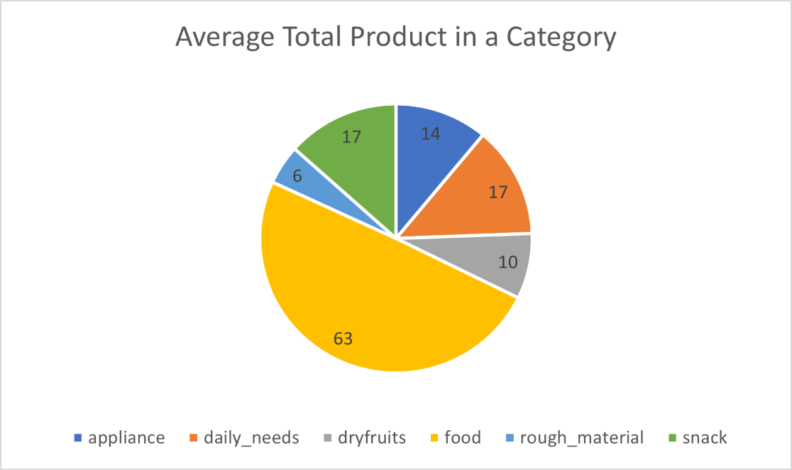

Fig2: Category wise product distribution

The meta-data contain more insignificant data, but finally I came to conclusion to have analysis only on 127 products and some seasonal once which contributes and give value to analysis.

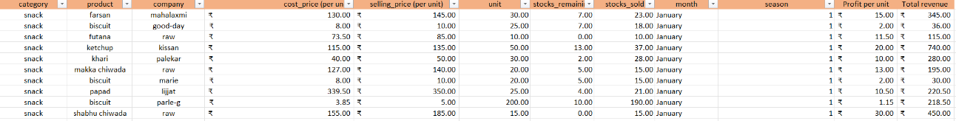

Fig3: Including computational parameters of Profit and Revenue

Furthermore, in Figure (3) to enhance the data calculating parameters like Total revenue and Profit per unit is calculated, it was important to make out analysis regarding profit with respect to a particular product and its contribution in revenue generation of the shop.

Now, for more in depth analysis I have used pandas, seaborn and matplotlib to draw out visualization more independently. I have constructed the graphs of sales for each category for each month. This will give a complete understanding on which of the core category we need to focus more on throughout the analysis.

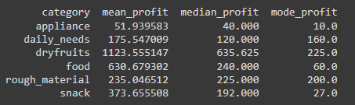

Fig4: Means, Median, Mode

I have calculated the mean, median and mode for each category over all months which shows the roughly which categories are more likely to bring profit over the months. This has dry fruits as top performer then food and snack category perform the best. Also, for median and mode dry fruits is top performer but mode for food decreases because the highest sold food is of profit bearing Rs 60.

Further, my analysis regarding, which product category was more prominent in generating revenue for the shop was made. This shows which items are most efficient for the firm and probably its stocking should not be overlooked.

To reach out to the problem I have calculated which are the products in a particular category has most sales in Ekadashi as well as Diwali period. Finally, I made analysis based on its purchasing value which would be helpful to Mr. Shrikant on when and which product to buy and maintain before those seasons.

A detail analysis is performed on each product and its remaining and transactional stock category wise. This gave an idea on which products from particular category should Mr. Shrikant look onto most. This holistic approach could be beneficial to get insights on the stock maintenance efficiency and alternatives selection of products if he feels to upscale his firm.

A trend line analysis of each category is also presented which shows how each category flows through these 7 months and which category is most or least sold based on total remaining stocks in each month. This line also depicts for which category to focus more on which month.

Finally, a scatter plot is presented which would give a clear idea on which product are fast moving, slow moving, more cost but slow moving and vice-versa. This graph would reflect entire product flow of the firm.

Link for meta-data:

https://drive.google.com/drive/folders/1r2HL5bBOan9LkhXcLMQfu9IjWymr6kpJ?usp=sharing

Link for cleaned-data:

<https://docs.google.com/spreadsheets/d/1SH3REAXkYkL_nVmwyO6xOQZbNhJU0fnwuSheqOkejP4/edit?usp=sharing>

1. **Result and Findings**

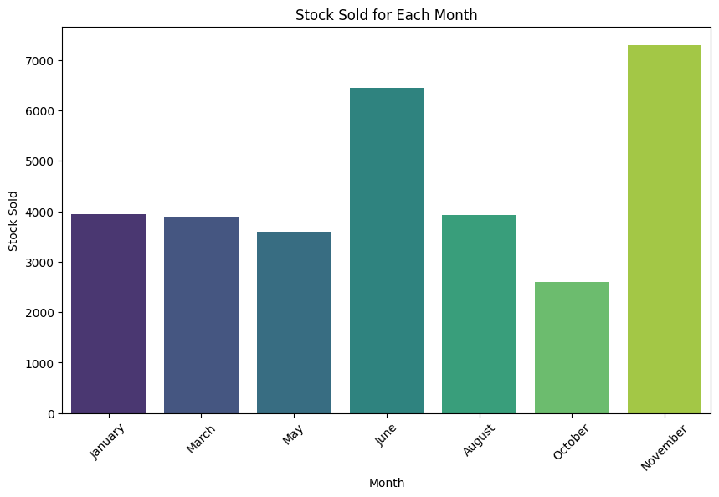

Fig5: Total Stock sold for each month

The above graph is constructed to get insights on which month has highest transaction. As per the above graph it is clear that month of June and November has seen highest stock sold of more than 6000 units. Also, this are the month where festival of Ekadashi and Diwali occurred. As per the graph month of October has seen lowest transaction of the year. Month of January, March, May and August has seen average performance as per selling the stock is concerned. The above graph made it clear that firm has to focus more on June and November for stock starving and overloading concerns.

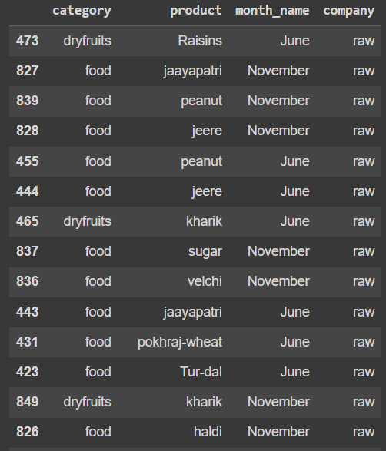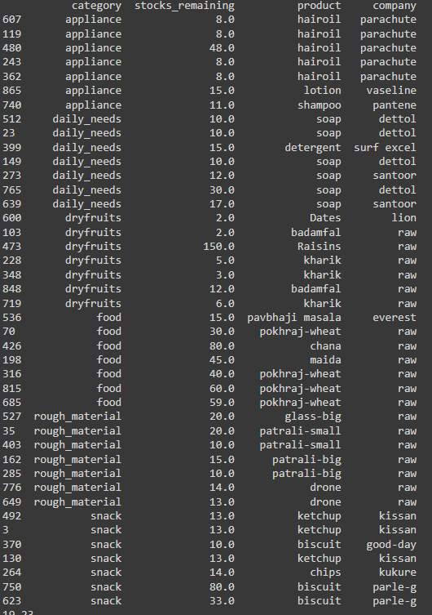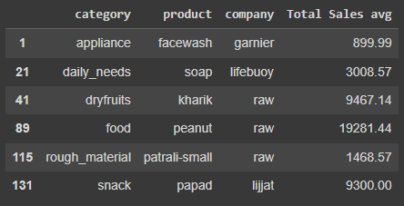

Fig 6: Prime Category for each month (Highest revenue generator)

The above results in figure 3 is about finding which are the prime products in each month, (i.e.) selling of which product has been done more. This finding was done category wise so as to get analysis on holistic view. It is seen widely that items of raw material are been sold more in the ratio of 19:23 from above results. Here 19 are company items and 23 are raw materials. This made it clear that the firm is being transacting a lot on raw materials. Furthermore, by communication with Mr. Shrikant it has been identified that cost price of the company material largely remains same throughout but cost price of raw materials changes based on supplier, demands and schemes.

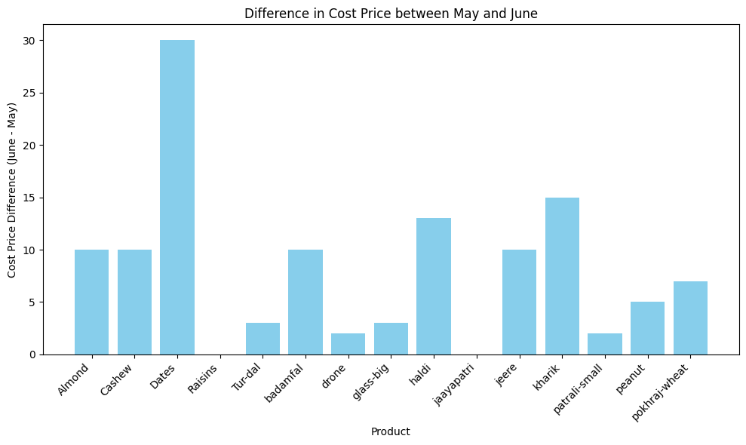

Fig7: Variation in price when buying from supplier in months of high sales (May, June)

The above graph is drawn out with the help of previous result this the total change in cost price for top performing raw materials in the firm in month of May and June. It has been seen that prices or raw dates has been varied the most. The price of raisins, though it is top performing dry fruit in month of June is not taken into consideration because it is outlier and only bought in bulk in month of June and it has 0 transaction in month of May. This filter was easily applied with the help of python and seaborn together.

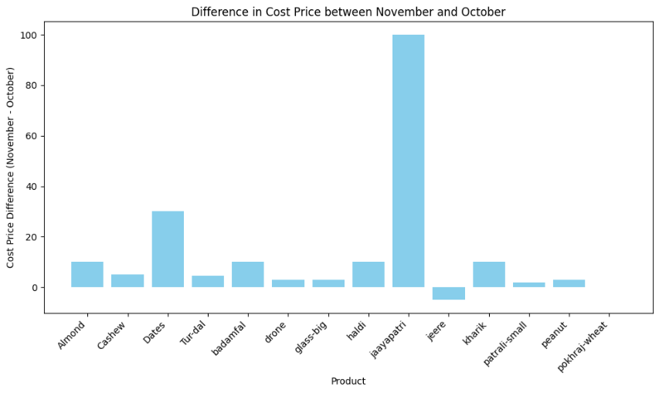

Fig8: Variation in price when buying from supplier in months of high sales (October, November)

Similarly in month of November it few raw materials prices has been varied. These materials are top performing in the month of November and October.

A conclusion can be made from this that, this firm can buy raw dry fruits and raw food item particularly grains and rough_materials (“patrali and drones”) in bulk before starting the festival, so that they don’t have to go through price hikes and still sells the items in their regular price. This could boost their sells.

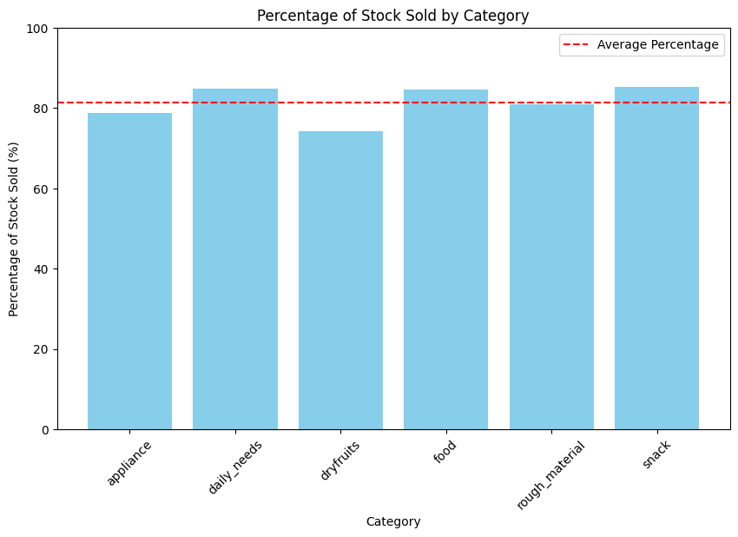

Fig 9: Categories with more rate of stock transaction than average

In this graph of figure (8) the percentage wise stock transaction is find out. Here it can be seen from the graph that daily_needs, food and snack category get highest transaction. Though this are the category with maximum of firm’s transaction involved still they may not be revenue generator.

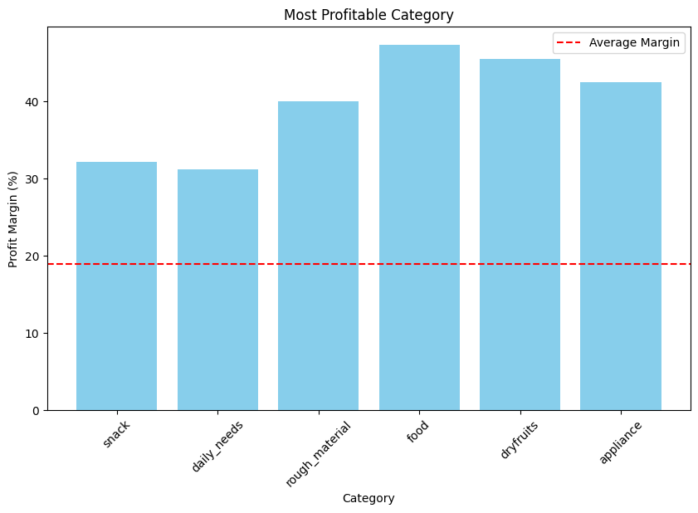

Fig 10: Category with most profit margin

This is the graph which will give more insights about how each category performs wit respect to the there profit margin. Percent wise it was found that food has highes profit margin, then dry fruits and appliances. These are more efficient categories of firm. These category needs to be focused more in order to generate higher revenue.

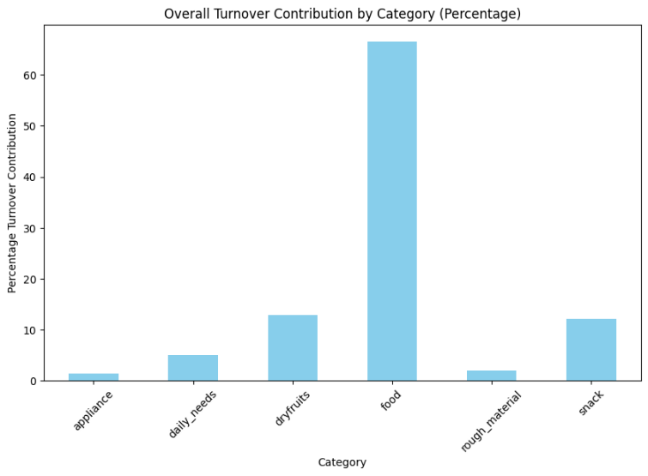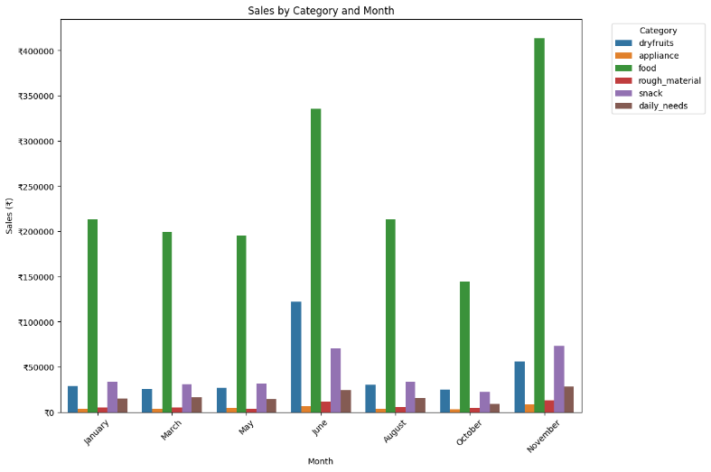

Fig 11: Turnover Contribution and sales by category

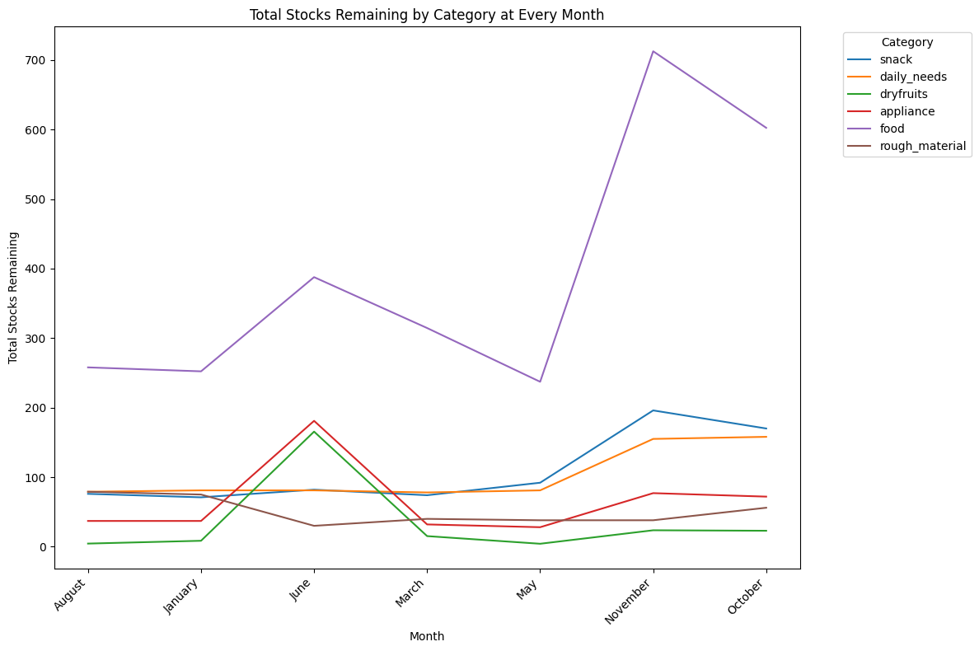Above graphs give information about categories which are more sold as well as bringing more revenue to the firm. The left graph shows the percent-wise revenue contribution to the firm. Here it has been fount out that more than 60% of entire firm’s revenue is generated by food items and then dry fruits and snack plays the role. It has also been made clear from the right graph which shows the distribution of revenue for each month. Food and dry fruits show highest spike in month of June and November. Therefore, it will be more efficient to up stock those products in the month earlier have been shown earlier.

Fig 12: Total remaining stocks

Graph in figure (11) describes about remaining stock of each category at the end of each month.

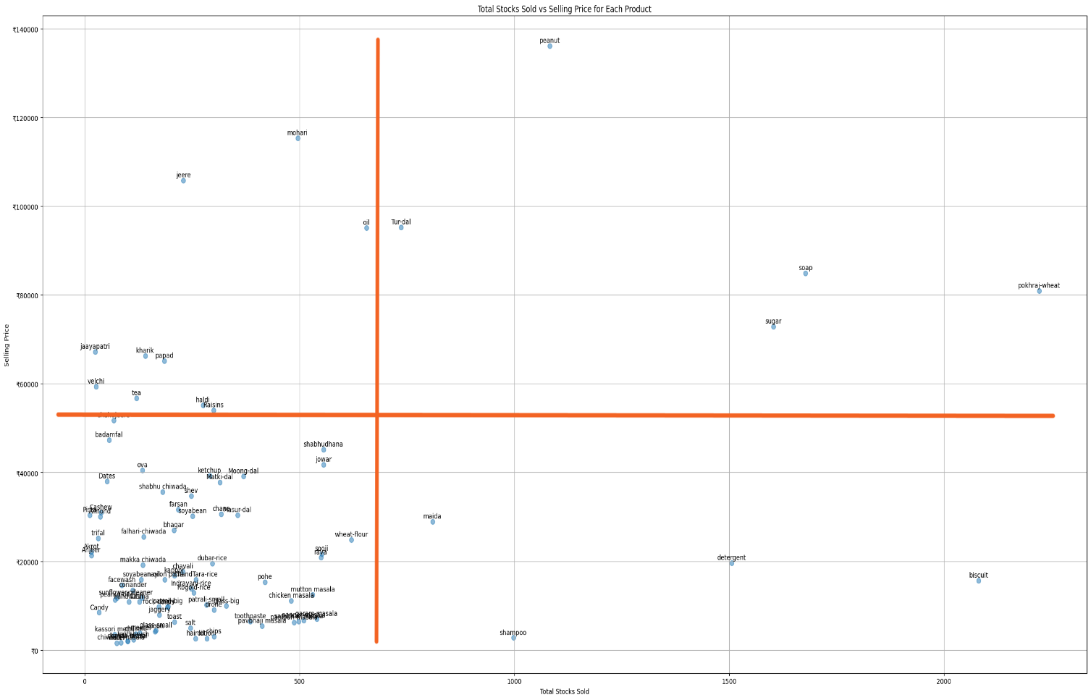Here everything is in units therefore if there is raw food item, then it comprises of a unit kg of item.

Fig 13: Scatter plot for total product analysis

This is the important graph which tells about overall frequent and high profitable product. Products in first quadrant is most beneficial for the firm. These include Peanut, tur-dal, wheat, sugar etc. These says that these products are most frequently sold as well as these are of high profit margin. One outcome that can be drawn from this part is, these products could be bought in bulk from supplier before the month of both festivals. Also, these are raw products therefore as mentioned earlier the prices of these material gets fluctuated upwards during festivals. Therefore, the material to be brought in the month of June and November could be brought in the month before. Below graph shows the revenue for raw and company items.

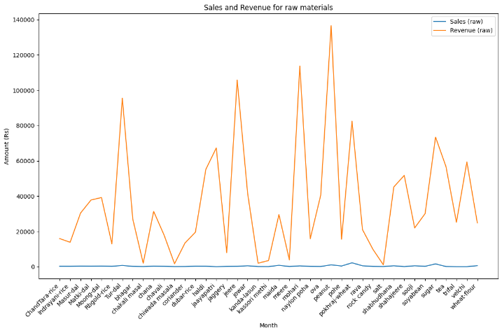

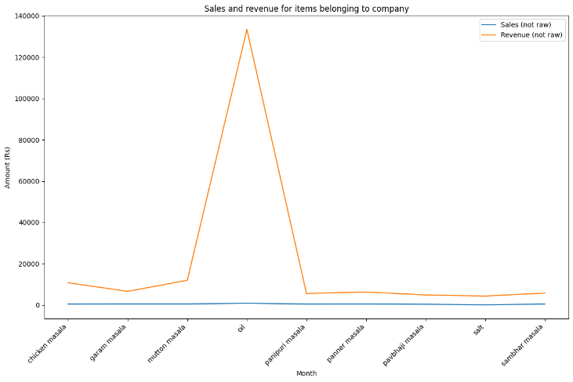

Fig 14: Raw vs Company item

These are the top items sold in each month of analysis and clearly it depicts the consistency of raw over company items. Moreover, there are some items in raw materials like salt, kanda-lasun masala, chiwada-masala, chakali-masala, mere etc. are sold relatively lower. One of the reasons could be these items are seasonal and has demand in particular month only. Like, chiwada-masal, chakali-masala in month of November.

1. **Interpretation of results**

**i) Efficient Categories:**

The analysis underscores the profitability of categories like food, dry fruits, and appliances, emphasizing their significant contribution to the store's revenue. Focusing on these categories can amplify efficiency and bolster profitability, aligning with consumer preferences and market demand.

**ii) Stock Management during Festivals:**

Amid festivals such as Ekadashi and Diwali, adept stock management is pivotal. Bulk ordering of raw materials before these occasions can preempt stockouts and price fluctuations, ensuring seamless operations and maximizing revenue potential during peak periods.

**iii) Slow-moving Products:**

Identifying slow-moving products is essential to minimize losses and optimize inventory turnover. By analyzing transactional data, products with low sales volumes can be identified and strategies can be devised to either promote them effectively or consider alternative options. These include toothpaste, brush, shampoo etc. There monthly sales and frequency is among lowest.

**iv) Raw vs. Company Items for Food:**

The analysis highlights a consistent preference for raw items over company-branded products, suggesting a consumer inclination towards authenticity or quality. Leveraging this insight can inform strategic inventory management decisions, ensuring alignment with consumer preferences and market dynamics. Items like wheat, rice, peanut etc. are regular as well as raw items. This is the important point of distinction for focus.

**v) Total Product Analysis and Optimization:**

Leveraging data-driven insights, strategic optimization of product offerings can be achieved. Prioritizing high-profitability, fast-moving items while recalibrating inventory levels of slower-moving products can enhance operational efficiency and maximize revenue generation, fostering sustained growth in a competitive market landscape. This are divided into 4 types or quadrants in graph. This gives bird’s eye overview of all products in firm and which products need optimization on the basis of either replacement or incoming frequency.

1. **Recommendations**

**i) Bulk Ordering for Raw Materials in Food and Dry Fruits:**

During festival seasons characterized by fluctuating prices, it's prudent to place bulk orders for essential raw materials like dry fruits and food items well in advance. By doing so, the store can secure favorable pricing from suppliers and ensure an ample supply of these items, mitigating the risk of stockouts and price hikes during peak demand periods. This proactive approach not only safeguards against supply chain disruptions but also enables the store to meet customer demands effectively, enhancing overall customer satisfaction and loyalty.

**ii) Selection of Right Supplier:**

Overcoming challenges in negotiating price rates with suppliers necessitates strategic supplier management. Exploring alternative suppliers or engaging in constructive discussions with existing ones can yield beneficial outcomes. By leveraging supplier schemes and incentives, the store can negotiate competitive pricing and favorable terms, optimizing procurement costs and bolstering profitability. Cultivating strong relationships with reliable suppliers fosters trust and collaboration, ensuring a dependable supply chain and facilitating smooth operations.

**iii) October Sales Promotion:**

Implement targeted promotional schemes during October, where sales are lower, with just over 2000 units sold. By offering special promotions or discounts during this period, the store can stimulate demand and increase sales volume. Strategically implementing schemes during slower months enhances revenue and optimizes inventory turnover, contributing to overall business success. Consider implementing promotional schemes during October to boost sales and drive revenue growth.

**iv) Strong Supply for High Performing Items:**

Recognizing the importance of maintaining robust supply chains for high-performing items is essential for sustaining business growth. Prioritizing the procurement and replenishment of popular products ensures consistent availability and meets customer demand promptly. By strengthening relationships with reliable suppliers and optimizing supply chain logistics, the store can capitalize on revenue-generating opportunities and maintain a competitive edge in the market. This strategic focus on high-performing items drives sales growth, enhances customer satisfaction, and reinforces the store's position as a trusted provider of quality products.

**v) Price Optimization:**

Prioritize suppliers offering competitive pricing for products without compromising on quality. Selecting suppliers based on cost-effectiveness ensures profitability while maintaining product standards. Prioritizing relationships with cost-efficient suppliers supports sustainable growth and operational efficiency. Choose suppliers that offer competitive pricing to optimize costs and enhance profitability.

By adopting these recommendations informed by the analysis findings, Purushottam Paraswar's grocery store can enhance operational efficiency, optimize inventory management practices, and foster sustainable growth in the dynamic and competitive market environment.

In conclusion, the analysis of Purushottam Paraswar's grocery store highlights key areas requiring focused attention. These include optimizing stock management during festivals, enhancing supplier selection processes, leveraging promotions during slower sales months like October, and reinforcing supply chains for high-performing items. By directing efforts towards these critical areas, the store can improve operational efficiency, maximize revenue generation, and strengthen its competitive position in the market.