**Optimization of Business Logistics: Data driven Analysis of Problem for a grocery firm**

**Mid-term report for the BDM capstone Project**

Submitted by

**Name: Varad Manoj Uttarwar**

**Roll number: 22F2001664**



IITM Online BS Degree Program,

Indian Institute of Technology, Madras, Chennai

Tamil Nadu, India, 600036

**Contents**

1 Executive Summary and Title (200 Words)

2 Proof of originality of data 2

2.1 Problem statement 1: Letter from organization in letter head with stamp and sign

2.2 Problem statement 2: Images related to organization along with your images with founder

2.3 Problem statement 2: Recorded video with the founder in the organization

3 Information

3.1 Meta Data

3.2 Descriptive Statistics

4 Detailed Explaination of Analysis Process and Method

5 Results and Findings

# Executive Summary

Purushottam Paraswar's grocery store, founded in 1963, has always been dedicated to providing exceptional customer service and catering to their daily needs. With a strong desire to expand their business, they have strived to meet the evolving demands of their clientele.

During my recent visit to the store and thorough examination of their transactions, I discovered that they primarily rely on handwritten notes to keep track of their dealings with suppliers and external purchases. Unfortunately, this manual approach results in extensive data cleaning efforts. To further complicate matters, the store lacks a computerized system to record customer purchases, making it challenging to maintain an accurate inventory.

Working closely with Mr. Shrikant, the owner of the store, I have made multiple efforts to streamline their inventory management. I personally dedicated several days to meticulously documenting the items purchased by customers, aiming to gain insights into the most popular and frequently sold products.

I have successfully conducted data analysis for the dry fruit and local spice categories, and the resulting trends are elaborated in the comprehensive report accompanying this document. However, there is still pending data collection for spices from various companies, as well as for items such as wafers, chocolates, and a few others.

The report specifically highlights the trends observed over a three-month period, with a focus on the store's performance during Ashadi Ekadashi in Pandharpur. These are explained by histogram and scatter plots by selecting the products which brings highest revenue and the products which are sold most.

Overall, the analysis and efforts undertaken shed light on the current state of Purushottam Paraswar's grocery store, providing valuable insights that can inform future strategies.

# Proof of Originality

1. Letter from organization in letter head with stamp and sign

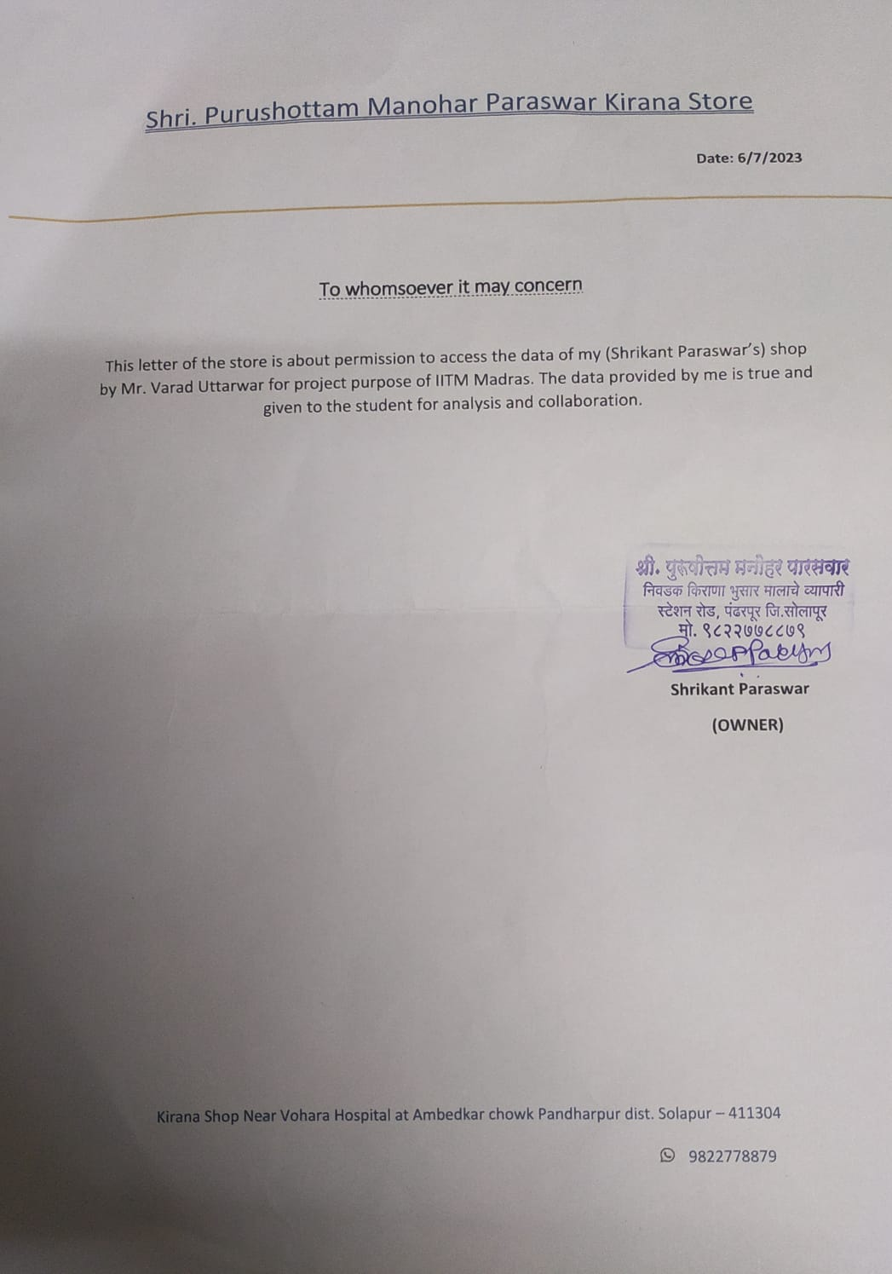

1. Images related to organization along with your images with founder

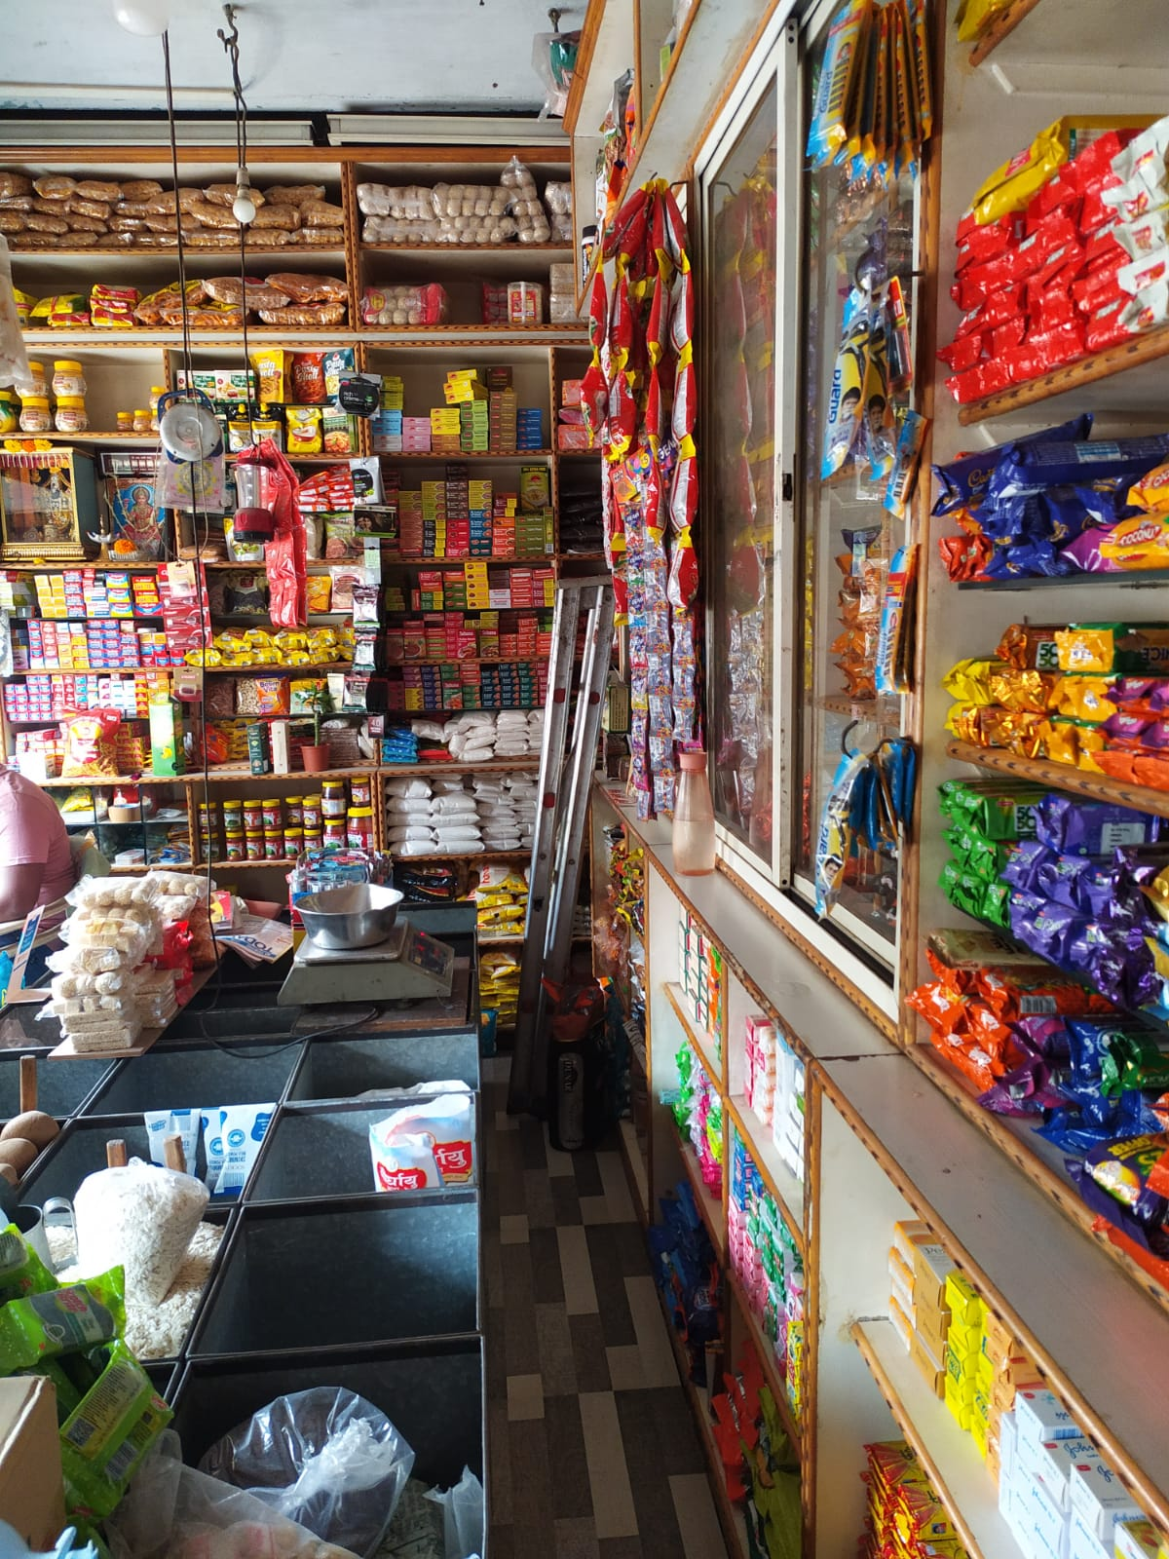

Img 1: Firm Photo

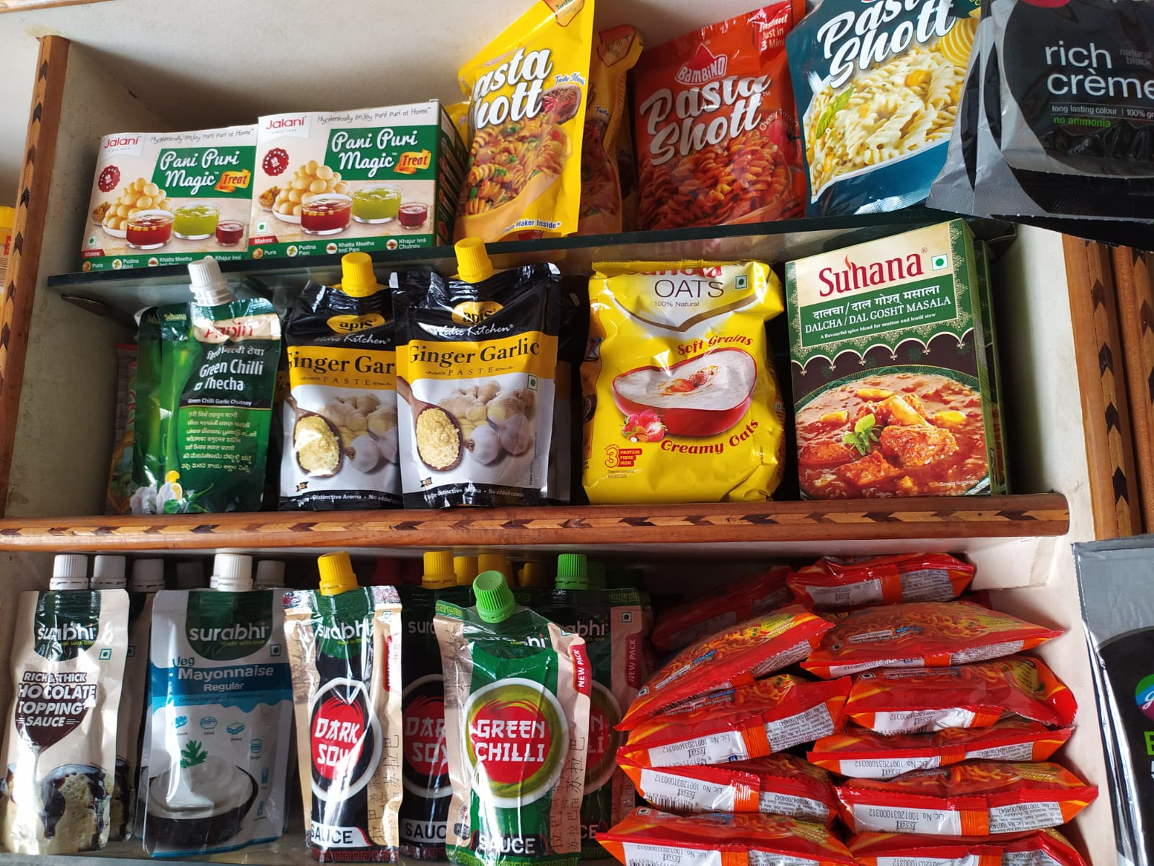

Img 2: Some Products of Firm

# G:\IITM\BDM\Proofs\WhatsApp Image 2023-07-10 at 21.54.25.jpeg

# 

# Fig 3: My image with Owner

# Recorded video with the founder in the organization

# <https://drive.google.com/file/d/1C1-05oFl4vz7c1zd-uxROovUBHHdxlu0/view?usp=sharing>

(Video is available on the above link)

https://drive.google.com/drive/folders/1deXzjQ5wg7lVtsDyU9NmBmQp3W0ZYem2?usp=sharing

(More Proofs are available here)

# 3.1) Meta Data

I have collected data which was hand written by the owner and workers. The data was extremely asymmetric and needed pre-processing. The images of meta data are following:

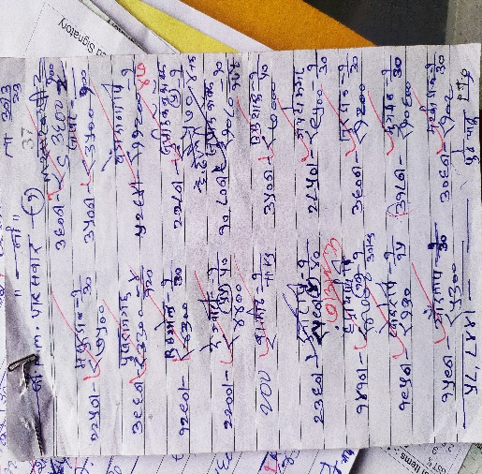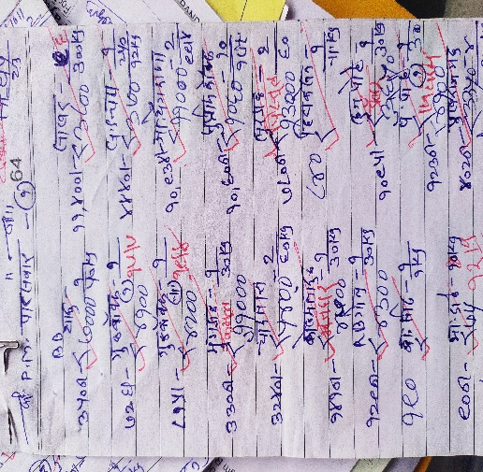

All meta data here: https://drive.google.com/drive/folders/1r2HL5bBOan9LkhXcLMQfu9IjWymr6kpJ?usp=sharing

# The above data is of month 5th where owner has bought items from supplier. This was the local items of Dry fruits and spice other items such as Grains data to be collected further. Here they have written about the item bought and quantity of item along with the price and date. Various items are being miss written and price and quantity was not understandable properly. Therefore, the meeting with owner has lead me to process this data more clearly.

The data collected are of month 5-6-7 where the festival was in 6th month. As per the final value of price after calculating spending in each month it can be concluded that spending in 6th was at peak.

Moreover, data of Items that belongs to companies need to be collected yet. After processing and analyzing the data altogether it can be very well identified that what are the fast-flowing products, which products brings more revenue and which are the products needs to be focused more.

# 3.2) Descriptive Statistics

Meta data of dry fruits and local spices is processed and cleaned. I have used features like Supplier Brand, Product, Item, Subtype, Quantity, Unit, Date, Month, Price. After few talks with owner we sorted out the features necessary for analysis and inserted and deleted rows based on the information provided by owner. Supplier says about from which supplier owner bought the items from, brand is about the product’s brand, item is the name of item, subtype is type of item it is, quantity is the number of item bought by owner, unit is the unit of item, date contains the date of item, month contains the number of the month and price has the price of products bought in each month. Initially the data has only quantity, price and item name. During the process of cleaning the data, rest of the features is being figured out.

|  |  |  |
| --- | --- | --- |
|  | Price | Quantity |
| Mean | ₹ 3,794.76 | 22 |
| Mode | ₹ 2,000.00 | 2 |
| Median | ₹ 2,100.00 | 5 |
| SD | ₹ 2,100.00 |  |

Mean calculated as 3,794 has the most data around it therefore for the further computation mean could be used mode and median is discarded because they are near to 2000 which is does not cover data around it. The mean price and quantity provide an overall picture of the average transaction. The mean price is higher than the median, indicating that there might be a few transactions with higher prices that are impacting the average.

The mode price and mode quantity provide insights into the most common price and quantity values in the dataset. The standard deviation for both price and quantity indicates that there is a notable variability in the dataset. This suggests that prices and quantities vary significantly from transaction to transaction. By analyzing the mean, mode, median, and standard deviation, we can see how the data is distributed and identify any potential outliers or trends.

**4) Analysis Process/Method**

The bar chart illustrates the quantity of each dry fruit and local spice purchased over a span of three months. Notably, raisins emerge as the highest-selling product. Upon further inquiry with the owner, it becomes apparent that the demand for raisins typically experiences a surge during festive periods. However, a substantial outlier is observed during the Ashadi festival, wherein raisin purchases significantly surpass other products. This phenomenon is attributed to pilgrims purchasing raisins for worship purposes during the Ashadi festivities. This distinct spike can be considered an outlier due to its exceptional magnitude and unique causative factor. This insightful observation underscores the influence of cultural and seasonal factors on purchasing behavior. Such insights empower the business to tailor its strategies to effectively cater to these trends, enhancing customer satisfaction and optimizing resource allocation.

This is the count plot of price after removing raisins. All the plots are made using pivot tables. This plot shows the dates makes the highest profit and then by cumin and so on. Sunth and food color makes the list profit in 3 months’ time period. Coconut, cardamom and almonds are being stable throughout 3 months

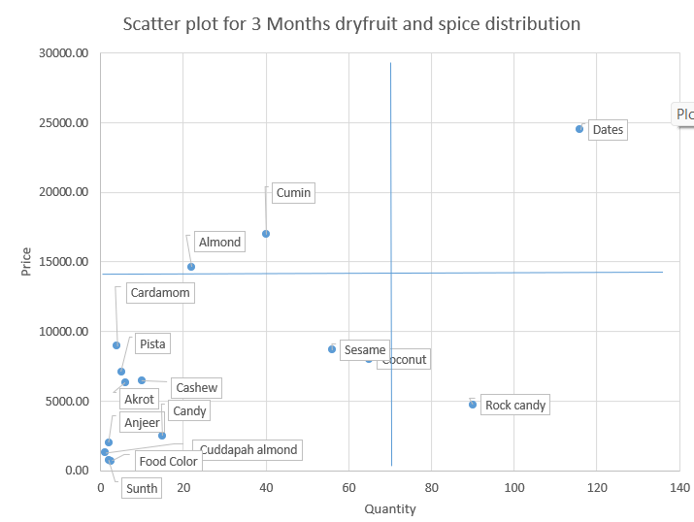

The scatter plot presents a valuable analysis of product quantity against return over a three-month period. This analysis aids in identifying products with distinct characteristics in terms of sales volume and revenue generation.

Upon careful examination, several key insights emerge:

**High Quantity and High Return:** Dates. Dates stand out as a prime product, being both frequently purchased and generating substantial returns. This indicates its popularity and strong revenue contribution to the shop's earnings.

**High Quantity and Low Return:** Rock Candy. Rock candy, while being sold in high quantities, generates comparatively lower returns. This suggests that despite its popularity, its pricing strategy or profit margins might need reevaluation.

**High Return and Low Quantity:** Almond and Cumin. Almond and cumin exhibit a distinctive pattern of relatively low quantities sold, yet yielding high returns. This pattern could be attributed to their higher price points or specialized demand.

**Least Popular Products**: Food Color, Sunth, etc. Items like food color and sunth have both low quantity sold and low returns, indicating limited customer interest and revenue generation.

The quadrant-based analysis effectively categorizes products into four distinct segments based on their sales volume and revenue contribution. This method offers a clear visual representation that aids in making informed decisions regarding pricing, inventory management, and marketing strategies. It enables the business to focus on products with optimal revenue potential while refining strategies for products that show room for improvement.

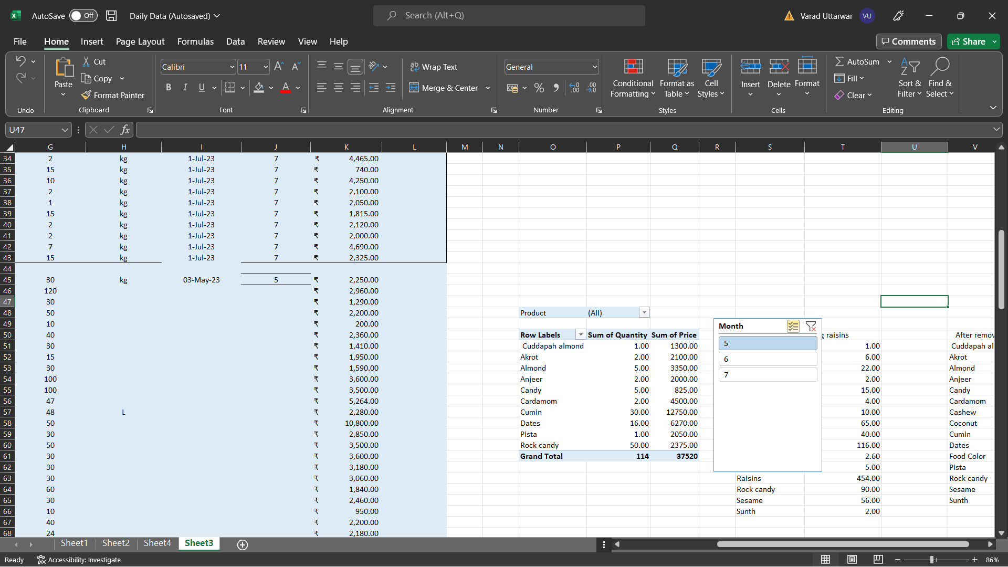

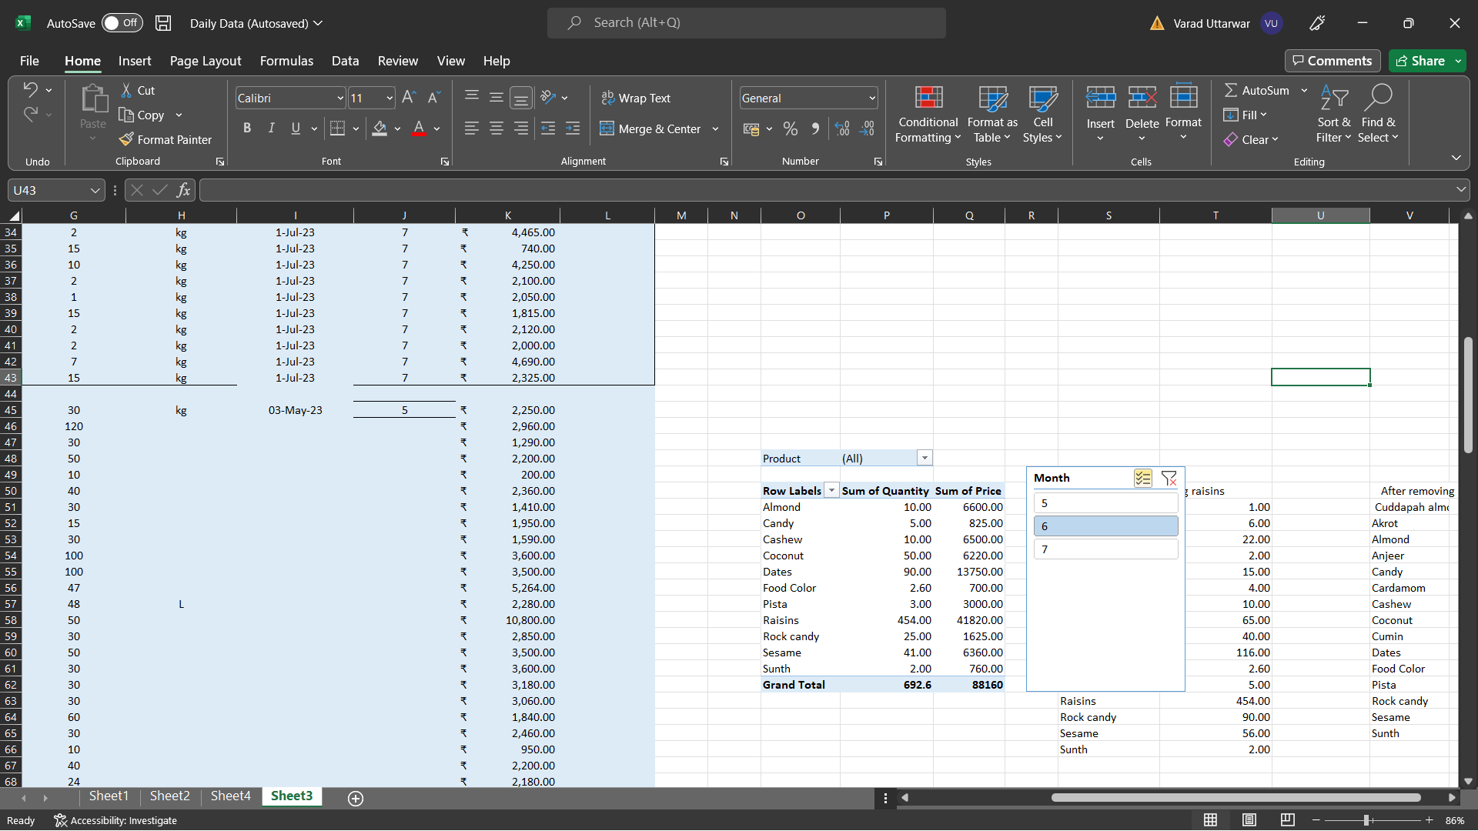

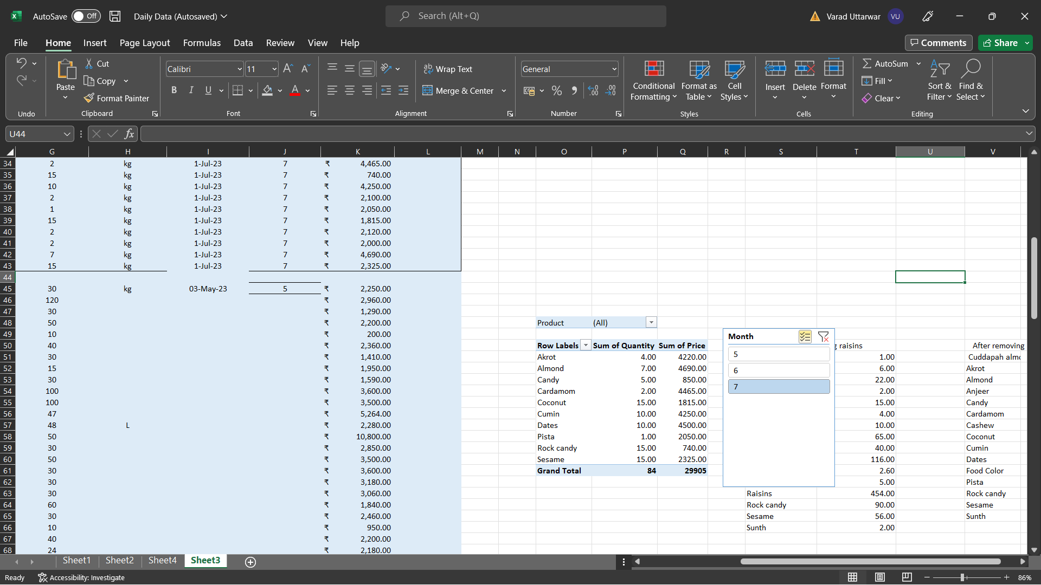

Above charts talks about which month firm has highest sell in dry fruits and spice. As per the data 6th month has highest among the two.

**5) Results and Findings**

**Focusing on Quadrants:** The analysis of the first and second quadrants suggests that these are the areas where the shop is making higher profits and sales. These products seem to have favorable prices and quantities. By focusing more on these quadrants, the shop can strategically allocate resources and marketing efforts to maximize profitability.

**Schemes and Promotions:** The suggestion to offer schemes and promotions on products from the third and second quadrant is a good strategy. By providing discounts or special offers on these products, the shop can attract more customers and potentially increase sales for items that might not be performing as strongly.

**Optimizing Product Mix:** The recommendation to reduce prices on almond and cumin products is based on the analysis of price distribution and variability. Lowering prices on these products could encourage more sales and contribute to a more balanced product mix across different quadrants.

**Buying in Bulk:** Recognizing that the 6th month experiences higher sales, the recommendation to buy in bulk during this period is aligned with the observed trend. Buying in larger quantities during the peak season can help the shop meet customer demand and potentially negotiate better prices with suppliers.

**Future Data Collection:** Acknowledging that the analysis is based on the available data and that there are sectors like grains, wafers, and items from specific companies where data is yet to be collected is an important note. Collecting data from these sectors will provide a more comprehensive understanding of the overall business dynamics and potentially lead to refined strategies and decisions.