**PROJECT VISUALIZATIONS**

1. Histograms showing distribution of variables

1. Heatmap of feature correlations

1. Scatter plots with regression line showing the relationships between other variables and exam score.

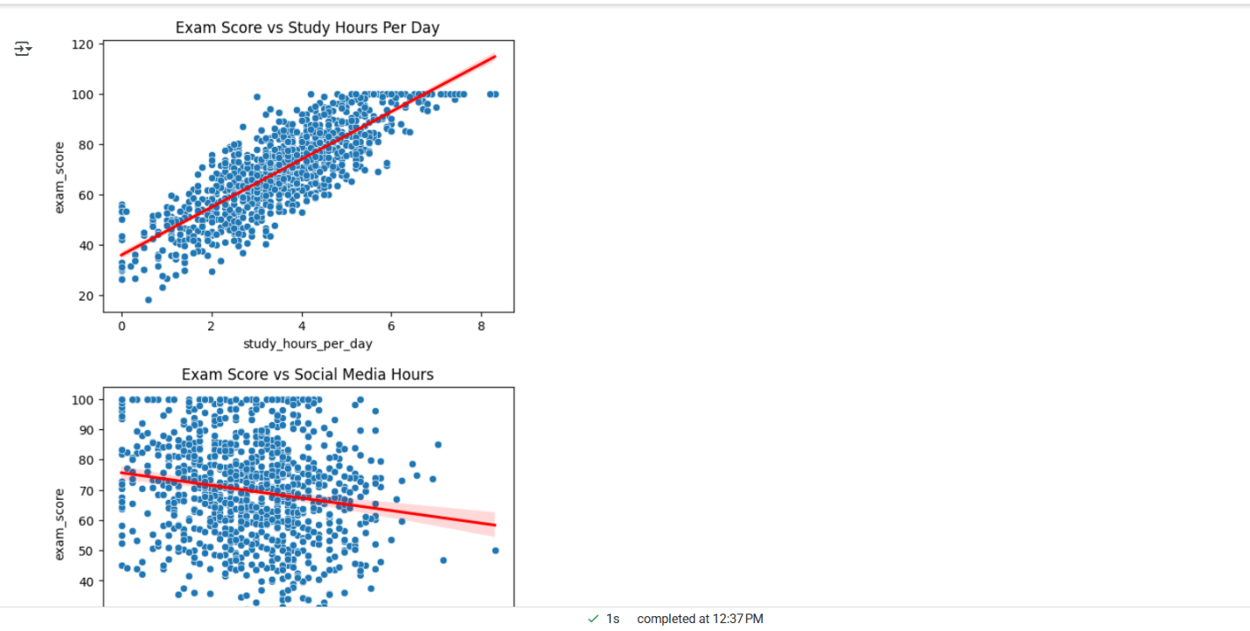

1. Outlier check

1. Bar plot comparing variables and its importance

1. Heatmap - correlation matrix between variables and exam score

