**Convolutional Neural Network (CNN) in Machine Learning**

A Convolutional Neural Network (CNN), also known as ConvNet, is a specialized type of deep learning algorithm mainly designed for tasks that necessitate object recognition, including image classification, detection, and segmentation.

**Key components of a Convolutional Neural Network include:**

* **Convolutional Layers:** These layers apply convolutional operations to input images, using filters (also known as kernels) to detect features such as edges, textures, and more complex patterns. Convolutional operations help preserve the spatial relationships between pixels.
* **Pooling Layers:** Pooling layers downsample the spatial dimensions of the input, reducing the computational complexity and the number of parameters in the network. Max pooling is a common pooling operation, selecting the maximum value from a group of neighboring pixels.
* **Activation Functions:** Non-linear activation functions, such as Rectified Linear Unit (ReLU), introduce non-linearity to the model, allowing it to learn more complex relationships in the data.
* **Fully Connected Layers:** These layers are responsible for making predictions based on the high-level features learned by the previous layers. They connect every neuron in one layer to every neuron in the next layer.

**Convolutional Neural Network Training**

* **Data Preparation:** The training images are preprocessed to ensure that they are all in the same format and size.
* **Loss Function:** A loss function is used to measure how well the CNN is performing on the training data. The loss function is typically calculated by taking the difference between the predicted labels and the actual labels of the training images.
* **Optimizer:** An optimizer is used to update the weights of the CNN in order to minimize the loss function.
* **Backpropagation:** Backpropagation is a technique used to calculate the gradients of the loss function with respect to the weights of the CNN. The gradients are then used to update the weights of the CNN using the optimizer.

**CNN Evaluation**

* **Accuracy:** Accuracy is the percentage of test images that the CNN correctly classifies.
* **Precision:** Precision is the percentage of test images that the CNN predicts as a particular class and that are actually of that class.
* **Recall:** Recall is the percentage of test images that are of a particular class and that the CNN predicts as that class.
* **F1 Score:** The F1 Score is a harmonic mean of precision and recall. It is a good metric for evaluating the performance of a CNN on classes that are imbalanced.

**Different Types of CNN Models**

* **LeNet**
* **AlexNet**
* **ResNet**
* **GoogleNet**
* **MobileNet**
* **VGG**

**LeNet:**

* LeNet is a pioneering convolutional neural network architecture designed for handwritten digit recognition.
* It consists of two convolutional layers followed by subsampling layers, and then fully connected layers that output the final classification.
* This architecture laid the groundwork for modern deep learning models in computer vision.

**AlexNet:**

* AlexNet is a deep convolutional neural network architecture that significantly advanced the field of computer vision, winning the ImageNet Large Scale Visual Recognition Challenge in 2012.
* It consists of five convolutional layers, followed by three fully connected layers, and employs techniques like ReLU activation, dropout, and data augmentation to improve performance and reduce overfitting.
* AlexNet's success demonstrated the effectiveness of deep learning for image classification tasks and inspired further research in neural networks.

**ResNet:**

* To address the vanishing gradient problem in very deep networks.
* It utilizes skip connections, or residual connections, that allow gradients to flow through the network more effectively, enabling the training of networks with hundreds or even thousands of layers.
* ResNet achieved state-of-the-art performance in image classification tasks and won the ImageNet Large Scale Visual Recognition Challenge in 2015, demonstrating that deeper networks can be trained successfully.

**GoogleNet:**

* GoogleNet, also known as Inception v1, is a deep convolutional neural network architecture that won the ImageNet Large Scale Visual Recognition Challenge in 2014.
* It introduced the Inception module, which allows for multiple filter sizes to be applied simultaneously at each layer, enabling the network to capture a variety of features at different scales.
* GoogleNet is notable for its depth, with 22 layers, and its use of global average pooling instead of fully connected layers, which reduces the number of parameters and helps prevent overfitting.
* This architecture paved the way for subsequent Inception models and advanced techniques in deep learning.

**MobileNet:**

* MobileNet is a lightweight deep learning architecture designed for mobile and embedded vision applications.
* It utilizes depth wise separable convolutions, which split the convolution operation into two layers: a depthwise convolution that applies a single filter to each input channel, followed by a pointwise convolution that combines the outputs.
* This design significantly reduces the number of parameters and computational cost while maintaining high accuracy.
* MobileNet is particularly effective for real-time image classification tasks on devices with limited processing power, making it a popular choice for mobile applications and edge computing.

**VGG:**

* VGG, or Visual Geometry Group, is a convolutional neural network architecture known for its simplicity and depth, introduced in the 2014 ImageNet Large Scale Visual Recognition Challenge.
* It consists of a series of convolutional layers with small 3x3 filters, followed by max pooling layers, and ends with fully connected layers.
* VGG is notable for its uniform architecture, where the number of filters doubles after each pooling layer, allowing it to capture complex features while maintaining a manageable number of parameters.
* VGG models, particularly VGG16 and VGG19, have been widely used as feature extractors in various computer vision tasks due to their strong performance and ease of use.

**Inspiration Behind CNN and Parallels With The Human Visual System**

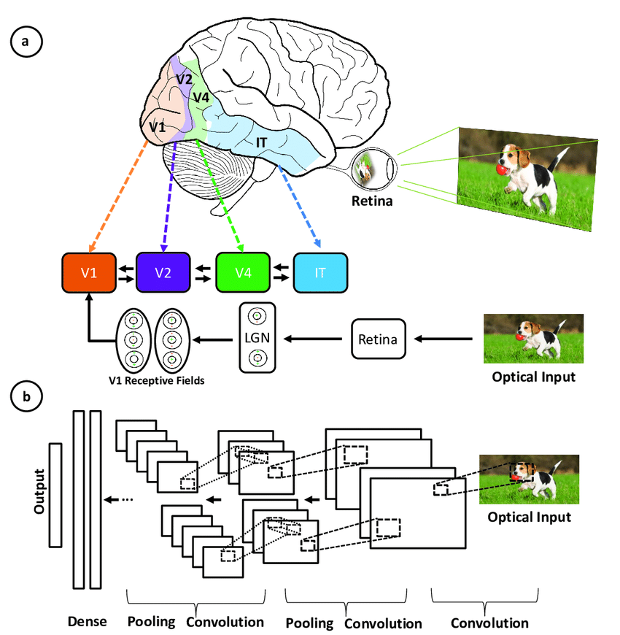

* **Hierarchical architecture:** Both CNNs and the visual cortex have a hierarchical structure, with simple features extracted in early layers and more complex features built up in deeper layers. This allows increasingly sophisticated representations of visual inputs.
* **Local connectivity:** Neurons in the visual cortex only connect to a local region of the input, not the entire visual field. Similarly, the neurons in a CNN layer are only connected to a local region of the input volume through the convolution operation. This local connectivity enables efficiency.
* **Translation invariance:** Visual cortex neurons can detect features regardless of their location in the visual field. Pooling layers in a CNN provide a degree of translation invariance by summarizing local features.
* **Multiple feature maps:** At each stage of visual processing, there are many different feature maps extracted. CNNs mimic this through multiple filter maps in each convolution layer.
* **Non-linearity:** Neurons in the visual cortex exhibit non-linear response properties. CNNs achieve non-linearity through activation functions like ReLU applied after each convolution.

**Key Components of a CNN**

* Convolutional layers
* Rectified Linear Unit (ReLU for short)
* Pooling layers
* Fully connected layers

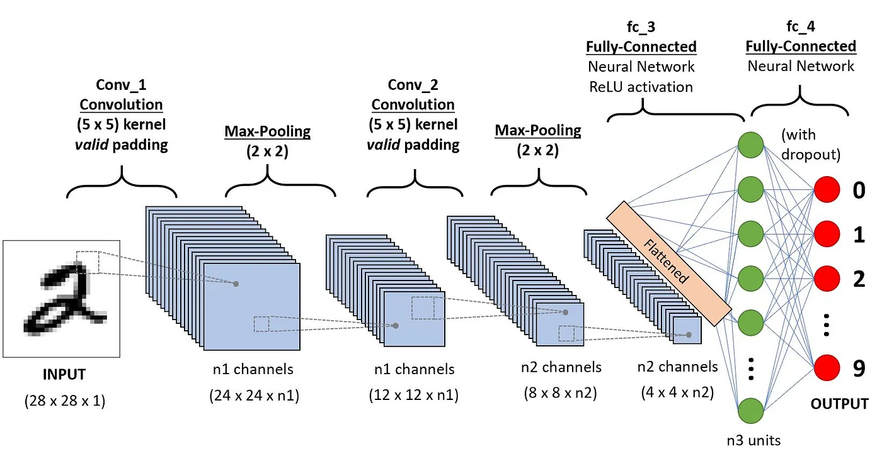

**1- Convolution layers:**

The convolution layer is the first building block of a CNN, where filters (or kernels) are applied to an image matrix to detect specific patterns.

Each filter slides over the image, acting like a mini magnifying glass that identifies features such as edges, curves, or shapes.

By using multiple filters, the CNN captures various patterns that contribute to understanding the image. For instance, one filter may detect straight lines while another identifies curves.

This process transforms the original image into a new grid that highlights the detected patterns.

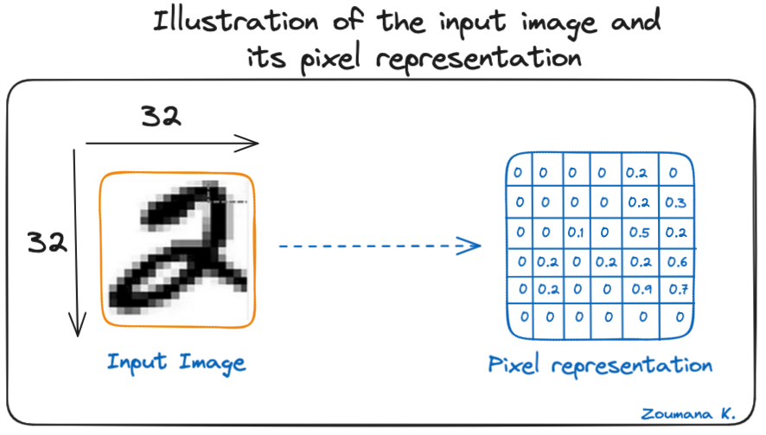

**2-**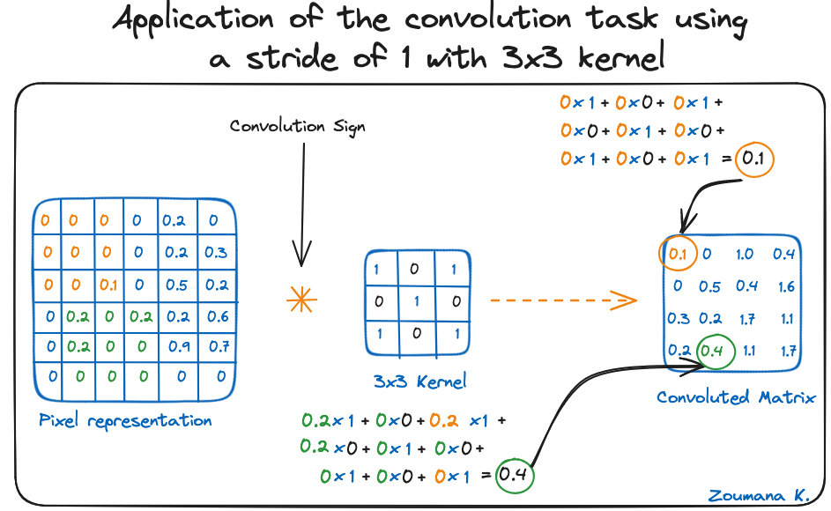

**instance:**

* Averaging neighboring pixels kernel can be used to blur the input image.
* Subtracting the neighboring kernel is used to perform edge detection.

**Activation function**

A ReLU activation function is applied after each convolution operation. This function helps the network learn non-linear relationships between the features in the image, hence making the network more robust for identifying different patterns.

**Pooling layer**

The goal of the pooling layer is to pull the most significant features from the convoluted matrix. This is done by applying some aggregation operations, which reduce the dimension of the feature map (convoluted matrix), hence reducing the memory used while training the network. Pooling is also relevant for mitigating overfitting.

**The most common aggregation functions that can be applied are:**

* Max pooling, which is the maximum value of the feature map
* Sum pooling corresponds to the sum of all the values of the feature map
* Average pooling is the average of all the values.

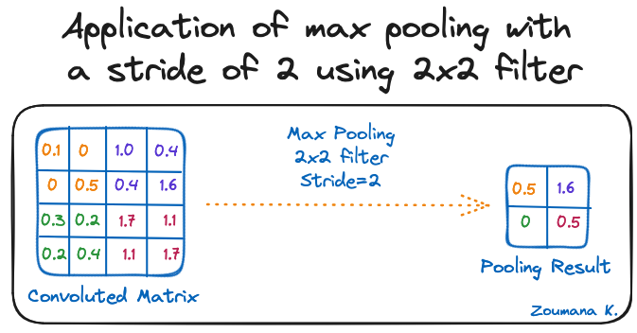

**Fully connected layers:**

**Overfitting and Regularization in CNNs**

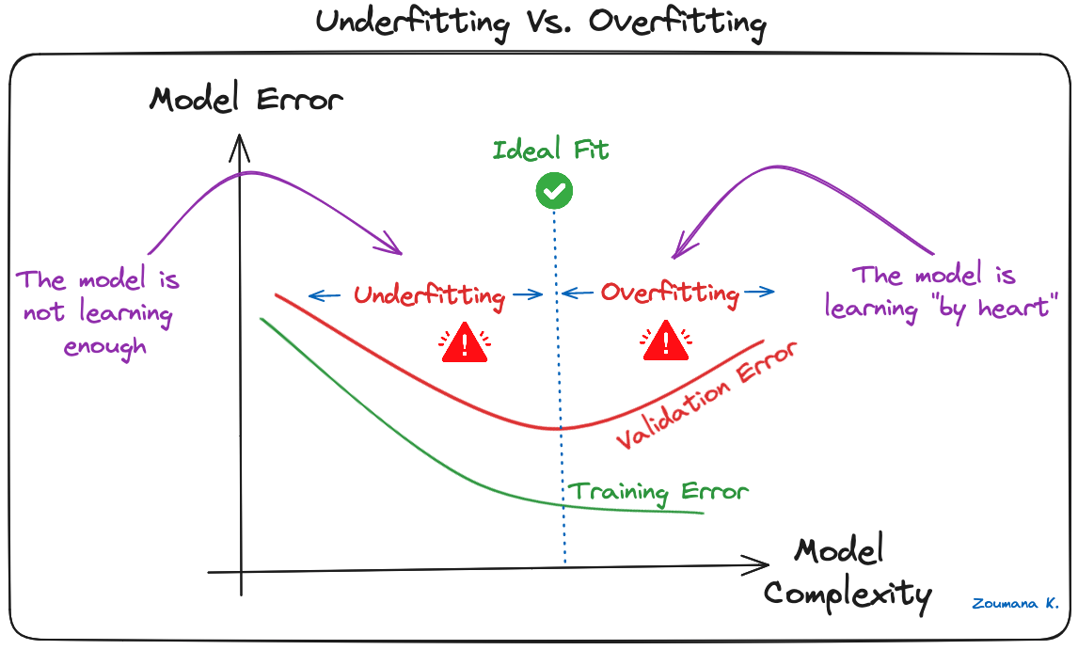

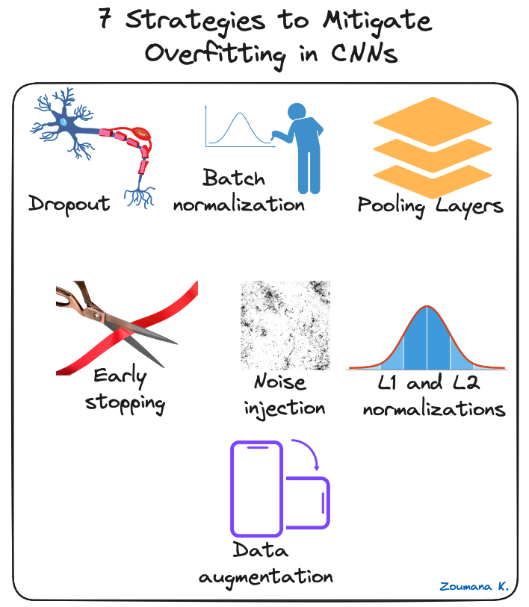

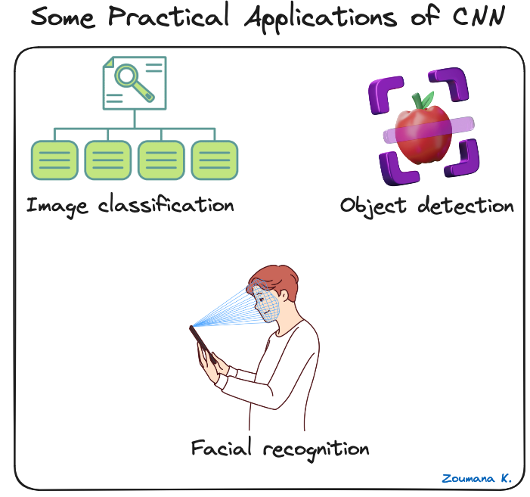

**DATA : CNN Fashion MNIST dataset**

This guide uses the Fashion MNIST dataset which contains 70,000 grayscale images in 10 categories. The images show individual articles of clothing at low resolution (28 by 28 pixels), as seen here:

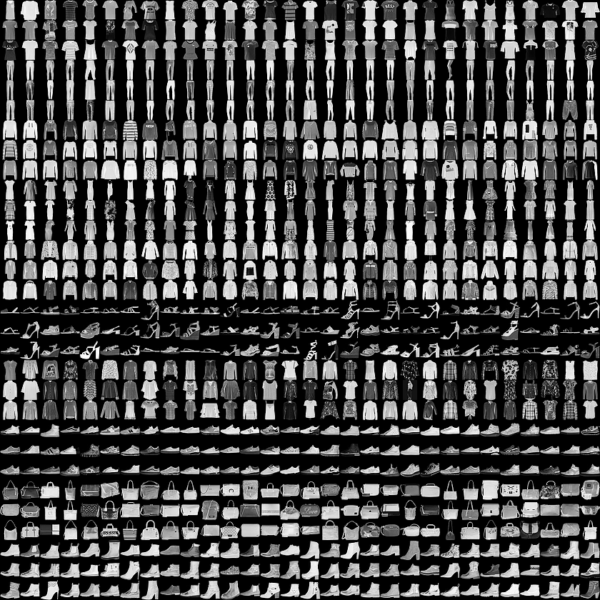

**Accuracy=99.75% using 25 Million Training Images**

It's amazing that convolutional neural networks can classify handwritten digits so accurately. In this kernel, we witness an ensemble of 15 CNNs classify Kaggle's MNIST digits after training on Kaggle's 42,000 images in "train.csv" plus 25 million more images created by rotating, scaling, and shifting Kaggle's images. Learning from 25,042,000 images, this ensemble of CNNs achieves 99.75% classification accuracy. This kernel uses ideas from the best published models found on the internet. Advanced techniques include data augmentation, nonlinear convolution layers, learnable pooling layers, ReLU activation, ensembling, bagging, decaying learning rates, dropout, batch normalization, and adam optimization.