r06946003 湯忠憲

Computation in Data Science - Background Removal

Try to analysis in better resolution.:

Here I try 75% scaling and original resolution (320 * 240 for every frame size) on two videos, respectively.

● Report should contain following information:

○ Select two videos to analyze, please specify which videos you used.

I select Video_008 (“Traffic during windy day”) and Video_003 (“Wandering students”) form Background Models Challenge[1].

○ Plot matrices

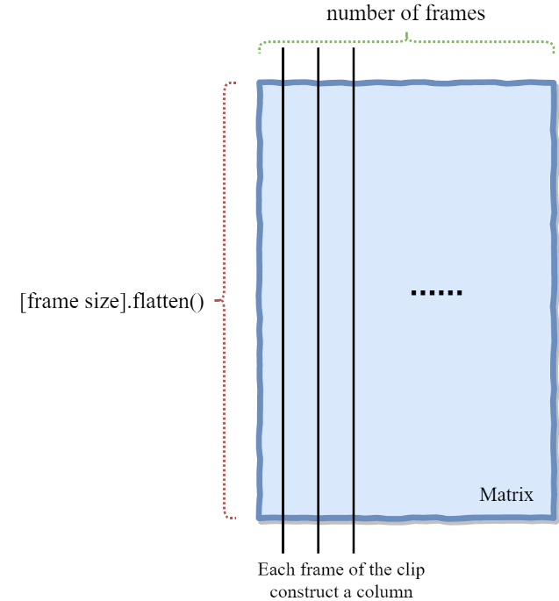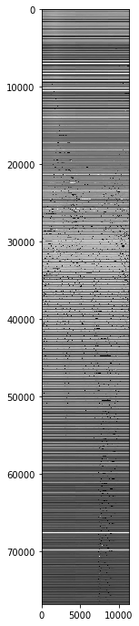

○ Background subtraction comparison

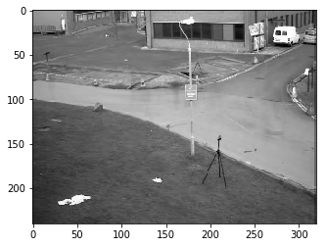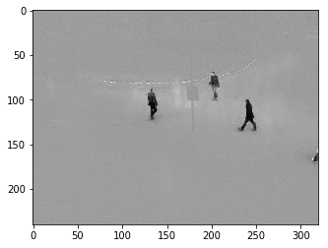 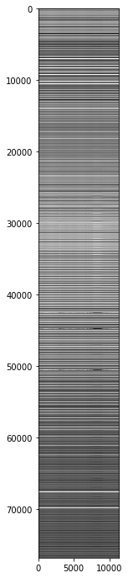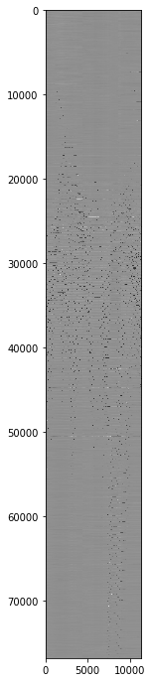

○ Try to analysis performance

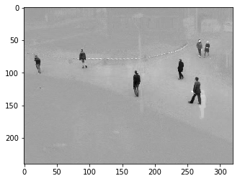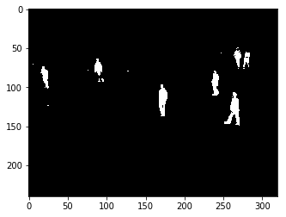

Video_003: average dice Coefficient= 0.869

○ How to improve performance

○ Summary

● Hand in the video

1. http://bmc.iut-auvergne.com/?page_id=24