 | VYNTYRA CONSULTANCY SERVICES PVT. LTD.  INDUSTRIAL INTERNSHIP PROGRAM 2026 • DESIGN DIVISION  TASK 2: UI/UX Architecture, Wireframing & Creative Design Report  Pure UI/UX Design & User Experience Deliverable | Academic Allocation: 20 Credits (100-Point Scale)

TASK NAME & FOCUS | TASK 2: UI/UX Architecture, Wireframing & Creative User Experience Design
ALLOCATED PROJECT TRACK | Smart Manufacturing & Warehouse ERP — Real-Time Inventory, Automated Procurement & Shop-Floor Telemetry
PRIMARY LEAD (INTERN 1) | Full Name: Bhavitha Varanasi | Intern ID: VYNT-08/26-CFC02721 | Email: bhavithavaranasi630@gmail.com | Dept: Engineering & Technology
PAIR PARTNER (INTERN 2) | Full Name: Anjali Gandeti | Intern ID: VYNT-08/26-40B9D378 | Email: gandetianjali9@gmail.com | Dept: Engineering & Technology
DESIGN TOOL / MEDIUM USED | Canva (4-page presentation-format wireframe deck, 1920 × 1080 px per screen)
LIVE DESIGN ARTIFACT URLS | Canva Master Design URL:  https://www.canva.com/design/DAHVRslG17U/A0UtIeqgzbsCOc9DkL5Y3Q/edit
SUBMISSION DATE & STATUS | Date of Submission: 16 / 09 / 2026 | Evaluation Status: Pending Mentor Review

SECTION 01 | USER PROBLEM STATEMENT & EMPATHY PERSONA MAPPING

Design Objective: Understand user pain points and demonstrate empathy by identifying real-world frustrations and defining clear UX goals.
- Problem Context: What specific problem or frustration do users experience when using existing systems in this domain?
- Primary User Persona (Daily User): Who is your main user? Describe their background, goals, habits, and biggest headaches.
- Secondary User Persona (Decision Maker): Who else interacts with or benefits from this interface?
- UX Improvement Goals: What 3–4 things will make this system significantly easier, faster, and more reliable to use?
1.1 Real-World Problem Overview
Manufacturing companies often face unexpected stock-outs, delayed purchase order approvals, and limited visibility into machine operations. These issues can interrupt production, increase costs, and delay material procurement.
The proposed system provides a centralized dashboard to monitor warehouse inventory, automatically generate purchase orders when stock reaches critical levels, manage multi-level approvals, monitor shop-floor machine telemetry, and evaluate vendor performance.
1.2 Primary Persona Profile (Main User)
Name: Ramesh, 38 | Role: Inventory Controller | Responsibility: Manages raw material stock thresholds, warehouse bin allocation, and reorder alerts across multiple warehouses.
Goals: Prevent line-stopping stock-outs, keep safety thresholds accurate, raise purchase orders before stock turns critical, and know exactly which bin holds which SKU.
Key Frustrations: Stock data that is already stale by the time he reads it, manually re-keying reorder requests, no single view of available versus allocated stock, and no early warning before a SKU crosses its safety threshold.
1.3 Secondary Persona Profile (Decision Maker)
Name: Meera, 45 | Role: Plant Operations Director | Responsibility: Approves purchase requisitions against budget and monitors shop-floor machine uptime.
Goals: Approve or reject procurement quickly with full budget context, keep spend inside the approved cap, spot machine faults before they become downtime, and hold vendors accountable on delivery and defect rates.
Key Frustrations: Approval requests arriving without vendor comparison or budget context, no audit trail of who signed off and when, and machine problems reported verbally rather than through instrumented data.
1.4 Core User Experience (UX) Goals
Goal 1: Make raw-material stock health readable at a glance through colour-coded depletion status rather than raw numbers alone.
Goal 2: Remove manual re-keying by auto-generating the purchase order directly from a low-stock warning.
Goal 3: Make multi-tier approval transparent — vendor quotes, itemised parts, budget compliance, and an audit trail on one screen.
Goal 4: Surface machine telemetry and vendor quality as continuous, monitored signals so problems are caught early instead of reported late.

SECTION 02 | LOGICAL USER FLOW & NAVIGATION STRUCTURE

Design Objective: Demonstrate logical thinking by mapping how a user navigates smoothly from screen to screen without confusion or getting lost.
- App Navigation Structure: How are pages organised? List main menu items, sub-pages, filters, and modal dialogs.
- Logical Step-by-Step User Journey: Walk through the user’s exact steps from opening the system to a successful outcome.
- User Feedback & Edge Cases: How does the UI guide users on empty results, missing input, or successful actions?
- Interactive Prototype & Design Links: Provide the live Canva prototype link or design document URL.

2.1 App Navigation Hierarchy
Main Navigation (ERPNavHeader): Real-Time Warehouse Inventory → Automated Purchase Order Approval → Shop-Floor Machine Telemetry → Vendor Performance & Quality Scorecard.
Secondary Controls: Warehouse selector on Screen 1, production-line selector on Screen 3, supplier selector on Screen 4, plus a shared status legend (Safe / Low / Critical, Running / Idle / Fault, Good / Warning / Poor) positioned directly beneath each filter bar.
Overlays & Panels: Three-step approval stepper (Vendor quotes → Budget check → Manager sign-off), budget compliance strip, approval and rejection action buttons, maintenance alert banner, and vendor quality escalation banner.
2.2 Step-by-Step User Journey (Logical Flow)
Step 1 — Inspect Warehouse Stock Matrix: Ramesh opens the inventory matrix and scans the stock grid showing Raw Material SKU, Bin Location, Available Stock, Allocated Stock, and Safety Threshold.
Step 2 — Detect Low-Stock Warning: Colour-coded depletion pills flag the exceptions immediately — green for Safe, yellow for Low, red for Critical Reorder — so attention goes to the two critical SKUs without reading every row.
Step 3 — Auto-Generate Purchase Order: The critical-stock condition generates PO-2026-0042 automatically, pre-populated from the triggering low-stock alert rather than typed by hand.
Step 4 — Route Through Multi-Tier Approval Wizard: The wizard presents the vendor quote comparison, the itemised parts list, and a budget compliance check (₹4,78,000 against a ₹5,00,000 cap), then routes the request from Procurement Lead to Plant Operations Director with a timestamped audit trail.
Step 5 — Inspect Machine Telemetry Gauges: Meera reviews the shop-floor panel showing machine status, operating temperature, and RPM per machine, with faults surfaced as a dedicated alert banner.
Step 6 — Review Vendor Performance: The scorecard closes the loop, rating each supplier on on-time delivery percentage, defect rate per thousand, contract pricing compliance, and invoice payment status.
Step 7 — Completion: The connected view lets the plant act on the next reorder, the next fault, and the next vendor review from one continuous operational picture.
2.3 User Feedback & Edge Case Handling
Critical Stock Reached: The SKU row turns red and carries an explicit "Critical Reorder" label, so status never depends on colour alone.
Budget Exceeded: The compliance strip states the total against the cap and returns a clear Within budget / Over cap verdict before any approval button is reachable.
Approval Pending: The pending tier is shown in amber with the approver named ("Pending – Plant Ops Director"), so it is always clear who the request is waiting on.
Machine Fault: The faulted row turns red and a banner states the specific breach and the notification that was raised — for example, Welding-Station-05 exceeding its safe temperature threshold at 89°C.
Vendor Quality Breach: A supplier whose defect rate passes the 5.0 per thousand threshold is flagged for quality escalation in a dedicated banner rather than being buried in the table.
Successful Action: The audit trail line records submission and approval events with name, role, and timestamp, confirming the action completed.
2.4 Live Design Artifact & Prototype Links
Interactive Prototype / Design Board: https://www.canva.com/design/DAHVRslG17U/A0UtIeqgzbsCOc9DkL5Y3Q/edit

SECTION 03 | WIREFRAME BLUEPRINTS & SCREEN LAYOUTS (4 CORE SCREENS)

Design Objective: Show visual layout creativity by presenting the 4 core wireframe screens of the project, with clear annotations.
- Screen 1 (Real-Time Warehouse Inventory Matrix): Stock grid with SKU, bin location, stock levels, safety threshold, and colour-coded depletion pills.
- Screen 2 (Automated Purchase Order Approval Wizard): Multi-step sign-off with quote comparison, parts list, budget check, and audit trail.
- Screen 3 (Shop-Floor Machine Telemetry Panel): Industrial IoT monitoring grid with machine status, temperature, RPM, and maintenance alerts.
- Screen 4 (Vendor Performance & Quality Scorecard): Supplier rating table covering delivery, defects, pricing compliance, and invoice status.

3.1 Screen 1 Blueprint: Real-Time Warehouse Inventory Matrix

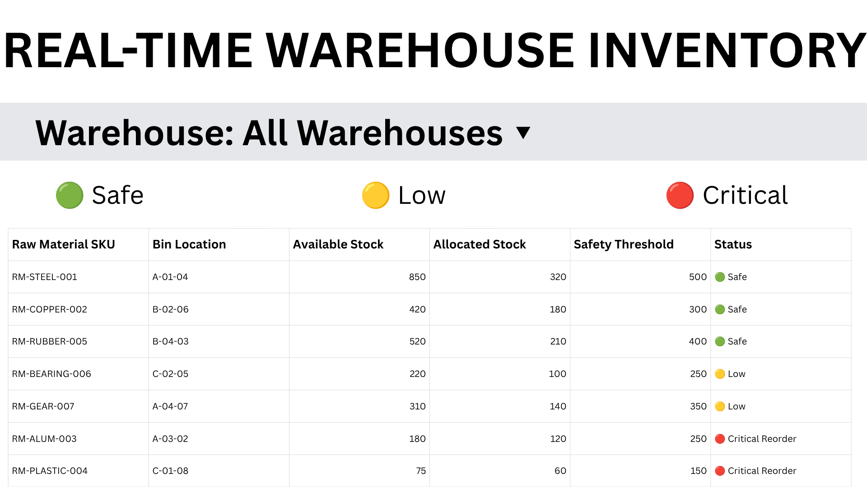

The screen is built around a StockMatrixTable listing seven raw-material SKUs against Bin Location, Available Stock, Allocated Stock, and Safety Threshold. A warehouse selector sits in the filter bar and a three-state legend — Safe, Low, Critical — is placed directly above the grid so the colour coding is decoded before the data is read.
Each row carries a ThresholdBadge in the Status column. RM-STEEL-001, RM-COPPER-002, and RM-RUBBER-005 read Safe in green; RM-BEARING-006 and RM-GEAR-007 read Low in amber; RM-ALUM-003 and RM-PLASTIC-004 read Critical Reorder in red. Comparing available against allocated stock makes the true free balance visible, which is the number that actually drives the reorder decision.
Live Screen URL: https://www.canva.com/design/DAHVRslG17U/A0UtIeqgzbsCOc9DkL5Y3Q/edit

3.2 Screen 2 Blueprint: Automated Purchase Order Approval Wizard

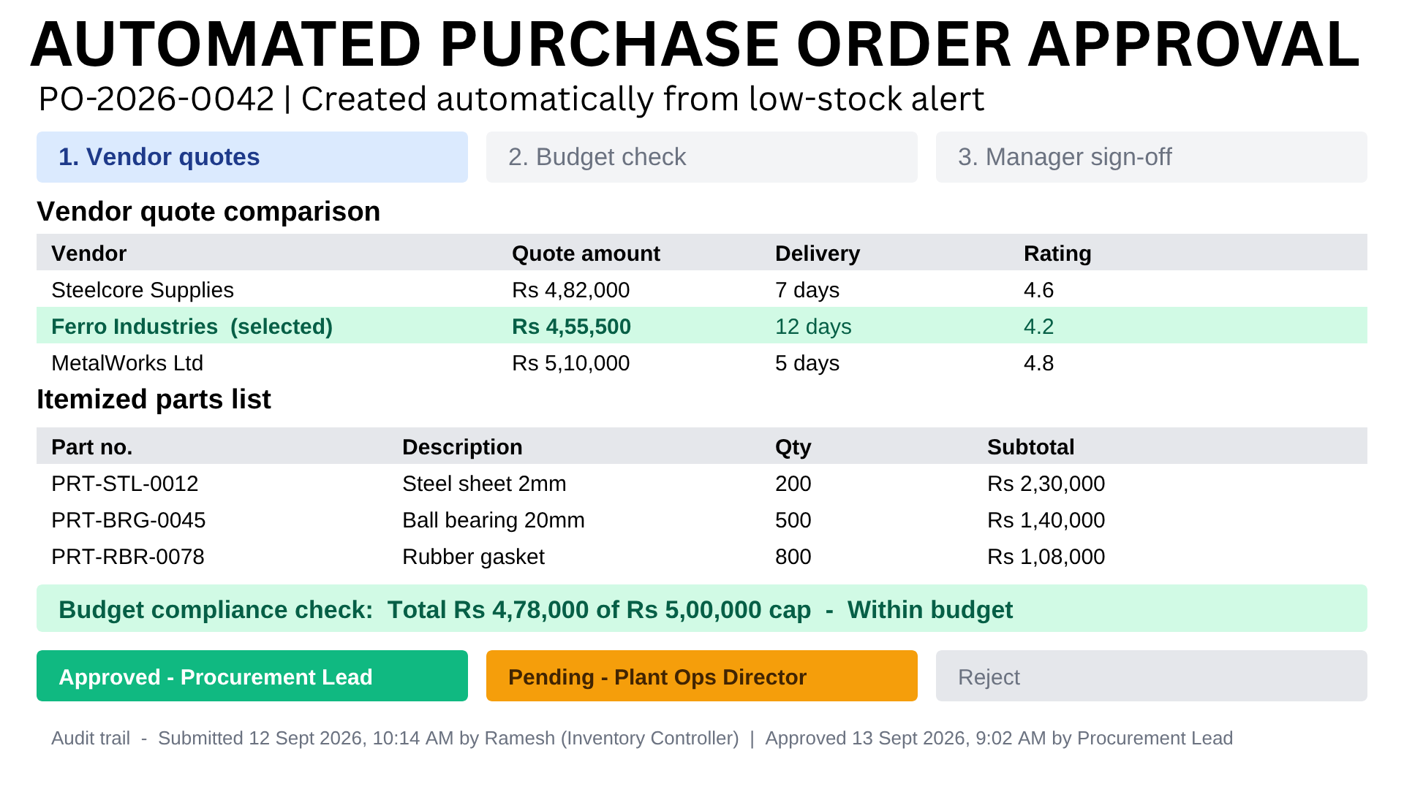

The header identifies PO-2026-0042 and states plainly that it was created automatically from a low-stock alert, establishing the causal link back to Screen 1. A three-step progress indicator — Vendor quotes, Budget check, Manager sign-off — communicates where the request currently sits in the approval chain.

The vendor quote comparison lists Steelcore Supplies, Ferro Industries, and MetalWorks Ltd against quote amount, delivery time, and rating, with the selected vendor highlighted. The itemised parts list breaks the order into part number, description, quantity, and subtotal. A budget compliance strip confirms the ₹4,78,000 total against the ₹5,00,000 cap, followed by POApprovalCard actions showing Procurement Lead approved, Plant Ops Director pending, and a reject option — all closed by a timestamped audit trail.
Live Screen URL: https://www.canva.com/design/DAHVRslG17U/A0UtIeqgzbsCOc9DkL5Y3Q/edit

3.3 Screen 3 Blueprint: Shop-Floor Machine Telemetry Panel

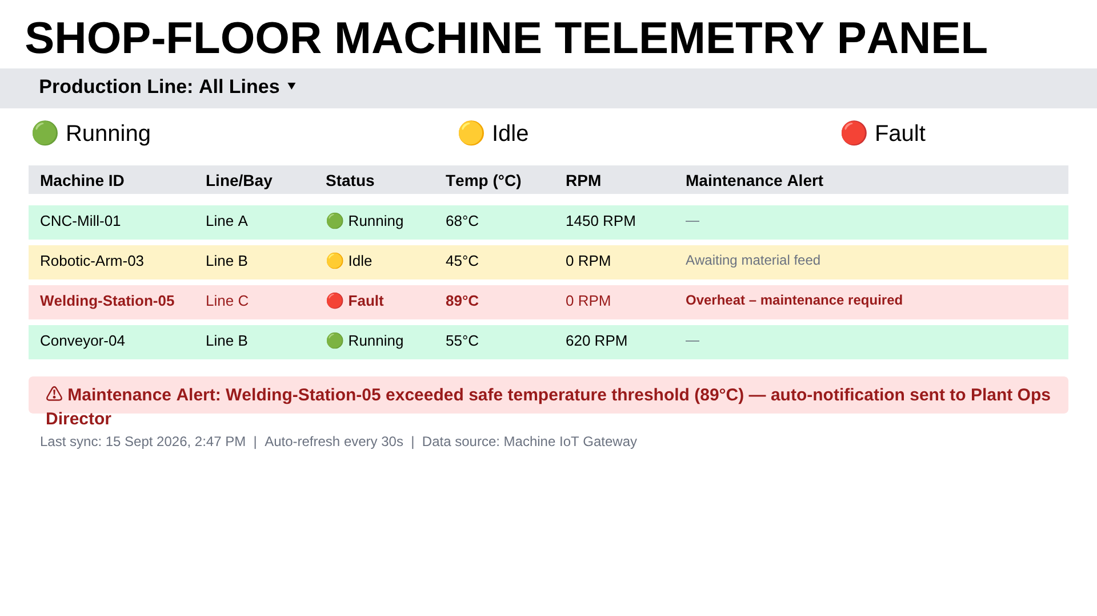

The telemetry panel applies the same structural pattern as Screen 1 — title, production-line filter, status legend, then grid — so the operator does not relearn the layout when switching context from inventory to machinery. The legend here reads Running, Idle, and Fault.
MachineStatusTile rows cover CNC-Mill-01, Robotic-Arm-03, Welding-Station-05, and Conveyor-04, each showing Line/Bay, status, operating temperature, RPM, and a maintenance alert column. TelemetryGauge values make the fault self-explanatory: the welding station reads 89°C at 0 RPM in red, and the alert banner beneath states the threshold breach and confirms that the Plant Operations Director was auto-notified. Idle machines carry a reason ("Awaiting material feed") rather than an unexplained blank.
Live Screen URL: https://www.canva.com/design/DAHVRslG17U/A0UtIeqgzbsCOc9DkL5Y3Q/edit

3.4 Screen 4 Blueprint: Vendor Performance & Quality Scorecard

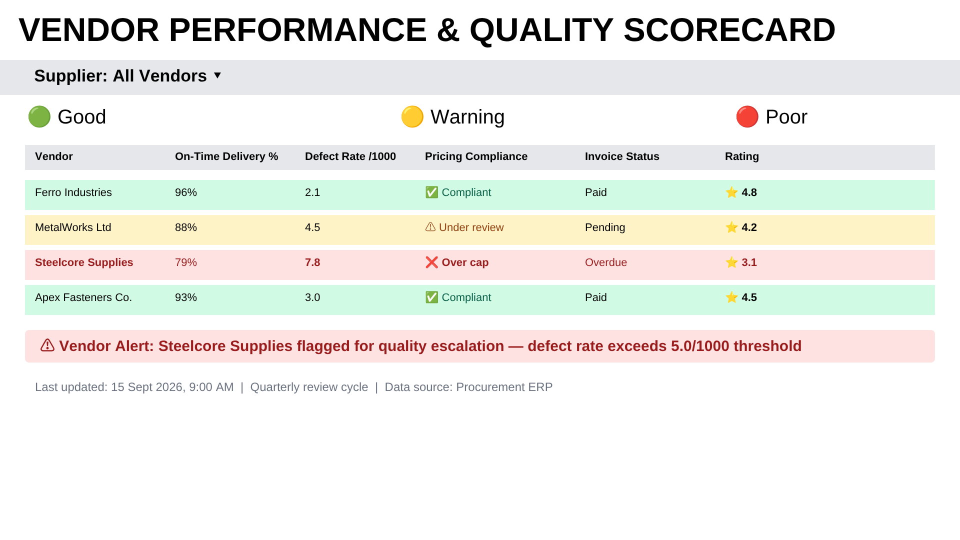

The VendorScoreTable evaluates four suppliers on the four contractual dimensions named in the brief: on-time delivery percentage, defect rate per thousand units, contract pricing compliance, and invoice payment status, with a consolidated star rating in the final column.
The colour logic is consistent with the rest of the deck. Ferro Industries (96%, 2.1 defects, compliant, paid) and Apex Fasteners (93%, 3.0, compliant, paid) sit green. MetalWorks Ltd is amber on an 88% delivery rate with pricing under review and a pending invoice. Steelcore Supplies is red across the board — 79% delivery, 7.8 defects per thousand, over the pricing cap, and overdue on invoice — and is escalated in the banner beneath the table for exceeding the 5.0 defect threshold.
Live Screen URL: https://www.canva.com/design/DAHVRslG17U/A0UtIeqgzbsCOc9DkL5Y3Q/edit

SECTION 04 | CREATIVE UI DESIGN & VISUAL ELEMENTS

Design Objective: Highlight visual creativity by explaining colour choices, typography, component styles, layout spacing, and aesthetic decisions.
- Colour Palette & Mood: What colours were chosen for status, background, and accents, and why do they suit the domain?
- Typography & Text Hierarchy: What styles were chosen for titles, table headers, body text, and data values?
- Reusable UI Components: Describe the buttons, tables, cards, badges, and banner treatments.
- Creative & Delightful Details: What unique touches were included?

4.1 Colour Palette & Visual Theme
The deck uses a light, high-contrast industrial palette rather than a dark dashboard theme. White surfaces with a neutral grey filter bar (#E5E7EB) keep dense tabular data legible under bright shop-floor and warehouse lighting, where dark backgrounds wash out under overhead glare.
Status Colours: Operational Green #10B981 for Safe, Running, and Good states; Warning Amber #F59E0B for Low, Idle, and Warning states; Critical Red #EF4444 for Critical Reorder, Fault, and Poor states. These three indicators carry the same meaning on every screen, so the operator learns the language once.
Surface Tints: Rows are filled with soft tints of the same triad (#D1FAE5 green, #FEF3C7 amber, #FEE2E2 red) so an entire row reads as a status band, while text on critical rows is deepened to #991B1B for contrast against the tint.
4.2 Typography & Text Styling
Each screen opens with a large bold uppercase display title, giving the deck a consistent rhythm when the four screens are reviewed in sequence. Beneath it, a clear hierarchy separates the filter bar, bold table headers, and regular-weight data rows.
Per the brief, monospace-style treatment is applied to SKU identifiers and part numbers (RM-STEEL-001, PRT-BRG-0045) so that alphanumeric codes align vertically and are easy to compare down a column — a small choice that materially reduces mis-reading in a warehouse context. Numeric values such as temperature, RPM, and percentages are kept at a uniform size so magnitudes can be scanned rather than parsed.
4.3 Reusable UI Components
ERPNavHeader: Consistent title-plus-filter-bar block anchoring every screen.
StockMatrixTable / VendorScoreTable: Shared table pattern — bold grey header row, tinted status rows, fixed column rhythm.
ThresholdBadge: Coloured dot plus text label used for Safe, Low, and Critical Reorder states.
POApprovalCard: Tiered approval action strip showing approved, pending, and reject states side by side.
TelemetryGauge / MachineStatusTile: Per-machine readouts for temperature, RPM, and live operating status.
Alert Banner: Rounded red-tinted strip used on Screens 3 and 4 to raise a single most-important exception above the table.
4.4 Creative Highlights & Visual Polish
1. A single status triad reused across inventory, machinery, and vendors gives four different data domains one shared visual grammar.
2. Status is never encoded by colour alone — every coloured state carries a written label, which keeps the interface usable for colour-blind operators.
3. Each screen surfaces its most urgent exception in a dedicated banner, so the operator sees the decision before the data.
4. Idle and pending states carry an explanatory reason and a named owner rather than leaving the user to guess why something has stalled.
5. A timestamped audit trail closes the approval screen, giving the procurement workflow accountability as a visible design element.

SECTION 05 | USER EXPERIENCE & MOBILE ERGONOMICS

Design Objective: Explain how the design is user-friendly, comfortable for one-handed use, and easy to navigate on mobile devices.
- Mobile Layout Adaptation: How does the layout adjust from desktop to a mobile phone screen?
- Thumb-Zone Ergonomics: Are primary action buttons easy to reach with one thumb?
- Touch Target Sizing: Are interactive elements at least 48px high?
- Mobile Wireframe Screenshot / Sketch: Paste the mobile layout image and provide the mobile design link.

5.1 Mobile Screen Adaptation
The four screens are authored at 1920 × 1080 px for desktop and warehouse terminal use. On a handheld scanner or phone, the wide tables should collapse from a six-column grid into stacked cards: one card per SKU, machine, or vendor, leading with the identifier and status badge, with the supporting metrics listed beneath as label-value pairs.
The filter bar and status legend should become a sticky header so the colour key stays visible while scrolling. On the approval wizard, the three-step indicator should compress to a single progress line ("Step 2 of 3 — Budget check"), with the vendor comparison becoming a horizontally swipeable card set rather than a scrolling table.
5.2 Thumb-Zone & Reachability
Primary actions — Approve, Reject, Raise Reorder, and Acknowledge Alert — belong in the lower third of the mobile viewport, within natural thumb reach, rather than at the top of a long scrolling table. A persistent bottom navigation bar can carry the four destinations: Inventory, Purchase Orders, Telemetry, and Vendors.
Destructive or irreversible actions such as Reject should be separated from Approve by spacing rather than sitting immediately adjacent, reducing accidental taps in a gloved warehouse environment.
5.3 Touch Targets, Accessibility & Readability
All approval buttons, filter dropdowns, and row selectors should render at a minimum height of 48px, which is also appropriate for operators wearing gloves. Row height on mobile should increase accordingly so a tap resolves to the intended record.
Accessibility is supported by the design decision already applied across every screen: status is communicated by colour and text together, never colour alone. The light background with dark text maintains strong contrast ratios in high-glare industrial lighting.
5.4 Mobile Wireframe Screenshot & Live Link
A separate mobile wireframe was not part of the required 4-screen deliverable for this track, so this section documents the intended responsive behaviour rather than claiming an artefact that was not produced.

SECTION 06 | PAIR WORK DIVISION, DESIGN SUMMARY & SUBMISSION PROTOCOL

Design Objective: Summarise how the pair collaborated on the design, divided the work, and solved creative challenges together.
- Partner Division of Work: Specify which screens, journeys, or components were designed by Intern 1 vs Intern 2.
- Creative Problem-Solving Reflection: What was the most interesting design challenge the team solved?
- Master Design Document Links: Provide the central Canva project link containing all wireframes.

6.1 Pair Partner Division of Responsibilities
Intern 1 (Lead) — Bhavitha Varanasi | VYNT-08/26-CFC02721: Problem statement and persona mapping, Screen 1 Inventory Matrix, Screen 2 Approval Wizard, visual palette and component tokens, and report documentation.
Intern 2 (Partner) — Anjali Gandeti | VYNT-08/26-40B9D378: Screen 3 Telemetry Panel, Screen 4 Vendor Scorecard, user-flow mapping, and mobile adaptation notes.
6.2 Creative Problem-Solving Reflection
The central design challenge was making four very different data domains — raw-material inventory, procurement approvals, machine telemetry, and vendor quality — feel like one system rather than four separate tools stitched together.
The solution was to commit to a single repeated structure and a single status language. Every screen opens with a title bar, a context filter, and a three-state legend, then presents its data in the same table rhythm, and finally raises its most urgent exception in a banner beneath. The same green, amber, and red triad means Safe / Running / Good, Low / Idle / Warning, and Critical / Fault / Poor respectively, so the operator interprets a red row identically whether it represents a depleted SKU, an overheating welder, or a failing supplier.
The second challenge was showing causation rather than four isolated snapshots. This was addressed by explicitly labelling PO-2026-0042 as created automatically from a low-stock alert, which visually ties Screen 2 back to the critical SKUs on Screen 1 and makes the workflow legible as a chain of consequences.
6.3 Master Design Links & Shared Files
Master Design Project URL: https://www.canva.com/design/DAHVRslG17U/A0UtIeqgzbsCOc9DkL5Y3Q/edit
Interactive Prototype URL: https://canva.link/0i0vkjmix21esu5
Shared Cloud Folder: https://docs.google.com/document/d/1Wiu-i9IvPv1-Bj0hnGaINLkExkv_AU4_/edit?usp=sharing&ouid=116488308740715389157&rtpof=true&sd=true

OFFICIAL GOVERNANCE & SUBMISSION PROTOCOL (20 ACADEMIC CREDITS):
1. Pair Group Submission: Submit ONE report per 2-person group with both partner names and verified Intern IDs clearly listed.
2. Single Allocated Track: Completing the UI/UX wireframes for the assigned track awards the full 20 Academic Credits upon mentor evaluation.
3. Mandatory Live Design Links: Include active URLs to the Figma / Canva / Stitch design file or clear scanned sketches.
4. File Naming Standard: Vyntyra_Task2_[TrackName]_[Partner1]_[Partner2].docx / .pdf
5. Submission Portal Deadline: Upload to the Vyntyra Internship Portal by the stated task due date (15 Sept 2026).
6. Proprietary Notice: © 2026 Vyntyra Consultancy Services Pvt. Ltd. All rights reserved.

