RAHUL VARANASI
Bengaluru, INDIA | rahulvaranasi04@gmail.com | +91 9346304157 | linkedin.com/in/VaranasiRahul | github.com/VaranasiRahul | Portfolio
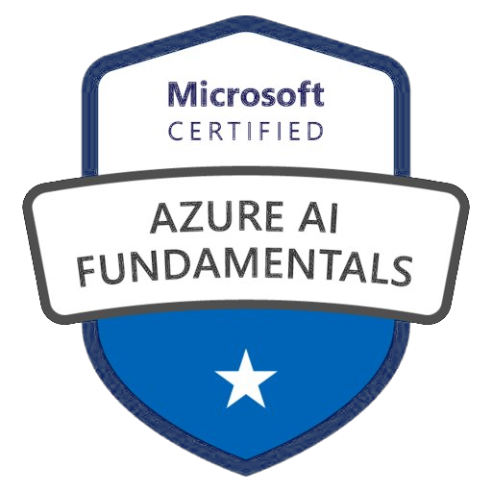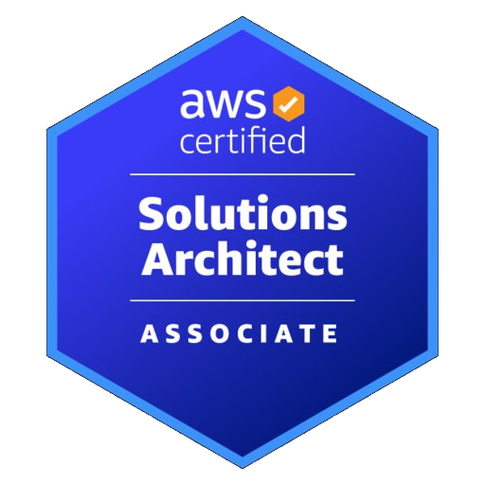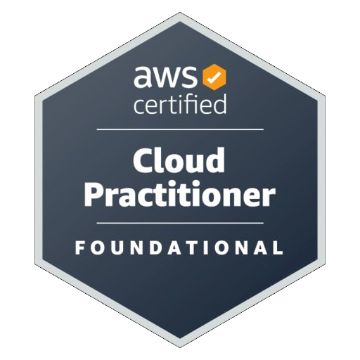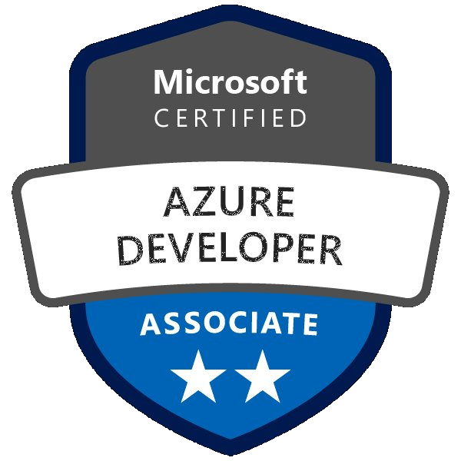
PROFESSIONAL SUMMARY
DevOps Engineer with 2+ years of experience at Tata Consultancy Services (TCS) delivering Continuous Integration and Continuous Deployment (CI/CD) automation, Kubernetes-based container orchestration, and cloud infrastructure management for Jaguar Land Rover. AWS Certified Solutions Architect – Associate and Microsoft Azure Developer Associate with expertise in GitOps, DevSecOps, Infrastructure as Code (IaC), SRE practices, and Agile/Scrum delivery across multi-cloud environments.
TECHNICAL SKILLS
Cloud Platforms | AWS (EC2, S3, VPC, RDS, Lambda, IAM, EKS, CloudWatch), GCP (GKE), Microsoft Azure
Containers & Orchestration | Docker, Kubernetes (K8s), Helm, ArgoCD, k3s, Container Security, GitOps
CI/CD & Release Management | GitLab CI/CD, Jenkins, Maven, Release Engineering, Build Automation, Pipeline Orchestration
Infrastructure as Code | Terraform, Ansible, Configuration Management, Immutable Infrastructure, Cost Optimisation
DevSecOps & Security | Trivy, Shift-Left Security, Vulnerability Scanning, Security Gates, RBAC, Container Hardening
Monitoring, Observability & SRE | Dynatrace, Prometheus, Grafana, SLO/SLI, Incident Management, Alerting, Dashboards
Scripting & Automation | Python, Bash/Shell Scripting, YAML, JSON, REST API Integration, Automation Scripts
Agile & Collaboration | Agile/Scrum, Sprint Planning, JIRA, Confluence, Cross-functional Collaboration, Runbooks
Databases & Web | MySQL, MongoDB, Nginx, Load Balancing, Linux/Unix (Ubuntu), Shell Administration
Version Control & Tools | Git, GitHub, GitLab, GitOps, VS Code, Backstage IDP

WORK EXPERIENCE
DevOps Engineer — Tata Consultancy Services (TCS), Hyderabad April 2024 – Present
Client: Jaguar Land Rover | Platform Engineering Team | Agile/Scrum
- Designed and maintained 18 GitLab CI/CD pipelines: build automation, DevSecOps scanning (Trivy), Docker containerisation, multi-environment deployments; improved deployment frequency by 40%.
- Architected a Backstage-inspired IDP with project scaffolding templates, RBAC, and self-service workflows; slashed team onboarding time by 60% across 10 squads.
- Configured Dynatrace AIOps-driven observability dashboards and defined SLOs/SLIs for availability and latency; established incident management runbooks that reduced mean time to detect (MTTD) incidents by 30%.
- Engineered multi-cloud infrastructure with Terraform (IaC) and Ansible across AWS and GCP; decreased environment setup time by 50% and eliminated configuration drift across dev, staging, and production.
- Delivered DevOps and infrastructure solutions across multiple cloud providers — AWS, Microsoft Azure, and Google Cloud Platform (GCP) — leveraging platform-specific services for compute, storage, networking, and IAM to support scalable, platform-agnostic deployments.
- Deployed 28 containerised applications to GCP Kubernetes Engine (GKE) using Helm and ArgoCD GitOps workflows; achieved seamless releases with self-healing rollback capability.
- Integrated SonarQube static code analysis into CI/CD pipelines as part of shift-left testing; enhanced release confidence and lowered post-deployment defects by 35%.

CERTIFICATIONS
 | Microsoft Azure Developer Associate (AZ-204) | Microsoft | Issued 2026
 | Microsoft Azure AI Fundamentals (AI-900) | Microsoft | Issued 2026
 | AWS Certified Solutions Architect – Associate (SAA-C03) | Amazon Web Services | Issued 2025
 | AWS Certified Cloud Practitioner (CLF-C02) | Amazon Web Services | Issued 2025

PROJECTS
GitOps DevSecOps Cloud-Native Showcase Platform January 2026 – Present
github.com/VaranasiRahul/MyPortfolio
- Built a production-grade GitOps pipeline using Jenkins, ArgoCD, Docker, and Kubernetes (k3s) on AWS; enabling hands-off zero-downtime deployments with sub-60-second release cycles and instant rollback.
- Built complete AWS infrastructure (VPC, EC2, subnets, security groups, IAM, Route 53) using Terraform — 100% reproducible, version-controlled, immutable.
- Integrated Trivy vulnerability scanning and enforced security gates; achieved zero critical/high CVEs in production images, improving security posture by 90%.
- Optimised multi-stage Docker builds reducing image size by 85%; adopted k3s clusters for cost optimisation, cutting infrastructure costs by 70%+.
- Implemented observability with Prometheus and Grafana; configured 12 dashboards and alerting for SLO/SLI monitoring, application health, and infrastructure performance.

RVX AI NOTES — Edge-AI Personal Knowledge Base January 2026 – Present
github.com/VaranasiRahul/RVX-AI-NOTES-PUBLIC
- Rebuilt the cross-platform mobile app (React Native, Expo) to run a 100% on-device Large Language Model (LLM) — Llama 3.2 1B via ExecuTorch — powering a 7-stage abstractive summarisation pipeline with smart topic parsing; zero cloud API dependency, absolute data privacy.
- Prototyped Retrieval-Augmented Generation (RAG) pipelines using Ollama for local LLM inference during early R&D; engineered a FileSystem-based JSON persistence layer delivering sub-100ms cold-start times.
- Applied Azure AI-900 certified knowledge to architect the on-device LLM and RAG-based retrieval pipeline, transitioning from server-side prototype to production; formally registered the novel system design as an independent technical innovation.

EDUCATION
B.Tech in Computer Science Engineering 2019 – 2023
GITAM University, Visakhapatnam, Andhra Pradesh
ICSE — Class X 2017
Timpany School, Visakhapatnam, Andhra Pradesh

