**How to install Web Server on Windows Machine?**

1. **Sign in to AWS Management Console.**

* Open the Amazon AWS website.
* Click on **Log Back In** it will redirect you to the sign in page.
* **a.** While signing through Root user enter your Email Address and Password.

**b.** On signing through IAM user, Enter the Account Id, Username and Password.

* After Signing in, make the default AWS Region as **Asia Pacific (Mumbai) ap-south-1.**

1. **Launching an Instance.**

* Click on **Services** on the top-left corner of the dashboard, click **Compute** and then **EC2**.
* Click on **Instances** and then **Launch Instances.**
* On the Name and Tags heading write the name of the instance.
* Under **Application and OS Images (Amazon Machine Image)** heading click Windows.
* Under the Instance type heading select **t2.micro**.
* Under Key pair (login) Heading click create new key pair. In Create key pair menu enter key pair name and select Private Key file format as .pem and click on Create key pair option. The file will be downloaded.
* Leave all setting as it is and click **Launch Instance.**
* An Instance will be created.

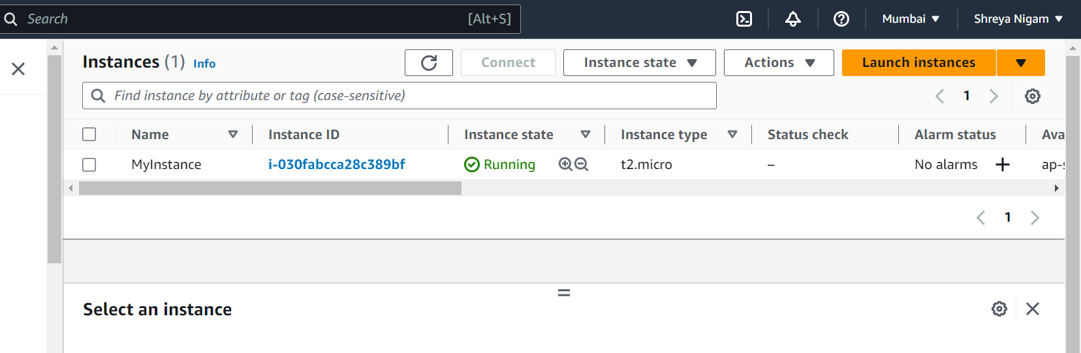

1. **Connecting the Instance.**

* Select the Instance, click **Connect** then click **RDP client** and click Download Remote Desktop file. The file gets downloaded.
* Click on Get password then upload primary key file. A dialog box appears select the remote desktop file previously downloaded then click on **Decrypt password**. Copy the password obtained.
* Open the remote desktop file then click Connect. Paste the password and press ok.
* Your Windows Instance will successfully after few minutes.

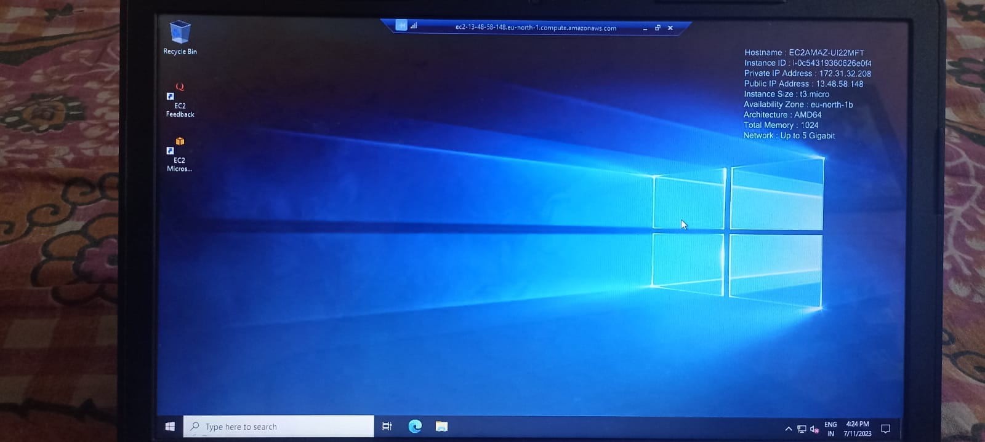

1. **Installing Apache Web Server.**

* Open Microsoft Edge and search Apache Install for Windows, go to the official website, click on Apache Lounge and download the zip file.
* Extract the contents of the zip file.
* Select the **Apache24** folder and move it to the **c drive**.
* Copy the path of the **bin** folder inside the Apache24 folder.
* Open Command Prompt.
* Type cd and paste the path copied. Press Enter.
* Type **httpd -k install** and press enter. Apache is installed successfully.
* Search Services, click Apache2.4 and click on start. It will start running.
* Open Microsoft Edge and type 127.0.0.1 to check if the server is working or not.
* You see the message **It works!** if the server is working.

