Framework Comparison
Implementation Plan & Gap Analysis

Date: 28 May 2026
Prepared for: Change Management Team

Contents
- 1. Existing Functions
- 2. What Is Missing
- 3. Proposed New Functions
- 4. Current Workflow (As-Is)
- 5. Proposed Workflow (To-Be)
- 6. Implementation Priority
- 7. Files to Modify

1. Existing Functions
These functions are already built and working in the system.

Function | What It Does
check_framework_updates | Searches the internet for the latest official amendment PDF for the selected framework and downloads it
query_perplexity_api | Calls the Perplexity AI search engine to find official amendment document links on regulator websites
start_amendment_analysis | Triggers the AI to read the downloaded PDF and extract all rules in a background thread so the user does not wait
process_downloaded_amendment | Main pipeline: extracts sections from PDF, then policies, then sub-policies, then compliance records using AI
get_framework_origin_data | Fetches your current framework data from the database (policies, sub-policies, compliances you already have)
get_framework_target_data | Fetches the AI-extracted rules from the amendment PDF stored in Framework.Amendment JSON
match_amendments_compliances | Compares every new rule from the amendment against your existing database rules using AI semantic matching
find_control_matches | Finds the best matching existing compliance for a single new control from the amendment
batch_match_controls | Matches multiple controls at once against your existing database for bulk comparison
add_compliance_from_amendment | Creates a brand-new compliance, sub-policy, and policy in the database and sends it for reviewer approval
get_framework_comparison_summary | Returns summary counts: how many new controls, modified controls, and deprecated controls exist
get_migration_gap_analysis | Returns a detailed breakdown of all gaps with priority levels (High, Medium, Low) and required actions
get_amendment_document_info | Returns the current document processing status so the frontend can poll for completion
calculate_hybrid_similarity | Calculates a similarity score using text matching, keyword overlap, and AI embeddings combined
match_all_amendments_compliances | Bulk matching of all amendment compliances against database compliances with AI fallback
_perform_ai_gap_analysis | Runs AI-powered gap analysis comparing the original framework version against the amended version
_assess_ai_compliance_impact | Assesses how framework changes will impact your organization's overall compliance posture using AI
cancel_amendment_analysis | Allows the user to cancel a long-running background analysis before it completes

2. What Is Missing
These are the critical gaps in the current implementation.

Missing Feature | What It Should Do
update_existing_rules | When an amendment changes an existing rule, the system shows 'You already have this' and offers NO way to update the existing compliance record. The old rule stays outdated in the database.
risk_module_connection | When a compliance changes, the system does NOT show which Risk entries in the Risk module are linked to it. Risk and Framework Comparison are completely disconnected.
audit_module_connection | When a policy or compliance changes, the system does NOT flag which audits cover that area and may need re-auditing. Audit and Framework Comparison are completely disconnected.
automatic_periodic_checking | A human must click 'Check the updates' every time. The system does NOT automatically search for new amendments on a weekly or monthly schedule.
policy_level_impact_summary | There is no high-level dashboard showing '3 policies, 7 sub-policies, 12 compliances affected.' Only rule-by-rule matching exists.

3. Proposed New Functions
These functions need to be implemented to close the gaps.

New Function | What It Does
detect_control_changes | Compares the amendment version of a rule against the database version and detects if wording, criticality, or requirements changed. Returns a change flag and a side-by-side diff.
get_compliance_change_detail | Returns the old values vs new values for every field that changed in a matched compliance, so the user can see exactly what is different.
create_compliance_update_request | Creates an approval workflow record for updating an EXISTING compliance. Similar to adding a new compliance, but modifies an existing record instead of creating one.
apply_compliance_update | Applies approved changes to the actual Compliance record in the database, saves the old version to history, and triggers risk/audit notifications.
get_pending_compliance_updates | Lists all compliance update requests that are currently pending reviewer approval for a given framework.
reject_compliance_update | Rejects an update request with a reason, keeping the existing compliance unchanged and notifying the requester.
get_affected_risks | Finds all Risk entries in the Risk module that are linked to a specific compliance or policy that changed in the amendment.
get_risk_impact_summary | Returns a count of how many risks are affected by the amendment, broken down by impact level (High, Medium, Low).
notify_risk_owners | Sends an email or in-app notification to risk owners when a compliance linked to their risk entry has changed.
get_affected_audits | Finds all audits in the Audit module that cover a specific policy, sub-policy, or compliance that changed in the amendment.
get_audit_impact_summary | Returns a count of how many audits are impacted and how many require re-auditing due to framework changes.
flag_audit_for_reaudit | Marks an audit record as needing re-audit because the underlying compliance or policy has changed.
schedule_framework_update_check | A scheduled background task (cron job) that automatically checks ALL active frameworks for new amendments on a weekly basis without human intervention.
send_update_notification | Sends an email notification to configured administrators when a new amendment is automatically found and downloaded.
get_policy_impact_summary | Returns a high-level dashboard summary showing total policies, sub-policies, compliances, risks, and audits affected by the amendment.

4. Current Workflow (As-Is)
This is how the system works today.

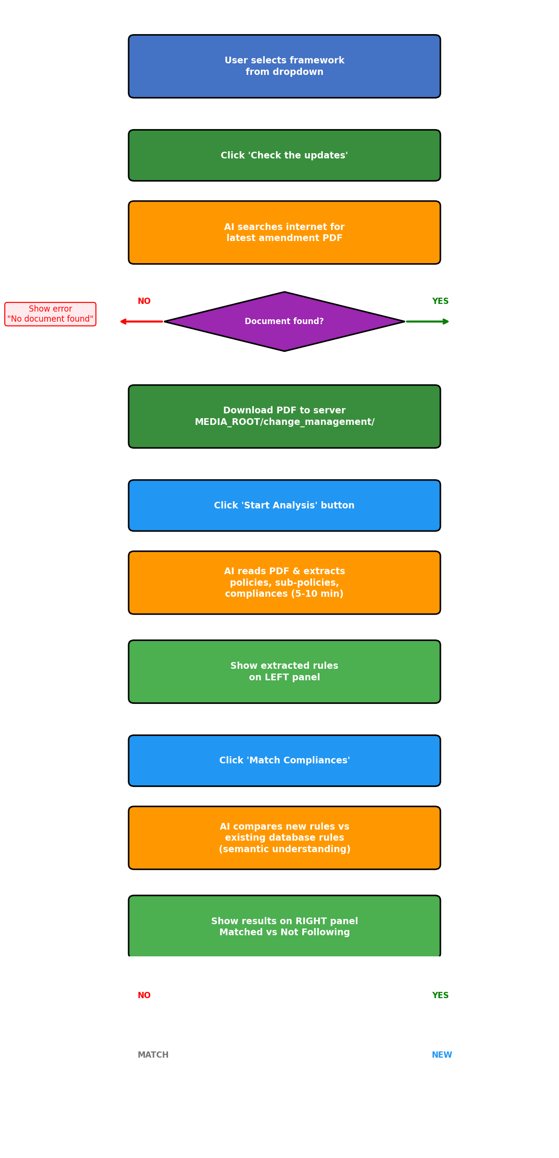

5. Proposed Workflow (To-Be)
This is how the system SHOULD work after implementation.

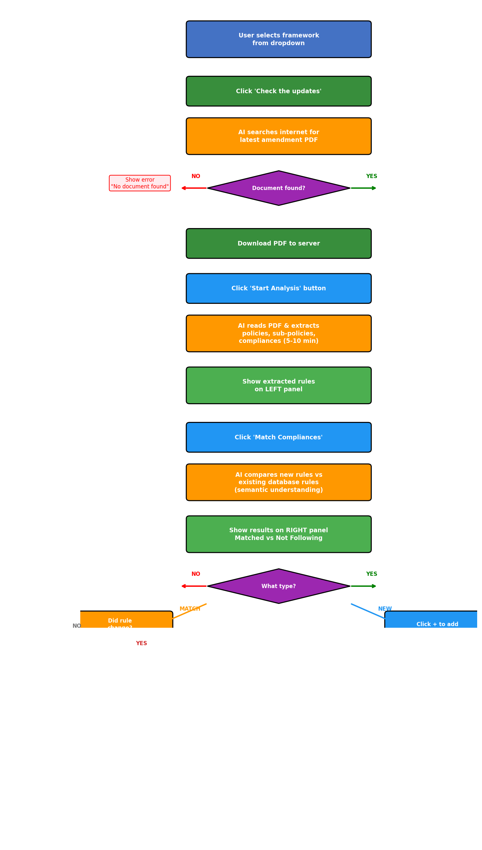

6. Implementation Priority

Phase | What It Does
Phase 1: Update Existing Rules  (Priority: CRITICAL) | When an amendment changes an existing rule, detect the change, show a diff, and allow updating through approval workflow. This is the #1 gap.
Phase 2: Risk Module Integration  (Priority: HIGH) | Show which Risk entries are affected when a compliance changes. Notify risk owners automatically.
Phase 3: Audit Module Integration  (Priority: HIGH) | Show which Audits are impacted. Flag audits that need re-auditing due to framework changes.
Phase 4: Automatic Checking  (Priority: MEDIUM) | Schedule weekly automatic checks so no human needs to click 'Check the updates' manually.
Phase 5: Impact Summary Dashboard  (Priority: MEDIUM) | Show a high-level summary card: X policies, Y sub-policies, Z compliances, N risks affected.

Estimated Timeline: 4-6 weeks with 1-2 developers

7. Files to Modify

File | What to Change
framework_comparison.py | Add new API endpoints for update requests, risk/audit lookups, impact summaries, and automatic checking
similarity_matcher.py | Add change detection logic to flag when a matched compliance has material changes vs the amendment
amendment_processor.py | Add hooks to store amendment source references on extracted compliances
framework_update_checker.py | Add automatic scheduling logic and email notification functions
FrameworkComparisonUpdated.vue | Add new UI: update modals, diff viewers, risk/audit expandable sections, impact summary card
frameworkComparisonService.js | Add new API service methods for update requests, risk/audit lookups, and auto-check
models.py (Compliance) | Add ComplianceHistory JSON field and AmendmentSource field
New: compliance_update_request model | Create ComplianceUpdateRequest table for approval workflow on existing compliance updates
New: risk_integration.py | Helper module to query Risk module and return linked risks for a compliance
New: audit_integration.py | Helper module to query Audit module and return linked audits for a compliance

