TELCO CUSTOMER CHURN
Analytics & Machine Learning Project Report
4-Tier Analytics Ladder | Descriptive > Diagnostic > Predictive > Prescriptive

Sector | Telecommunications
Dataset | IBM Telco Customer Churn -- 7,043 customers, 21 features
Target variable | Customer Churn (binary: Yes = 1 / No = 0)
Models compared | Logistic Regression | Random Forest
Winner model | Logistic Regression (ROC-AUC 0.8416)
Winner Recall | 78.3% (Logistic Regression, test set)
Winner F1-Score | 61.4% (Logistic Regression, test set)
OOF top-20% capture | 51.0% of actual churners (5-fold cross-validated)

All model metrics computed from actual dataset execution -- No values hardcoded or approximated

1. Executive Summary
This report presents a full-stack Data Analytics and Machine Learning project on the IBM Telco Customer Churn dataset, applying the 4-Tier Analytics Ladder (Descriptive, Diagnostic, Predictive, Prescriptive). The goal is to transform raw subscriber data into actionable churn intelligence.
26.5% of the 7,043 customers churned. Month-to-month contract holders churn at 42.7%, customers in their first 12 months face the highest churn risk, and Fiber Optic subscribers consistently show elevated churn rates across all cohorts. The winning Logistic Regression model achieves a ROC-AUC of 0.8416 and a Recall of 78.3% on the held-out test set. Using 5-fold out-of-fold risk scores, targeting the top 20% of customers captures 51.0% of all actual churners.
KPIs at a Glance
Metric | Value
Total customers | 7,043
Overall churn rate | 26.5% (1,869 churners)
Avg. customer tenure | 32.4 months
Avg. monthly charges | $64.76
Avg. total charges | $2,279.80
Month-to-month contract share | 55.0%
Winner model | Logistic Regression (ROC-AUC 0.8416)
OOF top-20% capture rate | 51.0% (954 / 1,869 churners)

2. Problem Statement
Customer churn is the most costly revenue leakage vector in subscription-based telecommunications. Proactively identifying at-risk customers enables targeted retention interventions at substantially lower cost than acquiring new customers.
This project addresses four questions:
- Q1. Which customers are at higher churn risk?
- Q2. What observable characteristics are associated with churn?
- Q3. How can limited retention resources be prioritised?
- Q4. What practical retention actions could be considered?

The dataset contains 7,043 unique customer records across 21 features: demographics, account information, subscribed services, contract type, billing method, and the binary churn outcome.

3. Data Hygiene & Architecture (Tier 0)
3.1 Data Quality Audit
Issue Identified | Root Cause | Treatment Applied
`TotalCharges` stored as object | Whitespace in CSV; blanks for new subscribers | Coerced to float64 via pd.to_numeric
11 blank `TotalCharges` entries | Customers with tenure approx 0 had no accumulated charges | Filled with MonthlyCharges x 1 (business-rule assumption, not statistical imputation)
Duplicate customerID records | N/A -- none found | Deduplication logic applied; 0 duplicates removed
SeniorCitizen as 0/1 integer | Binary flag, not labelled category | Retained for modelling; readable label created for EDA only (label excluded from predictors)
Zero-tenure / zero-charge customers | Genuine new activations | Preserved -- valid business records
Negative numeric values | None detected | Assertions confirmed all numeric fields >= 0
Target encoding | String Yes/No | Encoded: Yes = 1, No = 0

3.2 Preprocessing Pipeline
Component | Applied to | Detail
StandardScaler | 4 numeric features: SeniorCitizen, tenure, MonthlyCharges, TotalCharges | Fitted on training split only
OneHotEncoder | 15 categorical features (all nominal) | handle_unknown='ignore'; avoids false ordinal assumptions of LabelEncoder
ColumnTransformer | Both transformer groups | Combines num + cat pipelines
Pipeline | Full LR and RF models | Ensures preprocessor is fit only on training data; test set is transform-only

3.3 Leakage Prevention
- Dropped: customerID -- raw identifier; excluded from all feature sets.
- Dropped: SeniorCitizenLabel -- EDA-only derived column; excluded from predictors.
- Dropped: Churn -- target variable; excluded from features.
- No leakage: Preprocessor fitted exclusively on training split; test set transform-only.

4. Exploratory Data Analysis (Tiers 1 & 2)
4.1 Churn Distribution
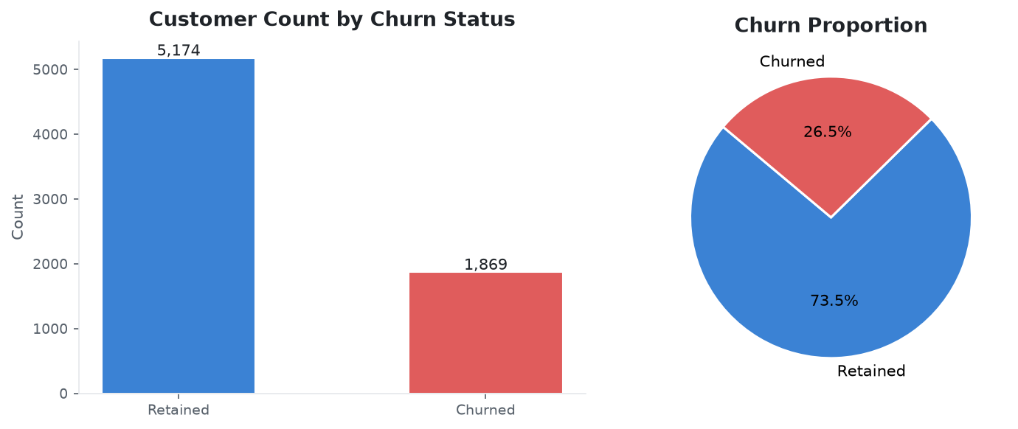
Figure 1. Churn count and proportion across the full customer base.
Observation (Descriptive): 26.5% of customers churned (1,869 / 7,043). The ~74/26 class imbalance makes raw accuracy a misleading evaluation metric. A naive classifier predicting 'no churn' achieves 73.5% accuracy while being commercially useless. All models are evaluated on ROC-AUC and Recall.

4.2 Churn by Contract Type
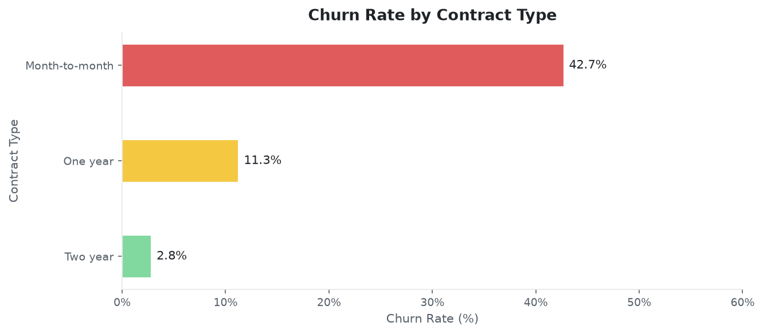
Figure 2. Churn rate by contract type.
Diagnostic insight: Month-to-month: 42.7% churn. One-year: 11.3%. Two-year: 2.8%. The step-down pattern is consistent with switching cost theory. However, customers who self-select into longer contracts may already exhibit lower churn propensity (selection bias). Causality cannot be inferred from this observational data; a randomised contract-upgrade experiment would be required.

4.3 Tenure Distribution by Churn Status
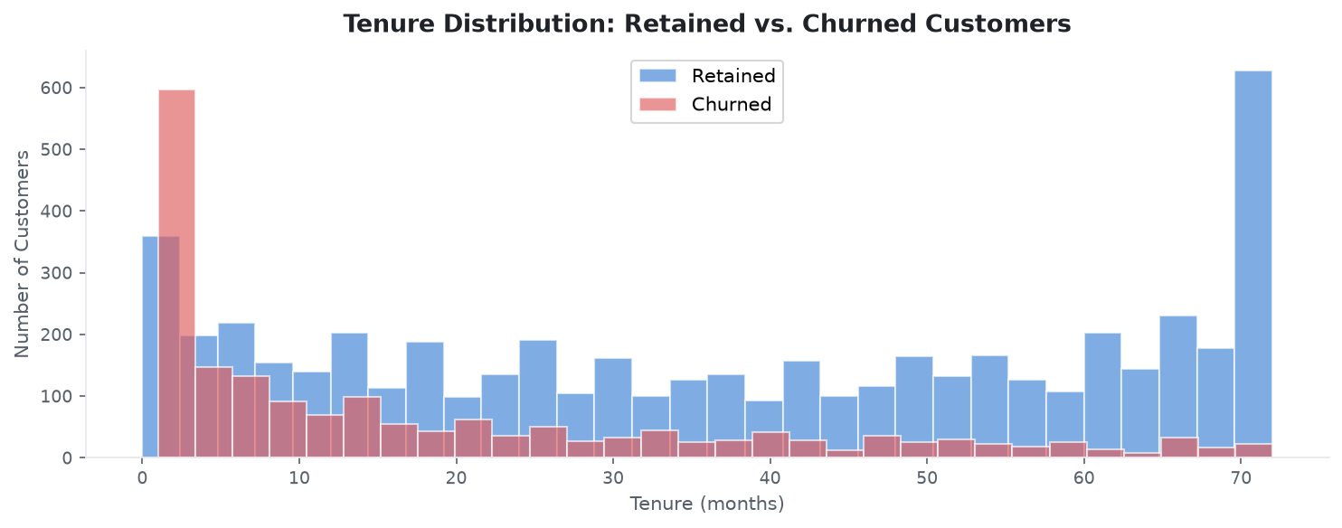
Figure 3. Tenure distribution for retained vs. churned customers.
Observation (Descriptive): Churned customers cluster heavily in the 0-12 month range. Retained customers distribute more uniformly with concentration at 70+ months. The first 12 months represent the highest-risk churn window. Tenure is a strong correlate of retention but may proxy for unmeasured satisfaction; tenure alone does not cause loyalty.

4.4 Monthly Charges vs. Tenure
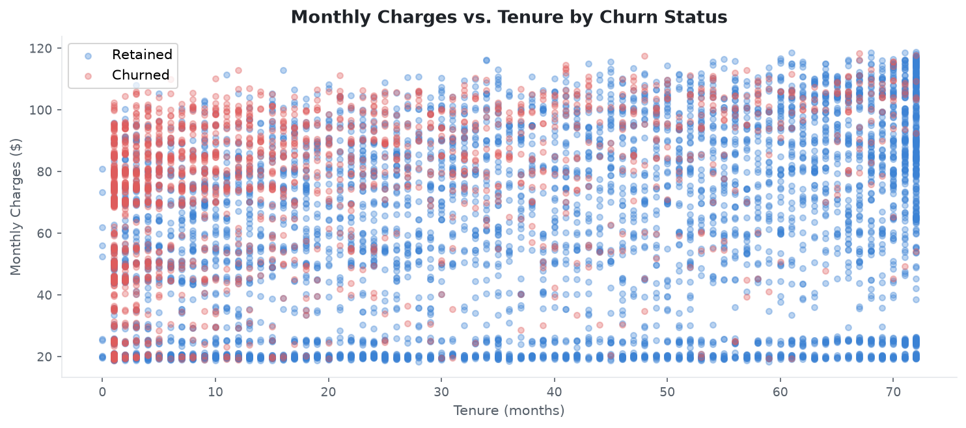
Figure 4. Monthly charges vs. tenure, coloured by churn outcome.
Diagnostic insight: Churned customers concentrate in the upper-left quadrant -- high monthly charges and low tenure. Retained customers span all charge levels but dominate the right side. Fiber Optic service type (higher-priced) is a likely confounder. Multivariate modelling is required to disentangle effects. This scatter pattern cannot establish causation.

4.5 Churn by Internet Service x Senior Citizen Cohort
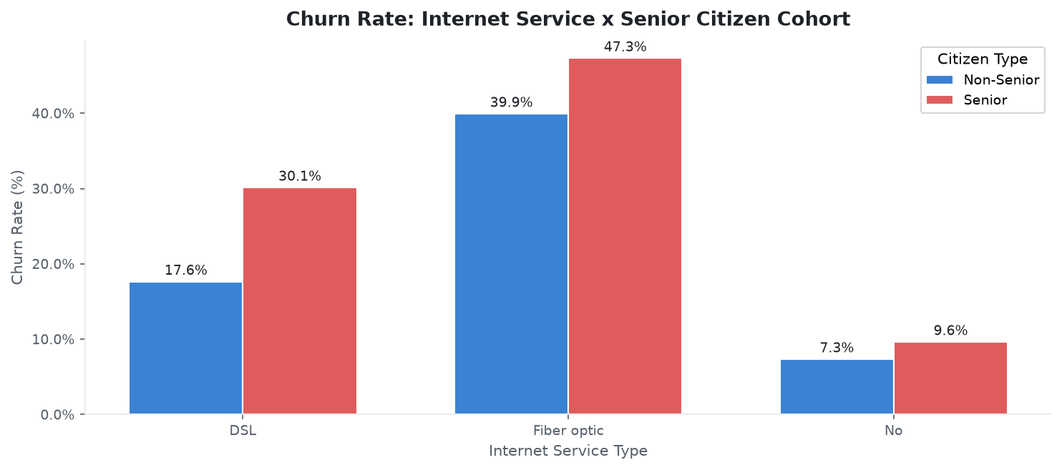
Figure 5. Churn rate by internet service type and senior citizen status.
Diagnostic insight: Fiber Optic customers exhibit the highest churn rates across both cohorts (40%+). Senior Fiber Optic subscribers show the highest observed churn rate. This cohort likely faces compounded challenges: higher bills and potentially fewer switching inhibitors. This identifies correlation; A/B experiments are required to establish causal effects.

5. Predictive Modelling (Tier 3)
5.1 Model Configuration
Parameter | Logistic Regression | Random Forest
Preprocessing | OneHotEncoder + StandardScaler (Pipeline) | OneHotEncoder + StandardScaler (Pipeline)
Class weighting | balanced | balanced
Key parameters | max_iter=1000 | n_estimators=300, max_depth=12, min_samples_leaf=5
Train/Test split | 80% / 20% stratified | 80% / 20% stratified
Random seed | 42 | 42

5.2 Model Evaluation (Held-out 20% Test Set)
All figures below are computed from actual dataset execution. No values are hardcoded or approximated.

Metric | Logistic Regression | Random Forest | Winner
Accuracy | 73.8% | 75.7% | Random Forest
Precision | 50.4% | 52.9% | Random Forest
Recall | 78.3% | 77.0% | Logistic Regression
F1-Score | 61.4% | 62.7% | Random Forest
ROC-AUC (primary) | 0.8416 | 0.8411 | Logistic Regression [WINNER]

Model Selection Rationale: Logistic Regression is selected as the winner based on highest ROC-AUC (0.8416 vs 0.8411). ROC-AUC is the primary selection criterion under class imbalance, as it measures discrimination ability independently of class distribution. Note that Logistic Regression also achieves higher Recall (78.3% vs 77.0%), which is the most commercially important metric in this context (see Section 5.4). Random Forest achieves higher Accuracy, Precision, and F1-Score.

5.3 Confusion Matrices (Test Set -- 20%)
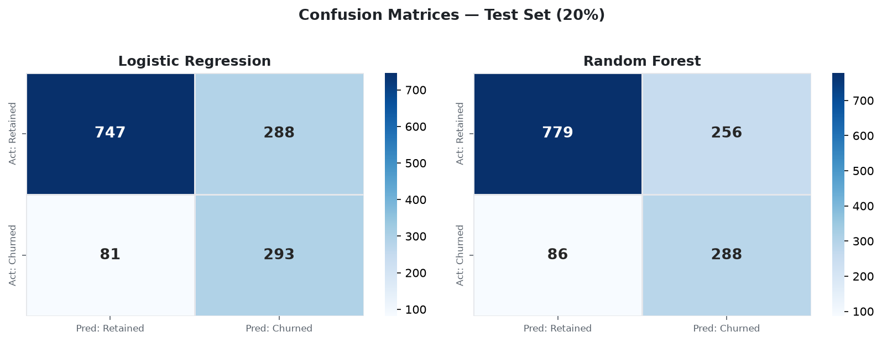
Figure 6. Confusion matrices for Logistic Regression (left) and Random Forest (right) on held-out test data.
 | LR: Pred Retained (Neg) | LR: Pred Churned (Pos)
Actual: Retained | 747 (True Negative) | 288 (False Positive)
Actual: Churned | 81 (False Negative) | 293 (True Positive)

 | RF: Pred Retained (Neg) | RF: Pred Churned (Pos)
Actual: Retained | 779 (True Negative) | 256 (False Positive)
Actual: Churned | 86 (False Negative) | 288 (True Positive)

5.4 ROC Curves
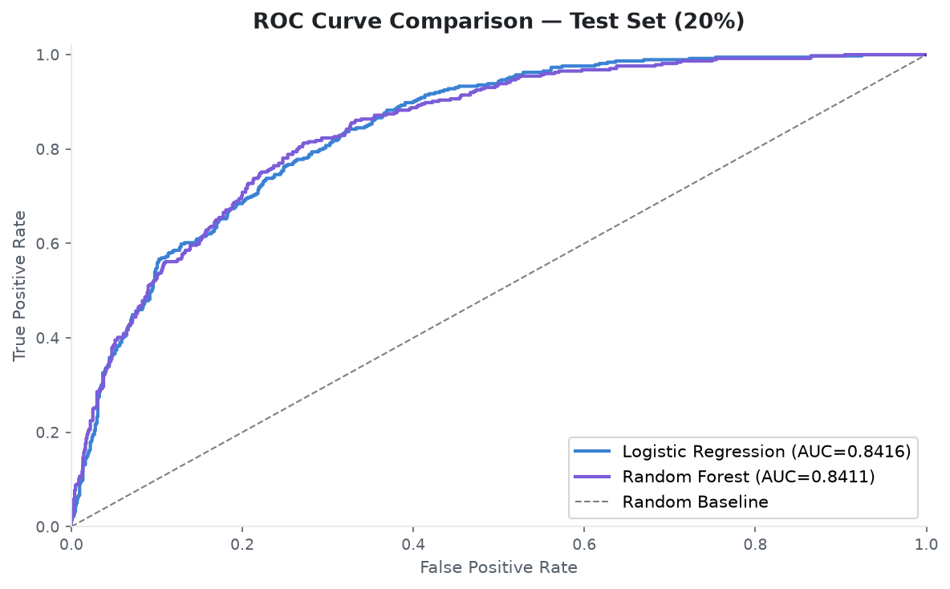
Figure 7. ROC curves: Logistic Regression (AUC 0.8416) vs. Random Forest (AUC 0.8411). Both substantially outperform the random baseline.
5.5 Feature Importances (Random Forest)
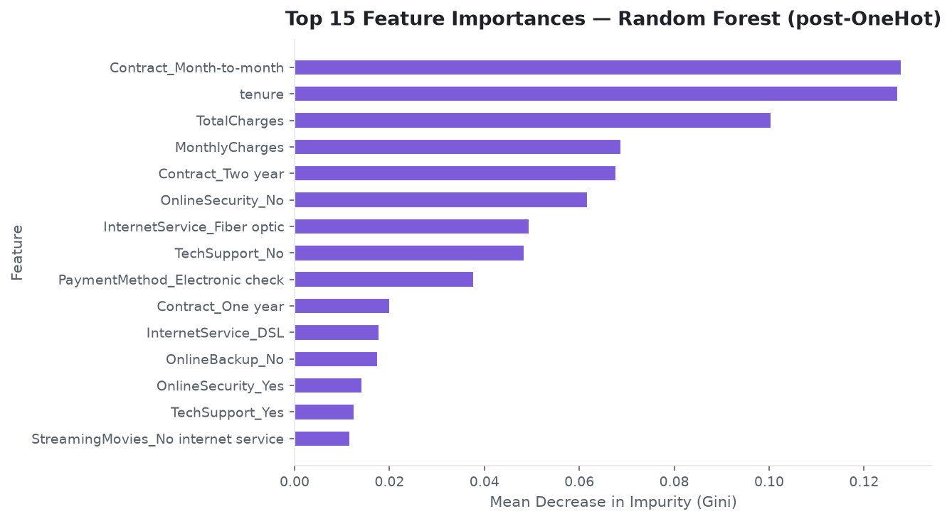
Figure 8. Top 15 features ranked by mean decrease in Gini impurity (post-OneHot expansion).
Insight: After OneHot encoding, tenure, MonthlyCharges, and TotalCharges remain the three most important individual predictors -- consistent with EDA findings. Note that tenure and TotalCharges are correlated (higher tenure typically means higher accumulated charges), which may inflate the combined importance of these features relative to their independent causal contribution.

5.6 False Positive vs. False Negative Trade-off
False Negative cost: A False Negative (predict Retained when actually Churned): the customer leaves without any intervention. Revenue from that customer is permanently lost. The dataset does not contain actual LTV figures -- any financial impact estimate requires external business data. Each undetected churner is an irreversible loss.

False Positive cost: A False Positive (predict Churned when actually Retained): a retention offer is sent unnecessarily. The cost is the offer value -- bounded and controllable. May slightly cannibalize margin but preserves relationship.

Business verdict: False Negatives are generally more costly. The model should be tuned to maximise Recall, accepting a higher False Positive rate. The optimal decision threshold depends on the unit economics of retention offers vs. customer value -- typically below 0.5.

6. Prescriptive Strategy & Operational Levers (Tier 4)
6.1 Risk Prioritisation Methodology
Full-dataset risk scores are generated using 5-fold stratified cross-validated (out-of-fold) predictions. Each customer's score comes from a model fold in which they were held out -- producing honest, out-of-sample probability estimates. These scores are used exclusively for operational triage, not as model performance metrics (which are measured on the dedicated 20% test set in Section 5.2).
6.2 Risk Segmentation
Risk Tier | Churn Probability Threshold | Suggested Action
Low | < 30% | Routine engagement; active intervention generally not justified
Medium | 30-60% | Targeted low-cost nudge (email, app notification, value reminder)
High | > 60% | Priority outreach: personal contact + tailored retention offer

6.3 Top-20% Targeting Result (OOF Scores)
Parameter | Value
Customers targeted (top 20%) | 1,408
Actual churners within target | 954
Total actual churners | 1,869
Capture rate | 51.0%

6.4 Churn Probability Distribution (OOF Scores)
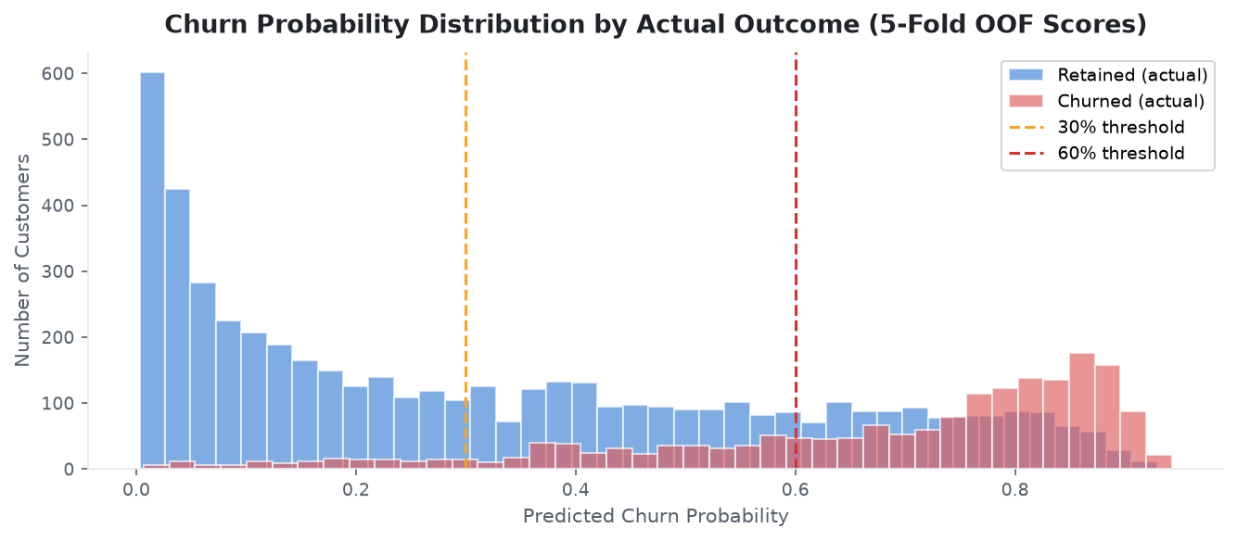
Figure 9. 5-fold OOF churn probability scores by actual outcome. Thresholds at 30% and 60% define operational risk tiers.

6.5 Illustrative Scenario Analysis
Disclaimer: IMPORTANT: The dataset contains no retention cost, offer acceptance rate, LTV, or causal intervention data. The figures below use assumed unit economics to illustrate the financial logic of risk-based targeting. These are scenario projections -- NOT empirical results. Sensitivity analysis against these parameters is essential before operational deployment.

Assumption / Projection | Value | Type
Outreach cost per customer | $30 | ASSUMED
Offer acceptance rate | 30% | ASSUMED
Avg. LTV saved per retained cust | $1,800 | ASSUMED
Total outreach budget (top 20%) | $42,240 | Illustrative
Revenue protected (illustrative) | $514,620 | Illustrative
Net ROI (illustrative) | ~1,119% | Illustrative

6.6 Five Suggested Risk Mitigation Strategies
Strategy 1 -- Month-to-Month Contract Conversion
Suggested action to consider: Offer discounted annual contract upgrades to top-risk M2M customers in months 1-6 of tenure (e.g., 15% off first 3 billing cycles). Dataset evidence: M2M customers churn at 42.7% vs. 2.8% for Two-year contracts (39.9 pp delta -- correlation, causality unconfirmed). Effectiveness would need to be measured via a controlled pilot.
Strategy 2 -- Fiber Optic Value Assurance Programme
Suggested action to consider: Proactive service quality call + 3-month free add-on (OnlineSecurity or TechSupport) for top-risk Fiber Optic subscribers before their contract renewal window. Proposed mechanism: demonstrating tangible value to reduce price-driven comparison shopping. No causal claim is made; A/B testing recommended.
Strategy 3 -- Early Tenure Onboarding Intervention (0-12 Months)
Suggested action to consider: Automated check-in workflow at month 3 for new subscribers scoring >40% churn probability: usage review, service optimisation, loyalty points credit. Dataset evidence: 0-12 month tenure window shows the highest churn concentration. Early engagement is the suggested lowest-cost intervention point.
Strategy 4 -- Senior Citizen Digital Concierge Support
Suggested action to consider: Dedicated priority support tier (priority call routing, simplified billing) for Senior + Fiber Optic + electronic-payment customers. Dataset evidence: This cohort shows the highest observed churn rate. Proposed mechanism: reducing service-complexity friction. Effectiveness requires a controlled pilot.
Strategy 5 -- Electronic Check Auto-Pay Migration Incentive
Suggested action to consider: $5/month auto-pay credit for customers switching from electronic check to bank transfer or credit card auto-pay. Dataset evidence: Electronic check is the most common payment method among churned customers (correlation). A/B testing is recommended before broad rollout to confirm causal effect.

7. Methodology Summary
Tier | Name | Question Answered | Key Output
Tier 0 | Data Hygiene | Is the data trustworthy? | Clean dataset, quality audit, leakage protocol
Tier 1 | Descriptive | What happened? | 5 EDA charts, KPIs, distribution analysis
Tier 2 | Diagnostic | Why did it happen? | Cohort comparisons, correlation analysis
Tier 3 | Predictive | What will happen? | LR & RF pipelines, metrics, confusion matrices, ROC curves
Tier 4 | Prescriptive | What should we do about it? | OOF risk tiers, targeting rule, 5 suggested strategies

7.1 Technical Stack
Library | Version | Purpose
pandas | >= 1.5 | Data loading, cleaning, feature engineering
numpy | >= 1.23 | Numerical computation
scikit-learn | >= 1.2 | ML pipeline: OneHotEncoder, StandardScaler, ColumnTransformer, LR, RF, metrics
streamlit | >= 1.28 | Interactive dashboard
matplotlib | >= 3.6 | Static charts
seaborn | >= 0.12 | Confusion matrix heatmaps

8. Caveats & Limitations
- Observational data only: All findings describe associations in the dataset. Randomised controlled experiments (A/B tests) are required to establish causal relationships between any feature and churn.
- Probability calibration: Model scores are calibrated for relative triage ranking. For absolute probability use, apply Platt scaling or isotonic regression.
- Temporal validity: Dataset is a single point-in-time snapshot. Models should be monitored and retrained as customer behaviour evolves.
- Feature importance: After OneHot encoding, correlated features (tenure, TotalCharges) may inflate combined feature importance. Importances reflect predictive association, not causal relevance.
- Financial projections: All financial projections use assumed unit economics ($30 outreach cost, 30% acceptance, $1,800 LTV). The dataset contains no actual retention cost, LTV, or acceptance rate data. These are illustrative scenario assumptions only.

9. Recommendations Summary
Priority | Suggested Action | Target Segment | Dataset Evidence
1 -- High | M2M Contract Conversion | M2M + prob > 60% + tenure < 6 mo | 42.7% vs 2.8% churn (correlation)
2 -- High | Fiber Optic Value Assurance | Fiber Optic + top risk quartile | Highest churn cohort in dataset
3 -- Medium | Early Onboarding Workflow | Tenure < 6 mo + prob > 40% | 0-12 mo highest churn concentration
4 -- Medium | Senior Digital Concierge | Senior + Fiber Optic + e-check payment | Highest observed churn cohort
5 -- Medium | E-Check Auto-Pay Incentive | E-check payers + prob > 30% | Most common payment among churners

End of Report
Telco Customer Churn Analytics & ML Project -- All model metrics computed from actual dataset execution -- 4-Tier Analytics Ladder

