BN314 – System Architecture
Assignment 2: Case Study Analysis
FreshBite Salads – Online Ordering System
Questions 5 & 6

Question 5: First-Level Data Flow Diagram (Level-1 DFD)
A Data Flow Diagram (DFD) is a graphical representation that models how data moves through a system. The Level-1 DFD expands the context diagram by decomposing the central system process into its major sub-processes, showing the data stores each process reads from or writes to, and the data flows that connect them.

5.1 Major Processes
- P1 – User Registration & Authentication: Handles new-user sign-up (collects username, name, DOB, email, password), enforces strong password rules, generates a verification code sent via email, and validates login credentials. After three failed attempts, it suspends the account.
- P2 – Browse Salads: Retrieves salad data (name, description, ingredients, nutritional info, allergen warnings, portion sizes, price) from the Salad Catalog and presents it to the customer.
- P3 – Shopping Cart Management: Allows customers to add, update, or remove items in a session-scoped cart. Persists cart contents to the Shopping Cart data store.
- P4 – Checkout & Order Processing: Calculates the order total including tax and delivery charges, reads the delivery address, creates a pending order record, and coordinates with Payment Processing. On successful payment it finalises the order and triggers confirmation emails.
- P5 – Payment Processing: Sends payment requests to the external Payment Gateway, receives the authorisation response, and returns a payment status to Checkout.
- P6 – Order Tracking: Updates and exposes the order lifecycle: Preparing → Out for Delivery → Delivered. Receives delivery status from the Delivery Service and notifies the customer.
- P7 – Reward Points Management: Awards 1 point per completed purchase, checks if the threshold of 15 points is reached to unlock a free salad, and updates the Reward Points database.

5.2 Data Stores
- D1 – Salad Catalog: Stores all salad records (ID, name, ingredients, price, sizes).
- D2 – User Database: Stores registered user profiles, credentials, and account status.
- D3 – Shopping Cart: Persists session-level cart items (salad ID, quantity, portion size).
- D4 – Order Database: Records all orders with status, cost breakdown, and timestamps.
- D5 – Address Database: Stores user-saved billing and delivery addresses.
- D6 – Reward Points DB: Tracks accumulated and redeemed loyalty points per user.

5.3 Diagram
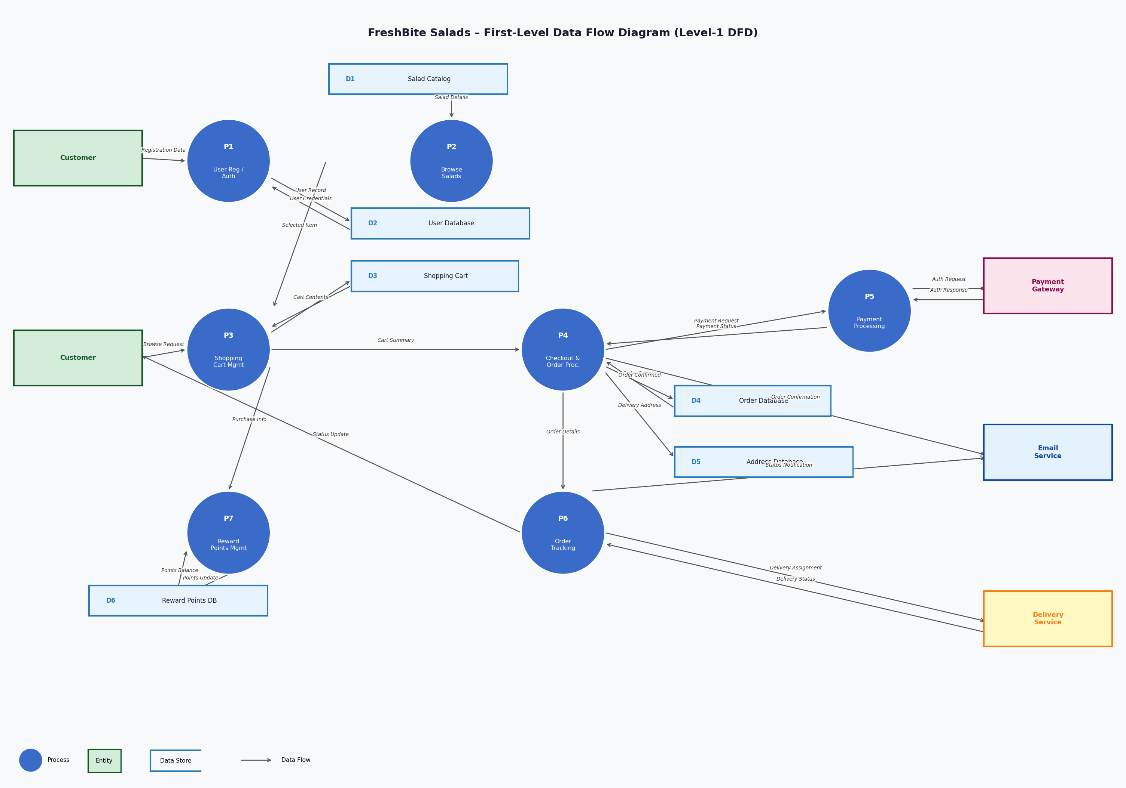
Figure 1: Level-1 Data Flow Diagram – FreshBite Salads Online Ordering System

Question 6: UML Class Diagram
The class diagram below models the static structure of the FreshBite Salads ordering system using UML notation. Each class is presented with its attributes (visibility, name, and type), its methods, and its associations to other classes, including multiplicity labels.

6.1 Key Classes, Attributes & Methods
User
Represents a registered customer.
- -userId: String
- -username: String
- -firstName / lastName: String
- -dateOfBirth: Date
- -email: String
- -password: String
- -accountStatus: String {Active | Suspended | Banned}
- -rewardPoints: int
- -loginAttempts: int
- +register()
- +login(): boolean
- +logout()
- +updateProfile()
- +reactivateAccount(): boolean

Salad
Represents a menu item.
- -saladId: String
- -name: String
- -description: String
- -ingredients: List<String>
- -nutritionalInfo: String
- -allergenWarnings: String
- -price: double
- -portionSizes: List<String>
- +getDetails(): String
- +getPrice(size): double
- +getSizes(): List<String>

CustomSalad (extends Salad)
Inherits from Salad; lets customers build their own salad.
- -customIngredients: List<String>
- -customName: String
- +createCustomSalad()
- +addIngredient(i: String)
- +removeIngredient(i: String)

ShoppingCart
Session-scoped container for selected items.
- -cartId: String
- -sessionId: String
- -createdAt: DateTime
- -status: String
- +addItem(item: CartItem)
- +removeItem(itemId: String)
- +updateQuantity(id, qty)
- +getTotal(): double
- +clearCart()

CartItem
A single line in the cart.
- -itemId: String
- -quantity: int
- -portionSize: String
- -unitPrice: double
- +calculateSubtotal(): double
- +updateQuantity(q: int)

Order
A confirmed purchase record.
- -orderId: String
- -totalCost: double
- -tax: double
- -deliveryCharge: double
- -status: String
- -createdAt: DateTime
- +placeOrder()
- +updateStatus(s: String)
- +cancelOrder()
- +getOrderDetails(): String

Payment
Tracks payment transaction details.
- -paymentId: String
- -amount: double
- -method: String {CreditCard|Debit|PayPal}
- -status: String
- -transactionId: String
- -paidAt: DateTime
- +processPayment(): boolean
- +verifyPayment(): boolean
- +refund()

Address
A saved delivery or billing address.
- -addressId: String
- -street/city/state/postCode/country: String
- -isDefault: boolean
- +addAddress()
- +updateAddress()
- +deleteAddress()

RewardPoints
Tracks loyalty points for a user.
- -pointsId: String
- -totalPoints: int
- -redeemedPoints: int
- -lastUpdated: DateTime
- +earnPoints(n: int)
- +redeemPoints(): boolean
- +getBalance(): int

Notification
Email or system message dispatched to users.
- -notifId: String
- -type: String
- -message: String
- -sentAt: DateTime
- +sendEmail()
- +sendVerificationCode()

6.2 Associations & Multiplicity
- User → Address: One-to-many (1..0..*) – A user can save multiple delivery/billing addresses.
- User → ShoppingCart: One-to-one (1..1) – Each user owns one active cart per session.
- User → Order: One-to-many (1..0..*) – A user can place many orders over time.
- User → RewardPoints: One-to-one (1..1) – Each user has exactly one rewards account.
- User → Notification: One-to-many (1..0..*) – Users receive multiple system notifications.
- ShoppingCart → CartItem: One-to-many (1..1..*) – A cart holds one or more line items.
- CartItem → Salad: Many-to-one (0..*.1) – Many cart items can reference the same salad.
- CustomSalad --|> Salad: Inheritance (generalisation) – CustomSalad extends Salad with custom ingredients.
- Order → CartItem: One-to-many (1..1..*) – An order is composed of one or more cart items.
- Order → Payment: One-to-one (1..1) – Each order is settled by exactly one payment record.
- Order → Address: Many-to-one (0..*.1) – Each order links to one delivery address.
- Order → Notification: One-to-many (1..0..*) – Order events (confirmed, dispatched) trigger notifications.

6.3 Diagram
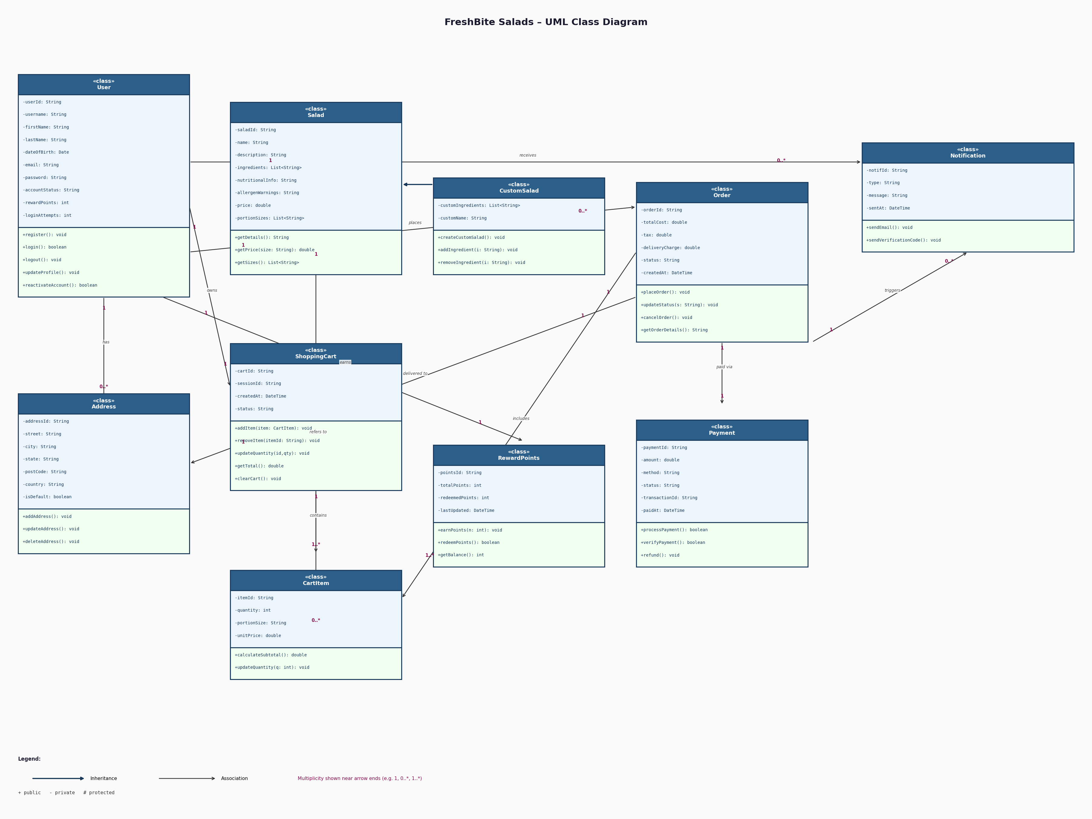
Figure 2: UML Class Diagram – FreshBite Salads Online Ordering System

References
- [1] I. Sommerville, Software Engineering, 10th ed. Pearson, 2016.
- [2] G. Booch, J. Rumbaugh, and I. Jacobson, The Unified Modeling Language User Guide, 2nd ed. Addison-Wesley, 2005.
- [3] E. Yourdon, Modern Structured Analysis. Prentice-Hall, 1989.
- [4] Object Management Group (OMG), 'OMG Unified Modeling Language Specification,' v2.5.1, 2017. [Online]. Available: https://www.omg.org/spec/UML/2.5.1/

