BN314 – System Architecture
Assignment 2
FreshBite Salads Online Ordering System
Information Management System – Case Study Analysis
Trimester T1 2026 | Questions 5 & 6

Question 5 – First-Level Data Flow Diagram (10 Marks)
A First-Level Data Flow Diagram (Level-1 DFD) decomposes the single process shown in the Context Diagram into its major sub-processes. It reveals how data moves between processes, data stores, and external entities using Yourdon & DeMarco notation: circles for processes, open-ended rectangles for data stores, rectangles for external entities, and labelled arrows for data flows.

5.1 External Entities
External Entity | Description
Customer | End user who browses salads, manages their account, adds items to cart, places orders, and receives status updates. Includes both unregistered (browse only) and registered users.
Payment Gateway | Third-party service that processes payments via Credit Card, Debit Card, or PayPal. Returns payment confirmation or rejection.
Email Service | External service that delivers verification emails during registration and order confirmation emails after successful payment.

5.2 Processes
ID | Process | Description | Key Inputs | Key Outputs
1.0 | Browse Menu | Retrieves salad details (name, ingredients, nutrition, allergens, portion sizes, price) from D1 and presents them to the customer. | Browse Request (Customer); Salad Info (D1) | Salad Details → Customer
2.0 | Manage User Account | Handles registration with strong-password enforcement, login/logout, email verification via system-generated code, account status management (Active/Suspended/Banned), and reactivation after suspension. | Reg/Login Details (Customer); User Details (D2); Verification Code Response | Store/Update User (D2); Verification Email; Account Status → Customer
3.0 | Manage Shopping Cart | Manages the session-based cart. Allows customers to add, update quantities, change portion sizes, and remove items. Retrieves pricing from D1 and persists cart items in D3. | Add/Remove/Update (Customer); Price & Portion Info (D1); Cart Data (D3) | Updated Cart → Customer; Store Cart Items (D3); Cart Items → P4
4.0 | Process Checkout | Verifies user authentication via D2, calculates total (items + tax + delivery), collects/saves delivery address (D5), sends payment request to Payment Gateway, and passes confirmed order to P5. | Cart Items (P3); Delivery Address/Payment (Customer); Auth Status (D2); Saved Addresses (D5) | Payment Request → Gateway; Store Address (D5); Confirmed Order → P5
5.0 | Manage Orders | Creates order records in D4 with "Pending" status, updates to "Confirmed" after payment verification, and tracks status through Preparing → Out for Delivery → Delivered. Sends confirmation email and forwards completed order info to P6. | Confirmed Payment & Order Details (P4); Order Status (D4) | Store Order (D4); Status Updates → Customer; Confirmation Email → Email Service; Order Info → P6
6.0 | Manage Reward Points | Awards 1 point per salad upon order completion. Checks eligibility for a free salad at 15 points. Updates the reward points balance in D2. | Completed Order Info (P5); Current Points Balance (D2) | Update Reward Points (D2); Points Balance/Eligibility → Customer

5.3 Data Stores
ID | Data Store | Data Stored
D1 | Salad Database | Salad ID, name, ingredients, description, allergen warnings, nutritional info, price, portion sizes (Regular, Large, Family)
D2 | User Account Database | User ID, username, first/last name, DOB, email, hashed password, account status (Active/Suspended/Banned), failed login attempts, last activity date, reward points
D3 | Shopping Cart | Cart ID, session ID, salad references, quantities, portion sizes, item subtotals
D4 | Order Database | Order ID, user ref, order items, total cost, tax, delivery charge, order status, order date, payment reference, delivery address
D5 | Address Database | Address ID, user ref, street, city, state, postcode, country, address type (Billing/Delivery)

5.4 Level-1 DFD Diagram
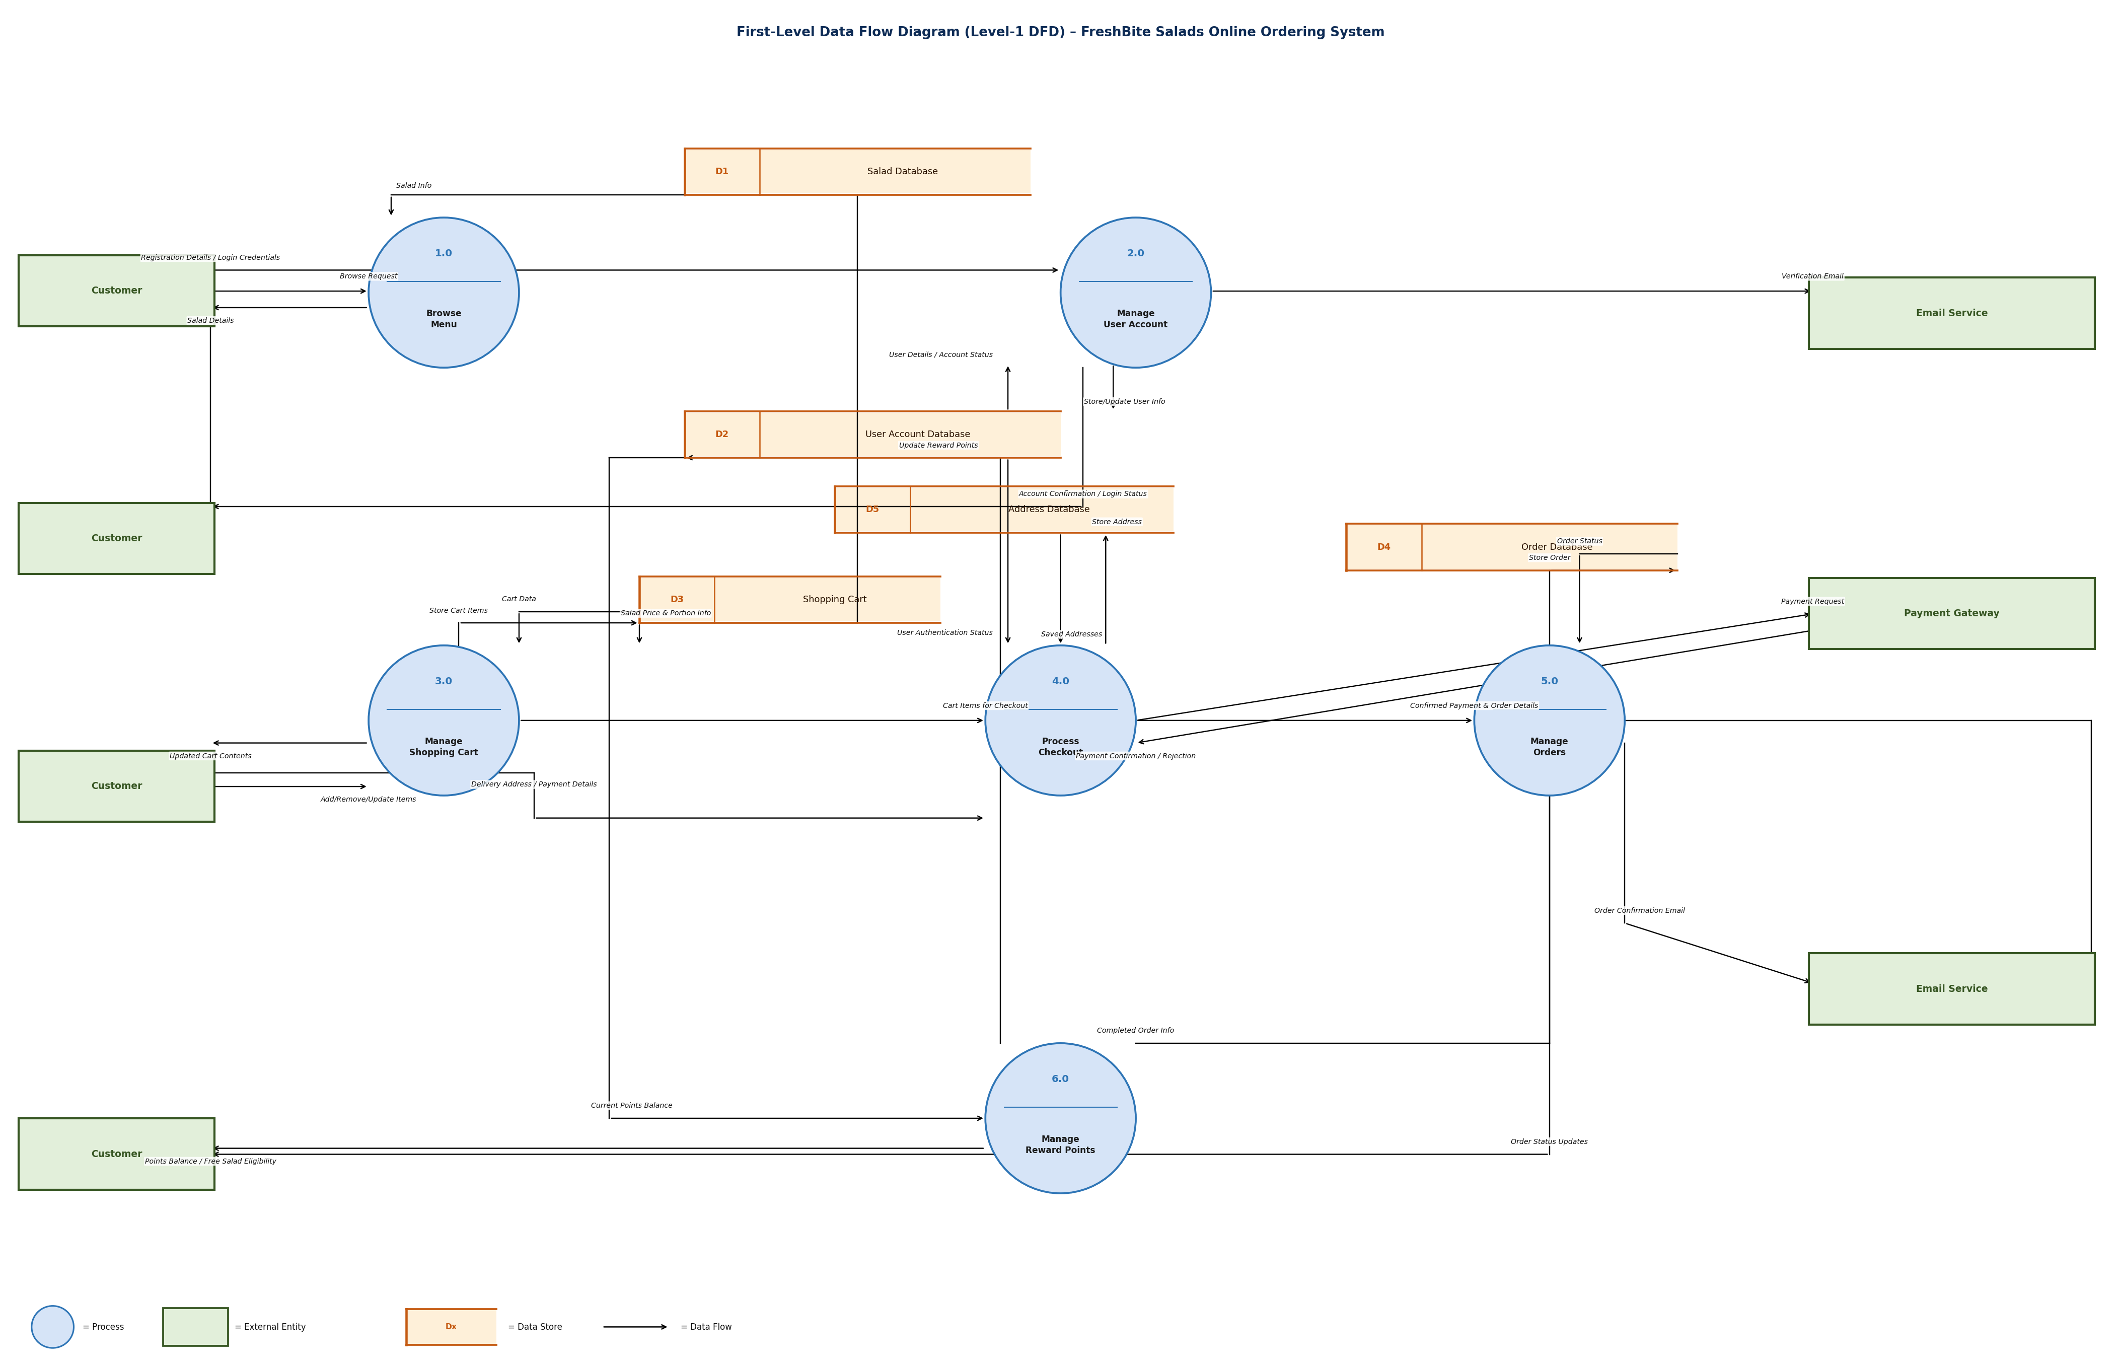
Figure 1: First-Level Data Flow Diagram (Level-1 DFD) – FreshBite Salads Online Ordering System

Question 6 – Class Diagram (15 Marks)
A UML Class Diagram represents the static structure of the system by showing its classes, their attributes and methods, and the relationships between them. For the FreshBite Salads Online Ordering System, ten key classes have been identified. Each class includes attributes with data types and visibility modifiers (- private, + public), methods with return types, associations with labelled relationships, and multiplicity indicators.

6.1 Class Diagram
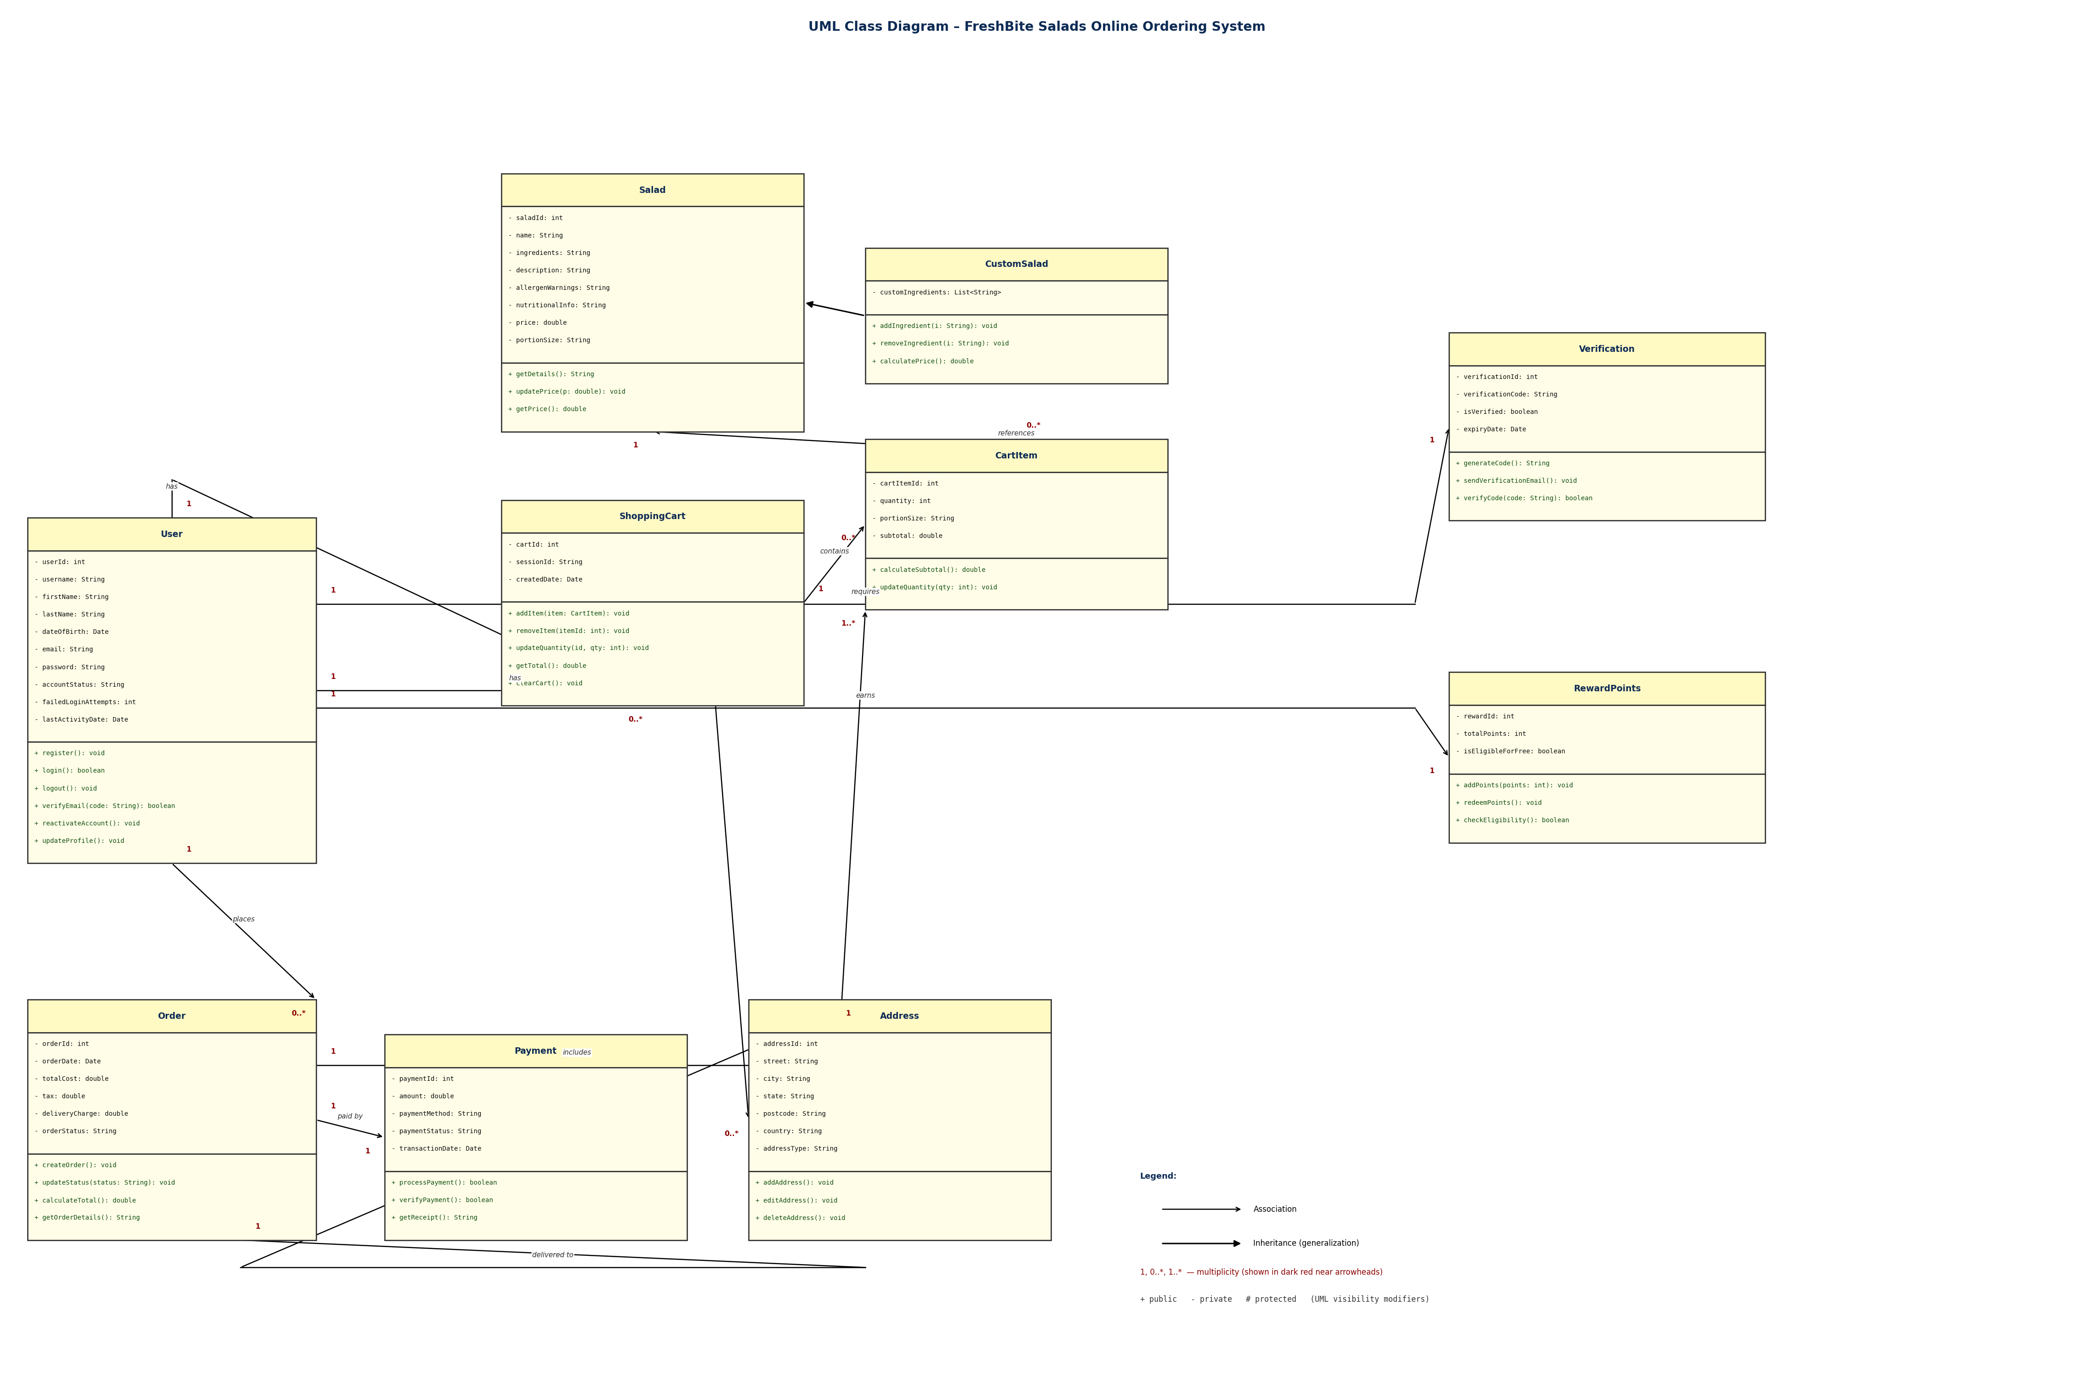
Figure 2: UML Class Diagram – FreshBite Salads Online Ordering System

6.2 Associations & Multiplicities
# | Class A | Mult. | Class B | Mult. | Label | Description
1 | User | 1 | ShoppingCart | 0..* | has | A user can have zero or many carts (one per session); each cart belongs to exactly one user.
2 | User | 1 | Order | 0..* | places | A registered user can place zero or many orders; each order belongs to exactly one user.
3 | User | 1 | Address | 0..* | has | A user can save zero or many billing/delivery addresses; each address belongs to one user.
4 | User | 1 | RewardPoints | 1 | earns | Each registered user has exactly one reward points record tracking accumulated points.
5 | User | 1 | Verification | 1 | requires | Each user has exactly one verification record created during registration.
6 | ShoppingCart | 1 | CartItem | 0..* | contains | A shopping cart contains zero or many cart items; each item belongs to exactly one cart.
7 | CartItem | 0..* | Salad | 1 | references | Each cart item references exactly one salad; a salad can appear in many cart items.
8 | Order | 1 | CartItem | 1..* | includes | An order must include at least one cart item linked from the checkout cart.
9 | Order | 1 | Payment | 1 | paid by | Each order has exactly one payment transaction; each payment is linked to one order.
10 | Order | 1 | Address | 1 | delivered to | Each order is delivered to exactly one delivery address provided at checkout.

6.3 Generalisation (Inheritance)
CustomSalad extends Salad using a generalisation (IS-A) relationship, shown in the class diagram as a hollow-triangle arrow pointing from CustomSalad (child) to Salad (parent). CustomSalad inherits all attributes and methods from Salad — including saladId, name, price, and getDetails() — and adds the customIngredients attribute plus addIngredient(), removeIngredient(), and calculatePrice() methods to support customer-built salads labeled "Custom Salad" in the system.

References
- I. Sommerville, Software Engineering, 10th ed. Pearson, 2016.
- G. Booch, J. Rumbaugh, and I. Jacobson, The Unified Modeling Language User Guide, 2nd ed. Addison-Wesley, 2005.
- E. Yourdon, Modern Structured Analysis. Prentice-Hall, 1989.
- Object Management Group, "OMG Unified Modeling Language Specification v2.5.1," 2017. [Online]. Available: https://www.omg.org/spec/UML/2.5.1/

