BN314 – System Architecture
Assignment 2
FreshBite Salads Online Ordering System
Questions 5 & 6 | Trimester T1 2026

Question 5 – First-Level Data Flow Diagram (10 Marks)
A Level-1 DFD decomposes the system into major processes, data stores, and data flows using Yourdon & DeMarco notation. External entities are rectangles, processes are circles, data stores are open-ended rectangles, and data flows are labelled arrows.

5.1 Processes
ID | Process | Description | Inputs | Outputs
1.0 | Browse Menu | Retrieves salad details (name, ingredients, nutrition, allergens, price, portions) from D1 and displays them to the customer. | Browse Request; Salad Info (D1) | Salad Details → Customer
2.0 | Manage User Account | Handles registration (with strong-password enforcement), login/logout, email verification, account status (Active / Suspended / Banned), and reactivation. | Reg/Login Details; User Details (D2); Verification response | Store/Update User (D2); Verification Email; Account Status → Customer
3.0 | Manage Shopping Cart | Allows add/remove/update of salad items per session. Retrieves price from D1; persists cart to D3. | Add/Remove/Update (Customer); Price Info (D1); Cart Data (D3) | Store Cart Items (D3); Updated Cart → Customer; Cart Items → P4
4.0 | Process Checkout | Verifies authentication (D2), calculates total (items + tax + delivery), collects delivery address, sends payment to gateway, and passes confirmed order to P5. | Cart Items (P3); Address/Payment (Customer); Auth (D2); Saved Addresses (D5) | Payment Request → Gateway; Store Address (D5); Confirmed Order → P5
5.0 | Manage Orders | Creates order records, tracks status (Pending → Confirmed → Preparing → Out for Delivery → Delivered), and sends confirmation email. | Confirmed Order (P4); Order Status (D4) | Store Order (D4); Status Updates → Customer; Confirmation Email → Email Service; Order Info → P6
6.0 | Manage Reward Points | Awards 1 point per salad on order completion; checks 15-point eligibility for a free salad; updates D2. | Completed Order Info (P5); Current Points Balance (D2) | Update Reward Points (D2); Points Balance / Eligibility → Customer

5.2 Data Stores
ID | Data Store | Data Stored
D1 | Salad Database | Salad ID, name, ingredients, description, allergens, nutrition, price, portion sizes
D2 | User Account DB | User ID, username, name, DOB, email, hashed password, account status, failed logins, last activity, reward points
D3 | Shopping Cart | Cart ID, session ID, salad references, quantities, portion sizes, item subtotals
D4 | Order Database | Order ID, user ref, items, total cost, tax, delivery charge, status, date, payment ref, delivery address
D5 | Address Database | Address ID, user ref, street, city, state, postcode, country, address type (Billing/Delivery)

5.3 Level-1 DFD Diagram
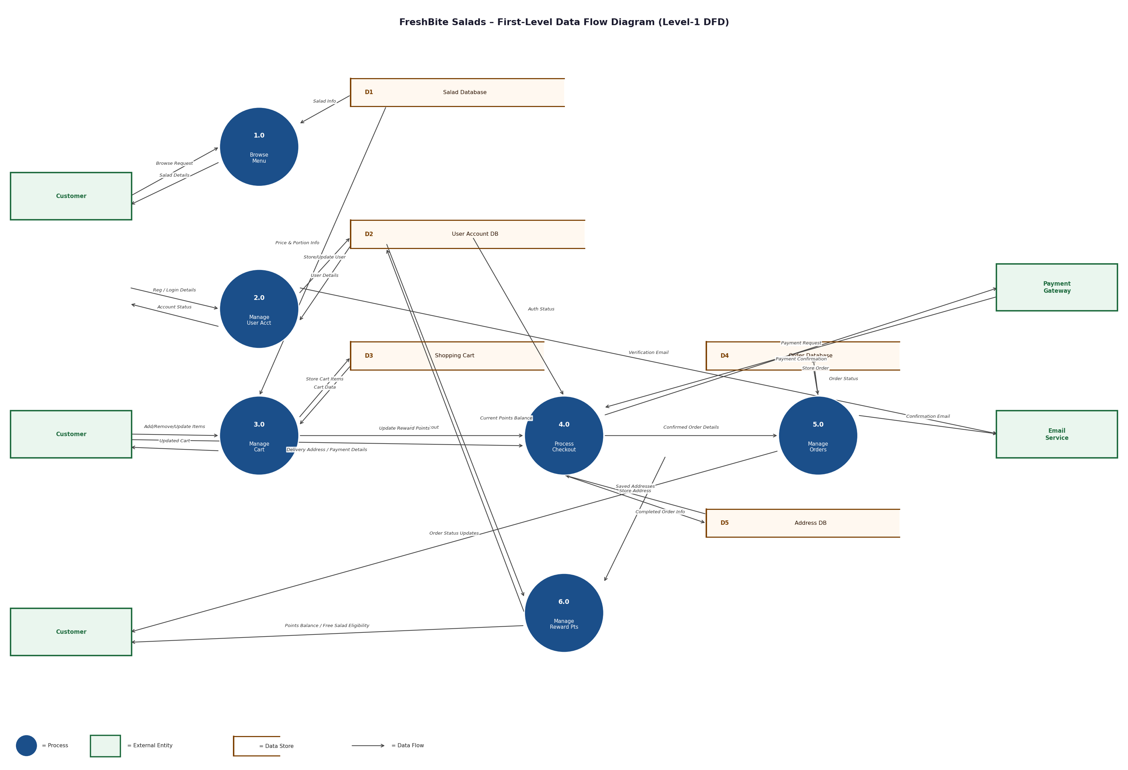
Figure 1: First-Level Data Flow Diagram – FreshBite Salads Online Ordering System

Question 6 – Class Diagram (15 Marks)
The UML class diagram models the static structure of the system. Each class lists attributes (name: type) and methods with visibility modifiers (+ public, - private). Associations are labelled with multiplicity at each end. CustomSalad inherits from Salad via a generalization (IS-A) relationship.

6.1 Class Diagram
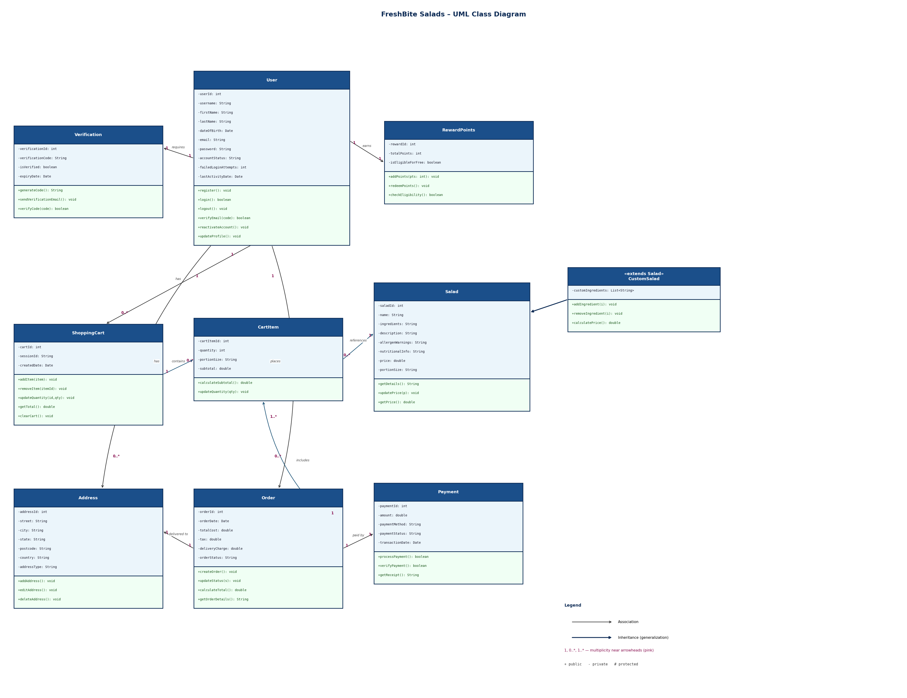
Figure 2: UML Class Diagram – FreshBite Salads Online Ordering System

6.2 Associations & Multiplicities
Class A | Mult. | Class B | Mult. | Label | Description
User | 1 | ShoppingCart | 0..* | has | A user can have zero or many carts (one per session).
User | 1 | Order | 0..* | places | A user can place zero or many orders over time.
User | 1 | Address | 0..* | has | A user can save zero or many billing/delivery addresses.
User | 1 | RewardPoints | 1 | earns | Each user has exactly one reward points record.
User | 1 | Verification | 1 | requires | Each user has exactly one verification record for email activation.
ShoppingCart | 1 | CartItem | 0..* | contains | A cart holds zero or many cart items.
CartItem | 0..* | Salad | 1 | references | Each cart item references exactly one salad.
Order | 1 | CartItem | 1..* | includes | An order includes one or more cart items.
Order | 1 | Payment | 1 | paid by | Each order is settled by exactly one payment record.
Order | 1 | Address | 1 | delivered to | Each order is linked to one delivery address.

6.3 Generalisation (Inheritance)
CustomSalad extends Salad using a generalisation (IS-A) relationship, shown as a hollow-triangle arrow from CustomSalad to Salad. CustomSalad inherits all attributes and methods of Salad (saladId, name, price, getDetails(), etc.) and adds customIngredients plus methods addIngredient(), removeIngredient(), and calculatePrice() to support customer-built salads.

References
- I. Sommerville, Software Engineering, 10th ed. Pearson, 2016.
- G. Booch, J. Rumbaugh, and I. Jacobson, The Unified Modeling Language User Guide, 2nd ed. Addison-Wesley, 2005.
- E. Yourdon, Modern Structured Analysis. Prentice-Hall, 1989.
- Object Management Group, "OMG UML Specification v2.5.1," 2017. [Online]. Available: https://www.omg.org/spec/UML/2.5.1/

