BN314 – System Architecture | Assignment 2
Case Study: FreshBite Salads Online Ordering System

Question 5: First-Level Data Flow Diagram (DFD)
A Level 1 DFD decomposes the central system process of the Context Diagram into its major functional sub-processes, showing how data moves between those processes, external entities, and internal data stores. For FreshBite Salads, seven core processes are identified.

Major Processes
- P1 – Register & Authenticate User: Handles new-user registration, email verification, login, account suspension (after 3 failed attempts), and reactivation. Reads/writes DS1 (User Account Store) and triggers a verification email to the Email Service.
- P2 – Browse & Manage Menu: Retrieves salad details, nutritional information, portion sizes, and prices from DS2 (Salad/Menu Store). Supports Admin inputs for menu updates.
- P3 – Manage Shopping Cart: Allows both guest and authenticated customers to add, update, or remove cart items. Persists the session cart in DS3 (Shopping Cart Store).
- P4 – Checkout & Calculate Total: Loads the cart from DS3, applies taxes and delivery charges, retrieves or saves the delivery address in DS7, and forwards payment details to P5.
- P5 – Process Payment: Communicates with the external Payment Gateway (credit/debit card or PayPal), stores the transaction record in DS5, and triggers reward-point accrual via P7.
- P6 – Manage Orders: Creates the initial 'Pending' order in DS4, updates statuses (Confirmed, Preparing, Out for Delivery, Delivered), and sends a confirmation email to the Email Service.
- P7 – Manage Rewards: Reads and updates reward-point balances in DS6 (1 point per salad purchased; 15 points redeemable for one free salad).

Data Stores
- DS1 – User Account Store: usernames, hashed passwords, statuses, verification codes.
- DS2 – Salad/Menu Store: salad IDs, names, descriptions, ingredients, allergens, prices.
- DS3 – Shopping Cart Store: session-scoped cart items, quantities, and unit prices.
- DS4 – Order Store: order records, statuses, item lines, timestamps.
- DS5 – Payment Store: transaction references, amounts, methods, and payment statuses.
- DS6 – Reward Points Store: per-user point balances and redemption history.
- DS7 – Address Store: saved billing and delivery addresses linked to user accounts.
The Level 1 DFD below illustrates all processes, data stores, external entities, and labelled data flows for the FreshBite Salads system.
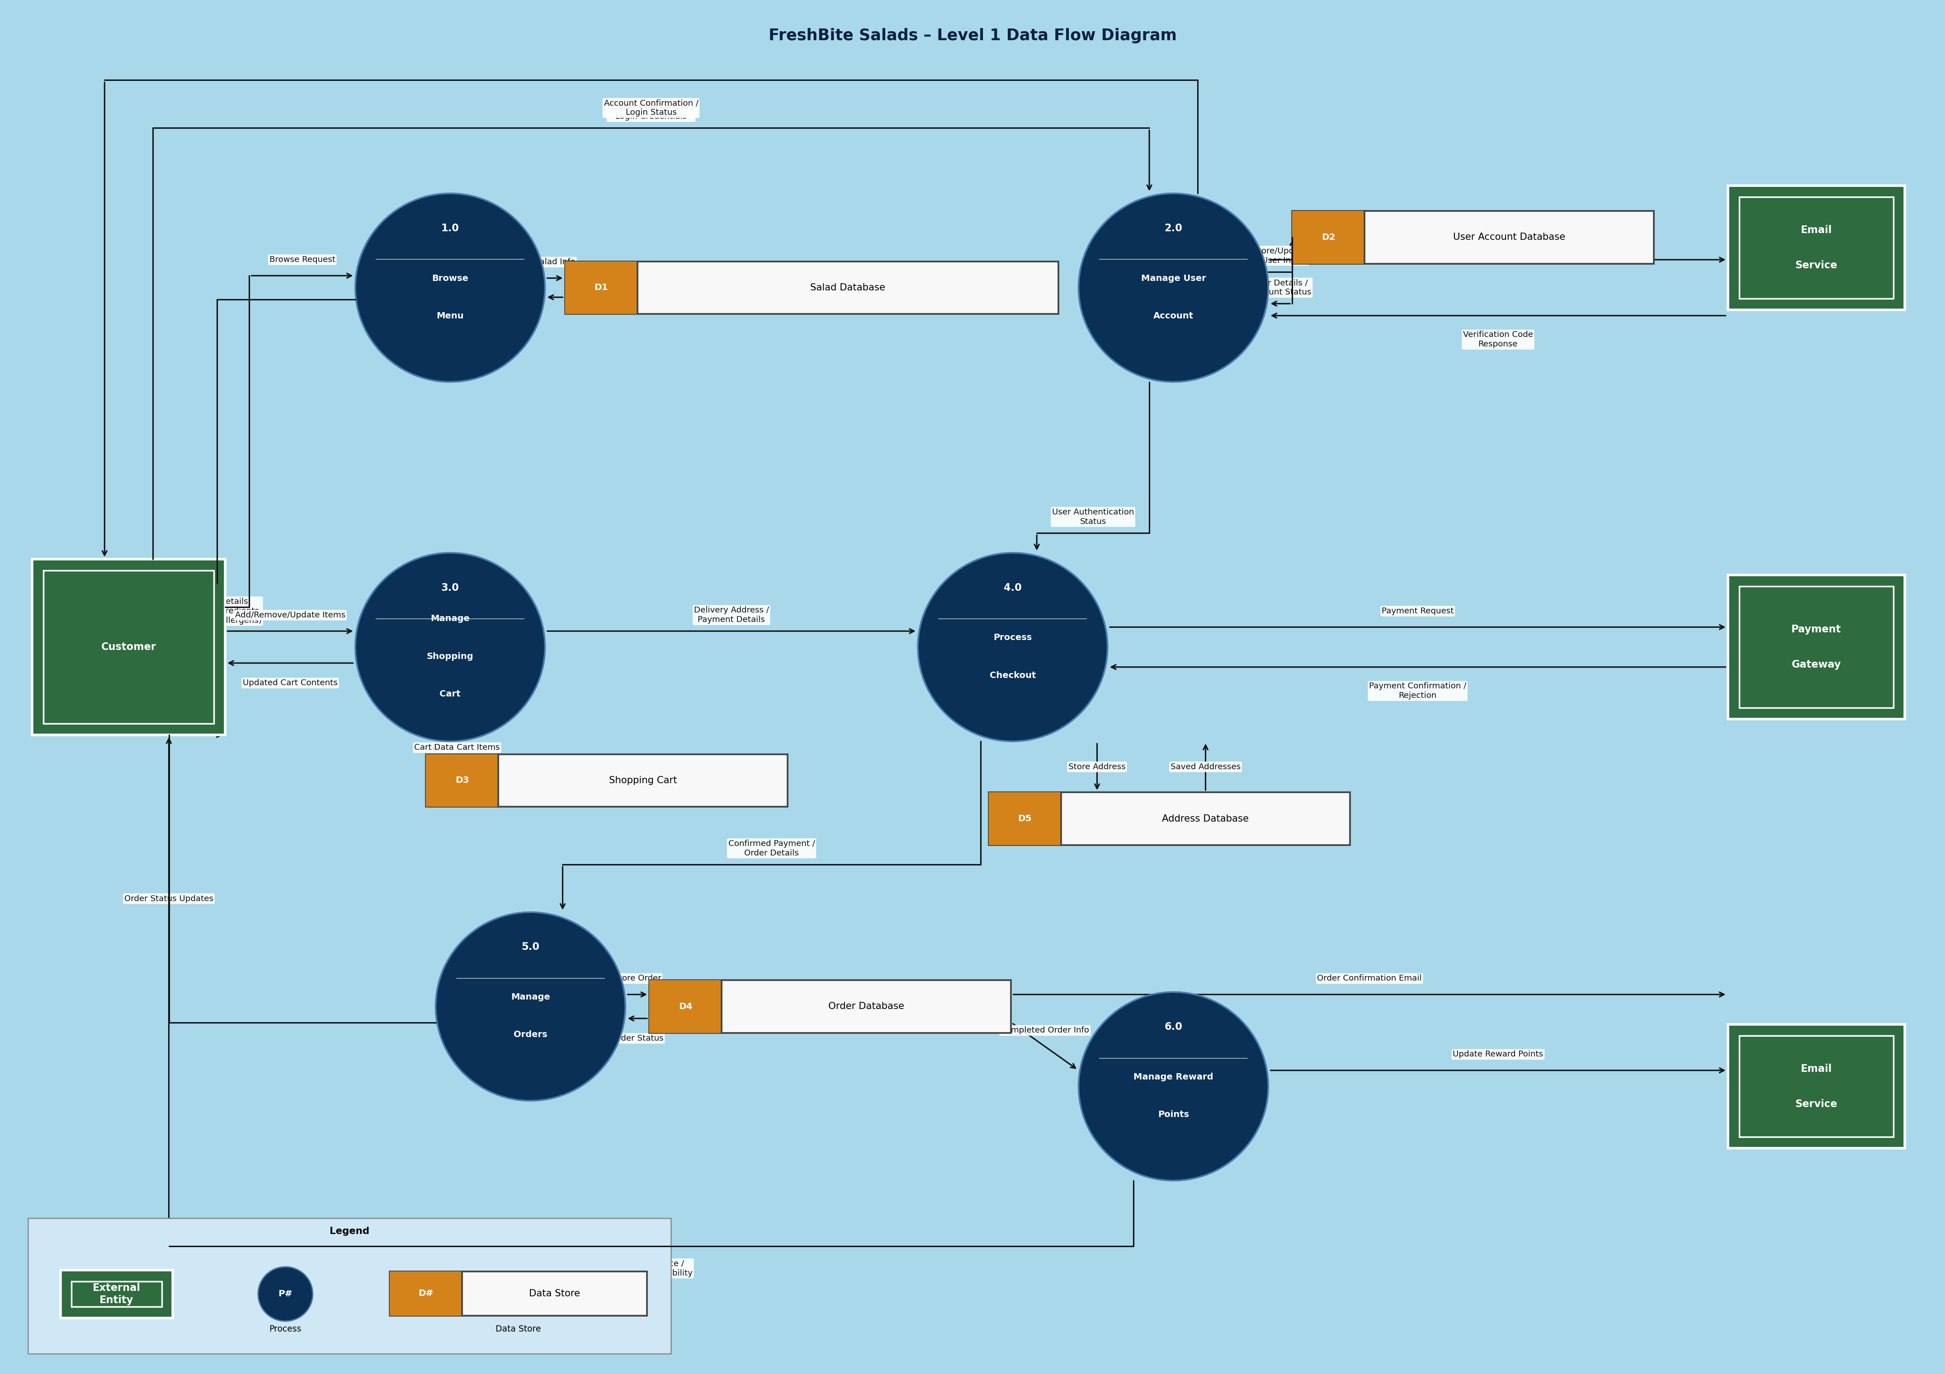
Figure 1: FreshBite Salads – Level 1 Data Flow Diagram

Question 6: Class Diagram
The class diagram below captures the static object-oriented structure of the FreshBite Salads system. Each class is shown with three compartments: name, attributes (with visibility modifiers), and methods. Relationships carry multiplicity labels.

Key Classes, Attributes & Methods
- User «abstract»: Base class for all system users. Holds private fields: userId, username, firstName, lastName, dateOfBirth, email, and protected fields: password (hashed), accountStatus (Active/Suspended/Banned), failedLogins, isVerified. Core methods: register(), login() : boolean, logout(), verifyAccount(), reactivateAccount().
- RegisteredUser (extends User): Adds rewardPoints : int and a collection of saved Address objects. Methods: updateProfile(), manageAddresses(), viewOrderHistory() : List<Order>, redeemPoints(), saveAddress().
- GuestUser (extends User): Holds sessionId and cartId. Limited to browseMenu(), addToCart(), and viewCart(). Cannot complete checkout until registered.
- Salad: Stores saladId, name, description, ingredients, nutritionalInfo, allergenWarnings, portionSizes, and a price map keyed on PortionSize (Regular/Large/Family). isCustom flag distinguishes build-your-own salads. Methods: getPrice(size), updatePrice(), isAvailable().
- ShoppingCart: Session-scoped container (cartId, sessionId, userId). Aggregates CartItem objects. Methods: addItem(), removeItem(), updateQuantity(), calculateTotal(), clearCart().
- CartItem: Line-item inside a cart: saladId, portionSize, quantity, unitPrice. Method getSubtotal() returns quantity × unitPrice.
- Order: Created on checkout. Tracks orderId, userId, orderStatus (Pending → Confirmed → Preparing → OutForDelivery → Delivered), totalAmount, tax, deliveryCharge, deliveryAddress, and timestamps. Methods: createOrder(), updateStatus(), calculateTotal(), cancelOrder().
- OrderItem: Immutable snapshot of a purchased salad line: saladId, portionSize, quantity, unitPrice. Method getSubtotal().
- Payment: Holds paymentId, orderId, amount, paymentMethod (CreditCard/DebitCard/PayPal), paymentStatus (Pending/Verified/Failed), transactionRef, transactionDate. Methods: processPayment(), verifyPayment(), refundPayment(), getReceipt().
- Address: Reusable billing/delivery address: street, suburb, city, state, postalCode, country, addressType. Methods: validate(), toString(), update().
- RewardProgram: Tracks per-user points (totalPoints, pointsPerSalad=1, pointsThreshold=15). Methods: addPoints(), deductPoints(), checkEligibility(), redeemFreeSalad(), getPointsBalance().

Associations & Multiplicity
- User ◁──|> RegisteredUser / GuestUser: Generalisation (inheritance). User is the abstract parent.
- RegisteredUser 1 ──▷ 0..* Order (places): One registered user may place zero or many orders.
- RegisteredUser 1 ──▷ 0..* Address (has): A user can store multiple billing/delivery addresses.
- User / GuestUser 1 ──▷ 1 ShoppingCart (owns): Every session has exactly one cart.
- ShoppingCart 1 ──▷ 0..* CartItem (contains): A cart holds zero or more items (composition).
- CartItem * ──▷ 1 Salad (references): Many cart-items may reference the same salad.
- Order 1 ──▷ 1..* OrderItem (contains): Each order must have at least one line item (composition).
- OrderItem * ──▷ 1 Salad (references): Many order-items may reference the same salad.
- Order 1 ──▷ 1 Payment (paid via): Every order has exactly one associated payment.
- Order 1 ──▷ 1 Address (delivers to): Each order carries one delivery address snapshot.
- RegisteredUser 1 ──▷ 1 RewardProgram (enrolled in): Every registered user has one rewards account.
The complete class diagram with all visibility modifiers, attributes, methods, associations, and multiplicities is shown below.
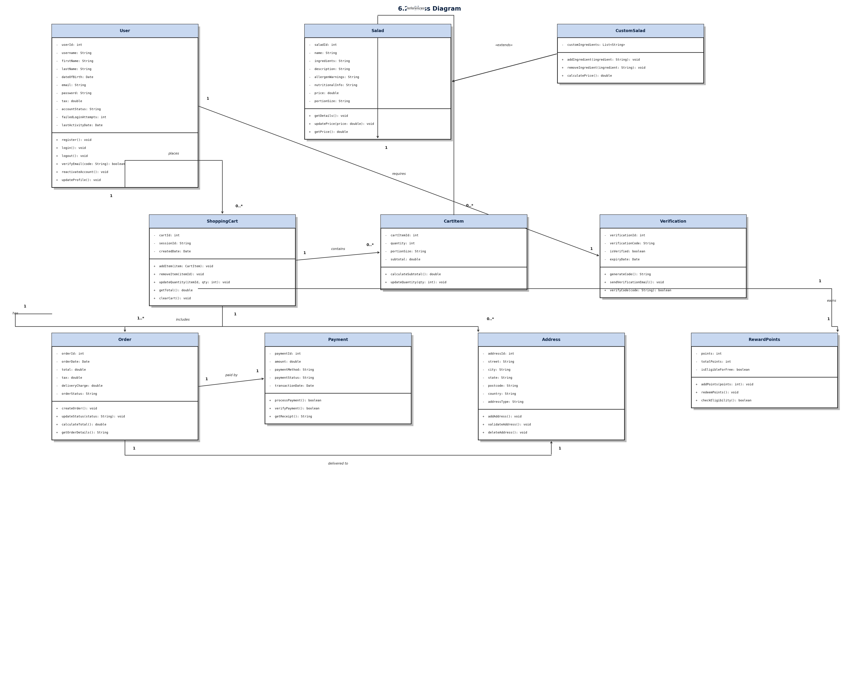
Figure 2: FreshBite Salads – Class Diagram

