BN314 – System Architecture

Lecture 10: Deploying the New System – Laboratory Activity

PART A – Group Activity

Group Activity 1: Generic Post-Implementation Evaluation Form
The following form can be used to evaluate any information system after deployment. It assesses training quality, system usability, technical performance, and overall satisfaction.

POST-IMPLEMENTATION EVALUATION FORM

Information System Evaluation – Confidential

Instructions: Please complete all sections. Your responses are anonymous and will be used to improve future system deployments. Rating scale: 1 = Very Poor, 5 = Excellent.

Section A – Respondent Information
Department / Role: _______________________________________________________
How long have you used this system? ☐ < 1 month ☐ 1–3 months ☐ 3–6 months ☐ 6+ months
How frequently do you use the system? ☐ Daily ☐ Weekly ☐ Monthly ☐ Rarely

Section B – Training Received
B1. Did you receive formal training before using the system? ☐ Yes ☐ No
B2. Training format received: ☐ Classroom ☐ Online/e-learning ☐ Manual/self-study ☐ On-the-job ☐ None
B3. Training was adequate for my role (1–5): 1 ☐ 2 ☐ 3 ☐ 4 ☐ 5 ☐
B4. Training materials were clear and easy to understand (1–5): 1 ☐ 2 ☐ 3 ☐ 4 ☐ 5 ☐
B5. Training duration was sufficient (1–5): 1 ☐ 2 ☐ 3 ☐ 4 ☐ 5 ☐
B6. What was missing from the training?
_________________________________________________________________
_________________________________________________________________

Section C – System Usability and Performance
C1. The system is easy to navigate and use (1–5): 1 ☐ 2 ☐ 3 ☐ 4 ☐ 5 ☐
C2. System response time meets my needs (1–5): 1 ☐ 2 ☐ 3 ☐ 4 ☐ 5 ☐
C3. The system produces accurate and reliable outputs (1–5): 1 ☐ 2 ☐ 3 ☐ 4 ☐ 5 ☐
C4. System availability / uptime has been acceptable (1–5): 1 ☐ 2 ☐ 3 ☐ 4 ☐ 5 ☐
C5. The system meets my day-to-day job requirements (1–5): 1 ☐ 2 ☐ 3 ☐ 4 ☐ 5 ☐

Section D – Problems and Issues
D1. Have you experienced any system errors or crashes? ☐ Yes ☐ No Comments: ________________________________
D2. Have you experienced data loss or incorrect results? ☐ Yes ☐ No Comments: ________________________________
D3. Were problems resolved promptly by the support team? ☐ Yes ☐ No Comments: ________________________________
D4. Describe the most significant problem you encountered:
_________________________________________________________________
_________________________________________________________________

Section E – Overall Assessment
E1. Overall satisfaction with the system (1–5): 1 ☐ 2 ☐ 3 ☐ 4 ☐ 5 ☐
E2. The system has improved my productivity (1–5): 1 ☐ 2 ☐ 3 ☐ 4 ☐ 5 ☐
E3. I would recommend this system to a colleague: ☐ Yes ☐ No
E4. Most important improvement needed:
_________________________________________________________________
_________________________________________________________________
E5. Any additional comments:
_________________________________________________________________
_________________________________________________________________

Thank you for completing this evaluation. Responses will be reviewed by the project team.

Group Activity 2: One-Page Post-Implementation Questionnaire (10+ Questions)
The following questionnaire is designed for distribution to users following a recent information system implementation. It focuses on system effectiveness, training quality, support, and overall impact.

POST-IMPLEMENTATION USER SATISFACTION QUESTIONNAIRE

System Name: ________________ Date: ________________
Please rate each statement using the scale: 1 = Strongly Disagree · 2 = Disagree · 3 = Neutral · 4 = Agree · 5 = Strongly Agree

Q1. The new system is easy to learn and use. 1 ☐ 2 ☐ 3 ☐ 4 ☐ 5 ☐
Q2. The system performs its functions accurately and reliably. 1 ☐ 2 ☐ 3 ☐ 4 ☐ 5 ☐
Q3. The system's response time and speed are acceptable. 1 ☐ 2 ☐ 3 ☐ 4 ☐ 5 ☐
Q4. The training I received was sufficient to use the system effectively. 1 ☐ 2 ☐ 3 ☐ 4 ☐ 5 ☐
Q5. The training materials (manuals, guides, videos) were clear and helpful. 1 ☐ 2 ☐ 3 ☐ 4 ☐ 5 ☐
Q6. The new system has improved my productivity compared to the previous system. 1 ☐ 2 ☐ 3 ☐ 4 ☐ 5 ☐
Q7. The system meets the needs of my daily work tasks. 1 ☐ 2 ☐ 3 ☐ 4 ☐ 5 ☐
Q8. The help desk / technical support team responds promptly to issues. 1 ☐ 2 ☐ 3 ☐ 4 ☐ 5 ☐
Q9. I feel confident and comfortable using all features I need. 1 ☐ 2 ☐ 3 ☐ 4 ☐ 5 ☐
Q10. Overall, I am satisfied with the new system. 1 ☐ 2 ☐ 3 ☐ 4 ☐ 5 ☐
Q11. What is the single biggest improvement you would suggest?
_________________________________________________________________
_________________________________________________________________
Q12. Did you experience any critical problems during the first 30 days? If yes, describe briefly.
_________________________________________________________________
_________________________________________________________________

Group Activity 3: Designing Training – Knowing the Recipient
When designing a tutorial to train a person in the use of specific software or hardware (e.g., a web browser), the following information about the recipient is essential:

Information Needed | How It Is Obtained | How It Affects Training Design
Technical proficiency | Beginner, intermediate, or advanced computer user. | Beginners need step-by-step screenshots and plain language; advanced users need only a quick-reference guide and shortcut keys.
Prior experience with similar tools | Has the trainee used a similar browser or application before? | If yes, training can focus on differences and new features. If no, foundational concepts must be covered.
Job role and use context | What tasks will the trainee perform? (e.g., browsing, form submission, web development) | A student needs different training content to an IT support officer using the same browser.
Learning style preference | Visual (video), reading (manual), or hands-on (sandbox exercises)? | Some learners absorb video tutorials; others prefer written step-by-step guides or interactive labs.
Availability and time constraints | How much time can the trainee dedicate? Is training self-paced or scheduled? | Short attention spans or limited time require condensed, modular micro-learning units.
Language and literacy level | Is English (or the training language) the trainee's first language? | Non-native speakers need simpler language, visual aids, and possibly translated materials.
Accessibility needs | Does the trainee have visual, motor, or cognitive accessibility requirements? | Screen reader-compatible materials, larger fonts, or keyboard-only navigation may be needed.

Group Activity 4: Internet Research – Training Example for Software/Hardware
Product: Microsoft Azure – Cloud Platform
Training Provider: Microsoft Learn (https://learn.microsoft.com)
Types of training offered: Free self-paced learning paths and modules; instructor-led courses via Microsoft and certified partners; sandbox labs with real Azure environments; certification preparation (e.g., AZ-900 Azure Fundamentals, AZ-104 Administrator Associate).
Cost: Microsoft Learn self-paced modules are entirely FREE. Instructor-led courses via partners range from AUD $500 to $3,500+ depending on course length and certification level. Certification exam vouchers cost AUD $165–$330.

Summary of findings:
- What we liked: The free tier is comprehensive and includes hands-on lab exercises in real Azure sandboxes — learners get genuine cloud experience without paying. Content is modular and role-based (Developer, Administrator, Architect), making it easy to find relevant material. Interactive quizzes reinforce learning at each step.
- What we did not like: The breadth of content is overwhelming for new learners — navigating hundreds of learning paths without guidance is difficult. Instructor-led training is expensive and primarily aimed at corporate buyers. Some content updates lag behind rapidly changing Azure features.
- Group discussion conclusion: The Microsoft Learn model is an excellent example of blended learning — free foundational self-paced content combined with paid certification pathways. The sandbox approach is particularly effective for technical audiences who learn best by doing.

PART B – Individual Written Questions

Written Question 1: Integration Testing vs System Testing
The diagram below shows where integration testing and system testing fit in the overall testing lifecycle:
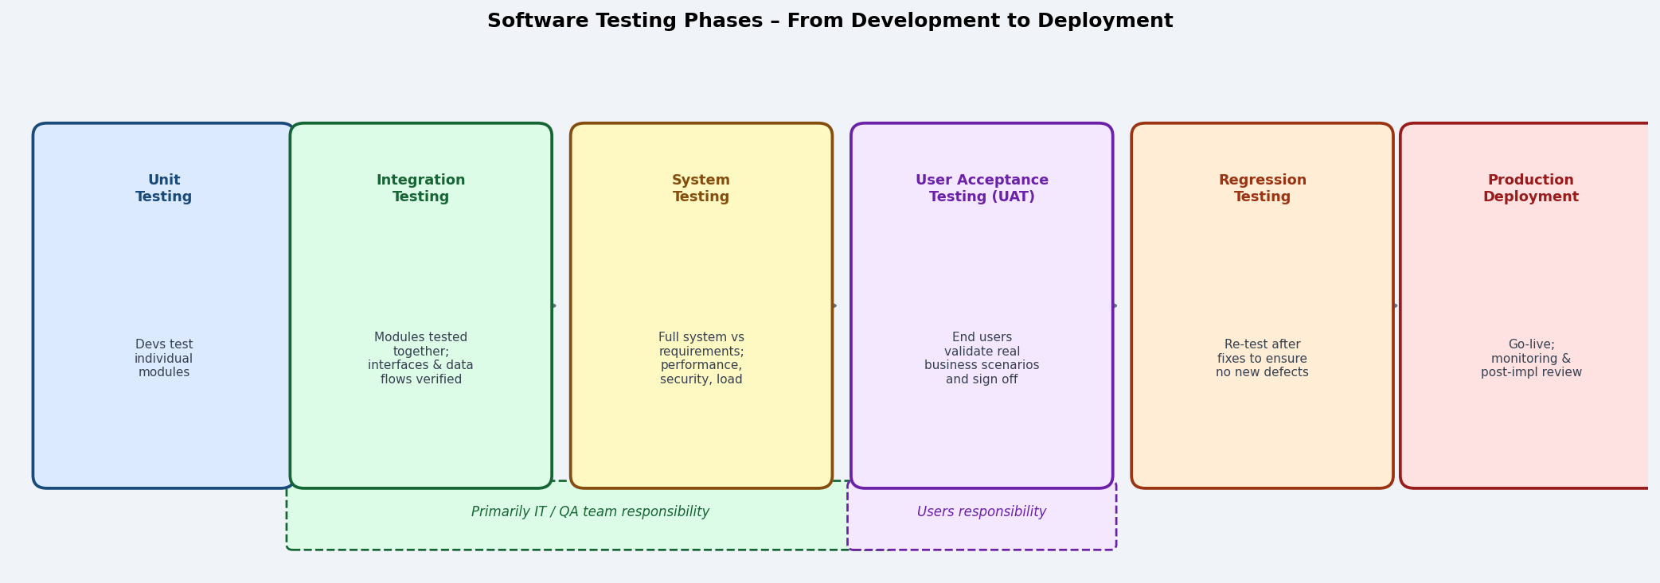

Aspect | Integration Testing | System Testing
Scope | Tests how two or more modules or components work together when combined. Focuses on interfaces, data flows, and interactions between components. | Tests the complete, fully integrated system against the original requirements specification.
Who performs it | Development team / QA engineers. | QA team, with oversight from the project manager.
What is checked | Correct data passing between modules, API contracts, database reads/writes across components, error handling at boundaries. | Functional correctness, performance, load capacity, security, usability, reliability, and compliance with requirements.
Timing | After unit testing; as modules are progressively combined. | After all integration testing is complete; before UAT.
Test basis | Interface specifications, API contracts, data flow diagrams. | System requirements specification, use cases, non-functional requirements.

Types of tests included in system testing:
- Functional testing – verifies each function against requirements.
- Performance/load testing – measures response time and throughput under expected and peak loads.
- Stress testing – pushes the system beyond normal limits to find breaking points.
- Security testing – attempts penetration, injection attacks, and authorisation bypass.
- Usability testing – evaluates ease of use, navigation, and UI clarity.
- Recovery testing – verifies system behaviour after crashes, power failures, or data corruption.
- Compatibility testing – ensures the system works across required browsers, OS versions, and devices.

Written Question 2: User Acceptance Testing (UAT) – Responsibility and Objectives
Who is responsible: UAT is the responsibility of the end users and business stakeholders — the people who will actually use the system in their daily work. This includes:
- Subject matter experts and business analysts who define and verify the real-world scenarios.
- End users from the relevant departments (e.g., student services staff, finance officers).
- Business owners and management who must formally sign off before go-live.
- Note: IT staff may support UAT by setting up test environments, but they should NOT perform the testing — independence is critical.

Primary objectives of UAT:
- Validate business requirements: confirm that the system correctly implements every agreed business requirement and use case in real-world conditions.
- Identify defects missed by earlier testing: surface issues that only become apparent when real users perform real tasks in a realistic environment.
- Build user confidence: give users hands-on experience before go-live, reducing anxiety, resistance to change, and post-deployment support calls.
- Obtain formal sign-off: produce documented evidence (test results, sign-off forms) that authorised business representatives approve the system for deployment.
- Final risk gate: act as the last quality checkpoint before production deployment, preventing premature go-live.

Written Question 3: Identifying Test Cases for UAT
The best approach to identifying UAT test cases is to derive them directly from use cases and business process scenarios:
- Use case descriptions: each use case (main flow + alternative flows + exception flows) maps directly to one or more test cases. The main flow becomes the happy-path test; alternative/exception flows become negative and boundary tests.
- Business scenarios: ask users to describe a typical day's work step by step. Each real workflow becomes an end-to-end test scenario that covers multiple use cases in sequence.
- Business rules: decision tables, decision trees, and documented rules from the requirements phase define conditions and expected outcomes — each rule combination is a test case.
- Previous defect logs: review defects from earlier system or integration testing; users should test scenarios around known weak areas to verify fixes.
- Data-driven testing: use realistic, production-like data sets (anonymised) including boundary values, edge cases, and known problem data formats.
- Risk-based prioritisation: focus the most test effort on high-business-impact, high-frequency functions (e.g., student enrolment, payment processing) before low-risk functions.

Written Question 4: When Is an Error Tracking Log Most Helpful?
An error tracking log (defect log / bug tracker) is helpful during any testing phase, but is most critical during the following:
Testing Phase | Role of Error Tracking Log
Integration Testing | Highly beneficial. Multiple modules interact for the first time — errors at interfaces (wrong data format, missing fields, incorrect API responses) must be logged with the exact module combination, input data, and error message to enable developers to reproduce and fix them.
System Testing | Essential. System testing produces a high volume of functional, performance, and security defects across many test areas. A structured log with severity, priority, test case ID, steps to reproduce, and assigned developer is critical for managing the defect backlog.
User Acceptance Testing (UAT) | Critical. Users may not describe technical issues precisely. A log helps them document the exact steps that caused a problem, the expected vs actual result, and the business impact. Provides formal evidence of outstanding issues before sign-off.
Regression Testing | Very useful. The log shows which defects were fixed; regression tests verify that the fixes did not introduce new errors. Tracking ensures no previously closed defect re-opens unnoticed.
Performance/Stress Testing | Useful for recording response time anomalies, memory leaks, and failure thresholds identified during load testing.

Written Question 5: Data Sources and Methods for Initialising a New System Database
Sources of data:
- Legacy / existing system: data exported from the old system via ETL (Extract, Transform, Load) tools or database migration scripts.
- Manual data entry: data that exists only on paper or in spreadsheets and must be keyed in by data entry staff or end users before go-live.
- External/third-party systems: data feeds from government databases (e.g., student identifiers from PRISMS), partner organisations, or purchased reference data sets.
- Archival records: scanned and OCR-processed historical records converted to digital format.
- Default / reference data: lookup tables (country codes, course codes, role types) pre-populated by the development team from standards or business rules.

Tools and methods for loading initial data:
Tool / Method | Description
ETL Tool  (e.g., Talend, SSIS) | Extracts data from the source, transforms it (cleans, reformats, deduplicates), and loads it into the new database. Best for large-volume migrations from legacy databases.
CSV / Spreadsheet Import | Data is prepared in CSV or Excel format and imported using database bulk-load utilities (e.g., COPY in PostgreSQL, LOAD DATA in MySQL, SQL*Loader in Oracle).
SQL Scripts | Developers write INSERT statements or stored procedures to populate reference/lookup tables and system configuration data before go-live.
Database Migration Tools  (e.g., Flyway, Liquibase) | Version-controlled migration scripts that initialise schema and seed data in a repeatable, auditable manner across environments.
API / Data Feed | New system calls a source system API to pull and import data directly into the new database in real time or in scheduled batches.
Manual Data Entry Forms | For small volumes or paper-based records, staff use the new system's own entry forms to enter data directly, often with data quality checks built in.

Written Question 6: User Documentation and Training – End Users vs System Operators
Aspect | End Users | System Operators
Audience | Employees, managers, and customers who use the system to perform their business tasks (e.g., enrol students, process invoices, generate reports). | IT staff, database administrators, and technical staff responsible for running, monitoring, and maintaining the system infrastructure.
Documentation type | User manuals, quick-start guides, online help, FAQs, tutorial videos focused on business tasks (e.g., "How to register a student"). | System administration guides, installation manuals, API documentation, backup/recovery procedures, troubleshooting reference guides.
Training content | Covers navigation, task workflows, data entry, report generation, and role-specific functions. Avoids technical jargon. | Covers system installation, configuration, performance tuning, backup/restore, security patching, log monitoring, and disaster recovery.
Training format | Classroom, e-learning, video tutorials, role-playing exercises with realistic scenarios. | Technical workshops, vendor certification courses, hands-on lab sessions, and reference documentation review.
Language / depth | Non-technical plain language; step-by-step screenshots; task-oriented. | Technical terminology; command-line instructions; architecture diagrams; error code references.
Timing | Training typically completed just before go-live to minimise forgetting. | Training completed earlier — operators must be ready to support go-live before end users are trained.

Written Question 7: Source Code Control System
Definition: A source code control system (also called a version control system or VCS) is a tool that tracks and manages all changes to source code over time. It maintains a complete history of every modification, records who made each change and when, and enables teams to work on the same codebase simultaneously without overwriting each other's work. Examples: Git (most widely used), Subversion (SVN), Mercurial.

Key features:
- Version history: every change is saved as a commit with a description, author, and timestamp — the full history is always available.
- Branching and merging: developers work on separate branches (e.g., feature/login-fix) without affecting the main codebase, then merge changes back when complete.
- Conflict resolution: when two developers change the same file, the VCS detects conflicts and helps merge the changes safely.
- Rollback: any version of the code can be restored — essential for undoing a breaking change.
- Audit trail: provides complete accountability for every change made to the system.

Why it is necessary when multiple programmers build a system:
Reason | Explanation
Prevents overwriting | Without VCS, Developer A's work can be erased when Developer B saves their version of the same file. VCS merges changes instead.
Enables parallel development | Each developer works on a separate branch; features are developed in isolation and merged only when stable and reviewed.
Supports code review | Pull requests / merge requests allow team members to review each other's changes before they enter the main codebase.
Enables CI/CD | Modern DevOps pipelines (GitHub Actions, Jenkins) trigger automated builds, tests, and deployments on every commit.
Provides traceability | Bug reports can be traced to the exact commit that introduced a defect; defect fixes can be tagged to issue tracker tickets.
Risk management | If a release introduces a critical bug, the team can immediately roll back to the last known-good version in minutes.

Reference: System Deployment Methods
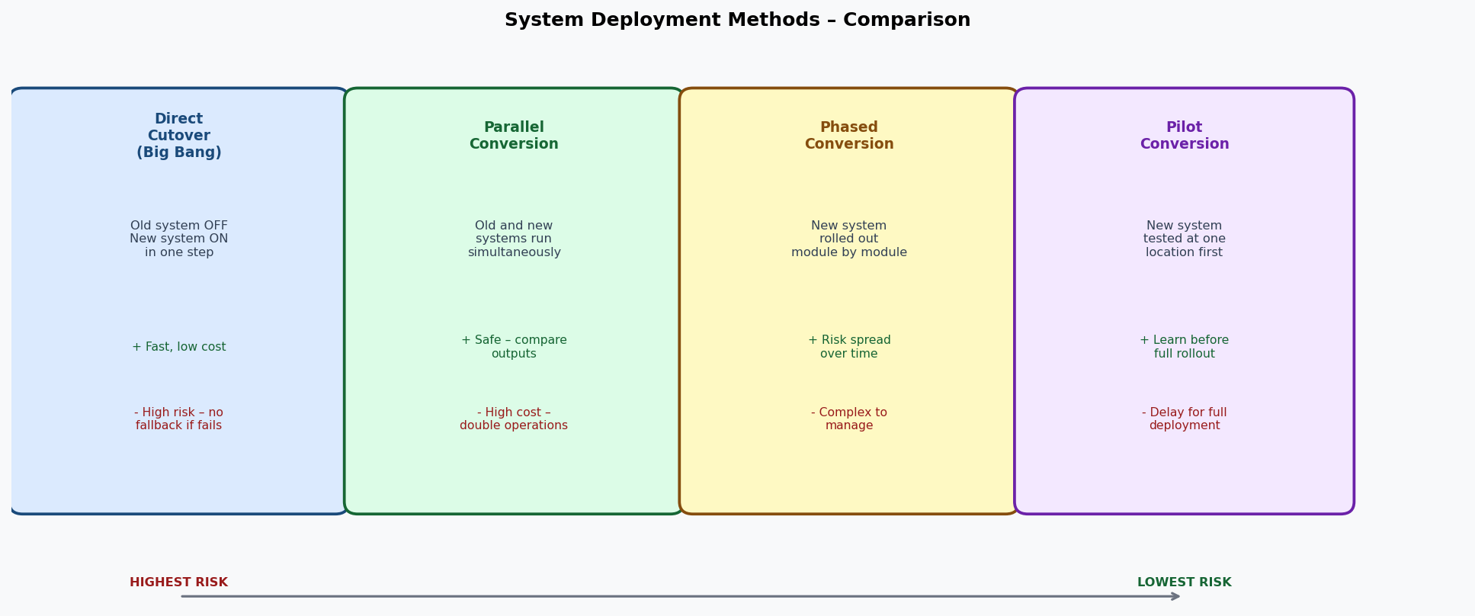
Four deployment strategies: Direct Cutover (highest risk/lowest cost) through Pilot Conversion (lowest risk/highest preparation), relevant to selecting the appropriate go-live approach for the deployment plan.

