BN314 – System Architecture

Lecture 3: Requirement Modelling II – Laboratory Activity

Question 1: Student Registration Process Questionnaire
The following questionnaire is designed to gather student feedback on the school registration process. Guidelines applied: questions are concise, unbiased, cover both open and closed formats, and progress from general to specific.

Melbourne Institute of Technology – Student Registration Feedback Survey
Instructions: Please answer all questions honestly. Your responses are anonymous and will be used to improve our registration system.

Section A – General Information
Q1. What is your current level of study?
☐ Undergraduate ☐ Postgraduate ☐ Diploma ☐ Certificate
Q2. How many times have you completed the registration process at this institution?
☐ Once ☐ Twice ☐ Three or more times

Section B – Registration Experience
Q3. On a scale of 1–5, how easy was the online registration process to navigate?
1 (Very Difficult) – 2 – 3 – 4 – 5 (Very Easy)
Q4. Were you able to find and enrol in your required subjects without difficulty?
☐ Yes ☐ No ☐ Partially
Q5. How long did the entire registration process take you?
☐ Less than 30 minutes ☐ 30–60 minutes ☐ Over 1 hour
Q6. Did you encounter any technical issues during registration (e.g., system errors, login problems)?
☐ Yes (please describe below) ☐ No
_______________________________________________
Q7. Were the registration instructions and guidelines clear and easy to follow?
☐ Strongly Agree ☐ Agree ☐ Neutral ☐ Disagree ☐ Strongly Disagree

Section C – Support & Assistance
Q8. Did you require assistance from student services during registration?
☐ Yes ☐ No
Q9. If yes, how responsive and helpful was the support you received?
☐ Very Helpful ☐ Somewhat Helpful ☐ Not Helpful

Section D – Open Feedback
Q10. What did you like most about the registration process?
_______________________________________________
Q11. What improvements would you suggest to make the process better?
_______________________________________________
Q12. Any additional comments?
_______________________________________________

Question 2: Simple Fill-in Registration Form (≥ 5 Fields)
The following is a simple fill-in form that could be used as a printed or digital student registration data-capture form (designed using Microsoft Word table style):

Melbourne Institute of Technology – Student Registration Form

Full Name | ________________________________________________
Student ID | ________________________________________________
Date of Birth | ____ / ____ / ________
Email Address | ________________________________________________
Phone Number | ________________________________________________
Program / Course | ________________________________________________
Year of Study | ☐ Year 1 ☐ Year 2 ☐ Year 3 ☐ Year 4
Study Mode | ☐ Full-time ☐ Part-time ☐ Online
Emergency Contact Name | ________________________________________________
Signature & Date | Signature: ____________________ Date: __ / __ / ____

Question 3: Functional Decomposition Diagram – School Management
The diagram below shows a Functional Decomposition Diagram (FDD) for a school, replacing the library example from Figure 4-8. The top-level function is "School Management", which decomposes into five major functional areas, each further broken down into sub-functions and processes.

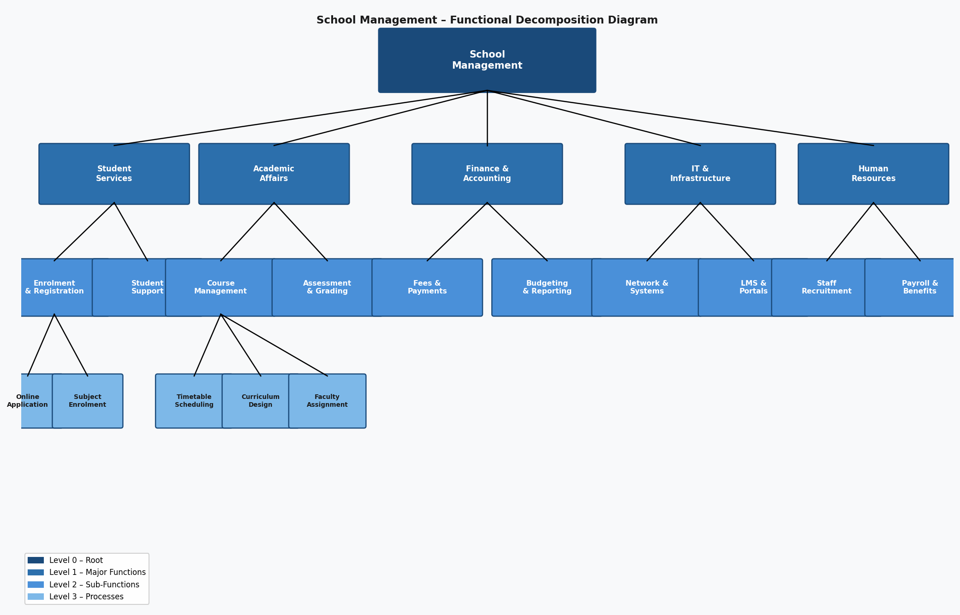

The five top-level functions are: Student Services, Academic Affairs, Finance & Accounting, IT & Infrastructure, and Human Resources. Each decomposes further — for example, Student Services → Enrolment & Registration → Online Application / Subject Enrolment; Academic Affairs → Course Management → Timetable Scheduling / Curriculum Design / Faculty Assignment.

Question 4: IT Industry News Website Review
Site visited: TechCrunch (https://techcrunch.com)

What I liked:
- TechCrunch publishes timely, well-sourced articles on emerging technologies, startup ecosystems, AI/ML developments, and enterprise software — highly relevant to IT industry professionals and students.
- The site is well-organised with clear category navigation (AI, Security, Cloud, Apps, etc.), making it easy to find topics of interest quickly.
- Articles include expert opinions, industry data, and links to original research, providing depth beyond surface-level news.
- The newsletter and podcast options allow users to consume content in multiple formats.

What I didn't like:
- The site is advertisement-heavy; pop-up ads and auto-play videos disrupt the reading experience, especially on mobile devices.
- Some content has a US-centric focus, with limited coverage of Asia-Pacific IT industry developments — less relevant for Australian-based students and professionals.
- Access to some premium analysis articles requires a paid subscription.

Question 5: How FDDs Are Used in Requirements Modelling
A Functional Decomposition Diagram (FDD) is a top-down hierarchical model that breaks a complex system or organisation into progressively smaller, more manageable functions. In requirements modelling, FDDs serve several important roles:

- Scope Definition: An FDD establishes and communicates the boundaries of a system. By identifying all major functions at the top level, analysts can confirm with stakeholders exactly what is (and is not) within the project scope.
- Requirements Organisation: FDDs provide a logical structure for organising requirements. Each node in the diagram corresponds to a function that will require detailed requirements. This prevents requirements from being overlooked.
- Communication Tool: FDDs are easy for non-technical stakeholders (managers, users) to understand. They bridge the gap between business needs and technical specifications without requiring IT expertise to interpret.
- Foundation for Other Models: FDDs are typically created before Data Flow Diagrams (DFDs) and process specifications. The lowest-level functions in an FDD become the processes in a DFD, ensuring consistency across models.
- Gap Analysis: By reviewing an FDD with subject-matter experts, analysts can identify missing functions, redundant processes, and opportunities for consolidation or automation.
- Modular Design: FDDs support a divide-and-conquer approach, allowing large projects to be broken into independent modules that can be designed, developed, and tested separately.

Question 6: Business Process Modelling (BPM)
Business Process Modelling (BPM) is a technique used to represent, analyse, and improve the workflows and processes within an organisation. It creates visual or formal representations of how work flows through a business — including who performs each step, what data or objects are involved, and how decisions are made.

Common BPM notations and tools include:
- Business Process Model and Notation (BPMN) – the international standard for graphical process modelling, using symbols for tasks, events, gateways, and flows.
- Swimlane Diagrams – show processes across different roles or departments using horizontal or vertical lanes, making accountability visible.
- UML Activity Diagrams – used to model workflows in object-oriented systems.

How BPM can be used:
- Requirements Elicitation: BPM models help analysts understand current ("as-is") processes before designing improved ("to-be") processes, ensuring new systems align with real business operations.
- Process Improvement: By visualising workflows, organisations can identify bottlenecks, redundancies, delays, and inefficiencies that can be eliminated or automated.
- System Design: BPM models translate business workflows into system requirements, showing which processes need software support, what data must be captured, and how users interact with the system.
- Communication: BPM diagrams serve as a shared language between business stakeholders and IT teams, reducing misunderstandings during development.
- Compliance and Auditing: Documented business processes help organisations demonstrate regulatory compliance and provide audit trails.
- Change Management: When implementing new systems, BPM models show employees exactly how their workflows will change, making training and adoption easier.

Question 7: How Data Flow Diagrams (DFDs) Are Used in Requirements Modelling
A Data Flow Diagram (DFD) is a graphical representation that shows how data moves through an information system — from external entities (sources/sinks), through processes, to data stores, and back. DFDs use four components:

- External Entities (squares/rectangles) – people or systems that send or receive data (e.g., Student, Lecturer, Admissions Office).
- Processes (circles/rounded rectangles) – functions that transform input data into output data (e.g., "Validate Enrolment", "Generate Timetable").
- Data Stores (open-ended rectangles) – repositories where data is held (e.g., Student Database, Course Register).
- Data Flows (arrows) – the movement of data between entities, processes, and data stores, labelled with the data being transferred.

How DFDs are used in requirements modelling:
- Context Diagrams (Level 0 DFD): A single-process diagram showing the entire system and its interactions with external entities. This defines the system boundary and is invaluable for agreeing scope with stakeholders early in the project.
- Detailed Process Modelling (Level 1, 2 DFDs): Each process from the context diagram is exploded into more detailed sub-processes, making data requirements explicit. Analysts can specify exactly what data each process needs as input and produces as output.
- Identifying Data Requirements: DFDs reveal what data must be stored, retrieved, and transformed — forming the basis for data dictionaries and database design.
- Detecting Missing or Redundant Processes: DFDs highlight data flows that have no destination (data sinks with no process) or processes that receive no input — indicating incomplete or incorrect requirements.
- Bridging Business and Technical Requirements: DFDs are accessible enough for business users to validate while being precise enough for developers to use as a design input.
- Supporting Structured Analysis: DFDs form a central artefact in Structured Systems Analysis and Design (SSAD), working alongside FDDs, data dictionaries, and process specifications to produce a complete requirements specification.

