BN314 – System Architecture

Lecture 4: Data and Process Modelling – Laboratory Activity

Question 1: Data and Process Modelling Concepts and Tools
Data and process modelling are structured techniques used in systems analysis to document, visualise, and analyse how data moves through an information system and how business processes transform that data.

Key Concepts:
- Data Modelling – describes the structure, attributes, and relationships of data within a system. Tools: Entity-Relationship Diagrams (ERDs), data dictionaries, normalisation techniques.
- Process Modelling – describes what a system does by depicting processes, data flows, data stores, and external entities. Tools: Data Flow Diagrams (DFDs), flowcharts, BPMN, UML Activity Diagrams.
- Data Dictionary – a centralised repository that defines the meaning, structure, and usage of every data element in a system. Complements DFDs.
- Process Specifications (Mini-specs) – detailed descriptions of the logic inside the lowest-level DFD processes, written in structured English, decision tables, or decision trees.

Common Modelling Tools:
Tool | Type | Purpose
Data Flow Diagram (DFD) | Process Model | Show data movement through processes and stores
Entity-Relationship Diagram (ERD) | Data Model | Define data structures and relationships
Flowchart | Process Model | Depict step-by-step logic and decision flows
BPMN Diagram | Process Model | Model business workflows with standard notation
UML Use Case / Activity Diagram | Behavioural Model | Show system behaviour and actor interactions

Question 2: Gane & Sarson vs Yourdon Symbols
Two major DFD notations exist: Gane & Sarson (widely used in structured systems analysis) and Yourdon/DeMarco (popular in academic and software engineering contexts). They use different shapes but convey the same concepts.

Component | Gane & Sarson Symbol | Yourdon Symbol
Process | Rounded rectangle divided horizontally — top section holds the process number, bottom holds the process name. | Circle (bubble) — the process name is written inside the circle.
Data Flow | Named arrow — shows direction and name of data being transferred. | Named arrow — identical to Gane & Sarson; arrows are labelled with data names.
Data Store | Open-ended rectangle (two horizontal lines with left vertical) — labelled with a data store ID and name. | Two parallel horizontal lines (open on both ends) — labelled with the store name.
External Entity | Plain rectangle — represents a person, organisation, or system outside the scope. Name written inside. | Rectangle — identical in shape to Gane & Sarson; sometimes shown with a shadow/duplicate for emphasis.

The diagram below shows examples of both notation systems:
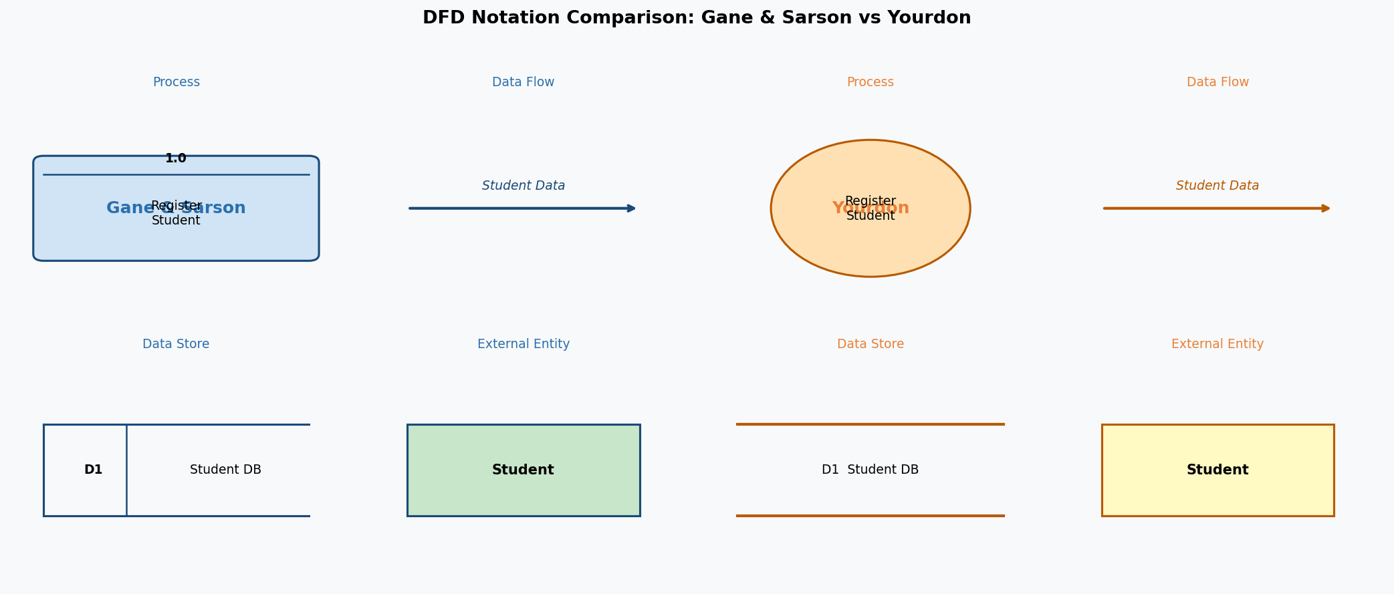

Question 3: Context Diagram vs Diagram 0 (Level 1 DFD)
Both a context diagram and Diagram 0 are types of Data Flow Diagrams, but they operate at different levels of abstraction:

Aspect | Context Diagram (Level 0) | Diagram 0 (Level 1)
Scope | Shows the entire system as a single process | Breaks the system into its major sub-processes (typically 6–8)
Processes | One single central process representing the whole system | Multiple processes, each with a unique number (1.0, 2.0, etc.)
Data Stores | NOT included — data stores are internal to the system | Included — shows all major data stores used by the system
Purpose | Define system boundary and external interfaces at the highest level | Show major functions of the system and how data flows between them

The symbol NOT used in a context diagram is the Data Store. Since a context diagram treats the entire system as a black box with a single process, all data stores are considered internal and are therefore hidden at this level. Only external entities, the single central process, and data flows between them appear in a context diagram.

Question 4: How to Level DFDs
Levelling (also called decomposition or exploding) is the process of breaking a higher-level DFD process into a more detailed, lower-level DFD. It allows analysts to manage complexity by moving from a broad overview to increasing detail.

Levelling process:
- Level 0 – Context Diagram: The entire system is represented as one process. External entities and the primary data flows in/out are shown.
- Level 1 – Diagram 0: The single process from the context diagram is exploded into 6–8 major sub-processes. Data stores appear for the first time. All data flows from the context diagram must still be present (balancing rule).
- Level 2 – Diagram 1, 2, etc.: Each sub-process from Level 1 that is too complex to describe simply is further decomposed. A process named 3.0 at Level 1 becomes processes 3.1, 3.2, 3.3 at Level 2.
- Level 3 and beyond: Decomposition continues until every process is a functional primitive — a process simple enough to be described by a process specification (mini-spec) without further decomposition.

Rules for levelling:
- Each level must balance with the level above it (inputs and outputs match).
- Do not show more than 6–8 processes per diagram to maintain readability.
- Number processes consistently: Level 1 uses 1.0, 2.0…; Level 2 uses 1.1, 1.2…; Level 3 uses 1.1.1, 1.1.2…
- Stop decomposing when a process can be fully described in a single page of structured English.

Question 5: How to Balance DFDs
Balancing ensures consistency between a DFD and its parent diagram — the data flows entering and leaving a process at one level must exactly match the data flows entering and leaving the same process's detailed diagram at the next level down.

Rules for balancing:
- Input/Output Match: Every data flow entering a process in the parent diagram must appear as an input to the child diagram. Every output in the parent must appear as an output in the child.
- No Extra External Flows: A child diagram cannot introduce new external entities or data flows that do not exist in the parent diagram at that same process.
- Data Stores: A data store used only within a single child process need not appear at the parent level (it is an internal store). However, a store shared across multiple child processes must appear at the parent level.
- Verification Technique: List all inputs and outputs on the parent process bubble. Then verify that the child diagram has exactly the same set of net inputs and outputs. Any mismatch indicates an imbalance that must be corrected.
- Typical imbalance errors: a data flow missing from the child, an extra data flow in the child not present in the parent, or a data store wrongly promoted to/from parent level.

Question 6: IT Service Company – Context DFD and Level 1 DFD
Company: TechNova IT Solutions
Start-up Budget: AUD $500,000
Services offered: IT Consulting, Custom Software Development, Cloud Managed Services, Cybersecurity Solutions, and IT Support & Helpdesk.

TechNova serves corporate clients, engages technology vendors for licences and hardware, employs consultants and developers, interacts with the bank for payments, and submits compliance reports to the regulatory/tax authority.

Context DFD (Level 0):
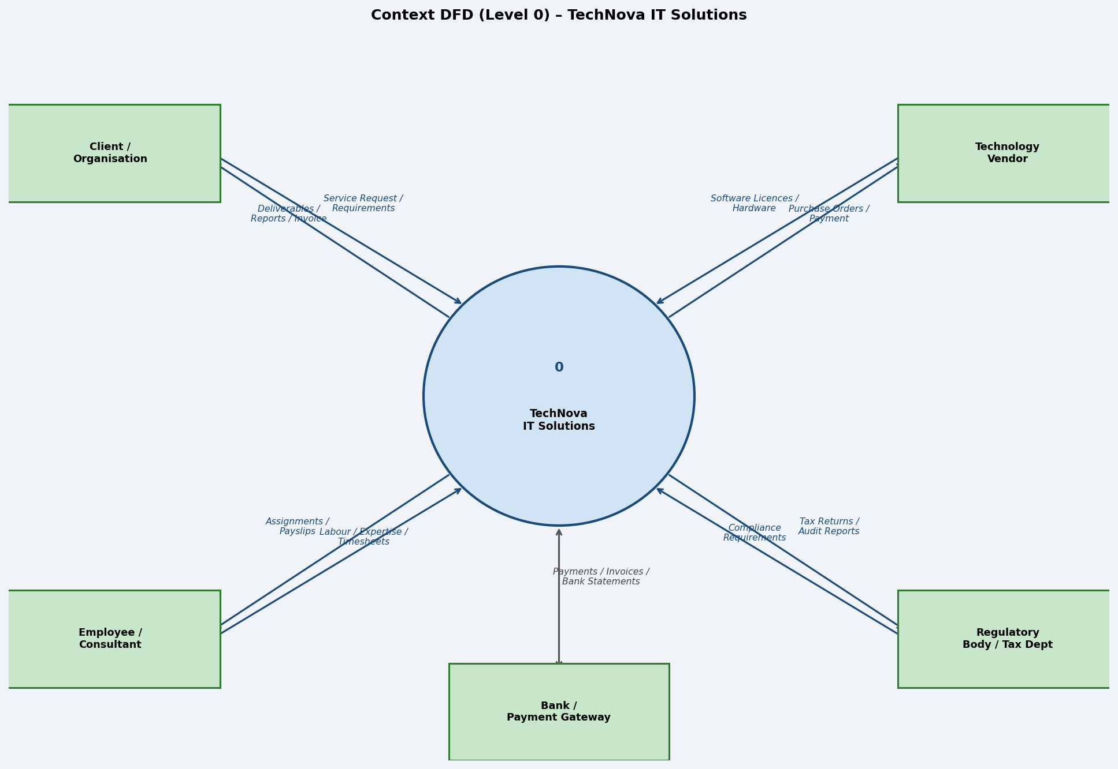

The context diagram shows TechNova as a single central process. The five external entities (Client, Employee/Consultant, Technology Vendor, Regulatory Body, and Bank) interact with the system via clearly labelled data flows. No data stores appear at this level.

Level 1 DFD (Diagram 0):
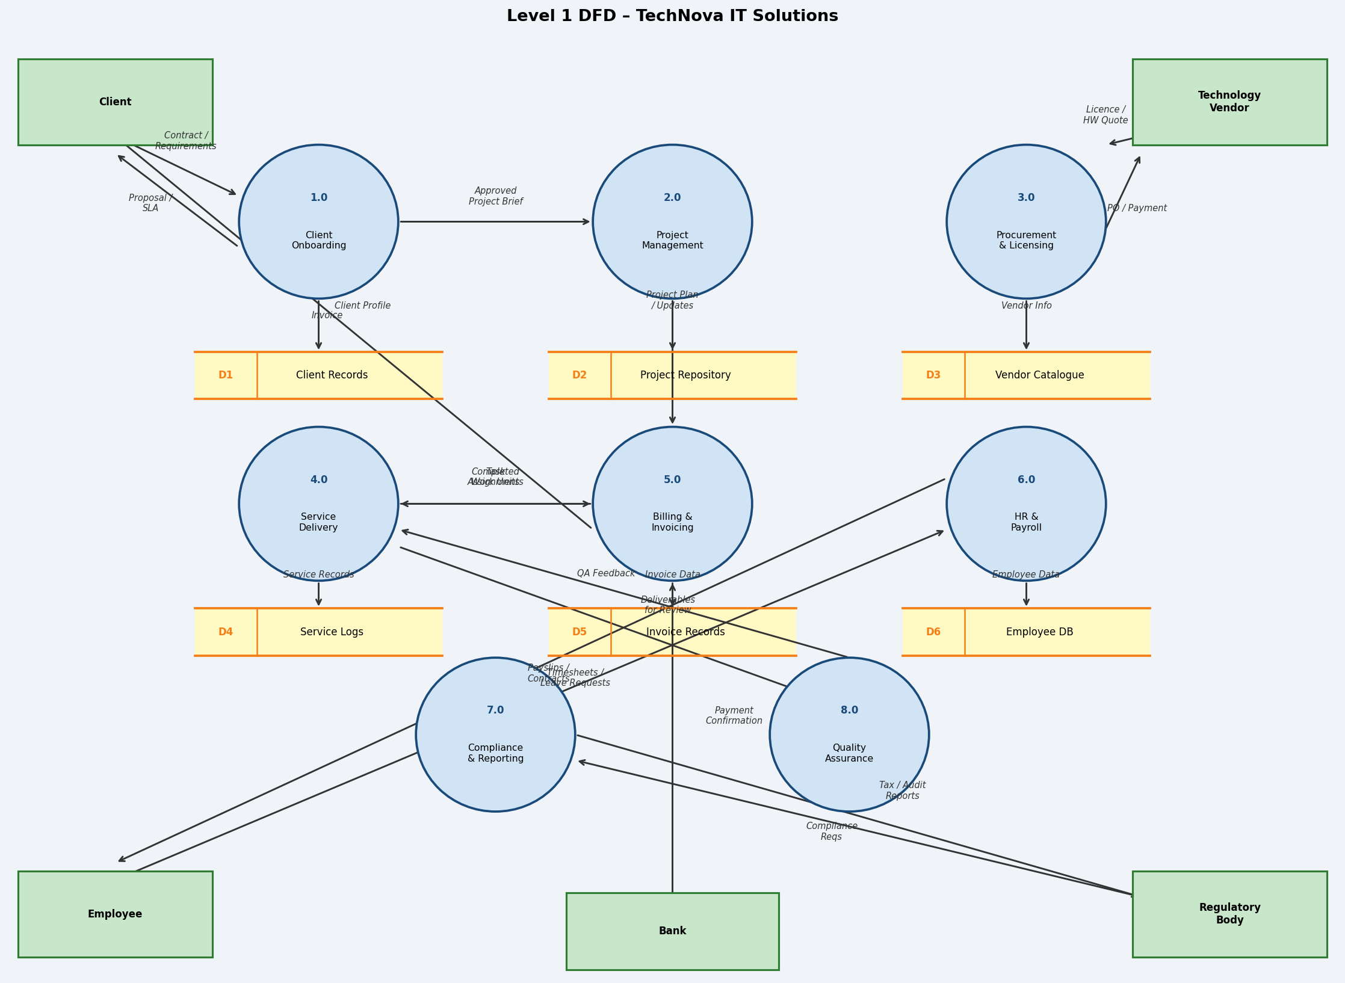

The Level 1 DFD decomposes TechNova into eight core processes:
Process | Description
1.0 Client Onboarding | Captures client requirements, generates proposals, and creates client records (D1).
2.0 Project Management | Plans, assigns, and tracks all project tasks stored in the Project Repository (D2).
3.0 Procurement & Licensing | Manages vendor relationships, purchase orders, and vendor catalogue (D3).
4.0 Service Delivery | Executes IT services; logs work in Service Logs (D4).
5.0 Billing & Invoicing | Generates invoices based on delivered work; stores records in D5; interfaces with Bank.
6.0 HR & Payroll | Manages employee data (D6), processes timesheets, and generates payslips.
7.0 Compliance & Reporting | Produces tax returns and audit reports submitted to the Regulatory Body.
8.0 Quality Assurance | Reviews deliverables from Service Delivery and provides QA feedback.

Question 7: Alternatives to DFDs – Pros, Cons, and Comparison
While DFDs are a powerful tool for process and data modelling, several alternatives exist, each with different strengths depending on the project context.

Alternative | Description | Pros | Cons
UML Use Case Diagram | Shows actors and their interactions with system use cases within a system boundary. | + Focus on user requirements; easy for stakeholders to validate; standard notation; integrates with other UML diagrams. | – Does not show data flows or data storage; no process logic; limited for data-intensive systems.
BPMN (Business Process Model & Notation) | Models end-to-end business workflows with tasks, events, gateways, and swimlanes. | + Rich notation for complex workflows; shows decision logic, roles, and parallel flows; widely supported by tools. | – Can become very complex; less focused on data structure; steeper learning curve than DFDs.
UML Activity Diagram | Depicts the sequence of activities and decisions within a process; similar to flowcharts. | + Good for control flow and parallel processes; integrates with OO design; familiar syntax. | – Does not explicitly model data flows or external entities; less intuitive for business users.
Flowchart | Step-by-step graphical representation of a process using standard symbols (start, decision, action, end). | + Simple and universally understood; good for algorithm and procedure documentation. | – Does not show data stores or external entities; poor for complex multi-actor systems; not scalable.

Recommended alternative: UML Use Case Diagram. For the TechNova IT Solutions scenario, a Use Case Diagram complements the DFD by showing which actors interact with which system functions, making it easier for clients and stakeholders to validate scope and requirements — something a DFD alone does not do clearly.

UML Use Case Diagram for TechNova IT Solutions:
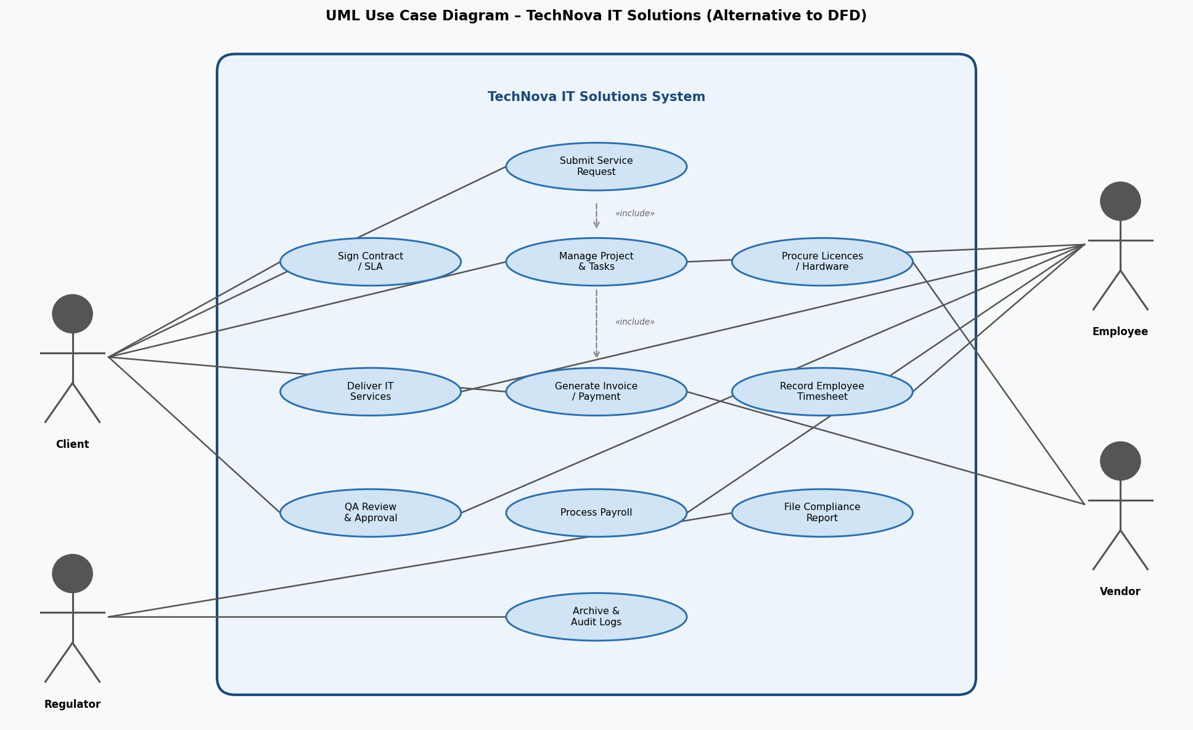

DFD vs UML Use Case – Direct Comparison:
Criterion | DFD | UML Use Case
Focus | Data movement and transformation | Actor-system interactions and system scope
Shows Data Flows | Yes — explicitly named arrows | No — only relationships
Shows Data Stores | Yes — named repositories | No
Audience | Analysts and developers | Stakeholders, clients, and product owners
Complexity Handling | Levelled hierarchy (Level 0 → 1 → 2…) | Include/extend relationships
Best For | Detailed data and process requirements | High-level scope and functional requirements

Conclusion: Neither tool is universally superior. DFDs are best for data-centric systems analysis where understanding data movement is critical. Use Case Diagrams are best for defining system scope and communicating with non-technical stakeholders. In practice, both are used together in a complete requirements specification.

