BN314 – System Architecture

Lecture 8: Defining System Architecture – Laboratory Activity

Question 1: Technology Architecture vs Application Architecture
Technology Architecture: Defines the physical and infrastructure foundation of the system — the hardware, network, operating systems, DBMS platforms, cloud services, and middleware that the system runs on. It answers "What platform and infrastructure will the system use?"
Application Architecture: Defines the logical structure of the software — how application components, tiers, modules, APIs, and design patterns are organised and interact. It answers "How is the software structured and how do its parts communicate?"

Aspect | Technology Architecture | Application Architecture
Focus | Physical/infrastructure layer — hardware, OS, network, cloud. | Logical/software layer — components, tiers, patterns, APIs.
Designed by | Infrastructure and network architects. | Software/application architects and systems analysts.
Examples | AWS EC2 servers, PostgreSQL on Linux, Azure VNet, TLS certificates. | MVC pattern, REST API, three-layer architecture, microservices.
Key concern | Availability, scalability, performance, and physical security. | Modularity, maintainability, reusability, and business logic separation.

Interdependence: Application architecture must be designed to run on the available technology architecture. If the tech architecture uses cloud containers (e.g., Kubernetes), the application must be designed as stateless, containerisable components. Conversely, technology choices are constrained by what the application architecture requires — a microservices architecture demands a different infrastructure than a monolith. Neither can be designed in isolation.
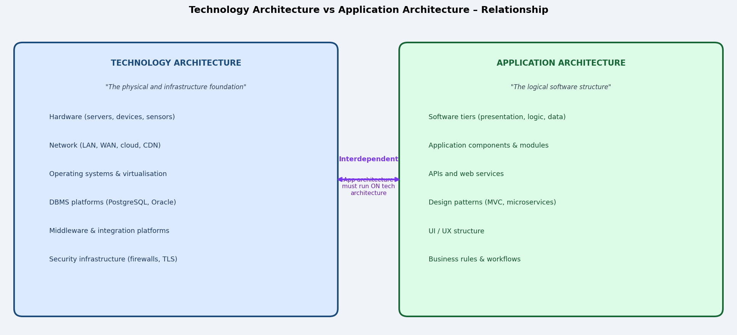

Question 2: Application Software vs System Software
Aspect | Application Software | System Software
Definition | Software that performs specific tasks for end users, directly supporting business processes or personal productivity. | Software that manages and controls hardware resources, providing a platform for application software to run.
Primary user | End users (students, staff, customers). | Computers/hardware and application software (not usually the end user directly).
Purpose | Solve a specific business or personal problem. | Manage hardware, memory, processes, security, and provide services to other software.
Examples | Microsoft Word, Canvas LMS, Xero (accounting), Salesforce CRM, Chrome browser, TechNova client portal. | Windows 11, Linux (Ubuntu), macOS, PostgreSQL DBMS, Apache web server, VMware hypervisor, Android OS.
Dependency | Depends on system software to run. | Runs directly on hardware (or firmware).

Question 3: Native App vs Web-Based Application – Which Is More Secure?
Native (installed) apps are generally considered more secure than web-based applications, though the answer is nuanced and depends on implementation quality.

Security Factor | Native App | Web-Based App
Attack surface | Smaller — runs locally; not exposed to the internet by default; no browser intermediary. | Larger — always internet-facing; exposed to XSS, SQL injection, CSRF, and man-in-the-middle attacks.
Data storage | Can store sensitive data locally in encrypted form without transmitting it. | Data transmitted to/from server over the network; dependent on TLS for encryption.
Code exposure | Compiled binary; harder to reverse-engineer. | HTML/JavaScript often visible in browser; logic exposure risk.
Update control | Updates must be installed by user; old vulnerable versions persist. | Always runs latest server-side version; easier to patch centrally.
Authentication | Can use OS-level biometrics, keychain, and device-bound credentials. | Relies on browser cookie/session management; CSRF and session hijacking risks.

Conclusion: Native apps have a smaller attack surface, but poorly coded native apps can still be highly insecure. Modern web apps with HTTPS, CSP headers, proper authentication (OAuth2/MFA), and input validation can achieve very high security. The implementation quality matters more than the type.

Question 4: Embedded Software on Smartphones and Its Benefits
Three types of embedded software on a typical smartphone:
1. Firmware / Bootloader: Low-level software (e.g., Qualcomm Snapdragon firmware) burned into hardware chips that initialises the device hardware and loads the operating system at startup.
2. Baseband Processor Software: Embedded software that manages all cellular radio communications (4G/5G, voice calls, SMS) independently of the main application processor, handling modem protocols.
3. Sensor Drivers / Hardware Abstraction Layer (HAL): Embedded software that provides standardised interfaces to hardware components such as the GPS module, accelerometer, fingerprint sensor, camera ISP, and NFC chip.

Benefit to application software developers: Embedded software abstracts hardware complexity through standardised APIs. An app developer calls camera.takePicture() without writing a single line of hardware-level code. This dramatically reduces development time, improves portability across device models, and allows app developers to focus entirely on business logic and user experience rather than hardware management.

Question 5: Role of Protocols in Modern Software and Systems
A protocol is a set of standardised rules and conventions that define how data is formatted, transmitted, received, and acknowledged between two or more systems or software components. Protocols ensure that different systems — regardless of vendor, language, or platform — can communicate reliably and consistently.

Roles protocols play:
- Interoperability: protocols allow systems from different vendors and platforms to exchange data (e.g., a Python backend communicating with a JavaScript frontend via HTTP/JSON).
- Reliability: protocols like TCP define error detection, retransmission, and sequencing to ensure data arrives complete and in order.
- Security: protocols like TLS/SSL encrypt data in transit, preventing eavesdropping and tampering between client and server.
- Standardisation: agreed protocols allow developers to build on existing infrastructure without reinventing communication mechanisms.
- Integration: web service protocols (REST, SOAP, GraphQL) allow application components and third-party services to integrate across organisational and geographic boundaries.

Question 6: Three Commonly Used Web Protocols
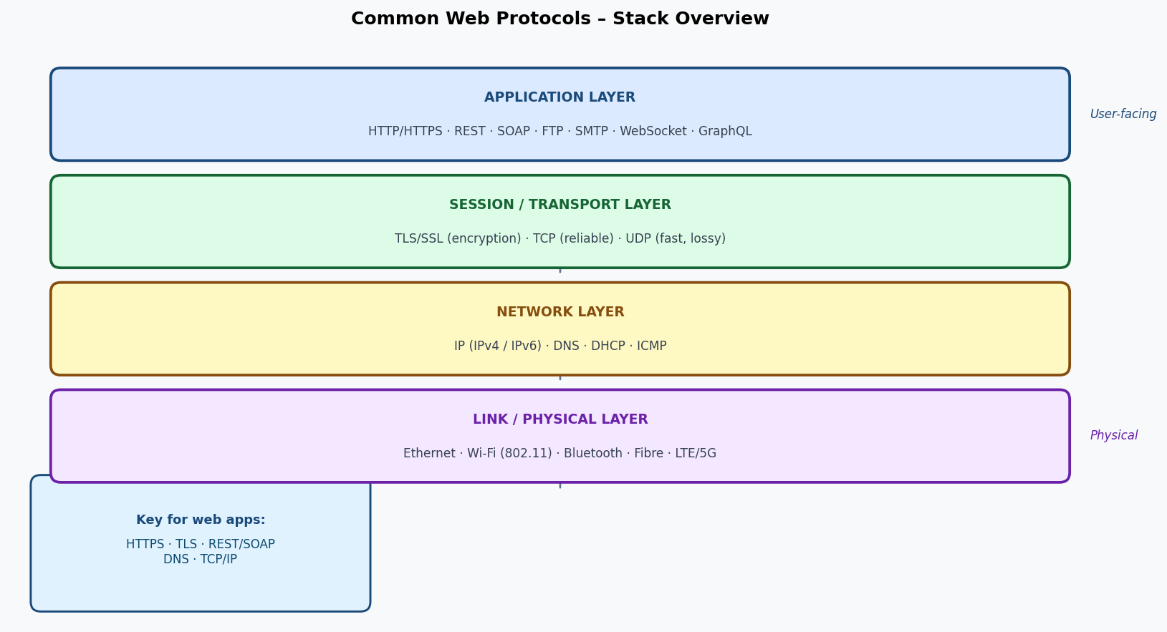

Protocol | Layer | Description | Example Use
HTTP / HTTPS  (HyperText Transfer  Protocol Secure) | Application layer | The foundation protocol of the World Wide Web. Defines how web clients (browsers) request resources and how servers respond. HTTPS adds TLS/SSL encryption, making all communication confidential and authenticated. Every web page load, API call, and form submission uses HTTP/HTTPS. | GET /students HTTP/1.1 (browser requests student list)  HTTPS encrypts the response
TLS / SSL  (Transport Layer  Security) | Session / Transport | Provides encryption, authentication, and data integrity for any TCP-based protocol. Uses digital certificates and asymmetric key exchange to establish a secure session, then switches to symmetric encryption for speed. Protects HTTPS, email (SMTPS), and database connections. | TLS 1.3 handshake establishes encrypted HTTPS session between browser and bank
REST  (Representational  State Transfer) | Application (architectural style over HTTP) | An architectural style for designing web APIs using standard HTTP methods (GET, POST, PUT, DELETE, PATCH). Resources are addressed by URLs; data is typically exchanged as JSON. REST is stateless, scalable, and the dominant pattern for modern web and mobile APIs. | GET /api/courses/BN314 returns course details as JSON
WebSocket | Application layer | A full-duplex, persistent communication protocol over a single TCP connection. Unlike HTTP (request-response), WebSocket allows the server to push data to the client at any time without a new request, enabling real-time features. | Live chat, stock tickers, multiplayer games, real-time dashboards

Question 7: Software as a Service (SaaS)
Software as a Service (SaaS): A cloud delivery model in which software applications are hosted by a provider and delivered to users over the internet via a browser or thin client — without installation, local hardware requirements, or manual updates. Examples: Microsoft 365, Salesforce, Canvas LMS, Xero, Google Workspace, Zoom.

Feature | SaaS | Locally Installed Application
Installation | None — accessed via browser or lightweight client. | Installed locally on each device; version management required.
Updates | Automatic, centrally managed by provider; users always have latest version. | Must be installed manually or via IT deployment tools per device.
Data storage | Data stored on provider's cloud infrastructure. | Data stored locally or on organisation's own servers.
Scalability | Scales elastically; add/remove users via subscription. | Limited by local hardware; additional licenses and installs needed.
Accessibility | Accessible from any device with internet; device-independent. | Tied to the device where installed (unless using VDI/RDS).
Cost model | Subscription (per user/month); operational expenditure (OpEx). | Licence purchase + IT support; capital expenditure (CapEx).
Customisation | Limited to provider-exposed configuration options. | Full control over configuration, plugins, and integration.

Question 8: Web Services in Modern Application Design
Why web services are important: Web services expose reusable, standardised functionality over the internet via protocols (REST, SOAP, GraphQL), allowing different applications — regardless of platform or language — to integrate and share capabilities. They enable:
- Modularity and reuse: common functions (payment, authentication, mapping, notifications) are consumed as services rather than built from scratch.
- System integration: organisations connect ERP, CRM, LMS, and HR systems through web service APIs without custom point-to-point integrations.
- Third-party capability: platforms like Stripe (payments), Twilio (SMS/voice), Google Maps (geolocation), and AWS Rekognition (AI) are consumed as web services.
- Microservices architecture: modern systems decompose into small, independently deployable web services, each responsible for one bounded context.

Decisions a system designer must make regarding web services:
- Build vs buy: should this capability be built in-house or consumed from a third-party API?
- Protocol choice: REST vs SOAP vs GraphQL — based on payload size, tooling, and client needs.
- Authentication/authorisation: how will API access be secured (OAuth2, API keys, JWT)?
- Service level and reliability: what uptime guarantees does the provider offer? What is the fallback if the service is unavailable?
- Data residency and privacy: does using an external service comply with data sovereignty laws (GDPR, Privacy Act)?

Question 9: Three-Layer Architecture vs Client/Server Architecture
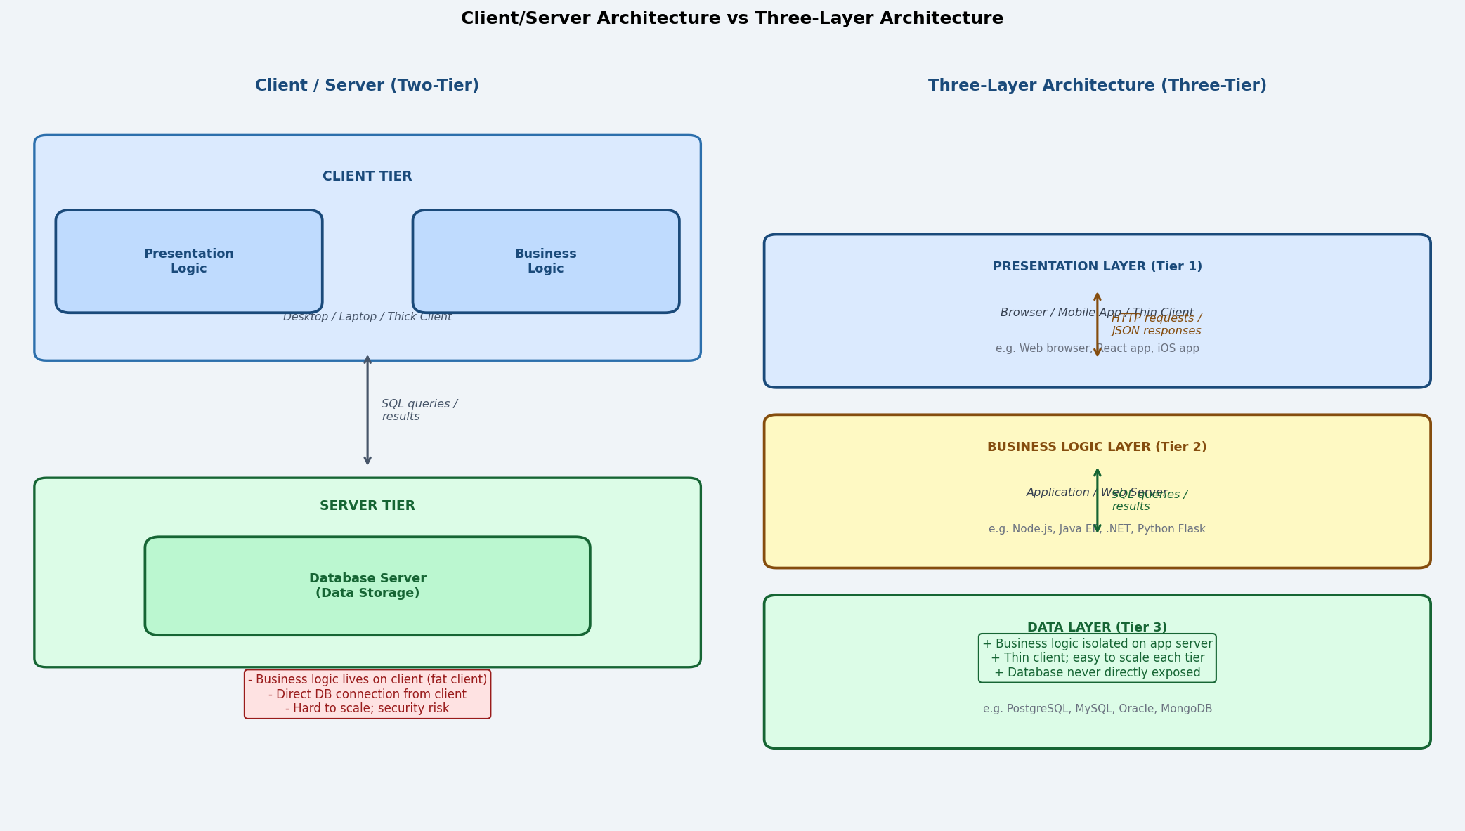

Aspect | Client/Server (2-Tier) | Three-Layer (3-Tier)
Number of tiers | Two — client and server. | Three — presentation, logic, data.
Business logic location | Often on the client (fat client), or split ambiguously. | Isolated on the dedicated application/logic server — never on the client.
Client type | Thick/fat client with significant processing. | Thin client (browser or lightweight app); minimal processing.
Database access | Client connects directly to the database server. | Client never touches the database; only the logic layer does.
Scalability | Difficult — client upgrades required; DB server becomes a bottleneck. | Each tier scaled independently; horizontal scaling of app servers is easy.
Security | DB credentials often on the client; larger attack surface. | Database is never directly exposed; all access mediated by logic layer.
Similarity | Both use a separation of concerns: frontend vs backend. | Both separate the user interface from data storage.

Question 10: Layers of Three-Layer Architecture
Layer | Function | Technology Examples | Deployment Device
Layer 1  Presentation Layer  (View) | Handles all user interaction — displays information, captures input, and sends requests to the logic layer. Contains no business logic or data access code. | Web browser, mobile app (iOS/Android), desktop GUI. | Client device: user's browser, smartphone, or desktop.
Layer 2  Business Logic Layer  (Application / Controller) | Implements all business rules, workflows, calculations, and decision logic. Acts as the intermediary between the presentation and data layers; validates input, applies rules, and orchestrates responses. | Node.js / Express, Java Spring Boot, Python Django, .NET Core, PHP Laravel. | Application server / web server in the data centre or cloud.
Layer 3  Data Layer  (Model / Repository) | Manages persistent data storage and retrieval. Handles all CRUD operations (Create, Read, Update, Delete) and enforces data integrity at the database level. | PostgreSQL, MySQL, Oracle DB, MongoDB, Redis, Microsoft SQL Server. | Dedicated database server (on-premise or cloud-managed DB service like AWS RDS).

Question 11: Interoperability – Why It Is Important
Interoperability: The ability of different systems, applications, or components — built on different platforms, by different vendors, or in different programming languages — to exchange information and work together effectively.

Why it is critical in modern systems:
- No organisation operates in isolation: modern IT ecosystems involve ERP, CRM, LMS, HR, payroll, banking, and cloud services from multiple vendors. All must exchange data seamlessly.
- Legacy system integration: most organisations have existing systems that cannot be replaced. New systems must interoperate with legacy infrastructure.
- Partner and customer integration: B2B supply chains, government data exchanges, and customer-facing APIs all require standardised, interoperable interfaces.
- Platform diversity: users access systems from Windows, macOS, iOS, Android, and Linux. Web-based, interoperable applications work across all platforms.
- Avoiding vendor lock-in: systems designed with open, interoperable standards (REST, JSON, OAuth2) can switch components without complete rewrites.
- Regulatory requirements: healthcare (HL7/FHIR), finance (ISO 20022), and government (GovTech interoperability frameworks) mandate standardised data exchange.

Question 12: Three Common Types of Architectural Diagrams
Diagram Type | Description | Purpose / Audience
Network / Infrastructure  Diagram | Shows the physical and logical arrangement of hardware, servers, network devices (routers, firewalls, switches), communication links, and cloud services. Defines zones (DMZ, internal, cloud) and connectivity. | Used by infrastructure architects, network engineers, and security teams to plan deployment, configure firewalls, and document the physical environment.
UML Deployment Diagram | A UML diagram that shows how software components (artifacts) are deployed onto hardware nodes (servers, devices, containers). Shows which node hosts which component and how nodes communicate. | Used by solution architects and developers to plan and document how the application is distributed across physical and virtual infrastructure.
Application / Component Diagram  (UML Component Diagram) | Shows the logical software components, their provided/required interfaces, and the dependencies between them. Does not show hardware — focuses on how software modules and services are structured and connected. | Used during application architecture design to define component boundaries, APIs, and service contracts before implementation begins.

Question 13: Key Questions When Describing the System Environment
When documenting the environment, a system designer should ask and answer the following questions:

Q: What hardware will the system run on?
A: Identify server specifications, client device types, storage capacity, and peripherals.
Q: What is the network topology and bandwidth?
A: Define LAN/WAN/cloud connectivity, expected traffic volumes, latency requirements, and CDN needs.
Q: What operating system and platform is required?
A: Specify OS versions, DBMS, web server, application server, and any required middleware.
Q: What is the hosting model?
A: On-premise, cloud (IaaS/PaaS/SaaS), hybrid — and which cloud provider(s) and regions?
Q: What are the performance and availability requirements?
A: Define uptime SLA (e.g., 99.9%), response time targets, disaster recovery RTO/RPO.
Q: What security infrastructure is in place?
A: Identify existing firewalls, IDS/IPS, VPN, TLS certificates, and compliance requirements (ISO 27001, PCI-DSS).
Q: What existing systems must the new system integrate with?
A: Identify legacy systems, third-party APIs, and data exchange formats.
Q: What are the constraints (budget, technology standards)?
A: Organisation-mandated technology standards, approved vendor lists, and budget ceiling.

Question 14: How Use Cases Guide Application Component Design
Use cases and their related artefacts directly drive the identification, scoping, and design of application components in the following ways:

- Identifying components: each use case represents a distinct system function (e.g., "Register for Course", "Process Payment", "Generate Report"). Each function typically maps to one or more application components (controllers, services, handlers). The set of use cases defines the complete set of required components.
- Defining component interfaces: a use case description lists the system messages (from the SSD) that the system must handle. Each system message becomes a method in an application component's public interface (e.g., registerStudent(sid, cid), processPayment(amount, card)).
- Identifying required data: the data flows in use cases (inputs and outputs) identify what data each component must read from and write to the data layer, informing data access component design.
- Business rule extraction: alternative flows and exception flows in use case descriptions document business rules and edge cases (e.g., "if course is full, add to waitlist") that must be implemented in the business logic layer.
- Component collaboration: use case diagrams show which actors and use cases interact, helping designers identify how components must collaborate and what dependencies exist between them.
- Testing foundation: each use case (main flow + alternative + exception flows) provides a ready-made set of test scenarios for the corresponding components, ensuring design decisions are traceable to verifiable requirements.

