Telugu–English Code-Mixed Sentiment Analysis
NLP Project Report

Abstract
Telugu–English code-mixing is common in informal online communication, where users combine Romanized Telugu and English words in the same sentence. This project presents a simple baseline for sentiment classification of such text. A small manually prepared dataset is normalized and represented using TF-IDF features. Logistic Regression is then used to classify the text as positive or negative. The current implementation achieved 70.00% accuracy on the held-out test split. The project is designed as a clean baseline for future experiments with transliteration normalization and multilingual transformer models such as mBERT, XLM-R and IndicBERT.

1. Introduction
Code-mixed text combines words from more than one language within the same communication. Telugu–English code-mixed text is frequently written using English characters, for example, “Ee movie chala bagundi super ga undi.” Standard sentiment models can struggle with informal spelling, transliteration and mixed vocabulary. This project develops an understandable baseline pipeline for this problem.

2. Problem Statement
Identify whether Telugu–English code-mixed social-media-style text expresses positive or negative sentiment.

3. Objectives
- Prepare a small code-mixed sentiment dataset.
- Normalize noisy Romanized Telugu–English text.
- Extract TF-IDF unigram and bigram features.
- Train a Logistic Regression classifier.
- Evaluate the model using standard classification metrics.
- Create a reusable prediction script for new text.

4. Dataset
The prototype dataset contains 40 manually prepared examples: 20 positive and 20 negative. The examples cover common topics such as movies, sports, food, applications, examinations, travel and daily experiences. Because the dataset is small and manually created, the result is intended for demonstration and baseline development rather than a general claim about Telugu sentiment.

5. Methodology

5.1 Text Normalization
Text is converted to lowercase. URLs, mentions, hashtags, punctuation and extra spaces are removed.

5.2 TF-IDF Feature Extraction
TF-IDF transforms normalized text into numerical vectors. Both unigrams and bigrams are used.

5.3 Classification
Logistic Regression learns a binary decision boundary between positive and negative examples.

5.4 Evaluation
The data is split into training and test sets using a fixed random state and stratification.

6. Implementation
The implementation is organized into preprocess.py for text preparation, train.py for model training and evaluation, and predict.py for interactive prediction. requirements.txt contains the required Python packages.

7. Results
Test-set accuracy: 70.00%
Negative — Precision: 0.67, Recall: 0.80, F1-score: 0.73
Positive — Precision: 0.75, Recall: 0.60, F1-score: 0.67
Macro-average F1-score: 0.70
These values are obtained from the current 40-example prototype dataset and a 25% test split. They should not be interpreted as benchmark performance.
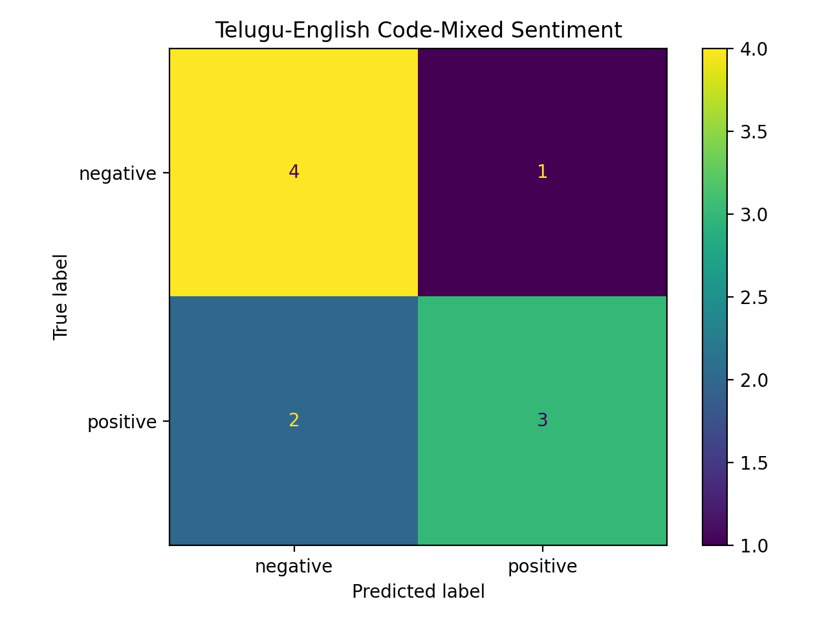
Figure 1. Confusion matrix for the current test split.

8. Sample Predictions
“Ee movie chala bagundi super ga undi” → Positive
“Movie asalu bagaledu waste” → Negative

9. Research Extension
The proposed research extension is to compare sentiment performance before and after transliteration normalization and to investigate code-mixed linguistic features. A stronger experimental study can then compare the baseline with multilingual transformer representations such as mBERT, XLM-R and IndicBERT.

10. Limitations
The main limitation is the small, manually created dataset. It does not capture the diversity of real social-media text, including slang, spelling variation, sarcasm, emojis and Telugu-script text. The current system is also a classical ML baseline rather than a transformer-based model.

11. Future Scope
- Build or use a larger real-world Telugu–English code-mixed dataset.
- Add transliteration normalization and language identification.
- Include emojis, slang, spelling variants and sarcasm handling.
- Compare TF-IDF + Logistic Regression with mBERT, XLM-R and IndicBERT.
- Perform cross-validation and statistical comparison of models.

12. Conclusion
This project demonstrates a complete and reproducible baseline for Telugu–English code-mixed sentiment analysis. The pipeline performs text normalization, TF-IDF feature extraction, Logistic Regression classification and evaluation. The 70.00% test accuracy provides a starting point for future research using larger datasets, transliteration normalization and multilingual transformer models.

13. References
- Python documentation.
- scikit-learn documentation for TfidfVectorizer and LogisticRegression.
- Research literature on code-mixed natural language processing.
- Research literature on multilingual transformer models including mBERT, XLM-R and IndicBERT.

