**Final Report: LearnHub - Your Center for Skill Enhancement**

**1. INTRODUCTION**

**1.1 Project Overview**

LearnHub is an Online Learning Platform (OLP) aimed at enhancing skills through a flexible, accessible, and user-friendly digital interface. This platform supports learners, educators, and administrators in managing, delivering, and accessing educational content efficiently. It provides flexible, interactive, and accessible education through the internet. It empowers learners of all ages with self-paced courses, certification options, and device-friendly access. Featuring intuitive course management for instructors, active student-instructor engagement through forums and webinars, and administrative tools for platform oversight.

LearnHub offers flexible, self-paced learning accessible from any device, making education more inclusive and convenient. It bridges the gap between digital education delivery and the individual needs of learners and educators.

**1.2 Purpose**

The purpose of LearnHub is to democratize education by providing interactive, certified, and self-paced learning opportunities for users of all backgrounds. It aims to facilitate professional growth, academic advancement, and lifelong learning.

**2. IDEATION PHASE**

**2.1 Problem Statement**

Many students and professionals struggle to find flexible, affordable, and accessible skill-building platforms that cater to their unique learning needs and schedules.

How Might We:

How can we build an online learning platformthat ensures flexibility, interactivity, and affordability while providing certification, collaboration tools, and admin control for diverse users?

**2.2 Empathy Map Canvas**

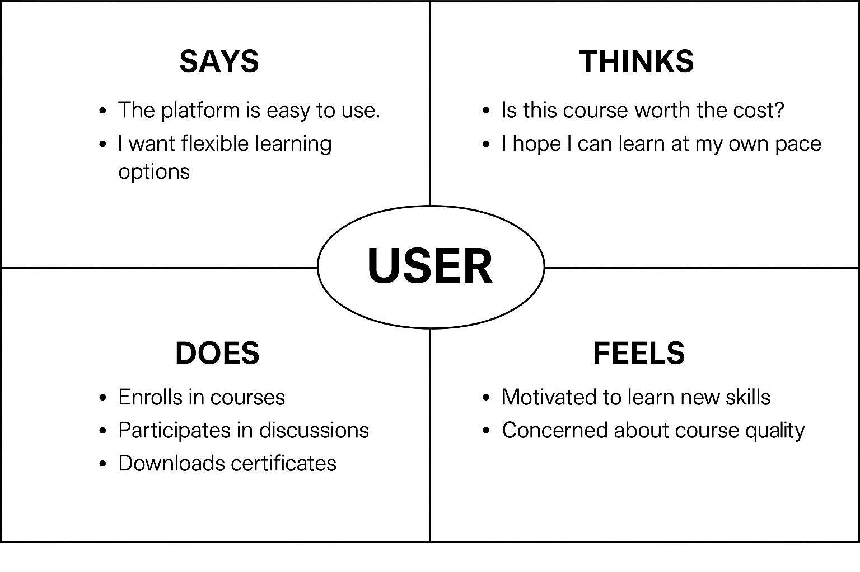

* **Says**: “I want to learn but don’t have time.”
* **Thinks**: “Will this course help my career?”
* **Does**: Searches online courses, reads reviews.
* **Feels**: Overwhelmed by options, unsure about credibility.

**2.3 Brainstorming**

* Integrate certified self-paced courses.
* Use interactive elements like webinars and forums.
* Enable payment gateway for premium content.
* Create separate dashboards for students, teachers, and admins.

**3. REQUIREMENT ANALYSIS**

**3.1 Customer Journey Map**

**Student Journey**

* Awareness: Learns about LearnHub via social media, ads, or recommendations.
* Registration/Login: Signs up with email and password.
* Searching for Courses: Filters by topic, difficulty, or popularity.
* Enrollment: Selects a course, views its details, and enrolls.
* Confirmation & Notification: Receives confirmation and access details via email/notification.
* Course Progression: Proceeds through modules at own pace.
* Interaction: Engages in forums, attends live sessions.
* Completion: Takes final exam, receives certificate**.**

**Teacher Journey**

* Awareness: Learns about opportunity to publish courses.
* Registration/Login: Registers as an educator.
* Course Creation: Uploads and manages course content.
* Publishing & Updates: Publishes new or revised content.
* Monitoring: Tracks enrollments and interacts with students.
* Feedback: Receives reviews and improves course accordingly**.**

**Admin Journey**

* Awareness: Assigned internal administrative role.
* Login: Enters through secure admin panel.
* Monitoring Activity: Reviews platform-wide user activity.
* Managing Content: Oversees all uploaded courses.
* Issue Resolution: Handles user queries and technical issues.
* Reporting: Maintains system integrity, usage stats.

**3.2 Solution Requirement**

* Registration & authentication system.
* Course browsing, filtering, and enrollment.
* Role-based dashboards (Admin, Student, Teacher).
* Certification generation.
* Payment integration.

**3.3 Data Flow Diagram**

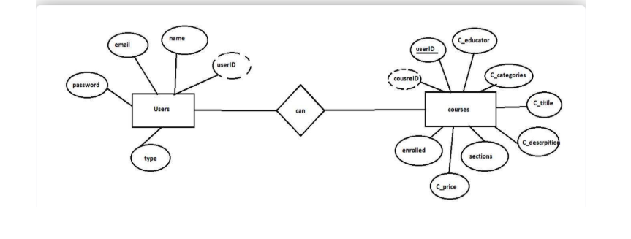

**3.4 Technology Stack**

* Frontend: React.js, Bootstrap, Material UI, Axios
* Backend: Node.js, Express.js
* Database: MongoDB
* Tools: Vite, Mongoose, Nodemon, JWT, Multer

**4. PROJECT DESIGN**

**4.1 Problem Solution Fit**

By addressing learners’ need for flexibility and certification, and educator’s need for content management, LearnHub bridges the gap between demand and availability of quality online education.

**4.2 Proposed Solution**

A full-stack platform that enables course creation, enrollment, learning progression tracking, and certification, all accessible from any device.

* Responsive web interface for all users
* Role-based dashboards: student, teacher, admin
* Course creation and management by instructors
* Course browsing, enrollment, and self-paced learning for students
* Certification and progress tracking
* Secure payment for premium content
* Admin tools for content and user management

**4.3 Solution Architecture**

A client-server model with:

* Frontend communicating via RESTful APIs.
* Backend using Express.js to serve API requests.
* MongoDB as a scalable NoSQL database.

**5. PROJECT PLANNING & SCHEDULING**

* 1. **Project Planning**

Sprint-1: 16 June 2025 - 18 June 2025: Requirement analysis and environment setup

Sprint-2: 19 June 2025 - 20 June 2025: Backend API development

Sprint-3: 21 June 2025 - 23 June 2025: Frontend UI and integration

Sprint-4: 24June 2025 - 26 June 2025: Testing and bug fixes

**6. FUNCTIONAL AND PERFORMANCE TESTING**

**6.1 Performance Testing**

* Load tested APIs using Postman.
* Monitored API response times under multiple user scenarios.
* Verified UI responsiveness on various screen sizes.

**7. RESULTS**

**7.1 Output Screenshots**

* Home page :

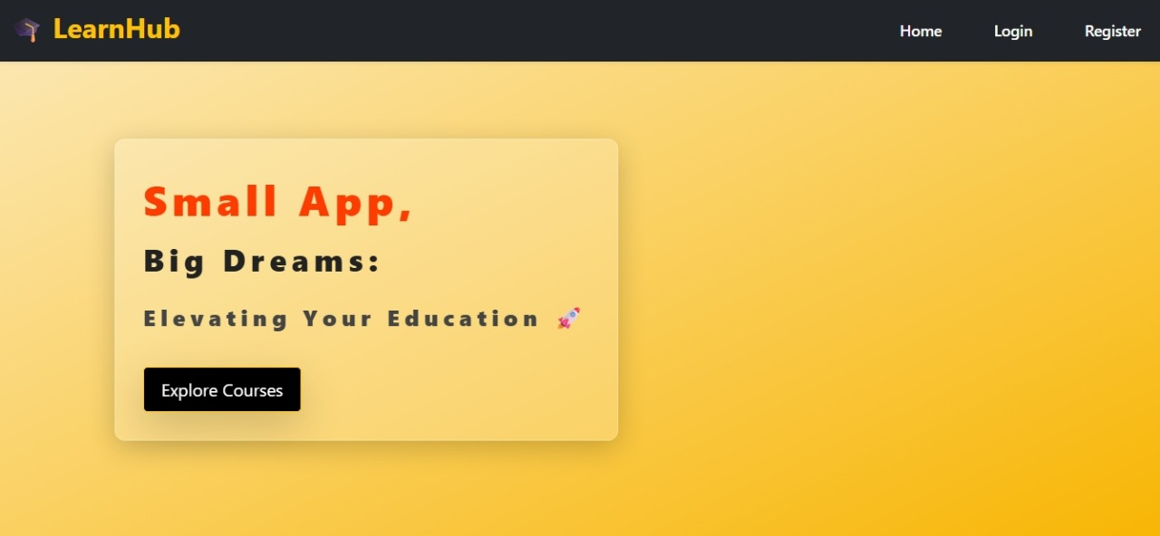

* Account Creation :

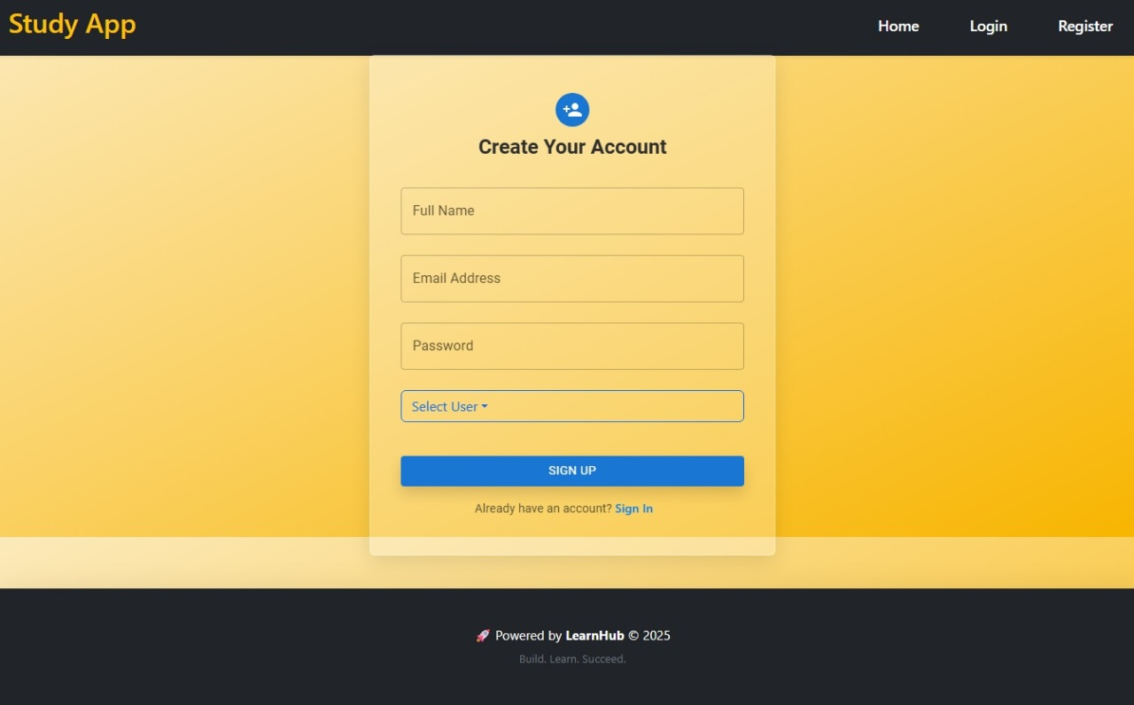

* Login Page :

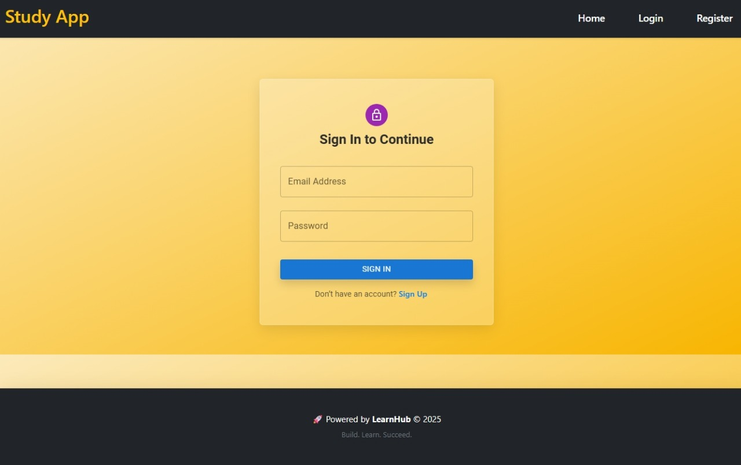

* Course Catalog :

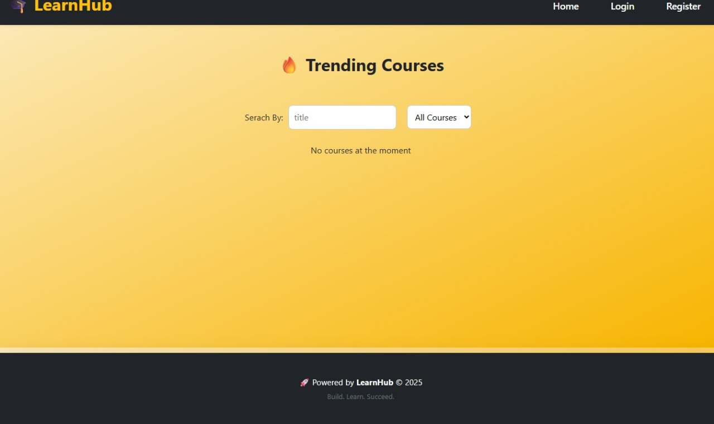

**8. ADVANTAGES & DISADVANTAGES**

**Advantages:**

* Accessible from anywhere, anytime
* Self-paced learning
* Certified content
* Scalability and modular architecture

**Disadvantages:**

* Requires consistent internet connection
* Initial setup complexity

**9. CONCLUSION**

LearnHub successfully delivers an inclusive and interactive learning environment. It bridges the gap between learners and quality educational content by offering a robust platform that supports course creation, enrollment, real-time interaction, and certification. The platform’s modular and scalable design enables educational institutions, instructors, and learners to participate in a flexible learning ecosystem. By supporting self-paced learning, teacher-student communication, and admin oversight, LearnHub provides a comprehensive end-to-end solution. The adoption of modern technologies like React, Express, and MongoDB ensures that the platform remains efficient, adaptable, and relevant to evolving user expectations and educational standards.

**10. FUTURE SCOPE**

* Mobile app development
* AI-based course recommendations
* Integration with job platforms
* Live class support

**11. APPENDIX**

**Source Code :**

<https://github.com/Vardhanbendadi/LEARNHUB>