GenAI Learning Mentor
An LLM + RAG-based Personalized Learning Assistant
Project Report

1. Problem Statement
Learners engaging with Generative AI (GenAI) topics — prompt engineering, RAG, fine-tuning, agents, and evaluation — face a fragmented learning experience. Course material is scattered across PDFs, blogs, and videos; there is no single system that understands a learner's current level, surfaces the right material, tests their understanding, and tells them exactly where they are weak. Generic chatbots can answer isolated questions but do not track progress, do not ground answers in a fixed, trustworthy knowledge base, and do not adapt follow-up content to a learner's demonstrated gaps.
The goal of this project is to build a GenAI Learning Mentor: a conversational assistant that combines Retrieval-Augmented Generation (RAG) with a Large Language Model (LLM) to deliver personalized, grounded, and adaptive learning support — including course notes, curated resources, quizzes, weak-area identification, and targeted practice questions — for anyone learning Generative AI.

1.1 Objectives
- Grounded answers: Retrieve accurate, source-grounded explanations instead of relying purely on an LLM's parametric memory.
- Personalization: Tailor explanations, pacing, and difficulty to the learner's stated level and history.
- Assessment: Generate topic-wise quizzes and score responses automatically.
- Weak-area detection: Detect low-scoring or frequently-missed concepts and flag them for review.
- Reinforcement: Produce targeted practice questions for identified weak areas.

2. Architecture
The system follows a linear RAG pipeline: User → RAG → LLM → Response, with an additional feedback loop so that quiz performance feeds back into future retrieval and personalization decisions. The diagram below expands each stage.
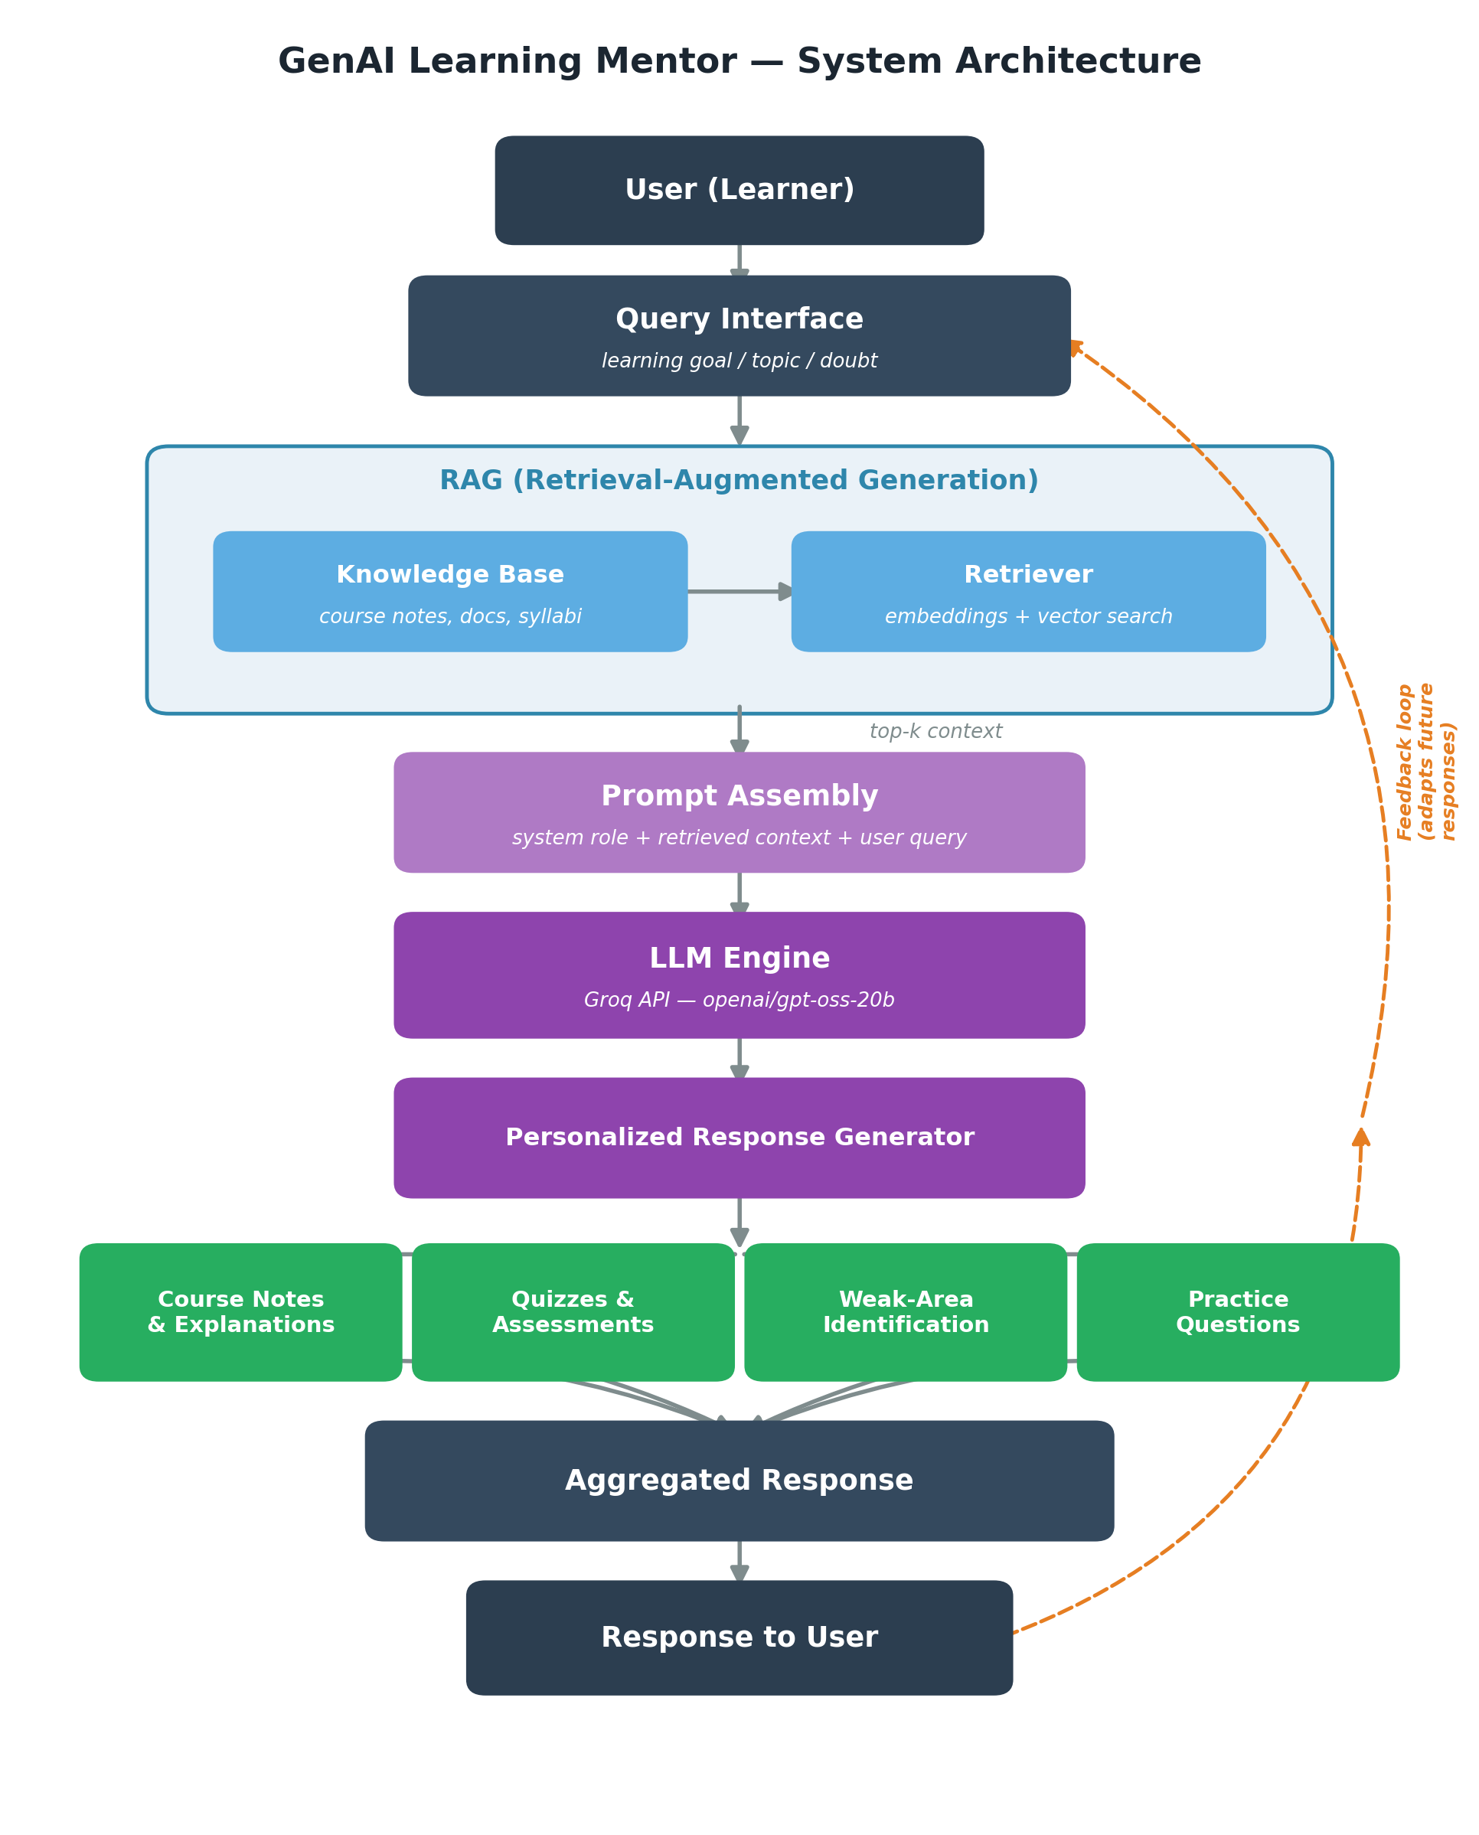
Figure 1: End-to-end system architecture of the GenAI Learning Mentor

2.1 Component Description
- Query Interface: Captures the learner's query — a topic to learn, a doubt, or a request for a quiz.
- RAG (Retriever): Embeds the query and retrieves the top-k most relevant chunks from a knowledge base of course notes, syllabi, and reference documents using vector similarity search.
- Prompt Assembly: Combines a system role (“learning mentor” persona), retrieved context, and the user's query into a single, well-structured prompt sent to the LLM.
- LLM Engine: The retrieved context and query are sent to an LLM hosted on Groq (model: openai/gpt-oss-20b), chosen for its low-latency inference.
- Response Generator: The LLM's output is parsed into four learner-facing modules: course notes/explanations, quizzes, weak-area flags, and practice questions.
- Feedback Loop: Quiz results and flagged weak areas are stored and used to bias future retrieval and prompt content toward the learner's gaps.

2.2 Tech Stack
- Groq API (inference), model openai/gpt-oss-20b
- Python (client SDK: groq)
- Vector store / embeddings for the RAG retriever (e.g. FAISS or ChromaDB)
- Notebook / script-based orchestration for prompt assembly and response parsing

2.3 Sample Inference Call
The core LLM call used to generate a response is shown below (API key omitted — load it from an environment variable, never hardcode it):
from groq import Groq
import os

client = Groq(api_key=os.environ["GROQ_API_KEY"])

completion = client.chat.completions.create(
model="openai/gpt-oss-20b",
messages=[
{"role": "system", "content": "You are a learning mentor."},
{"role": "user", "content": prompt_with_retrieved_context}
],
temperature=0.2,
max_tokens=5000
)
print(completion.choices[0].message.content)

3. Prompt Design
The system prompt fixes the assistant's persona and output contract (“You are a learning mentor”), while the user turn combines three elements at request time: the retrieved context passed through the RAG stage, the learner's stated goal or question, and an explicit instruction describing which output modules are needed.

3.1 Prompt Template
SYSTEM: You are a learning mentor for Generative AI.
Ground every explanation in the provided context.
If context is insufficient, say so explicitly.

USER: Context: {retrieved_chunks}
Learner level: {beginner|intermediate|advanced}
Request: provide personalized learning guidance for
{topic}. Include course notes, learning resources,
a short quiz, weak-area identification based on the
learner's last quiz attempt, and 3-5 practice questions.

3.2 Design Principles
- Role fixing — a persistent system role keeps tone and scope consistent across turns.
- Context grounding — retrieved chunks are always injected ahead of the query so the LLM prioritizes them over parametric knowledge.
- Structured output request — the prompt explicitly enumerates the four deliverables (notes, quiz, weak areas, practice questions) so the response is easy to parse into UI sections.
- Low temperature (0.2) — favors factual, consistent answers over creative variation, appropriate for educational content.

4. Evaluation
Evaluation combines qualitative review of generated content with quantitative checks on retrieval and answer quality.

4.1 Evaluation Criteria
- Retrieval relevance: Do retrieved chunks actually contain the answer to the query? Measured via manual top-k inspection on a sample of test queries.
- Answer correctness: Cross-checking generated explanations and quiz answer keys against the source notes for factual correctness.
- Personalization accuracy: Whether quiz difficulty and explanation depth match the learner's stated level.
- Weak-area detection accuracy: Whether weak-area flags correctly correspond to topics the learner scored poorly on.
- Response latency: End-to-end time from query to full response, relevant given Groq's low-latency inference target.

4.2 Observations
In manual testing, grounding responses in retrieved context measurably reduced hallucinated facts compared to querying the LLM directly without RAG. Quiz generation was reliable for well-represented topics in the knowledge base but degraded when a topic was thinly covered, underscoring the dependence of RAG quality on knowledge-base completeness.

5. Challenges
- Knowledge base curation: Course notes vary in structure and formatting, making chunking and embedding consistency difficult.
- Chunking strategy: Fixed-size chunking sometimes split explanations mid-concept, hurting retrieval quality; overlap tuning was needed.
- Maintaining learner state: Without conversation memory, the mentor could not naturally reference a learner's earlier mistakes across sessions.
- Evaluating free-text answers: Automatically grading open-ended quiz answers (versus multiple-choice) required additional LLM-based grading logic and careful prompt design to avoid inconsistent scoring.
- Secure credential handling: The provided sample code hardcoded the Groq API key directly in the notebook, which is a security risk if shared or committed to version control.
- Latency vs. response length: Longer responses (up to 5000 tokens) increased latency and occasionally produced verbose output that needed post-processing into concise sections.

6. Future Enhancements
- Persistent learner profiles: Persist quiz history and weak-area flags per learner to enable true multi-session adaptive learning.
- Adaptive retrieval: Move from static top-k retrieval to feedback-informed retrieval that prioritizes chunks related to a learner's known weak areas.
- Interactive front-end: Present quizzes and progress dashboards through a web UI rather than notebook output.
- Voice interface: Support voice-based Q&A for accessibility and hands-free study sessions.
- Resource recommendation engine: Recommend external videos, articles, or courses alongside internal notes, ranked by relevance to the weak area.
- Automated evaluation pipeline: Automatically evaluate RAG and LLM output quality using metrics such as answer relevance, faithfulness, and context precision (e.g. via RAGAS).
- Secure key management: Store the API key in environment variables or a secrets manager, and add key rotation.

End of Report

