**U-Net Based Semantic Segmentation**

**Batch – 8**

**CH. Sri Vardhan**

**K. Pavan Kalyan**

**Problem statement:**

The goal is to develop a semantic segmentation model using the U-Net architecture to accurately segment various objects in urban street scenes. This segmentation will help in identifying and delineating different classes such as roads, sidewalks, buildings, pedestrians, vehicles, trees, and other relevant objects in the scene.

**Introduction:**

Semantic segmentation, a fundamental task in computer vision, plays a pivotal role in various applications such as autonomous driving, medical imaging, and augmented reality. It involves the pixel-wise classification of objects within an image, enabling machines to understand the semantic meaning of each pixel and extract meaningful information about the scene. Among the myriad of techniques developed for semantic segmentation, deep learning has emerged as a powerful paradigm, offering unprecedented accuracy and efficiency in complex image understanding tasks.

In recent years, the U-Net architecture has gained significant traction for semantic segmentation due to its remarkable performance and architecture simplicity. Inspired by the encoder-decoder framework, U-Net features a symmetrical architecture with skip connections, facilitating the precise localization of objects while effectively capturing contextual information. This unique design makes U-Net particularly suitable for tasks requiring high-resolution segmentation, such as medical image analysis and fine-grained object detection.

Motivated by the success of U-Net in various domains, this study focuses on its application to semantic segmentation on a person dataset sourced from Kaggle. The dataset encompasses a diverse range of images depicting individuals in various contexts, presenting challenges such as occlusions, varying poses, and complex backgrounds. The objective is to accurately delineate person instances within the images, facilitating applications like human activity recognition, crowd analysis, and video surveillance.

**Challenges:**

Semantic segmentation of person instances poses several significant challenges due to the diverse nature of human appearances, varied poses, occlusions, and complex backgrounds present in real-world images. These challenges necessitate the development of sophisticated algorithms capable of robustly delineating person instances while maintaining high accuracy and efficiency.

Human appearances exhibit significant variability in terms of clothing, skin color, hairstyles, and accessories. This variability introduces complexities in accurately identifying and segmenting person instances across different images. Moreover, variations in illumination and imaging conditions further exacerbate the challenge, requiring models to generalize well across diverse appearances and lighting conditions.

**Semantic Segmentation**

Semantic segmentation is a computer vision task that involves partitioning an image into multiple segments, or regions, and assigning each segment a label that represents the category of the object it belongs to. Unlike object detection, which typically identifies objects by drawing bounding boxes around them, semantic segmentation provides a pixel-level understanding of the image by labeling each pixel with a class label.

The U-Net architecture is a popular neural network architecture designed for semantic segmentation tasks, particularly in biomedical image segmentation, where it has shown remarkable performance. It was introduced by Olaf Ronneberger, Philipp Fischer, and Thomas Brox in 2015. The architecture is characterized by its U-shaped design, which resembles an encoder-decoder architecture with skip connections.

**U-Net Architecture**

**Encoder Path:**

The encoder path is responsible for extracting features from the input image. It consists of a series of convolutional and pooling layers that gradually reduce the spatial dimensions of the input image while increasing the number of feature channels. This process is akin to downsampling or feature extraction.

**Decoder Path:**

The decoder path is responsible for upsampling the feature maps to generate the segmentation mask. It consists of a series of upsampling layers, which increase the spatial dimensions of the feature maps back to the size of the input image. Each upsampling step is usually accompanied by a concatenation operation with the corresponding feature maps from the encoder path.

**Skip Connections:**

One of the key innovations of the U-Net architecture is the extensive use of skip connections. These connections facilitate the flow of high-resolution information from the encoder to the decoder path, helping the network to recover spatial details lost during downsampling. Skip connections are typically implemented using concatenation or element-wise addition.

**Final Layer:**

The final layer of the U-Net architecture typically consists of a 1x1 convolutional layer followed by a softmax activation function. This layer generates the segmentation mask by assigning a class label to each pixel in the input image.

**Loss Function:**

The training of U-Net is typically done using a loss function such as cross-entropy loss, which measures the dissimilarity between the predicted segmentation mask and the ground truth mask. Additionally, auxiliary losses can be incorporated at different stages of the decoder path to encourage the network to learn hierarchical representations.

**Data Augmentation and Regularization:**

To improve generalization and robustness, data augmentation techniques such as rotation, scaling, and flipping are often applied during training. Regularization techniques like dropout or batch normalization may also be employed to prevent overfitting.

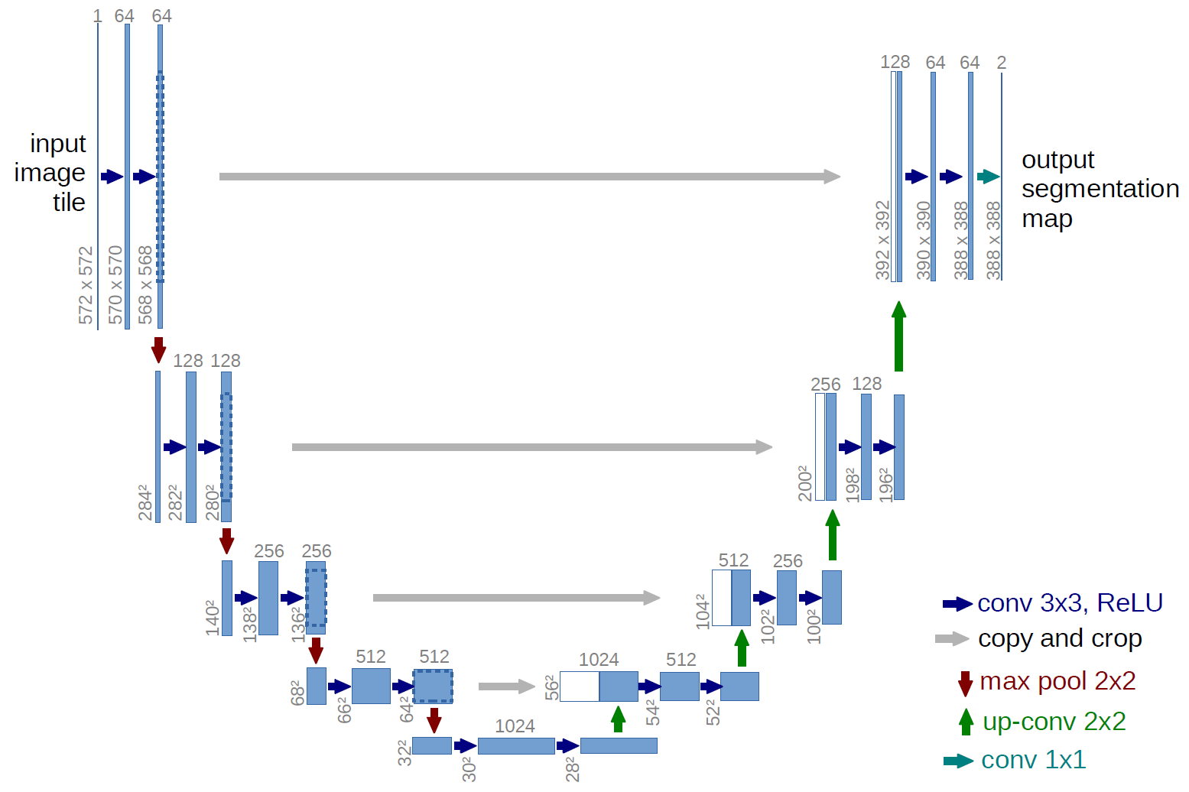

**Experimental Results**

In this section, we present the experimental results of applying the U-Net architecture to the semantic segmentation of person instances using the Kaggle dataset. We detail the dataset statistics, training setup, quantitative metrics, qualitative analysis, and comparison with existing methods.

We evaluate the performance of the trained U-Net model on the test set using standard quantitative metrics for semantic segmentation tasks. These metrics include pixel accuracy, mean Intersection over Union (IoU), and the Dice coefficient. Pixel accuracy measures the percentage of correctly classified pixels, while IoU quantifies the overlap between predicted and ground truth masks. The Dice coefficient computes the similarity between predicted and ground truth segmentations.

**Conclusion**

In this study, we investigated the effectiveness of the U-Net architecture for semantic segmentation of person instances using the Kaggle dataset. By leveraging deep learning techniques, transfer learning, and extensive experimentation, we developed a robust pipeline for accurately delineating person instances from complex backgrounds.

Our experimental results demonstrate the efficacy of the proposed approach in semantic segmentation tasks. The trained U-Net model achieves competitive performance metrics, including pixel accuracy, mean Intersection over Union (IoU), and the Dice coefficient, on the test set. Qualitative analysis further confirms the model's ability to capture fine-grained details and contours, even in challenging scenarios with occlusions and cluttered backgrounds.