Student Report System – Mini Project Documentation
Course / Subject: PYTHON PROGRAMMING
Academic Year:2025-26

Team Members
• Name: Sanjana Pandharkar PRN: 1262251827
• Name: Pragnya Pal PRN: 1262252574
• Name: Tania Roy PRN: 1262251952
• Name:Vardhini Chavan PRN:1262251614
• Name: Samiksha Satav PRN: 1262253498
• Batch:2 Division:6

This document presents a detailed explanation of the mini project titled “Student Report System”. It covers the dataset used, preprocessing steps, functions implemented in Python, visualization techniques, algorithm, and final conclusions.

1. Introduction
In schools and colleges, teachers and students often struggle to manually track academic performance for an entire class. Marksheets are usually maintained in registers or static spreadsheets, which makes it difficult to quickly identify weak subjects, compare students, or visualize the overall performance of the class. The Student Report System aims to solve this problem by using Python, pandas, and matplotlib to build a simple yet powerful analysis tool.
The project provides two modes of interaction:
1) Teacher Mode – allows the teacher to add student records, analyze performance using visual graphs, view rank lists, and compare subject-wise averages.
2) Student Mode – allows a student to log in using their name, view their marks, identify weak subjects, and receive a list of suggested study materials to improve in those subjects.
By combining data analysis with visualization, this mini project demonstrates how programming can make evaluation more interactive, faster, and more insightful for both teachers and students.

2. Problem Statement

To design and implement a Python-based Student Report System which reads student performance data from a CSV file, processes the data to identify weak subjects and overall performance levels, and generates meaningful visualizations (heatmap, radar chart, trendline, bar charts) to help teachers and students understand academic performance in a clear and structured way.

3. Objectives of the Mini Project

The main objectives of the Student Report System are:
• To automate the basic analysis of student marks using Python and pandas.
• To provide a simple interface for teachers to add new student records and view summarized information.
• To help students identify their weak subjects based on their marks and get recommended study material.
• To visualize class performance through graphs such as heatmaps, radar charts, trendlines, and bar charts.
• To demonstrate the use of data preprocessing, conditional logic, and plotting in a real-world scenario.

4. Dataset Description
The project uses a CSV file named “students.csv” as the main dataset. Each row in this file represents one student. The file contains the following columns:
• Name – Name of the student.
• Maths – Marks obtained in Mathematics.
• Science – Marks obtained in Science.
• English – Marks obtained in English.
• History – Marks obtained in History.
• Computer – Marks obtained in Computer Science / IT.
• Assignments Completed – Number of assignments submitted by the student.
• Assignments Due – Number of assignments still pending.
These fields together give a complete picture of the academic status of each student. The subject marks help in computing total and average scores, while the assignment-related columns provide an idea about the student’s consistency and discipline. The dataset is simple but sufficient for demonstrating data analysis operations such as filtering, aggregating, and ranking.

4.1 Sample Dataset View
A portion of the dataset is shown below to illustrate its structure. Each record corresponds to one student:
This tabular structure makes it easy to load the data using pandas and perform further analysis such as computing averages, totals, and comparisons.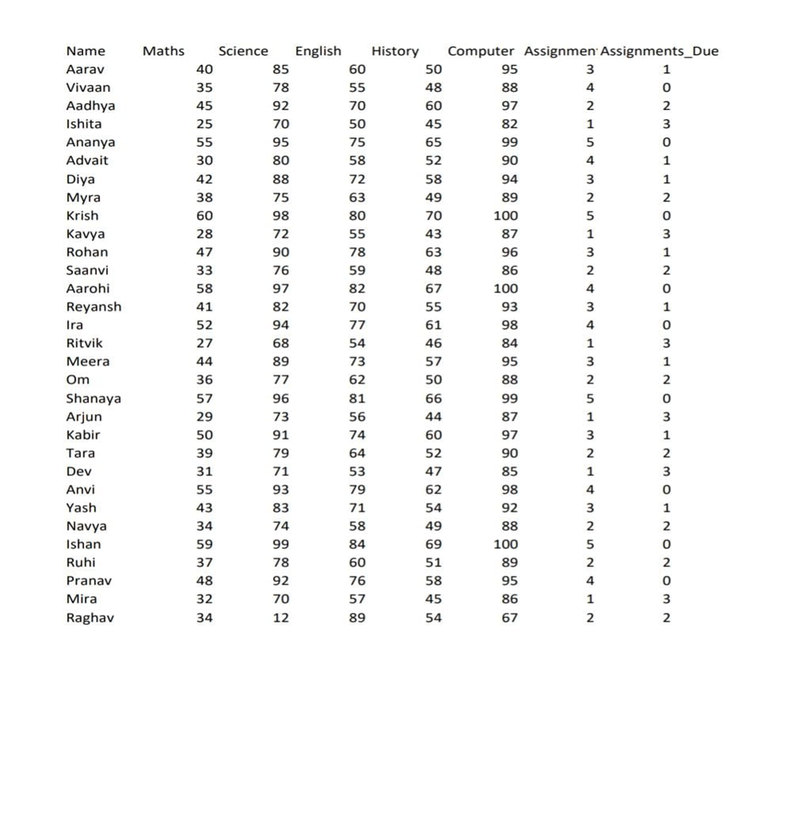

5. Data Preprocessing and Analysis Tasks Performed
Several preprocessing and analysis steps are performed on the dataset before generating the final outputs:
1) Loading the dataset: The function load_data() checks whether the CSV file exists and loads it into a pandas DataFrame. This forms the basis for all further operations.
2) Handling missing file: If the CSV file is not found, an appropriate message is printed so that the user can create or provide the correct dataset.
3) Identification of weak subjects: For each student, marks in each subject are checked. If a mark is less than 60, that subject is considered a weak subject and the system recommends study material.
4) Calculation of total and average marks: Using the subject columns (Maths, Science, English, History, Computer), a total score is computed. The average is then used to assign a performance badge.
5) Badge assignment: Depending on the average marks, students are given badges like “Top Performer”, “Consistent Performer”, “Improving Student”, or “Needs Support”. This gives a quick qualitative overview of performance.
6) Ranking students: A separate “Total” column is added and students are sorted in descending order to generate a rank list showing the highest scoring students at the top.
In addition to these numeric calculations, the system also focuses on visual analysis:
• Heatmap: Shows the distribution of marks across all subjects and students, helping teachers spot patterns.
• Radar chart: Highlights the strengths and weaknesses of an individual student across all five subjects.
• Trendline: Displays the average marks of the class in each subject, indicating which subjects the class finds easier or more difficult.
• Subject comparison bar chart: Visually compares average marks of all subjects side by side.

5.1 Study Material Recommendation Logic
The project also integrates a simple recommendation system using a predefined dictionary named STUDY_MATERIALS. For every subject, a list of useful resources such as NCERT PDFs, YouTube playlists, or learning websites is stored. When a student’s mark in a subject is below 60, that subject name is added to the weak_subjects dictionary along with the corresponding study material list. This makes the output more meaningful, as it not only tells the student that a subject is weak but also shows what they can do to improve it.

6. List of Functions and System Design
The system is divided into multiple functions, each handling a specific responsibility. This modular design improves readability, debugging, and future extension of the code.
• load_data(): Reads the CSV file “students.csv” and returns a pandas DataFrame.
• save_data(df): Saves any updated DataFrame back into the CSV file.
• loading(text): Displays a simple loading animation with a progress bar in the console.
• assign_badge(student): Calculates the average of five subjects for a student and returns the appropriate badge based on the range in which the average falls.
• get_study_material(student_row): Checks each subject score; if it is less than 60, it fetches the list of recommended resources for that subject and returns them.
• add_student(df): Interacts with the user to input a new student’s name, subject marks, and assignment data, then appends this information as a new row in the DataFrame and saves it.
• show_heatmap(df): Uses matplotlib to generate a heatmap where rows represent students and columns represent subjects. Color intensity indicates the marks obtained.
• radar_chart(student): Generates a circular radar/spider chart showing how a particular student scores across the five subjects.
• show_trendline(df): Plots the average marks of the entire class for each subject in the form of a line graph.
• subject_comparison(df): Creates a bar chart of subject-wise class averages.
• ranklist(df): Computes total marks for each student and displays the top students in descending order.
• student_mode(df): Handles the interaction when a student logs in, prints their marks, generates a radar chart, shows weak subjects, and displays their badge.
• teacher_mode(df): Provides a menu-driven interface for teachers to add students and view all visualizations.
• main(): The entry point which loads the data, shows the initial menu and calls teacher_mode or student_mode based on user choice.

7. Algorithm & Flow of Execution
Step 1: Start the program and call main().
Step 2: Load the dataset using load_data(). If the file is missing, display an error and stop execution.
Step 3: Display the main menu with options: Teacher Login, Student Login, or Exit.
Step 4: If Teacher Login is chosen, ask for password. On successful authentication, call teacher_mode().
Step 5: Inside teacher_mode(), repeatedly show a menu with options like Add Student, View Heatmap, Radar Chart, Class Trendline, Subject Comparison, Rank List, and Exit. Perform the selected operation.
Step 6: If Student Login is chosen, ask for the student’s name. If the name exists in the dataset, display their full record, generate the radar chart, show weak subjects with recommended study materials, and display their badge.
Step 7: Continue running until the user chooses the Exit option. Then, terminate the program gracefully.
Flowchart: A flowchart can be drawn showing the branching between Teacher Mode and Student Mode, and how each option leads to different functions and visual outputs.

8. Screenshots of Obtained Results

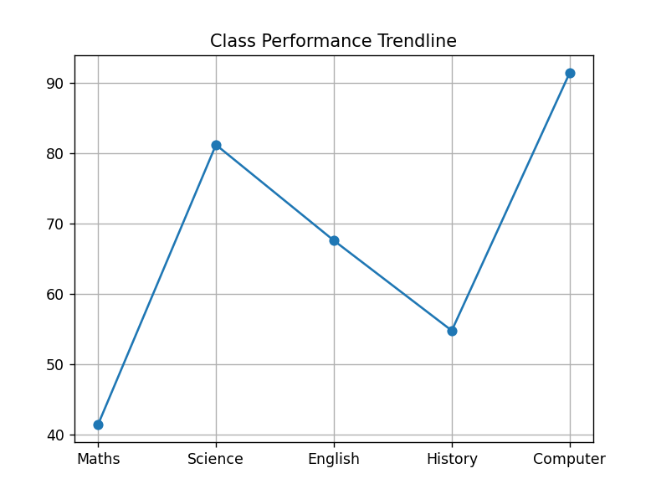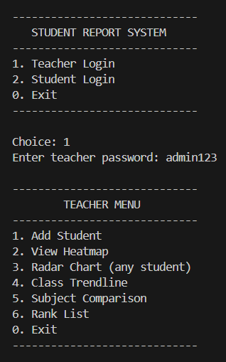: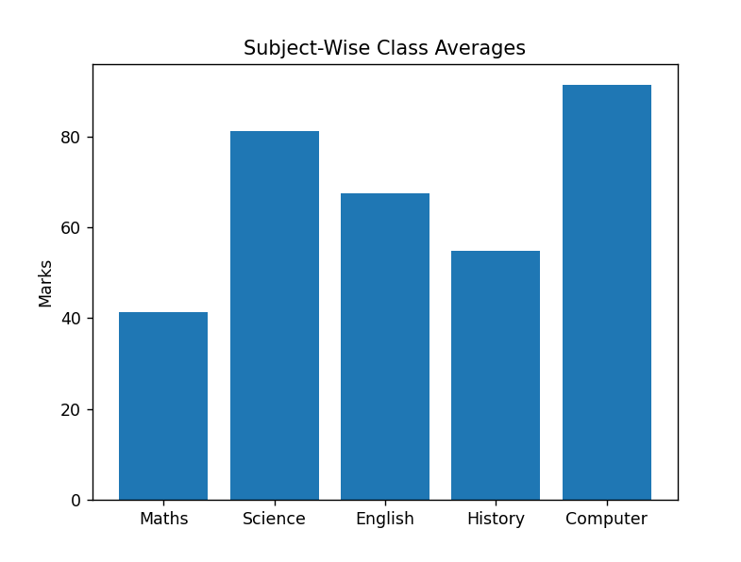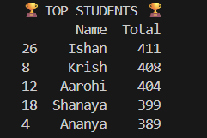

Console view of Student Login and performance output

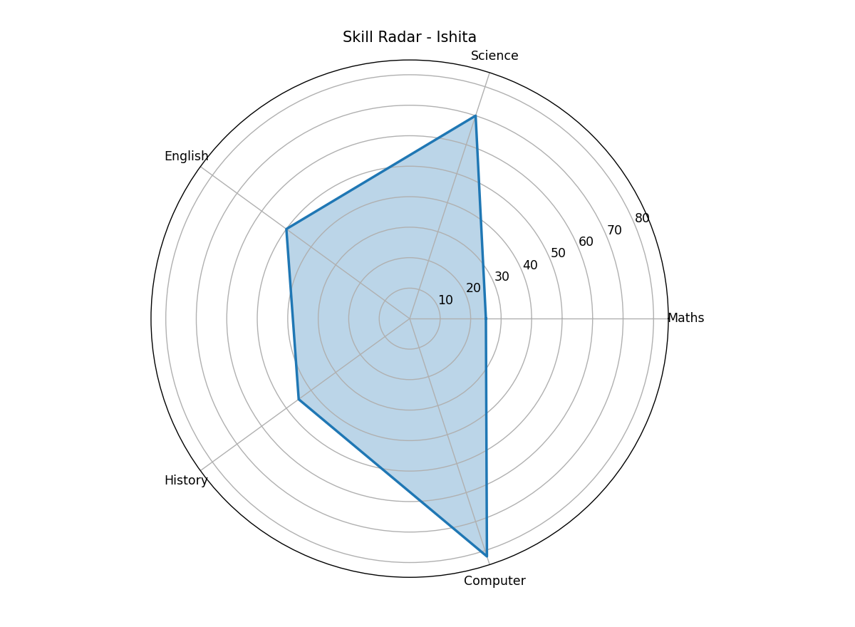
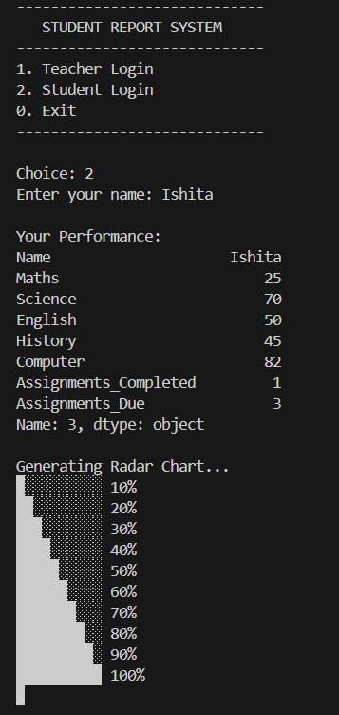

9. Conclusion
The Student Report System mini project demonstrates how basic concepts of Python programming, file handling, data preprocessing, and visualization can be combined to solve a real academic problem. It helps teachers quickly understand the overall performance of a class and gives students clear feedback about their strengths and weaknesses. The use of visual tools such as heatmaps and radar charts makes the analysis more intuitive compared to plain text or tables.
The modular function-based design ensures that the system can be easily maintained and extended. For example, additional subjects, new types of graphs, or advanced analytics (like predicting future performance) can be added without changing the core structure of the program.

10. Future Scope
This project can be extended in several ways:
• Adding a graphical user interface (GUI) using libraries like Tkinter or PyQt.
• Integrating a database system (MySQL / SQLite) instead of a CSV file for better scalability.
• Providing login credentials for each student and teacher for better security.
• Implementing predictive analytics such as forecasting performance trends based on past marks.
• Exporting performance reports as PDF files automatically for each student.

