Module | Z03DT
Academic Year | 2023-24
Block | 4
Title | Reflective Report
Student Name | Jambayev Mansur
Student ID:
Date: | 5-25-2026
Word Count: | 1556

Table of contents
1 Introduction 2
2 Network Design 3
2.1 Network Topology 3
2.2 Intermediate Network Design 3
2.3 Local Network Designs 4
2.4 IP Addressing Scheme 5
2.4.1 WAN IP Addresses 6
2.4.2 LAN IP Addresses (Building A) 6
2.4.3 LAN IP Addresses (Building B) 6
2.5 Network Function 6
3 Scalability, Security, Redundancy and Efficiency 8
3.1 Scalability 8
3.2 Redundancy & Efficiency 8
3.3 Security 8
4 Network Evaluation 9
4.1 Network Performance 9
4.2 Design Challenges 9
4.3 Testing Strategy 10
5 Conclusion & Recommendations 10
References 10
Appendix A – Topologies 11
Topologies 11
Intermediate Network 11
Local Network A 11
Local Network B 11
Appendix B - IP Addressing Scheme 11
WAN IP Address Scheme 11
Intermediate Level (MAN) IP Address Scheme 11
Building A (LAN) IP Address Scheme 11
Building B (LAN) IP Address Scheme 11
Appendix C – Device Purpose and Configuration 11
Top Level (WAN) 11
Intermediate Level (MAN) 11
Building A (LAN) 11
Building B (LAN) 11
Appendix D - Testing Documents 11
Appendix E - Documents 11

Table of Figures
Figure 1 – Network Topology 2
Figure 2 – Outline Intermediate Design 3
Figure 3 – Building A Local Network Design 3
Figure 4 - Building B Local Network Design 3
Figure 5 - Server Resources 4
Figure 6 – Network Switches 4
Figure 7 – Network Routers 4
Figure 8 – Security Configuration 5

Introduction
This report reflects on the design and implementation of a network connection of two Kawa Marketing company’s buildings in Astana and Almaty. The project required VLAN segmentation, IP addressing with VLSM, dynamic routing (OSPF), DHCP, DNS, web server, wireless access, and security measures. The network supports 30 devices per department in Astana and 15 in Almaty with 50% scalability.

Network Design

Network Topology

Figure 1 – Network Topology
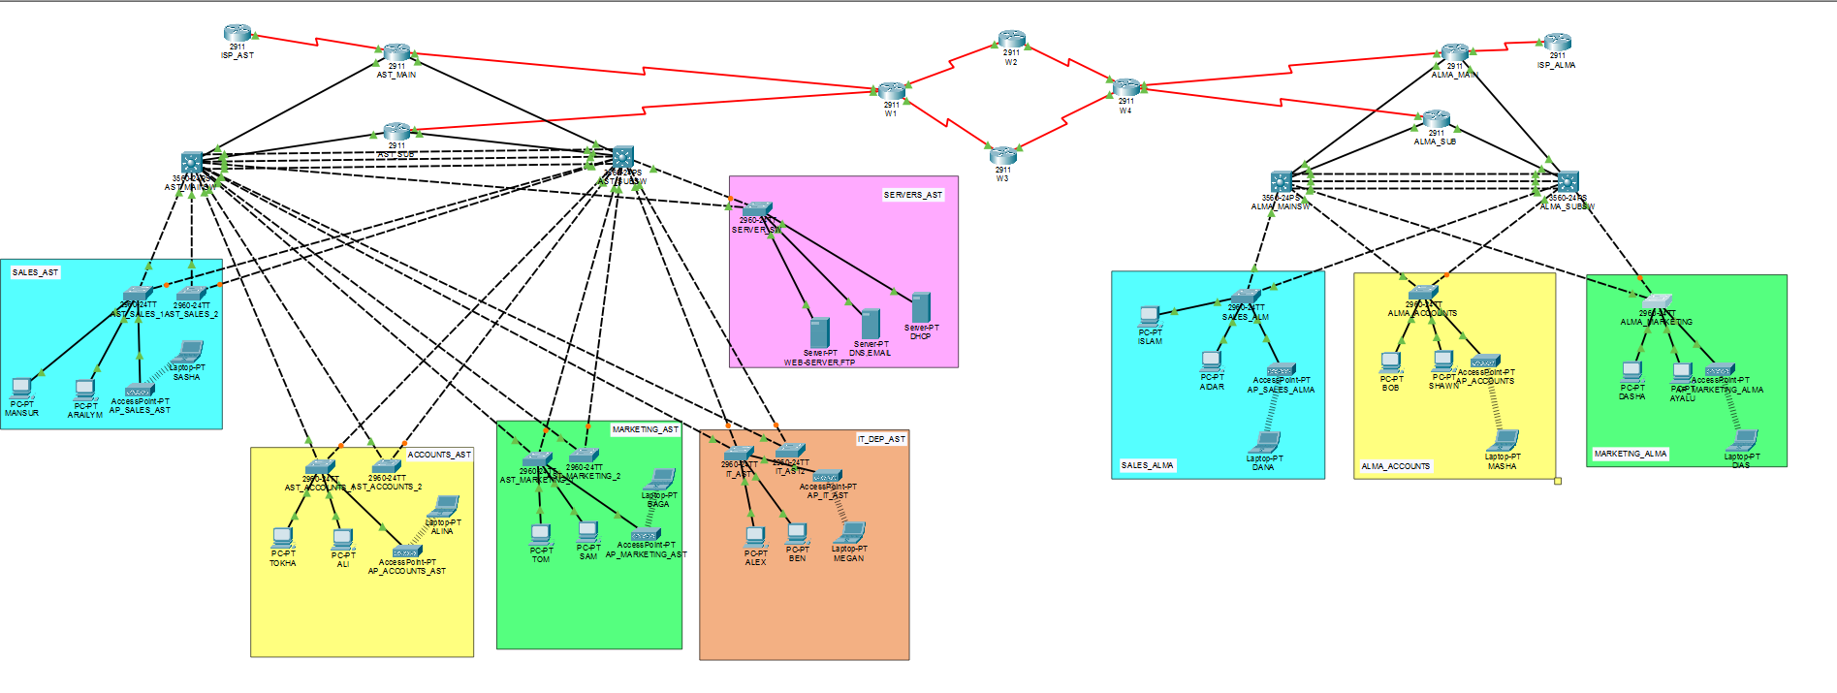
The network uses a hierarchical hybrid topology: partial mesh at WAN level (multiple serial links for redundancy), and star topology within each building. This provides scalability and redundancy. Other topologies such as pure star were considered, and it would be cheaper to construct. However, it lacks redundancy. Another approach was a full mesh, but it would be extremely expensive. Therefore, the chosen design balances cost and reliability.

Intermediate Network Design
Figure 2 – Outline Intermediate Design
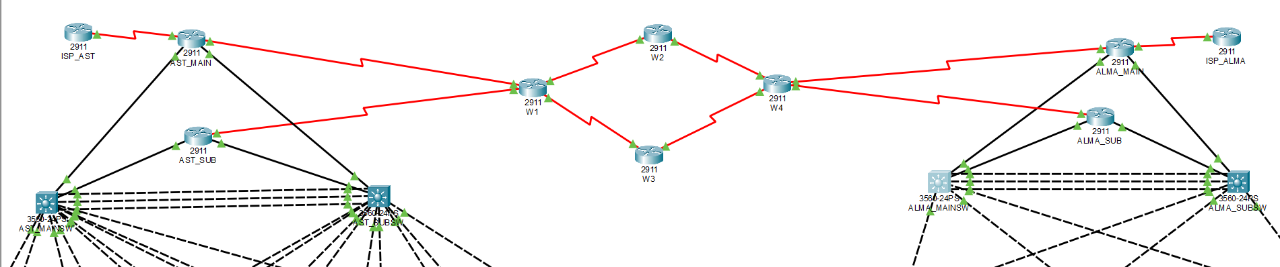
The intermediate network design connects the Astana and Almaty sites using a serial point-to-point topology with two edge routers on both buildings (AST_MAIN, AST_SUB and ALMA_MAIN, ALMA_SUB), also includes 4 WAN routers: W1, W2, W3, W4. Each link uses a /30 subnet from the allocated WAN range 10.10.76.0/24, which conserves address space. OSPF v.2 is deployed across all routers with area 0. Because it provides fast convergence and dynamic route exchange. Hence, this design meets the requirement of at and ensures reliable long-distance communication. Moreover, redundancy can be added by introducing parallel links.

Local Network Designs
Figure 3 – Building A (Astana Building) Local Network Design
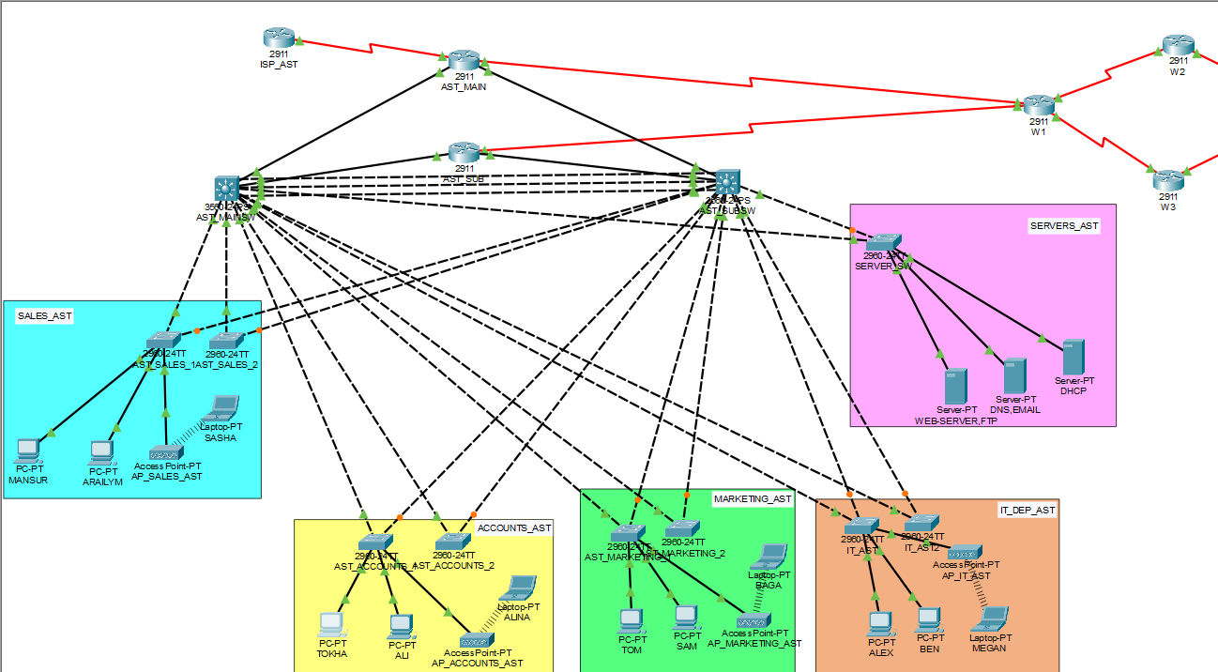
The local network design in Astana follows a hierarchical star topology. A two Layer-3 switches (AST_MAINSW and AST_SUBSW) acts as the distribution and core devices, interconnecting two access switches for each department, and one access switch for the server room. VLANs (10,20,30,40,50,99) segment each department, with inter-VLAN routing performed on the L3 switch. The server room (VLAN 50, subnet 192.168.38.224/28) is logically separated from client devices. Also, the VLAN99 - AST_MGMT use 192.168.39.112/28 address. Moreover, a wireless access point is connected to each access switch, providing Wi-Fi coverage. This design enables scalability to +50% devices.

Figure 4 - Building B (Almaty Building) Local Network Design
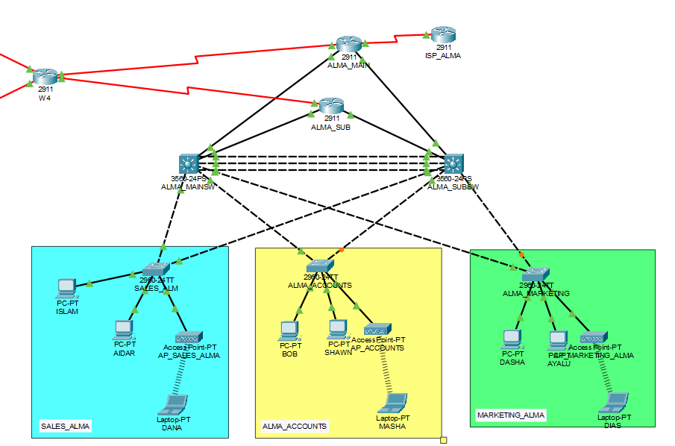
The Almaty’s local design uses a similar hierarchical star topology, but with fewer devices. A Layer-3 switches ALMA_MAINSW and ALMA_SUBSW connect three access switches corresponding to three departments (VLANs 110,120,130). A separate management VLAN 199 (ALMA_MGMT) is used for network equipment. Inter-VLAN routing is handled by the L3 switch. Wireless access points are attached to each access switch. The addressing uses 192.168.39.0/24 with /27 subnets, providing 30 usable addresses per department – sufficient for 15 devices plus 50% expansion.

IP Addressing Scheme
The IP addressing structure uses VLSM (Variable Length Subnet Masking), which allows to use subnets according to the needs of each network segment. The private network range 192.168.38.0/23 is allocated for all internal LANs, with subnet sizes determined by the required number of devices plus an additional 50% for future expansion. For instance, Astana Sales department needs to support for 30 devices, so the calculation increased this to 45 hosts. Therefore, a /26 subnet was chosen because it provides 62 usable addresses. The 10.10.76.0/24 network is used for WAN connections between routers, while 85.76.10.0/24 is used for links between edge routers and the ISP. VLAN implementation also improves security by separating departments and restricting unauthorized communication between them. The detailed IP Addressing Scheme is available in Appendix B.

WAN IP Addresses
WAN IP addresses are assigned from the 10.10.76.0/24 network and used for serial connections between routers in Astana and Almaty. Therefore, the usage of dedicated WAN address block helps separate inter-city routing traffic from internal LAN communication and avoids IP address conflicts. Also, the /30 subnet mask was used to provide peer-to-peer link between routers and remove unnecessary hosts. The serial links operate with DCE/DTE configuration. Edge routers function as DCE devices, supplying the 64000 clock rate to regulate transmission speed, while the R-WAN routers operate as DTE devices, receiving the timing signal.

LAN IP Addresses (Building A)
For Building A (Astana), the private range 192.168.38.0/23 is subnetted using VLSM. Departments Sales, Accounts, Marketing receive /26 subnets (62 hosts) to support 30 devices plus 50% expansion. The IT department uses a /27 subnet (30 hosts), while the server room is allocated a separate /28 subnet (14 hosts) for logical isolation. Management VLAN AST_MGMT uses 192.168.39.112/28. DHCP helper addresses are configured on SVIs to relay requests to the DHCP server. Full details are in Appendix B.

LAN IP Addresses (Building B)
For Building B (Almaty), the same private range 192.168.38.0/23 is used, but Almaty departments are allocated from 192.168.39.0/24. Each department (Sales_Alm, Alma_Accounts, Alma_Marketing) receives a /27 subnet (30 usable addresses), which comfortably supports 15 devices with 50% expansion. Management VLAN 199 (ALMA_MGMT) uses 192.168.39.96/28. Moreover, there are no servers in Almaty. Therefore, ip helper-address command was written in each department’s vlan in distribution switches to forward requests to the central DHCP server in Astana. Complete addressing details are in Appendix B.

Network Function
Figure 5 - Server Resources
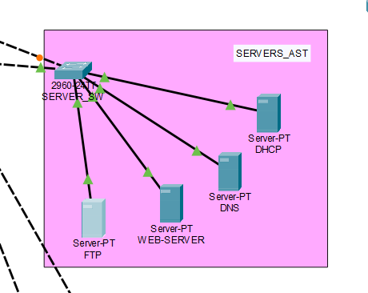
Several devices were utilized in the design, and their broad functions are outlined here. In this project, servers (DHCP, DNS, WEB, TFTP) are hosted on VLAN 50 (192.168.38.224/28) and connected to the Server_SW L2 switch. The location, configuration information and purpose of each device is described in detail in Appendix C
Figure 6 – Network Switches
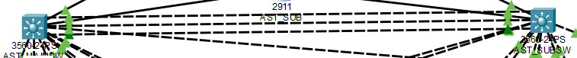

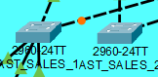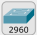
The 2960-24TT L2 switch was used access switch that provide network access to end devices. Similarly, the role of the backbone L3 switches is performed by the 3560-24TS, providing high-speed routing between departments and connection to the edge routers. All devices configured with redundancy via HSRP and secured by ACL and SSH. Also, EtherChannel (Port-Channel) is enabled on L3 switches for higher throughput. Full details are provided in Appendix C.
Figure 7 – Network Routers
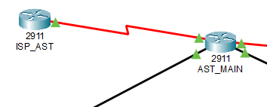
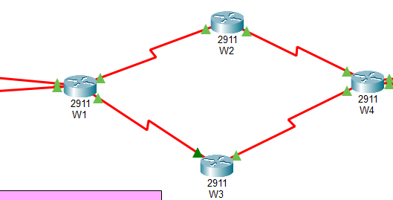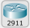
The 2911 routers were deployed as edge and WAN transit devices. Firstly, ISP_AST simulates the Internet provider, providing a public IP and a static return route to the corporate network. Secondly, AST_MAIN acts as the Astana edge router. Lastly, W1 has a role of WAN router that simulates connection to Almaty building. They run OSPF area 0 to exchange routes with Almaty, edge router performs NAT overload for internet access, and ACLs and SSH v.2 were applied on each device. Full configuration details are available in Appendix C.

Scalability, Security, Redundancy and Efficiency

Scalability
The network can support 50% scalability through VLSM addressing. For instance, Astana departments use /26 subnets (62 hosts), Almaty uses /27 (30 hosts). Moreover, additional access switches can be added to each department without re-addressing. The core L3 switch (AST_MAINSW) has sufficient routing capacity and can be stacked or grouped. OSPF scales to 50+ routers. However, the single WAN link between Astana and Almaty is a limitation, due to chance of becoming overloaded. To response this challenge, adding a second serial link with equal-cost multipath (ECMP) in OSPF would resolve this. Also, the current HSRP pair allows adding more distribution switches.

Redundancy & Efficiency
Redundancy is concentrated at critical points: HSRP protects gateway SVIs on AST_SUBSW and ALMA_SUBSW, ensuring seamless failover. In addition, EtherChannel provides access switch uplinks, providing link redundancy without STP blocking. Moreover, the TFTP server keeps all configs of all devices in this network. Consequently, the initial startup-config can be easily restored, if necessary. However, the WAN chain lacks parallel links, because redundancy is sacrificed for cost efficiency. This balance keeps hardware low while protecting core LAN segments. Also, OSPF is configured to support future ECMP if secondary links are added, improving both redundancy and throughput without a full redesign.

Security
The main security risks are unauthorized access to VTY lines, weak password storage, and unauthorized devices on access ports. To reduce these risks, enable secret (cisco123) and local users with service password-encryption (admin!) was enabled to protect credentials. SSHv2 replaces Telnet, and ACL SSH_ACCESS permits management only from IT subnet (192.168.38.192/27). Port security limits MAC addresses on access ports; also, OSPF uses passive-interface default to avoid hello packets on LANs. Logging is not implemented in this simulation. To address future enhancements, OSPF MD5 authentication and AAA configuration can be added.

Figure 8 – Security Configuration of AST_MAIN
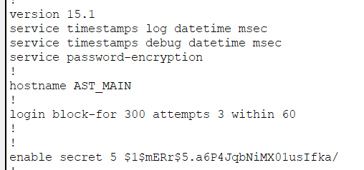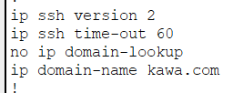
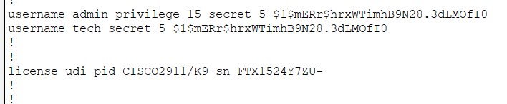
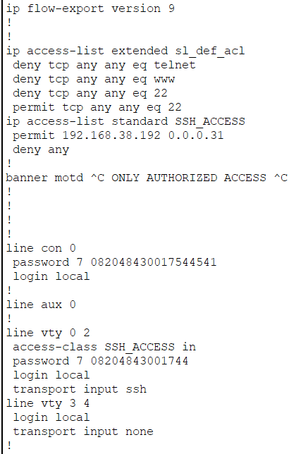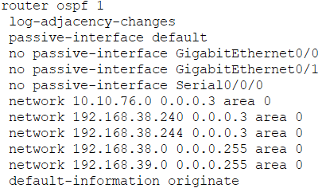

Network Evaluation

Network Performance
Performance was enhanced in the design by using EtherChannel between distribution switches, increasing total bandwidth and removing STP blocking. Also, OSPF with ECMP is ready for parallel WAN links (currently single path). In addition, VLANs reduce broadcast domains and improve switching efficiency. Potential bottlenecks are the serial WAN chain that runs at 64 kbps, which may cause latency and packet loss under heavy traffic. Therefore, to further relieve congestion, additional parallel serial links and faster interfaces (e.g., Ethernet) could be deployed, allowing ECMP load balancing.

Design Challenges
Key challenges were OSPF neighborship failing and ISP configuration. OSPF was failing due to passive-interface default on WAN serial links. To address this problem, passive-interface Serial0/0/0 was added. Another major issue was traffic between Astana and Almaty went via ISP. It was fixed by adding no passive- interface on ISP to edge router connection and L3 switch to edge router connection, and ensuring OSPF advertises LAN subnets.

Testing Strategy
Firstly, WAN connectivity was tested with extended pings between AST_MAIN and ALMA_MAIN, plus traceroute to ensure traffic does not pass via ISP. Secondly, LAN testing included pings within same VLAN and between different VLANs. In addition, OSPF neighbour states were verified using show ip ospf neighbor. Lastly, DHCP, DNS, TFTP and HTTP services were validated from client workstations. All test logs and screenshots are provided in Appendix D.

Conclusion & Recommendations
This network successfully connects Astana and Almaty sites using OSPF over serial WAN links. VLAN segmentation, HSRP redundancy, and SSH-based security meet all requirements. Moreover, DHCP, DNS, and web servers operate correctly. A key achievement is isolating server traffic and enabling site-to-site communication without going through ISP. Future enhancements add parallel connections for ECMP load balancing. Also, the usage of OSPF MD5 authentication and AAA for stronger security.

AI Use Referencing
AI use category | tool | How AI tool was used in this assignment
Writing Support | DeepSeek | Improving Grammar and paraphrasing

References

Appendix A – Topologies

Topologies
Figure A1 – Network Topology
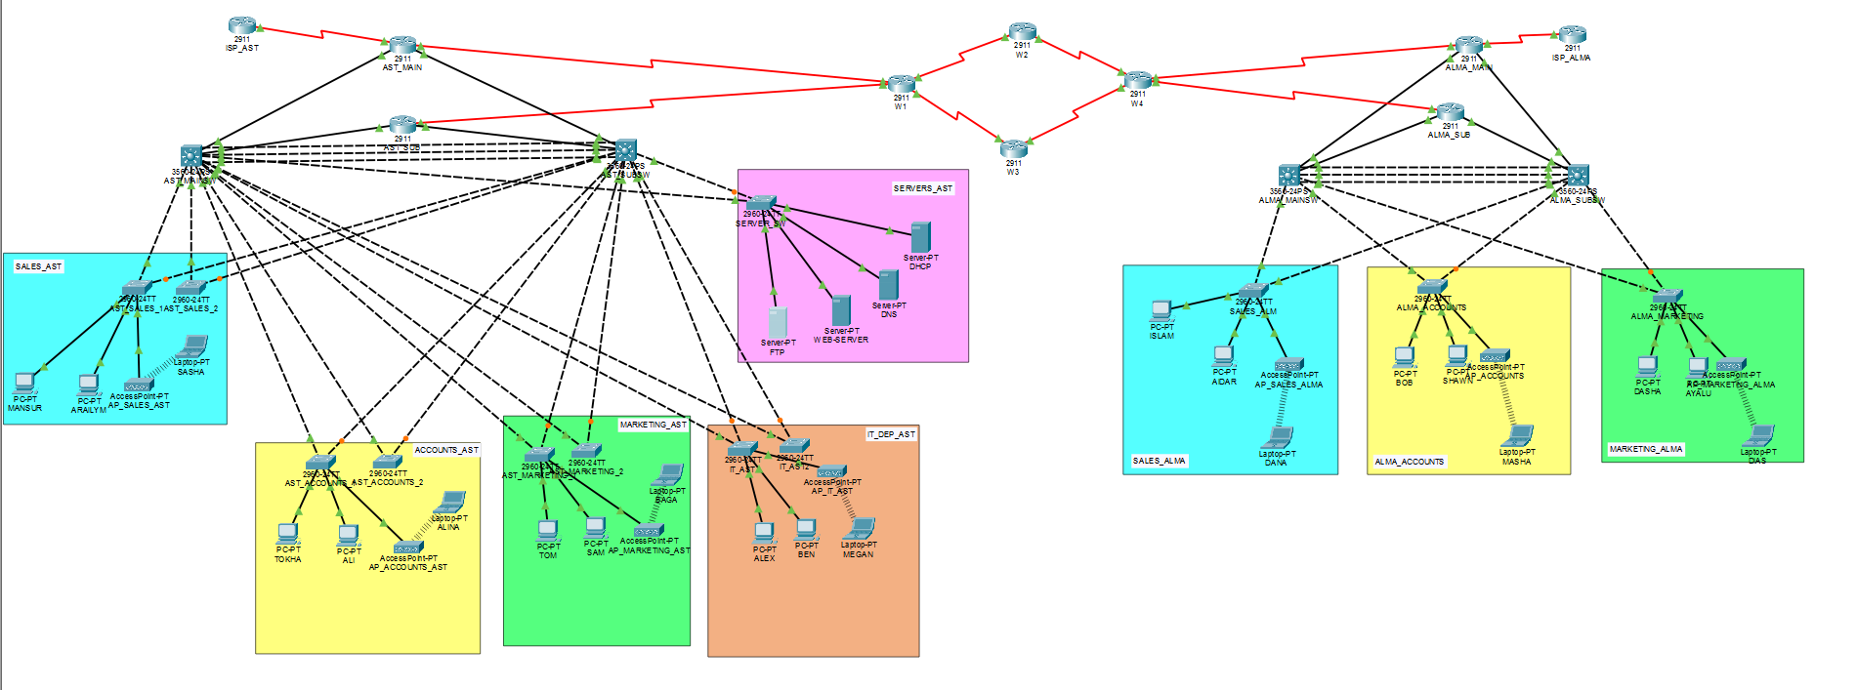

Intermediate Network
Figure A2 – Outline Intermediate Design

Local Network A
Figure A3 – Building A (Astana Building) Local Network Design
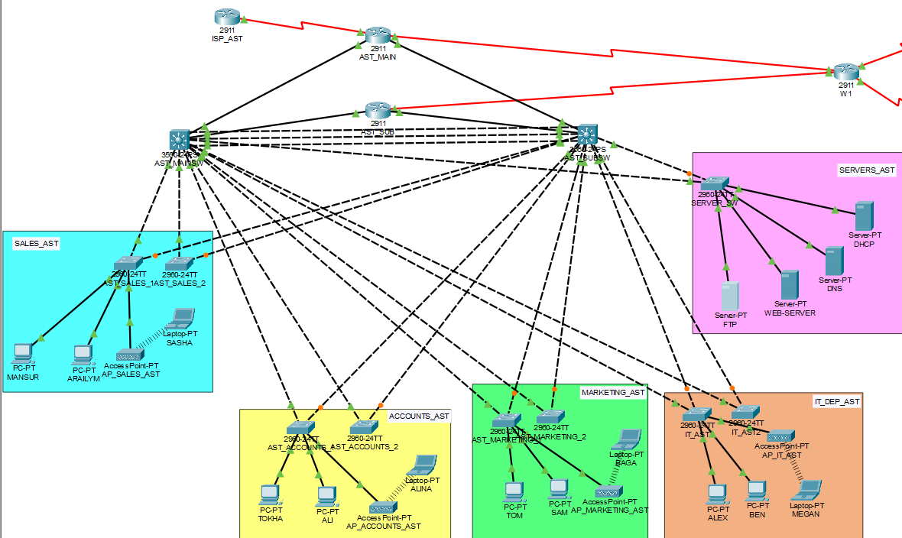

Local Network B
Figure A4 - Building B (Almaty Building) Local Network Design
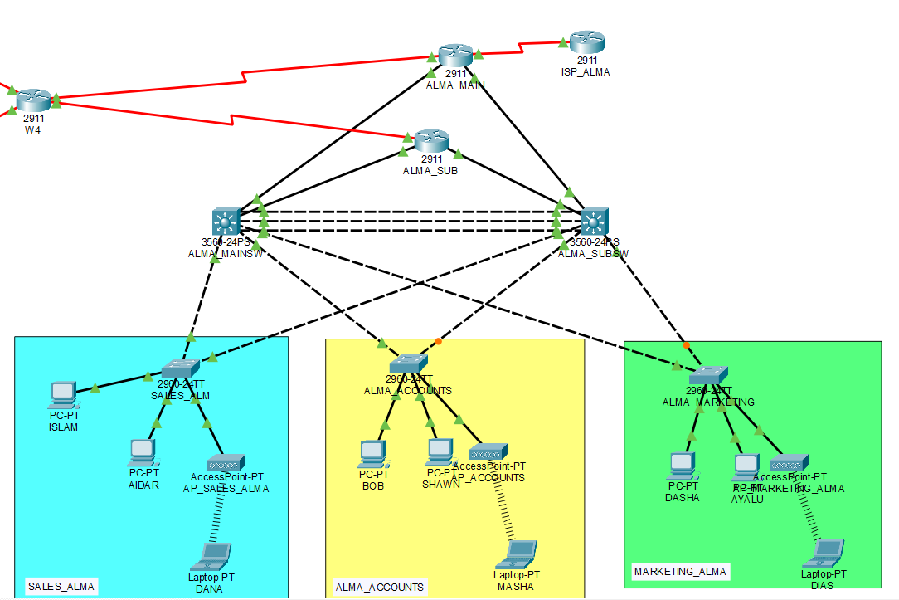

Appendix B - IP Addressing Scheme
A strategy was used to minimize overall address waste and support 50% expansion by applying VLSM. Full tables are below.

WAN IP Address Scheme
Describe your strategy and reasoning for your choice of WAN IP Addresses
Router name | Network Address | Mask | port | DCE/DTE | Ip address | Broadcast Address
AST_MAIN | 10.10.76.0 | 255.255.255.252 | S0/0/0 | DCE | 10.10.76.1 | 10.10.76.3
W1 | 10.10.76.0 | 255.255.255.252 | S0/0/0 | DTE | 10.10.76.2 | 10.10.76.3
W1 | 10.10.76.4 | 255.255.255.252 | S0/0/1 | DTE | 10.10.76.5 | 10.10.76.7
W2 | 10.10.76.4 | 255.255.255.252 | S0/0/0 | DCE | 10.10.76.6 | 10.10.76.7
W1 | 10.10.76.8 | 255.255.255.252 | S0/1/0 | DTE | 10.10.76.9 | 10.10.76.11
W3 | 10.10.76.8 | 255.255.255.252 | S0/0/0 | DCE | 10.10.76.10 | 10.10.76.11
W3 | 10.10.76.12 | 255.255.255.252 | S0/0/1 | DTE | 10.10.76.13 | 10.10.76.15
W4 | 10.10.76.12 | 255.255.255.252 | S0/0/1 | DCE | 10.10.76.14 | 10.10.76.15
W2 | 10.10.76.16 | 255.255.255.252 | S0/0/1 | DCE | 10.10.76.17 | 10.10.76.19
W4 | 10.10.76.16 | 255.255.255.252 | S0/1/0 | DTE | 10.10.76.18 | 10.10.76.19
W4 | 10.10.76.20 | 255.255.255.252 | S0/0/0 | DTE | 10.10.76.21 | 10.10.76.23
ALMA_MAIN | 10.10.76.20 | 255.255.255.252 | S0/0/0 | DTE | 10.10.76.22 | 10.10.76.23
AST_SUB | 10.10.76.24 | 255.255.255.252 | S0/0/0 | DCE | 10.10.76.25 | 10.10.76.27
W1 | 10.10.76.24 | 255.255.255.252 | S0/1/1 | DTE | 10.10.76.26 | 10.10.76.27
ALMA_SUB | 10.10.76.28 | 255.255.255.252 | S0/0/0 | DCE | 10.10.76.29 | 10.10.76.31
W4 | 10.10.76.28 | 255.255.255.252 | S0/1/1 | DTE | 10.10.76.30 | 10.10.76.31

Intermediate Level (MAN) IP Address Scheme
Device name | NA | Mask | port | IP Address | BA
AST_MAIN | 192.168.38.240 | /30 | G0/1 | 192.168.38.241 | 192.168.38.243
AST_MAIN | 192.168.38.244 | /30 | G0/2 | 192.168.38.245 | 192.168.38.247
AST_MAINSW | 192.168.38.240 | /30 | G0/1 | 192.168.38.242 | 192.168.38.243
AST_SUBSW | 192.168.38.244 | /30 | G0/1 | 192.168.38.246 | 192.168.38.247
AST_SUB | 192.168.38.248 | /30 | G0/1 | 192.168.38.249 | 192.168.38.251
AST_MAINSW | 192.168.38.248 | /30 | G0/2 | 192.168.38.250 | 192.168.38.251
AST_SUB | 192.168.38.252 | /30 | G0/2 | 192.168.38.253 | 192.168.38.255
AST_MAINSW | 192.168.38.252 | /30 | G0/2 | 192.168.38.254 | 192.168.38.255

Device name | Network Address | Mask | port | IP Address | BA
ALMA_MAIN | 192.168.39.128 | /30 | G0/0 | 192.168.39.129 | 192.168.39.131
ALMA_MAINSW | 192.168.39.128 | /30 | G0/1 | 192.168.39.130 | 192.168.39.131
ALMA_MAINSW | 192.168.39.132 | /30 | G0/1 | 192.168.39.133 | 192.168.39.135
ALMA_SUBSW | 192.168.39.132 | /30 | G0/1 | 192.168.39.134 | 192.168.39.135
ALMA_SUB | 192.168.39.136 | /30 | G0/1 | 192.168.39.137 | 192.168.39.139
ALMA_MAINSW | 192.168.39.136 | /30 | G0/2 | 192.168.39.138 | 192.168.39.139
ALMA_SUB | 192.168.39.140 | /30 | G0/2 | 192.168.39.141 | 192.168.39.143
ALMA_SUBSW | 192.168.39.140 | /30 | G0/2 | 192.168.39.142 | 192.168.39.143

Building A (LAN) IP Address Scheme
Department | vlan | NA | MASK | BA | SW_MAIN | STANDBY | SW_SUB
Sales_Ast | 10 | 192.168.38.0 | /26 | 192.168.38.63 | 192.168.38.2 | 192.168.38.1 | .38.3
Accounts_Ast | 20 | 192.168.38.64 | /26 | 192.168.38.127 | 192.168.38.66 | 192.168.38.65 | .38.67
Marketing_Ast | 30 | 192.168.38.128 | /26 | 192.168.38.191 | 192.168.38.130 | 192.168.38.129 | .38.131
IT DEPARTMENT_Ast | 40 | 192.168.38.192 | /27 | 192.168.38.223 | 192.168.38.194 | 192.168.38.193 | .38.195
SERVERS_Ast | 50 | 192.168.38.224 | /28 | 192.168.38.239 | 192.168.38.226 | 192.168.38.225 | .38.227
Management_Ast | 99 | 192.168.39.112 | /28 | 192.168.39.127 | 192.168.39.114 | 192.168.39.113 | .39.115

Building B (LAN) IP Address Scheme
Department | vlan | NA | mask | BA | SW_MAIN | Standby | SW_SUB
Sales_Alm | 110 | 192.168.39.0 | /27 | 192.168.39.31 | 192.168.39.2 | 192.168.39.1 | .39.3
Accounts_Alm | 120 | 192.168.39.32 | /27 | 192.168.39.63 | 192.168.39.34 | 192.168.39.33 | .39.35
Marketing_Alm | 130 | 192.168.39.64 | /28 | 192.168.39.95 | 192.168.39.66 | 192.168.39.65 | .39.67
Management_Alm | 199 | 192.168.39.96 | /28 | 192.168.39.111 | 192.168.39.98 | 192.168.39.97 | .39.99

Appendix C – Device Purpose and Configuration

Top Level (WAN)
Device Type | Device Name | Configuration Information | Specific Purpose / Rationale
2911 ROUTER | W1 | OSPF, WAN serial links | Connects Astana’s edge routers to WAN network
2911 ROTER | W2 | OSPF, WAN serial links | Connects W1 to W4
2911 ROUTER | W3 | OSPF, WAN serial links | Connects W1 to W4
2911 ROUTER | W4 | OSPF, WAN serial links | Connects Almaty’s edge routers to WAN network

Intermediate Level (MAN)
Device Type | Device Name | Configuration Information | Specific Purpose / Rationale
2911 ROUTER | ISP_AST | Default route, serial link | Provides access to Internet for Astana building
2911 ROUTER | ISP_ALMA | Default route, serial link | Provides access to Internet for Almaty building
2911 ROUTER | AST_MAIN | Default route to ISP, OSPF, serial link to WAN, ACL, SHH v.2, NAT | The main edge router of Astana building. Its goal is to provide secure Internet access, as well as communication with a remote building in Almaty.
2911 ROUTER | AST_SUB | OSPF, serial link to WAN, ACL, SHH v.2, NAT | The reserve edge router of Astana building. Its main role is to easily take over all the tasks of the main router, if necessary. Moreover, it takes over some of the traffic to not overload the main one.
3560 L3 SWITCH | AST_MAINSW | OSPF, ACL, SSH v.2, VLAN, EtherChannel, default route, HSRP | The main distribution switch of Astana building. It connects all departments with each other, controls access, helps to go to Almaty and the Internet.
3560 L3 SWITCH | AST_SUBSW | OSPF, ACL, SSH v.2, VLAN, EtherChannel, default route, HSRP | The reserve distribution switch of Astana building. It provides redundancy for a network.
2911 ROUTER | ALMA_MAIN | Default route to ISP, OSPF, serial link to WAN, ACL, SHH v.2, NAT | The main edge router of Astana building. Its goal is to provide secure Internet access, as well as communication with a remote building in Astana.
2911 ROUTER | ALMA_SUB | Default route to ISP, OSPF, serial link to WAN, ACL, SHH v.2, NAT | The reserve edge router of Astana building. Its main role is to easily take over all the tasks of the main router, if necessary. Moreover, it takes over some of the traffic to not overload the main one.
3560 L3 SWITCH | ALMA_MAINSW | OSPF, ACL, SSH v.2, VLAN, EtherChannel, default route, HSRP | The main distribution switch of Almaty building. It connects all departments with each other, controls access, helps to go to Astana and the Internet.
3560 L3 SWITCH | ALMA_SUBSW | OSPF, ACL, SSH v.2, VLAN, EtherChannel, default route, HSRP | The reserve distribution switch of Almaty building. It provides redundancy for a network.

Building A (LAN)
Device Type | Device Name | Configuration Information | Specific Purpose / Rationale
2960 L2 SWITCH | SERVER_SW | SSH v.2, VLAN, ACL, default-gateway | L2 access switch for departmental users. Connects end devices to the network via access ports in the specific VLAN.
2960 L2 SWITCH | IT_SW | SSH v.2, VLAN, ACL, default-gateway | L2 access switch for departmental users. Connects end devices to the network via access ports in the specific VLAN.
2960 L2 SWITCH | AST_SALES_1 | SSH v.2, VLAN, ACL, default-gateway | L2 access switch for departmental users. Connects end devices to the network via access ports in the specific VLAN.
2960 L2 SWITCH | AST_SALES_2 | SSH v.2, VLAN, ACL, default-gateway | L2 access switch for departmental users. Connects end devices to the network via access ports in the specific VLAN.
2960 L2 SWITCH | AST_ACCOUNTS_1 | SSH v.2, VLAN, ACL, default-gateway | L2 access switch for departmental users. Connects end devices to the network via access ports in the specific VLAN.
2960 L2 SWITCH | AST_ACCOUNTS_2 | SSH v.2, VLAN, ACL, default-gateway | L2 access switch for departmental users. Connects end devices to the network via access ports in the specific VLAN.
2960 L2 SWITCH | AST_MARKETING_1 | SSH v.2, VLAN, ACL, default-gateway | L2 access switch for departmental users. Connects end devices to the network via access ports in the specific VLAN.

Building B (LAN)
Device Type | Device Name | Configuration Information | Specific Purpose / Rationale
2960 L2 SWITCH | ALMA_SALES | SSH v.2, VLAN, ACL, default-gateway | L2 access switch for departmental users. Connects end devices to the network via access ports in the specific VLAN.
2960 L2 SWITCH | ALMA_ACCOUNTS | SSH v.2, VLAN, ACL, default-gateway | L2 access switch for departmental users. Connects end devices to the network via access ports in the specific VLAN.
2960 L2 SWITCH | ALMA_MARKETING | SSH v.2, VLAN, ACL, default-gateway | L2 access switch for departmental users. Connects end devices to the network via access ports in the specific VLAN.

Appendix D - Testing Documents
Figure D1 – Test of the connection between Astana and Almaty
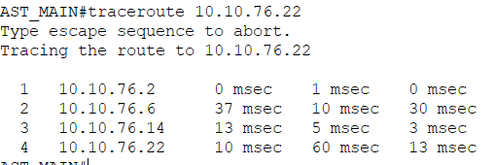
Figure D2 – Test of the connection within VLAN 10
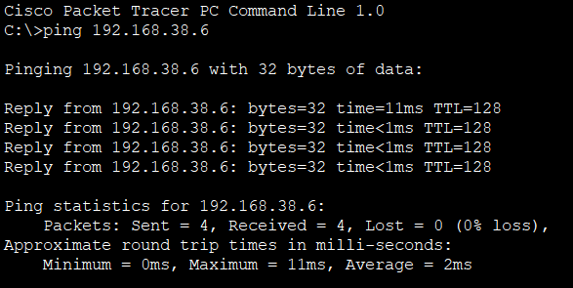
Figure D3 – Test of the connection between VLANs (10 and 110)
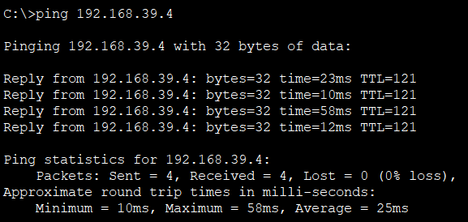
Figure D4 – Test of the OSPF connection in W1 router
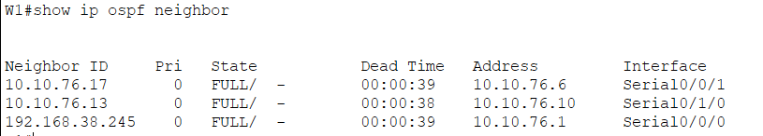
Figures D5 – Test of the servers (DHCP, Web server, DNS, TFTP in this order)
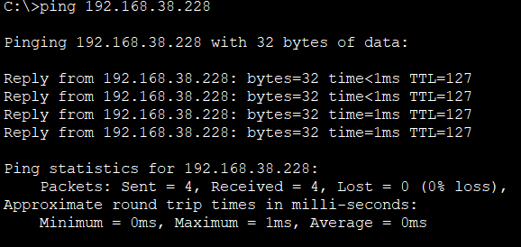
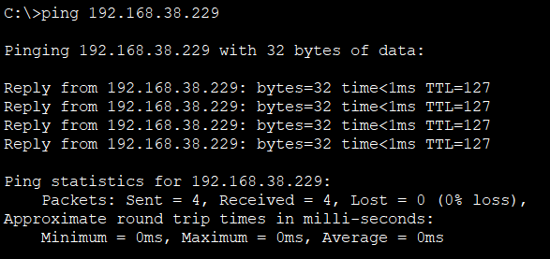
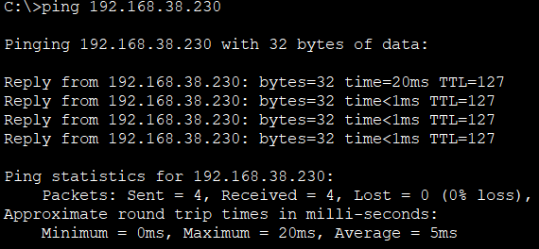
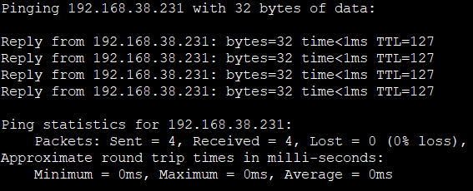

Appendix E - Documents
Enable secret – cisco123
Username – admin, secret – admin!
Username – tech, secret – admin!

