Ex.No.: 1 |  | CREATION OF BASE TABLE AND  DML OPERATIONS
Date: |  | CREATION OF BASE TABLE AND  DML OPERATIONS

- Create MY_EMPLOYEE table with the following structure

NAME | NULL? | TYPE
ID | Not null | Number(4)
Last_name |  | Varchar(25)
First_name |  | Varchar(25)
Userid |  | Varchar(25)
Salary |  | Number(9,2)

CREATE TABLE MY_EMPLOYEE (ID NUMBER(4) NOT NULL, Last_name VARCHAR2(25), First_name VARCHAR2(25), Userid VARCHAR2(25),Salary NUMBER(9, 2));
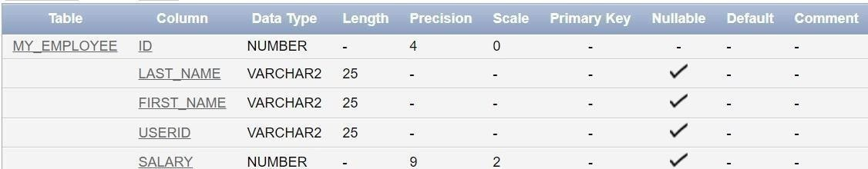

- Add the first and second rows data to MY_EMPLOYEE table from the following sample data.

ID | Last_name | First_name | Userid | salary
1 | Patel | Ralph | rpatel | 895
2 | Dancs | Betty | bdancs | 860
3 | Biri | Ben | bbiri | 1100
4 | Newman | Chad | Cnewman | 750
5 | Ropebur | Audrey | aropebur | 1550

Begin
INSERT INTO MY_EMPLOYEE VALUES (1, 'Patel', 'Ralph', 'rpatel', 895); INSERT INTO MY_EMPLOYEE VALUES (2, 'Dancs', 'Betty', 'bdancs', 860);
End;
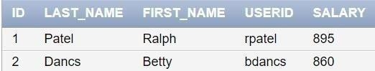

- Display the table with values.
Select * from My_Employee;

- Populate the next two rows of data from the sample data. Concatenate the first letter of the first_name with the first seven characters of the last_name to produce Userid.
Begin
INSERT INTO MY_EMPLOYEE (ID, Last_name, First_name, Userid, Salary) VALUES (3, 'Biri', 'Ben', SUBSTR('Biri', 1, 1) || SUBSTR('Biri', 1, 7), 1100);
INSERT INTO MY_EMPLOYEE (ID, Last_name, First_name, Userid, Salary)
VALUES (4, 'Newman', 'Chad', SUBSTR('Newman', 1, 1) || SUBSTR('Newman', 1, 7), 750);
End;
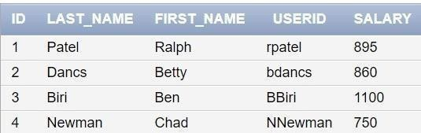
- Delete Betty dancs from MY _EMPLOYEE table.
DELETE FROM MY_EMPLOYEE WHERE Last_name = 'Dancs';
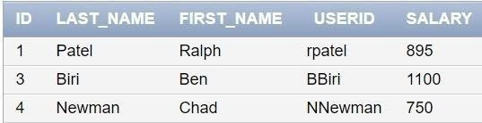

- Empty the fourth row of the emp table.
DELETE FROM MY_EMPLOYEE WHERE ID = 4;

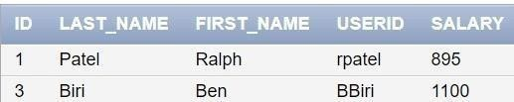

- Make the data additions permanent.
COMMIT;

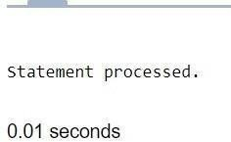
- Change the last name of employee 3 to Drexler.
UPDATE MY_EMPLOYEE SET Last_name = 'Drexler' WHERE ID = 3;
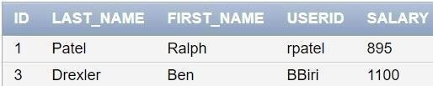
- Change the salary to 1000 for all the employees with a salary less than 900.

UPDATE MY_EMPLOYEE SET Salary = 1000 WHERE Salary < 900;
