Ex.No.: 11 |  | PL SQL PROGRAMS
Date: |  | PL SQL PROGRAMS

PROGRAM 1
Write a PL/SQL block to calculate the incentive of an employee whose ID is 110.

declare
a employees.employee_id%type;
b employees.salary%type; begin
Select salary into a from employees where employee_id = 110; b:=0.05*a;
dbms_output.put_line('Salary after incentive : '||(a+b)); end;

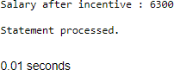

Write a PL/SQL block to show an invalid case-insensitive reference to a quoted and without quoted user-defined identifier.

declare
non_quoted_variable varchar2(10) := 'Hi'; "quoted_variable" varchar2(10) := 'Hello'; begin
dbms_output.put_line(NON_QUOTED_VARIABLE); dbms_output.put_line("quoted_variable"); dbms_output.put_line("QUOTED_VARIABLE"); end;

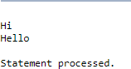

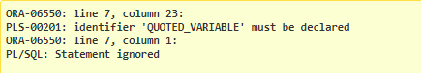

Write a PL/SQL block to adjust the salary of the employee whose ID
122. Sample table: employees

declare
old_salary employees.salary%type; new_salary employees.salary%type; begin
new_salary:= :sal;
Select salary into old_salary from employees where employee_id = 122; dbms_output.put_line('Before updation: '||old_salary);
Update employees set salary = salary + new_salary where employee_id = 122; Select salary into new_salary from employees where employee_id = 122; dbms_output.put_line('After updation: '||new_salary);
end;

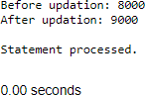

Write a PL/SQL block to create a procedure using the "IS [NOT] NULL Operator" and show AND operator returns TRUE if and only if both operands are TRUE.
Create or replace procedure proc1( a boolean, b boolean) IS BEGIN
if(a is not null) and (b is not null) then if(a = TRUE and b = TRUE) then dbms_output.put_line('TRUE');
else dbms_output.put_line('FALSE'); end if;
else
dbms_output.put_line('NULL VALUES in arguments'); end if;
end proc1;

BEGIN proc1(TRUE,TRUE); proc1(TRUE,FALSE); proc1(NULL,NULL);
end;

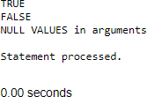

Write a PL/SQL block to describe the usage of LIKE operator including wildcard characters and escape character.

Declare
name varchar2(20); num number(3);
Begin num := :n;
Select first_name into name from employees where employee_id=num; if name like 'D%' then
dbms_output.put_line('Name starts with "D"'); end if;
if name like 'Dan_el%' then
dbms_output.put_line('Name contains "Dan" followed by one character'); end if;
name := 'Daniel_Andrea';
if name like 'Daniel\_Andrea' escape '\' then dbms_output.put_line('Name contains "Daniel_Andrea"'); end if;
end;

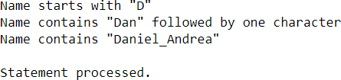

Write a PL/SQL program to arrange the number of two variable in such a way that the small number will store in num_small variable and large number will store in num_large variable.

declare
a number(2);
b number(2); num_small number(2); num_large number(2); begin
a := :s;
b := :l;
dbms_output.put_line('Value in a : '||a); dbms_output.put_line('Value in b : '||b); if a>b then
num_small := b; num_large := a; else
num_small :=a; num_large :=b; end if;
dbms_output.put_line('Smaller number is '||num_small); dbms_output.put_line('Larger number is '||num_large); end;

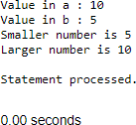

Write a PL/SQL procedure to calculate the incentive on a target achieved and display the message either the record updated or not.

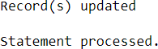
Create or replace procedure calc_incen(emp_id number,achievement number,target number) AS
incentive number; rowcount number;
Begin
if achievement > target then incentive:= achievement*0.2; else
incentive:=0; end if;
Update employees set salary = salary + incentive where employee_id = emp_id; rowcount:= SQL%ROWCOUNT;
if rowcount>0 then dbms_output.put_line('Record(s) updated'); else
dbms_output.put_line('No Record(s) updated'); end if;
end;
Declare
id number; achievement number; target number;
Begin
id := :emp_id; achievement := :achieve; target := :target_;
calc_incen(id,achievement,target); end;

Write a PL/SQL procedure to calculate incentive achieved according to the specific sale limit.

Create or replace procedure calc_incen(emp_id number,sales number) AS incentive number;
rowcount number;
Begin
if sales < 1000 then incentive:= 0;
elsif sales > 1000 and sales < 2000 then incentive := sales * 0.2;
else
incentive := sales * 0.5; end if;
Update employees set salary = salary + incentive where employee_id = emp_id; rowcount:= SQL%ROWCOUNT;
if rowcount>0 then dbms_output.put_line('Record(s) updated'); else
dbms_output.put_line('No Record(s) updated'); end if;
end;
Declare
id number; sales number; sal number;
Begin
id := :emp_id; sales := :sale;
select salary into sal from employees where employee_id = id; dbms_output.put_line('Before incentive calculation: '||sal); calc_incen(id,sales);
select salary into sal from employees where employee_id = id; dbms_output.put_line('After incentive calculation: '||sal); end;

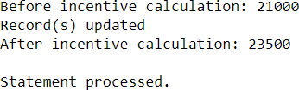

Write a PL/SQL program to count number of employees in department 50 and check whether this department have any vacancies or not. There are 45 vacancies in this department.

declare
emp_count number; vacancy number := 20; begin
Select count(*) into emp_count from employees where department_id = 10; dbms_output.put_line('Total seats : '||vacancy); dbms_output.put_line('Number of employees in Department 50 : '||emp_count); if emp_count>vacancy then
dbms_output.put_line('No vacancies available'); else
dbms_output.put_line('Available vacancies : '||(vacancy-emp_count)); end if;
end;

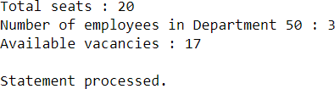

Write a PL/SQL program to count number of employees in a specific department and check whether this department have any vacancies or not. If any vacancies, how many vacancies are in that department.

declare
dept_id number; emp_count number; vacancy number := 10; begin
dept_id := :id;
Select count(*) into emp_count from employees where department_id = dept_id; dbms_output.put_line('Total seats : '||vacancy);
dbms_output.put_line('Number of employees in Department : '||emp_count); if emp_count>vacancy then
dbms_output.put_line('No vacancies available'); else
dbms_output.put_line('Available vacancies : '||(vacancy-emp_count)); end if;
end;

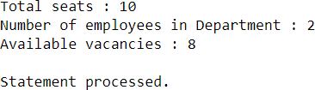

Write a PL/SQL program to display the employee IDs, names, job titles, hire dates, and salaries of all employees.
begin
for i in (select employee_id, first_name, job_id, hire_date, salary from employees) loop
dbms_output.put_line('employee id: ' || i.employee_id); dbms_output.put_line('name: ' || i.first_name); dbms_output.put_line('job title: ' || i.job_id);
dbms_output.put_line('hire date: ' || to_char(i.hire_date, 'dd-mon-yyyy')); dbms_output.put_line('salary: ' || i.salary);
dbms_output.put_line(' ');
end loop; end;

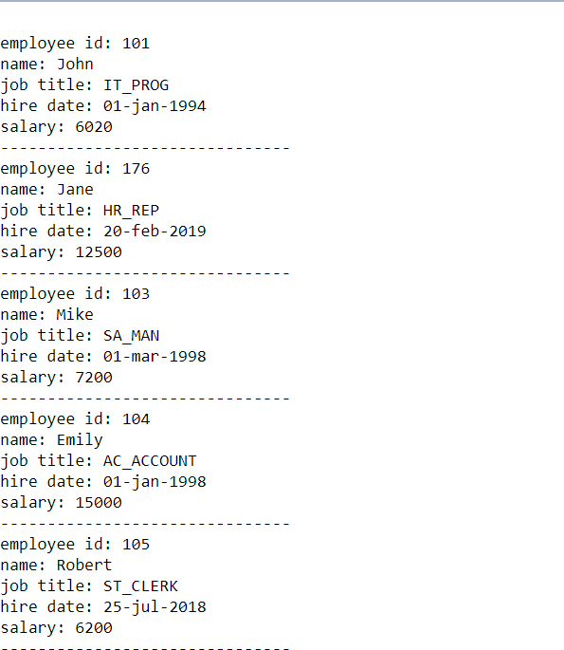

Write a PL/SQL program to display the employee IDs, names, and department names of all employees.
begin
for i in (select e.employee_id, e.first_name, e.job_id from employees e) loop
dbms_output.put_line('employee id: ' || i.employee_id); dbms_output.put_line('name: ' || i.first_name); dbms_output.put_line('department name: ' || i.job_id); dbms_output.put_line(' ');
end loop; end;

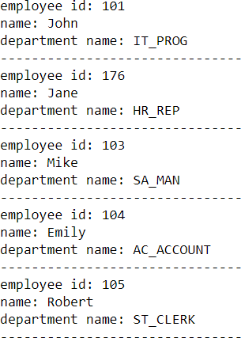

Write a PL/SQL program to display the job IDs, titles, and minimum salaries of all jobs.
Begin
for i in (select job_id,job_title,min_salary from jobs) loop
dbms_output.put_line('job id: ' || i.job_id); dbms_output.put_line('job title: ' || i.job_title); dbms_output.put_line('minimum salary: ' || i.min_salary); dbms_output.put_line(' ');
end loop; end;

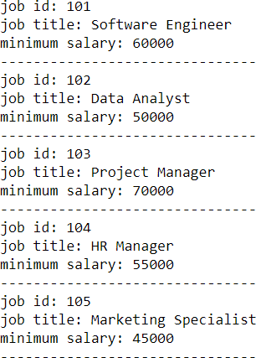

Write a PL/SQL program to display the employee IDs, names, and job history start dates of all employees.
Begin
for i in (select employee_id,employee_name,start_date from job_history) loop
dbms_output.put_line('employee id: ' || i.employee_id); dbms_output.put_line('name: ' || i.employee_name); dbms_output.put_line('start date: ' ||to_char(i.start_date, 'dd-mon-yyyy')); dbms_output.put_line(' ');
end loop; end;

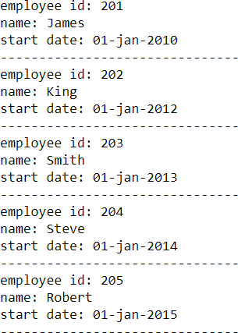

Write a PL/SQL program to display the employee IDs, names, and job history end dates of all employees.
Begin
for i in (select employee_id,employee_name,end_date from job_history) loop
dbms_output.put_line('employee id: ' || i.employee_id); dbms_output.put_line('name: ' || i.employee_name); dbms_output.put_line('end date: ' ||to_char(i.end_date, 'dd-mon-yyyy')); dbms_output.put_line(' ');
end loop; end;

