DATE: EXP-13 WORKING WITH TRIGGER

Program 1
Write a code in PL/SQL to develop a trigger that enforces referential integrity by preventing the deletion of a parent record if child records exist.

CREATE OR REPLACE TRIGGER prevent_parent_deletion BEFORE DELETE ON employees

FOR EACH ROW DECLARE
pl_dept_count NUMBER; BEGIN

SELECT COUNT(*)
INTO pl_dept_count FROM department
WHERE dept_id = :OLD.employee_id; IF pl_dept_count > 0 THEN
RAISE_APPLICATION_ERROR(-20001, 'Cannot delete employee record as department records exist.');

END IF; END;

DELETE FROM employees WHERE employee_id = 70;
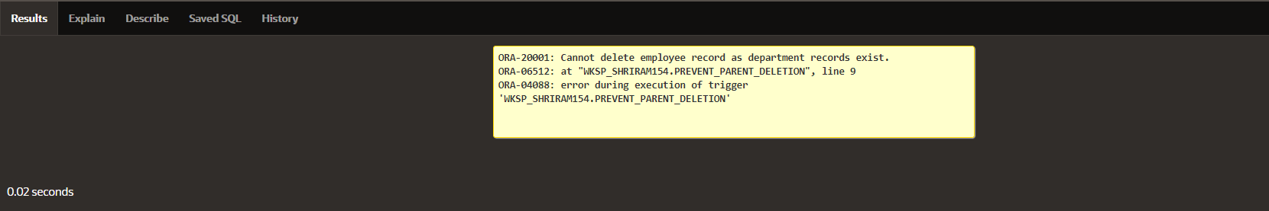

Program 2

Write a code in PL/SQL to create a trigger that checks for duplicate values in a specific column and raises an exception if found.

CREATE OR REPLACE TRIGGER prevent_duplicate_manager_id BEFORE INSERT OR UPDATE ON employees

FOR EACH ROW DECLARE
pl_count NUMBER; BEGIN

SELECT COUNT(*)
INTO pl_count FROM employees
WHERE manager_id = :NEW.manager_id AND employee_id != :NEW.employee_id; IF pl_count > 0 THEN
RAISE_APPLICATION_ERROR(-20003, 'Duplicate manager_id found: ' ||
:NEW.manager_id); END IF;

END;

INSERT INTO employees (employee_id, first_name, last_name, email, phone_number, hire_date, job_id, salary, commission_pct, manager_id, department_id)
VALUES (202, 'Jane', 'Smith', 'john006@gmail.com',7383922241,'11/9/2000','ST_CLERK',10000,0.15,400,80);

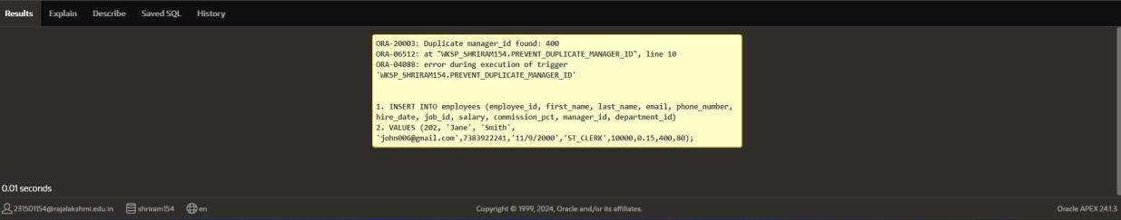

Program 3

Write a code in PL/SQL to create a trigger that restricts the insertion of new rows if the total of a
column's values exceeds a certain threshold.

CREATE OR REPLACE TRIGGER restrict_salary_insertion BEFORE INSERT ON employees

FOR EACH ROW DECLARE
total_salary NUMBER; threshold NUMBER := 100000;

BEGIN

SELECT SUM(salary) INTO total_salary FROM employees;
IF (total_salary + :NEW.salary) > threshold THEN
RAISE_APPLICATION_ERROR(-20004, 'Insertion denied: Total salary exceeds the threshold of ' || threshold);

END IF; END;

INSERT INTO employees (employee_id, first_name, last_name, email, phone_number, hire_date, job_id, salary, commission_pct, manager_id, department_id)
VALUES (203, 'Charlie', 'Brown', 'charlie203@gmail.com', '9122334455','03/01/2021', '#cb203', 5000, 0.20, 1000, 50);
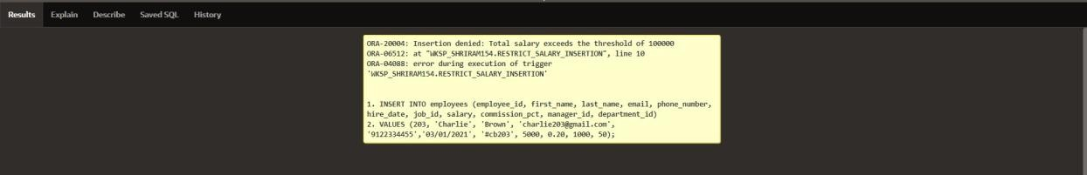

Program 4

Write a code in PL/SQL to design a trigger that captures changes made to specific columns and logs them in an audit table.

CREATE OR REPLACE TRIGGER audit_changes AFTER UPDATE OF salary, job_id ON employees FOR EACH ROW

BEGIN
IF :OLD.salary != :NEW.salary OR :OLD.job_id != :NEW.job_id THEN INSERT INTO employee_audit (
employee_id, old_salary, new_salary, old_job_title, new_job_title, change_timestamp, changed_by

) VALUES (
:OLD.employee_id,
:OLD.salary,
:NEW.salary,
:OLD.job_id,
:NEW.job_id, SYSTIMESTAMP, USER

); END IF;
END;

UPDATE employees
SET salary = 55000, job_id = 'ST_CLERK' WHERE employee_id = 176;

SELECT * FROM employee_audit;
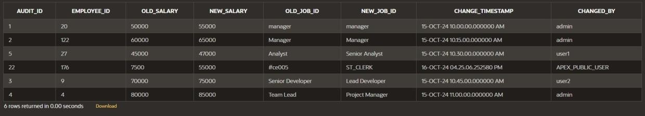

Program 5

Write a code in PL/SQL to implement a trigger that records user activity (inserts, updates, deletes) in an audit log for a given set of tables.

CREATE OR REPLACE TRIGGER trg_audit_employees AFTER INSERT OR UPDATE OR DELETE ON employees FOR EACH ROW

DECLARE
v_old_values CLOB; v_new_values CLOB;

BEGIN
IF INSERTING THEN
v_old_values := NULL;
v_new_values := 'employee_id: ' || :NEW.employee_id || ', ' || 'first_name: ' || :NEW.first_name || ', ' ||
'salary: ' || :NEW.salary;

INSERT INTO audit_log (action, table_name, record_id, changed_by, new_values) VALUES ('INSERT', 'employees', :NEW.employee_id, USER, v_new_values);

ELSIF UPDATING THEN
v_old_values := 'employee_id: ' || :OLD.employee_id || ', ' || 'first_name: ' || :OLD.first_name || ', ' ||
'salary: ' || :OLD.salary;
v_new_values := 'employee_id: ' || :NEW.employee_id || ', ' || 'first_name: ' || :NEW.first_name || ', ' ||
'salary: ' || :NEW.salary;

INSERT INTO audit_log (action, table_name, record_id, changed_by, old_values, new_values)
VALUES ('UPDATE', 'employees', :NEW.employee_id, USER, v_old_values, v_new_values);

ELSIF DELETING THEN
v_old_values := 'employee_id: ' || :OLD.employee_id || ', ' || 'first_name: ' || :OLD.first_name || ', ' ||
'salary: ' || :OLD.salary; v_new_values := NULL;

INSERT INTO audit_log (action, table_name, record_id, changed_by, old_values) VALUES ('DELETE', 'employees', :OLD.employee_id, USER, v_old_values);

END IF;

END trg_audit_employees;

INSERT INTO employees (employee_id, first_name, salary) VALUES (3, 'Ball', 50000);
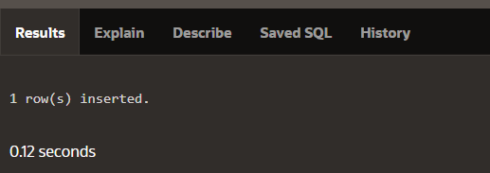

UPDATE employees SET salary = 55000
WHERE employee_id = 3;
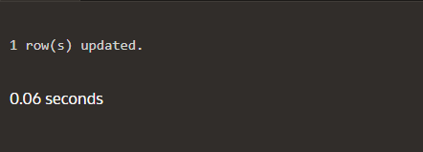

DELETE FROM employees WHERE employee_id = 3;

SELECT * FROM audit_log;
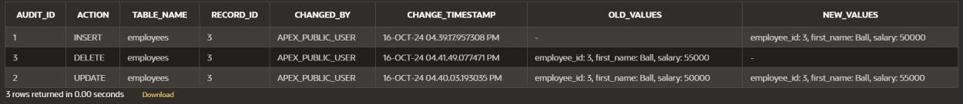

Program 6

Write a code in PL/SQL to implement a trigger that automatically calculates and updates a running total column for a table whenever new rows are inserted.

CREATE TABLE transactions ( transaction_id NUMBER PRIMARY KEY, amount NUMBER,
running_total NUMBER
);

CREATE OR REPLACE TRIGGER update_running_total FOR INSERT ON transactions

COMPOUND TRIGGER

TYPE amount_array IS TABLE OF NUMBER INDEX BY PLS_INTEGER;
new_amounts amount_array;

BEFORE EACH ROW IS BEGIN
new_amounts(:NEW.transaction_id) := :NEW.amount; END BEFORE EACH ROW;

AFTER STATEMENT IS BEGIN
DECLARE
v_total NUMBER; BEGIN
SELECT NVL(MAX(running_total), 0) INTO v_total
FROM transactions;

FOR i IN new_amounts.FIRST .. new_amounts.LAST LOOP v_total := v_total + new_amounts(i);
UPDATE transactions
SET running_total = v_total WHERE transaction_id = i;

END LOOP; END;
END AFTER STATEMENT;

END update_running_total;

INSERT INTO transactions (transaction_id, amount) VALUES (1, 10000);

INSERT INTO transactions (transaction_id, amount) VALUES (2, 20000);
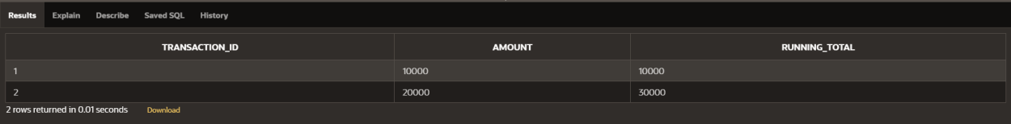

Program 7

Write a code in PL/SQL to create a trigger that validates the availability of items before allowing an order to be placed, considering stock levels and pending orders.

CREATE TABLE inventory ( item_id NUMBER PRIMARY KEY,
item_name VARCHAR2(100), stock_level NUMBER
);

CREATE TABLE orders (
order_id NUMBER PRIMARY KEY, item_id NUMBER,
quantity NUMBER, order_status VARCHAR2(20),
CONSTRAINT fk_item FOREIGN KEY (item_id) REFERENCES inventory(item_id)
);

CREATE OR REPLACE TRIGGER validate_stock_before_order BEFORE INSERT ON orders

FOR EACH ROW DECLARE
v_stock_level NUMBER; v_pending_orders NUMBER;

BEGIN
SELECT stock_level INTO v_stock_level FROM inventory
WHERE item_id = :NEW.item_id; SELECT NVL(SUM(quantity), 0) INTO v_pending_orders
FROM orders
WHERE item_id = :NEW.item_id AND order_status = 'Pending';
IF (:NEW.quantity + v_pending_orders) > v_stock_level THEN RAISE_APPLICATION_ERROR(-20001, 'Insufficient stock for item: ' || :NEW.item_id);

END IF; END;

INSERT INTO orders (order_id, item_id, quantity, order_status) VALUES (1, 101, 5, 'Pending');
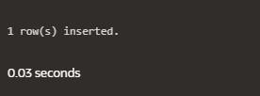

INSERT INTO orders (order_id, item_id, quantity, order_status) VALUES (2, 103, 20, 'Pending');
