Ex.No.: 2 |  | DATA MANIPULATIONS
Date: |  | DATA MANIPULATIONS

Create the following tables with the given structure. EMPLOYEES TABLE

NAME | NULL? | TYPE
Employee_id | Not null | Number(6)
First_Name |  | Varchar(20)
Last_Name | Not null | Varchar(25)
Email | Not null | Varchar(25)
Phone_Number |  | Varchar(20)
Hire_date | Not null | Date
Job_id | Not null | Varchar(10)
Salary |  | Number(8,2)
Commission_pct |  | Number(2,2)
Manager_id |  | Number(6)
Department_id |  | Number(4)

- Find out the employee id, names, salaries of all the employees
SELECT Employee_id, First_name, Last_name, Salary FROM EMPLOYEES;
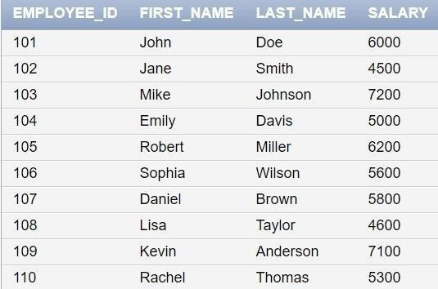

- List out the employees who works under manager 100
SELECT Employee_id, First_name, Last_name FROM EMPLOYEES WHERE Manager_id = 100;
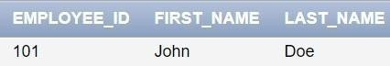

- Find the names of the employees who have a salary greater than or equal to 4800 SELECT First_name, Last_name FROM EMPLOYEES WHERE Salary >= 4800;
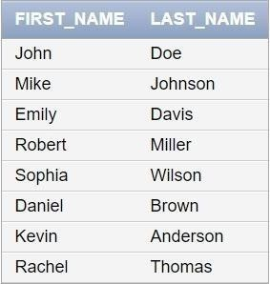

- List out the employees whose last name is ‗AUSTIN‘
SELECT Employee_id, First_name, Last_name FROM EMPLOYEES WHERE Last_name = 'AUSTIN';
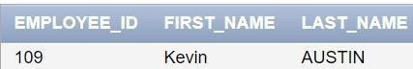

- Find the names of the employees who works in departments 60,70 and 80
SELECT First_name, Last_name FROM EMPLOYEES WHERE Department_id IN (60, 70, 80);
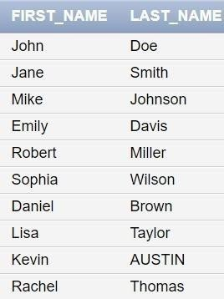

- Display the unique Manager_Id.
SELECT DISTINCT Manager_id FROM EMPLOYEES;
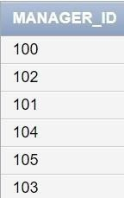

Create an Emp table with the following fields: (EmpNo, EmpName, Job,Basic, DA, HRA,PF, GrossPay, NetPay) (Calculate DA as 30% of Basic and HRA as 40% of Basic)
- Insert Five Records and calculate GrossPay and NetPay.

INSERT INTO EMP (EmpNo, EmpName, Job, Basic, DA, HRA, PF, GrossPay, NetPay) VALUES (1, 'John Doe', 'Manager', 50000, 0.30 * 50000, -- DA as 30% of Basic
0.40 * 50000, -- HRA as 40% of Basic,0.12 * 50000, -- PF as 12% of Basic
50000 + (0.30 * 50000) + (0.40 * 50000), -- GrossPay (50000 + (0.30 * 50000) + (0.40 *
50000)) - (0.12 * 50000) -- NetPay
);
INSERT INTO EMP (EmpNo, EmpName, Job, Basic, DA, HRA, PF, GrossPay, NetPay) VALUES (2, 'Jane Smith', 'Clerk', 30000, 0.30 * 30000, 0.40 * 30000,
0.12 * 30000,
30000 + (0.30 * 30000) + (0.40 * 30000),
(30000 + (0.30 * 30000) + (0.40 * 30000)) - (0.12 * 30000)
);
INSERT INTO EMP (EmpNo, EmpName, Job, Basic, DA, HRA, PF, GrossPay, NetPay) VALUES (3, 'Mike Johnson', 'Salesman', 40000,
0.30 * 40000,
0.40 * 40000,
0.12 * 40000,
40000 + (0.30 * 40000) + (0.40 * 40000),
(40000 + (0.30 * 40000) + (0.40 * 40000)) - (0.12 * 40000)
);
INSERT INTO EMP (EmpNo, EmpName, Job, Basic, DA, HRA, PF, GrossPay, NetPay) VALUES (4, 'Emily Davis', 'Accountant', 35000,
0.30 * 35000,
0.40 * 35000,
0.12 * 35000,
35000 + (0.30 * 35000) + (0.40 * 35000),
(35000 + (0.30 * 35000) + (0.40 * 35000)) - (0.12 * 35000)
);

INSERT INTO EMP (EmpNo, EmpName, Job, Basic, DA, HRA, PF, GrossPay, NetPay) VALUES (5, 'Robert Miller', 'Clerk', 25000,
0.30 * 25000,
0.40 * 25000,
0.12 * 25000,
25000 + (0.30 * 25000) + (0.40 * 25000),
(25000 + (0.30 * 25000) + (0.40 * 25000)) - (0.12 * 25000)
);

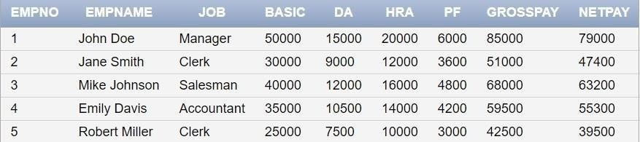

- Display the employees whose Basic is lowest in each department.
SELECT EmpNo, EmpName, Job, Basic FROM EMP E1 WHERE Basic = ( SELECT MIN(Basic) FROM EMP E2 WHERE E2.Job = E1.Job);
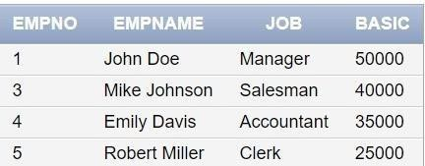

- If Net Pay is less than 50000, display employee number,name and net pay SELECT EmpNo, EmpName, NetPay FROM EMP WHERE NetPay < 50000;
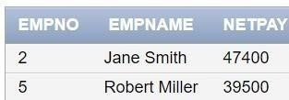

DEPARTMENT TABLE
NAME | NULL? | TYPE
Dept_id | Not null | Number(6)
Dept_name | Not null | Varchar(20)
Manager_id |  | Number(6)
Location_id |  | Number(4)

JOB_GRADE TABLE
NAME | NULL? | TYPE
Grade_level |  | Varchar(2)
Lowest_sal |  | Number
Highest_sal |  | Number

LOCATION TABLE
NAME | NULL? | TYPE
Location_id | Not null | Number(4)
St_addr |  | Varchar(40)
Postal_code |  | Varchar(12)
City | Not null | Varchar(30)
State_province |  | Varchar(25)
Country_id |  | Char(2)

  - Create the DEPT table based on the DEPARTMENT following the table instance chart below. Confirm that the table is created.

Column name | ID | NAME
Key Type
Nulls/Unique
FK table
FK column
Data Type | Number | Varchar2
Length | 7 | 25

CREATE TABLE DEPT (Dept_id NUMBER(6) NOT NULL, Dept_name VARCHAR2(20)
NOT NULL,Manager_id NUMBER(6), Location_id NUMBER(4), CONSTRAINT my_dept_id_pk PRIMARY KEY (Dept_id));
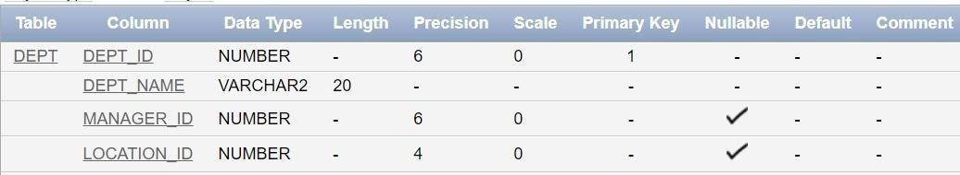

  - Create the EMP table based on the following instance chart. Confirm that the table is created.

Column name | ID | LAST_NAME | FIRST_NAME | DEPT_ID
Key Type
Nulls/Unique
FK table
FK column
Data Type | Number | Varchar2 | Varchar2 | Number
Length | 7 | 25 | 25 | 7

CREATE TABLE EMP (EmpNo NUMBER(7) PRIMARY KEY,Last_name VARCHAR2(25)
NOT NULL,First_name VARCHAR2(25),Dept_id NUMBER(7), CONSTRAINT my_emp_dept_id_fk FOREIGN KEY (Dept_id) REFERENCES DEPT(Dept_id));
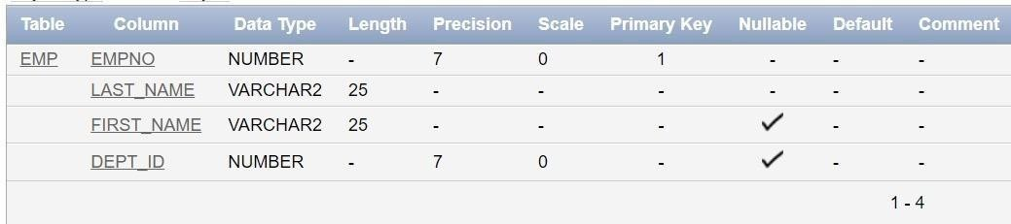

  - Modify the EMP table to allow for longer employee last names. Confirm the modification.(Hint: Increase the size to 50)
ALTER TABLE EMP MODIFY (Last_name VARCHAR2(50));
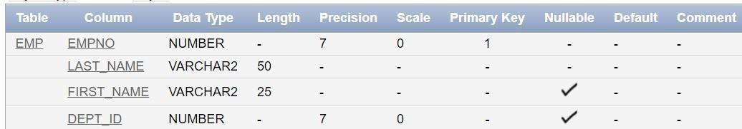

  - Create the EMPLOYEES2 table based on the structure of EMPLOYEES table. Include Only the Employee_id, First_name, Last_name, Salary and Dept_id coloumns. Name the columns Id, First_name, Last_name, salary and Dept_id respectively.
CREATE TABLE EMPLOYEES2 (Id NUMBER(6) PRIMARY
KEY,First_name VARCHAR2(20),Last_name VARCHAR2(25), Salary NUMBER(8,2),Dept_id NUMBER(4));
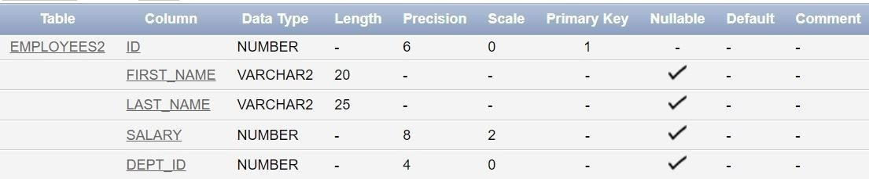

  - Drop the EMP Table DROP TABLE EMP;

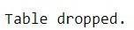

  - Rename the EMPLOYEES2 table as EMP.
ALTER TABLE EMPLOYEES2 RENAME TO EMP;

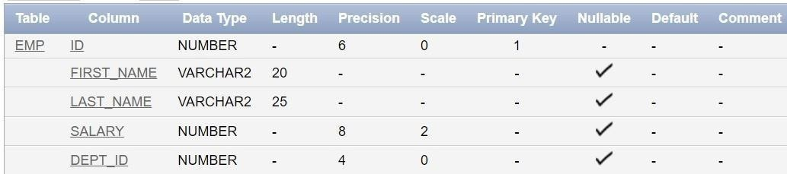

  - Add a comment on DEPT and EMP tables. Confirm the modification by describing the table.
COMMENT ON TABLE DEPT IS 'This table contains department information.'; COMMENT ON TABLE EMP IS 'This table contains employee information.';
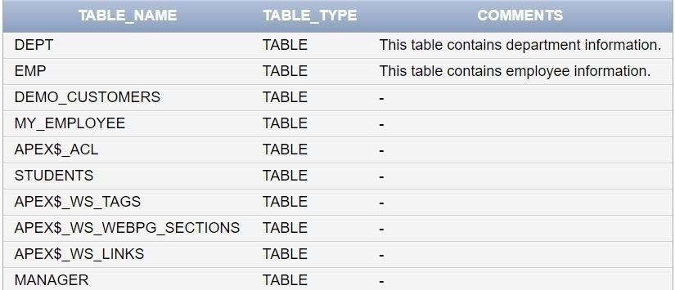

  - Drop the First_name column from the EMP table and confirm it.
ALTER TABLE EMP DROP COLUMN First_name;
