Ex.No.: 3 |  | WRITING BASIC SQL SELECT STATEMENTS
Date: |  | WRITING BASIC SQL SELECT STATEMENTS

Find the Solution for the following:
True OR False
- The following statement executes successfully.

Identify the Errors
SELECT employee_id, last_name sal*12 ANNUAL SALARY
FROM employees;

False ->Corrected Query and Output
Select employee_id,last_name,salary*12 AS "Annual Salary" from Employees;
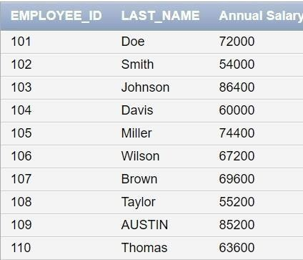

- Show the structure of departments the table. Select all the data from it.

DESC department;

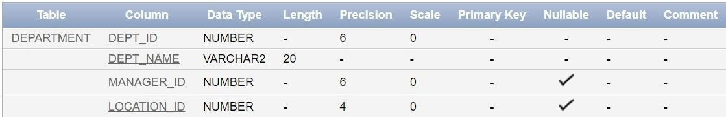

Select * from Department;

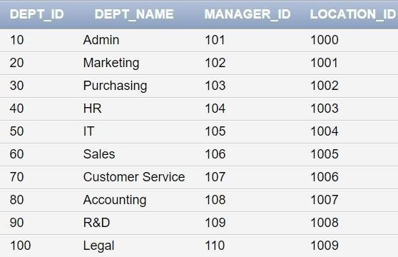

- Create a query to display the last name, job code, hire date, and employee number for each employee, with employee number appearing first.
SELECT employee_id, last_name, job_id, hire_date FROM employees;
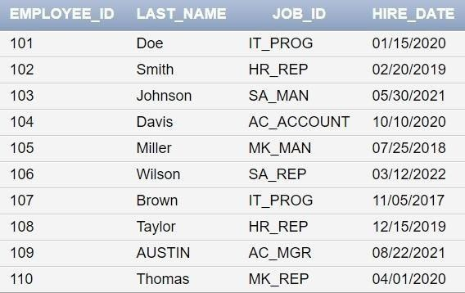

- Provide an alias STARTDATE for the hire date.

SELECT employee_id, last_name, job_id, hire_date AS STARTDATE FROM employees;
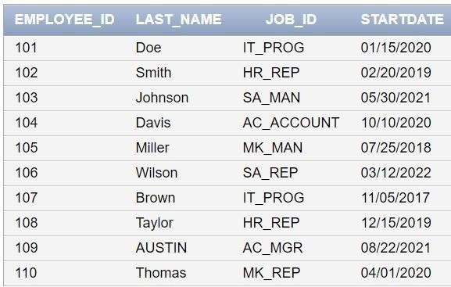

- Create a query to display unique job codes from the employee table.
SELECT DISTINCT job_id FROM employees;
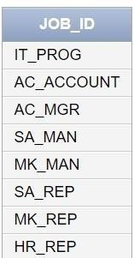

- Display the last name concatenated with the job ID , separated by a comma and space, and name the column EMPLOYEE and TITLE.
SELECT last_name || ', ' || job_id AS "EMPLOYEE and TITLE" FROM employees;
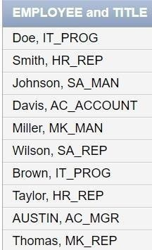

- Create a query to display all the data from the employees table. Separate each column by a comma. Name the column THE_OUTPUT.
SELECT employee_id || ', ' || last_name || ', ' || job_id || ', ' || hire_date AS THE_OUTPUT FROM employees;
