Ex.No.: 4 |  | WORKING WITH CONSTRAINTS
Date: |  | WORKING WITH CONSTRAINTS

- Add a table-level PRIMARY KEY constraint to the EMP table on the ID column.The constraint should be named at creation. Name the constraint my_emp_id_pk.

CREATE TABLE EMP ( EmpNo NUMBER(7) PRIMARY KEY,
Last_name VARCHAR2(25) NOT NULL,First_name VARCHAR2(25));
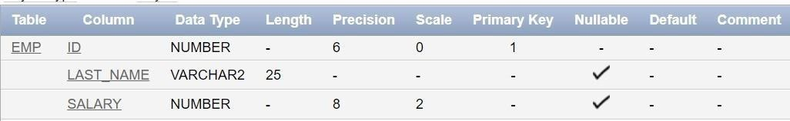

- Create a PRIMAY KEY constraint to the DEPT table using the ID colum. The constraint should be named at creation. Name the constraint my_dept_id_pk.

CREATE TABLE DEPT (Dept_id NUMBER(6) NOT NULL,Dept_name
VARCHAR2(20) NOT NULL,Manager_id NUMBER(6), Location_id NUMBER(4),CONSTRAINT my_dept_id_pk PRIMARY KEY (Dept_id));
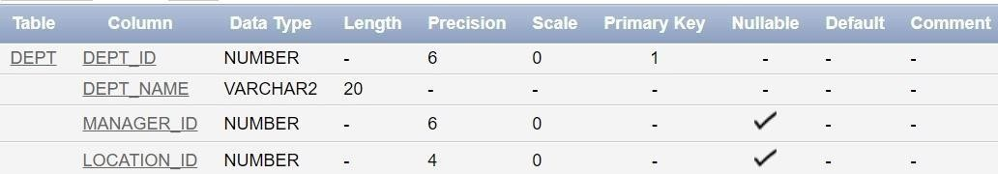

- Add a column DEPT_ID to the EMP table. Add a foreign key reference on the EMP table that ensures that the employee is not assigned to nonexistent deparment. Name the constraint my_emp_dept_id_fk.

ALTER TABLE EMP ADD Dept_id NUMBER(6);
ALTER TABLE EMP ADD CONSTRAINT my_emp_dept_id_fk FOREIGN KEY (Dept_id) REFERENCES DEPT (Dept_id);
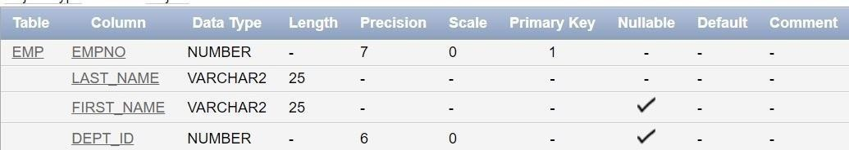

- Modify the EMP table. Add a COMMISSION column of NUMBER data type, precision 2, scale 2. Add a constraint to the commission column that ensures that a commission value is greater than zero.

ALTER TABLE EMP
ADD Commission NUMBER(8,2) CONSTRAINT commission_check CHECK (Commission > 0);
