Ex.No.: 5 |  | CREATING VIEWS
Date: |  | CREATING VIEWS

- Create a view called EMPLOYEE_VU based on the employee numbers, employee names and department numbers from the EMPLOYEES table. Change the heading for the employee name to EMPLOYEE.
CREATE VIEW EMPLOYEE_VU AS SELECT employee_id, last_name AS EMPLOYEE, department_id FROM EMPLOYEES;
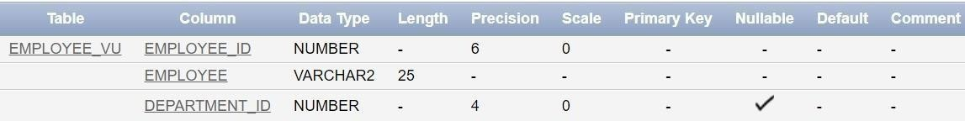

- Display the contents of the EMPLOYEES_VU view.

SELECT * FROM EMPLOYEE_VU;
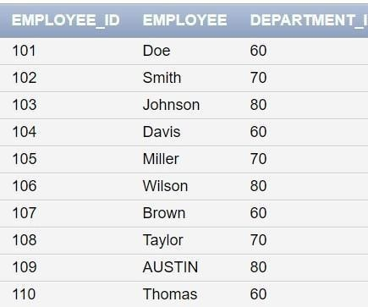

- Select the view name and text from the USER_VIEWS data dictionary views.
SELECT view_name, text FROM USER_VIEWS WHERE view_name = 'EMPLOYEE_VU';

- Using your EMPLOYEES_VU view, enter a query to display all employees names and department.
SELECT EMPLOYEE, department_id FROM EMPLOYEE_VU;

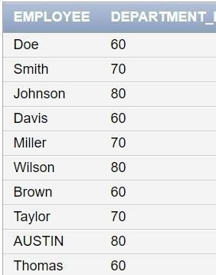

- Create a view named DEPT50 that contains the employee number, employee last names and department numbers for all employees in department 50.Label the view columns EMPNO, EMPLOYEE and DEPTNO. Do not allow an employee to be reassigned to another department through the view.
CREATE OR REPLACE VIEW DEPT50 (EMPNO, EMPLOYEE, DEPTNO) AS
SELECT employee_id, last_name, department_id FROM EMPLOYEES
WHERE department_id = 50 WITH CHECK OPTION;

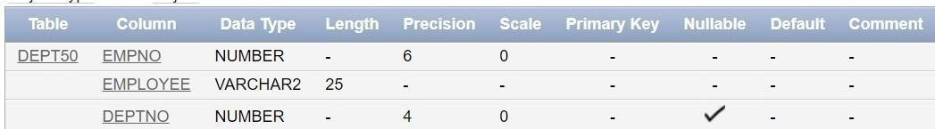

- Display the structure and contents of the DEPT50 view.
SELECT * FROM DEPT50;
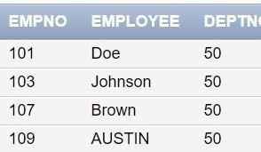

- Attempt to reassign Matos to department 80.
UPDATE DEPT50 SET DEPTNO = 80 WHERE EMPLOYEE = 'Matos';

- Create a view called SALARY_VU based on the employee last names, department names, salaries, and salary grades for all employees. Use the Employees, DEPARTMENTS and JOB_GRADE tables. Label the column Employee,Department, salary, and Grade respectively.
CREATE VIEW SALARY_VU AS
SELECT e.last_name AS Employee, d.department_name AS Department, e.salary AS Salary,
j.grade_level AS Grade FROM EMPLOYEES e

JOIN DEPARTMENTS d ON e.department_id = d.department_id
JOIN JOB_GRADE j ON e.salary BETWEEN j.lowest_sal AND j.highest_sal;
