Ex.No.: 6 |  | RESTRICTING AND SORTING DATA
Date: |  | RESTRICTING AND SORTING DATA

- Create a query to display the last name and salary of employees earning more than 12000.
SELECT last_name, salary FROM employees WHERE salary > 12000;
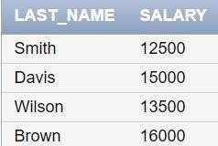

- Create a query to display the employee last name and department number for employee number 176.
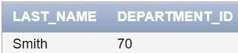
SELECT last_name, department_id FROM employees WHERE employee_id = 176;

- Create a query to display the last name and salary of employees whose salary is not in the range of 5000 and 12000. (hints: not between ).

SELECT last_name, salary FROM employees WHERE salary NOT BETWEEN 5000 AND 12000;
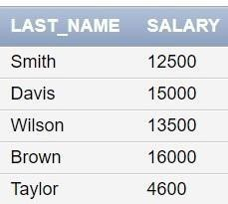

- Display the employee last name, job ID, and start date of employees hired between February 20,1998 and May 1,1998.order the query in ascending order by start date.(hints: between)
SELECT last_name, job_id, hire_date FROM employees WHERE hire_date BETWEEN '02-20-1998' AND '05-01-1998' ORDER BY hire_date ASC;
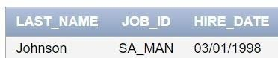

- Display the last name and department number of all employees in departments 20 and 50 in alphabetical order by name.(hints: in, orderby)
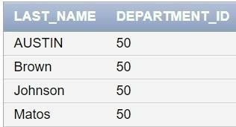
SELECT last_name, department_id FROM employees WHERE department_id IN (20, 50) ORDER BY last_name ASC;

- Display the last name and salary of all employees who earn between 5000 and 12000 and are in departments 20 and 50 in alphabetical order by name. Label the columns EMPLOYEE, MONTHLY SALARY respectively.(hints: between, in)
SELECT last_name AS "EMPLOYEE", salary AS "MONTHLY SALARY" FROM
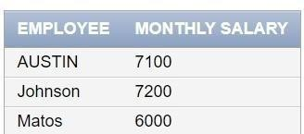
employees WHERE salary BETWEEN 5000 AND 12000 AND department_id IN (20, 50) ORDER BY last_name ASC;

- Display the last name and hire date of every employee who was hired in 1994.(hints: like) SELECT last_name, hire_date FROM employees WHERE hire_date LIKE '%1994%';

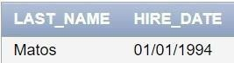

- Display the last name and job title of all employees who do not have a manager.(hints: is null)
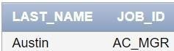
SELECT last_name, job_id FROM employees WHERE manager_id IS NULL;

- Display the last name, salary, and commission for all employees who earn commissions. Sort data in descending order of salary and commissions.(hints: is not nul,orderby)
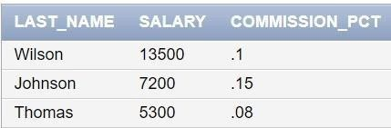
SELECT last_name, salary, commission_pct FROM employees WHERE commission_pct IS NOT NULL ORDER BY salary DESC, commission_pct DESC;

- Display the last name of all employees where the third letter of the name is a.(hints:like) SELECT last_name FROM employees WHERE last_name LIKE ' _a%';
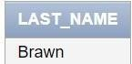

- Display the last name of all employees who have an a and an e in their last name.(hints:

like)
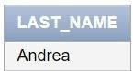
SELECT last_name FROM employees WHERE last_name LIKE '%a%' AND last_name LIKE '%e%';

- Display the last name and job and salary for all employees whose job is sales representative or stock clerk and whose salary is not equal to 2500 ,3500 or 7000.(hints:in,not in)

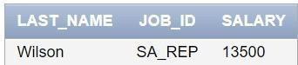
SELECT last_name, job_id, salary FROM employees WHERE job_id IN ('SA_REP', 'ST_CLERK') AND salary NOT IN (2500, 3500, 7000);

