Cpt_S 223

Group: Freya Varez, James Ponce

**Report – PA4**

**Problem Statement**:

The goal of the exercise was to design and implement a ‘board simulator’ program with the following characteristics:

* The ‘board’ is an $m*m$ square matrix (where $m∈Z^{+}$). Note that the implementation of the board is purely conceptual within the program (see *algorithm design)*.
* Within the simulator there are $n$ players (where $n∈Z^{+}$ and $n<m$). $n$ is specified by the user and may change during runtime. Each player has a unique integer *ID*. Similarly, each player construct occupies a unique cell within the bounds of the game board mentioned above.

During runtime, the simulator must support the following functions:

* **Insert():** Loads a new player into the simulator, taking care to follow the above characteristics of the board – meaning an appropriate error message will print to the console when a players insertion fails.
* **Remove():** Deletes a player with a specified ID provided by the user, again printing an appropriate error message in the case of a failed removal.
* **Find():** Searches for a player with the specifies ID provided by the user, returning true is the player is found, false otherwise.
* **MoveTo():** Searches for a player specifies by the user, and moves them to a location on the board (again, specified by the user), granted this location is in the same row, column or diagonal to the players initial location.

(Note: if a player is moved to an occupied space, the occupying player is deleted and an appropriate message displayed through the console).

A program with the above specifications was designed and implemented to optimize runtime and memory usage; taking into account that the size of the board ($m$) and player count ($n$) may be especially large (tested up to $m=1000000$).

**Experimental Setup:**

The program was compiled and experimentally tested using a Unix system through the EECS servers and using a g++ compiler.

The algorithm design for search() was efficient enough that for $n<$ 1000000 the runtime was <1 microsecond (for $m=$ 1000000) and thus could not be measured. This was contrary to the theoretical $O(\log\left(n\right))$ time complexity, however this may have been due to the algorithms design (see *Algorithm Design*).

Due to being unable to test the runtime complexity of search(), the runtime of printByID() was used instead – being that it implements a compilation of $n$ similar functions (see *figure* 1). The printByID() experiment was run 56 times on various inputs of $n$ and $m$ (*see table 1* and respective *figure 2*).

|  |  |  |  |  |  |  |  |
| --- | --- | --- | --- | --- | --- | --- | --- |
| size m | 100 | 500 | 1000 | 5000 | 10000 | 100000 | 1000000 |
| 1 | 14 | 46 | 39 | 74 | 117 | 727 | 6387 |
| 2 | 12 | 19 | 33 | 65 | 70 | 576 | 5654 |
| 3 | 28 | 124 | 38 | 62 | 82 | 608 | 5734 |
| 4 | 29 | 20 | 28 | 112 | 77 | 592 | 5649 |
| 5 | 18 | 57 | 25 | 76 | 88 | 584 | 5734 |
| 6 | 16 | 80 | 30 | 62 | 79 | 586 | 5720 |
| 7 | 11 | 27 | 32 | 100 | 73 | 600 | 5769 |
| 8 | 11 | 56 | 87 | 80 | 86 | 585 | 6674 |

Table 1: PrintByID() samples (time in microseconds)

*Figure 2: Testing runtime of printByID() (time in microseconds)*

*Figure 3: Smaller sample sizes of table 1 (time in microseconds)*

**Algorithm Design:**

The overall program was designed with the possibility of large game board $m$ and number of players $n$ in mind. Thus, all algorithms had to balance an optimized runtime and memory usage. However, the program also takes into account that in most cases the number of players ($n$) is much less than $m$.

Thus, the game board was implemented conceptually in the form of integer coordinates within each player node. This was to avoid the memory strain of loading a full game board (likely through the use of a 2D array) and also to optimize the search() algorithm below. Similarly, each node was placed into a std∷map container by both ID and position. The balancing mechanisms for each map was done through the built in algorithms; these are implementation dependent, but usually rely on Red-Black or AVL tree algorithms.[1]

* **Insert():** The insert algorithm was basic and relied upon the search() algorithm below to determine if the new nodes destination was currently occupied. $O(\log\left(n\right))$
* **Remove():** Again, the design of the deletion algorithm was simple, since no direct board was implemented, a node could be deleted without any effect. $O(\log\left(n\right))$

*Note:* The *key* for the above map implementation was based on the (x,y) position within the board. This takes into account that each player holds a unique position.

* **Find():** Find was optimized using a map, which requires a $θ\left(\log\left(n\right)\right)$ to search based on ID as a search key.
* **MoveTo():** This algorithm simply implemented the remove() and insert() algorithm above with the slight change that upon insert() into an occupied position – the occupying player is in turn deleted (as opposed to simply printing an error message to the user and cancelling the move). $O(\log\left(n\right))$

*Figure 1: PrintByID() algorithm design*

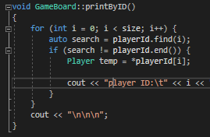

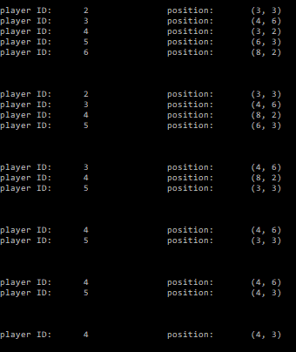

*Figure 3: Test output*

1. *Std::map Insert() Algorithm*, n.d., http://www.cplusplus.com/reference/map/map/.