Show DB’s:

Open mongo DB shell and insert command “show dbs”. This will list all the available DB’s which has collections.

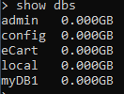

To select a particular DB:

Open mongo DB shell and insert command “use <DB name>”.



To insert multiple Documents:

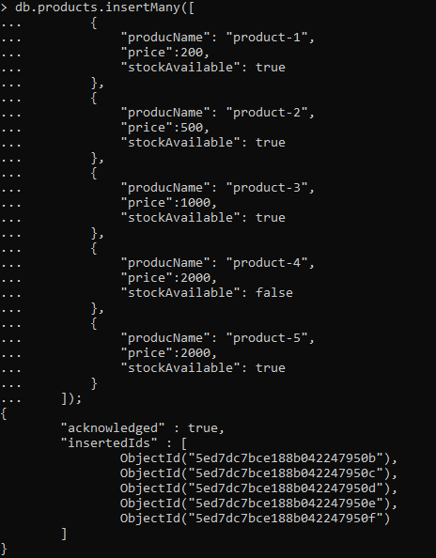

Users age greater than 18.



Find all products with price greater than 500 and available.



Find the orders which is done by person-1;

