Troubleshooting DAY 4

# Team B

Sachin John Thomas

A.K. Anandan

Alfred Varghese

Ajin Raj

**Table**

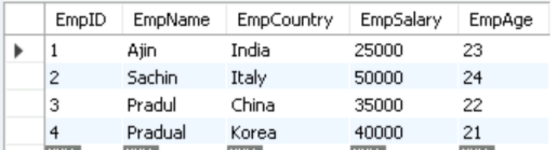

**WHERE, AND, NOT :**

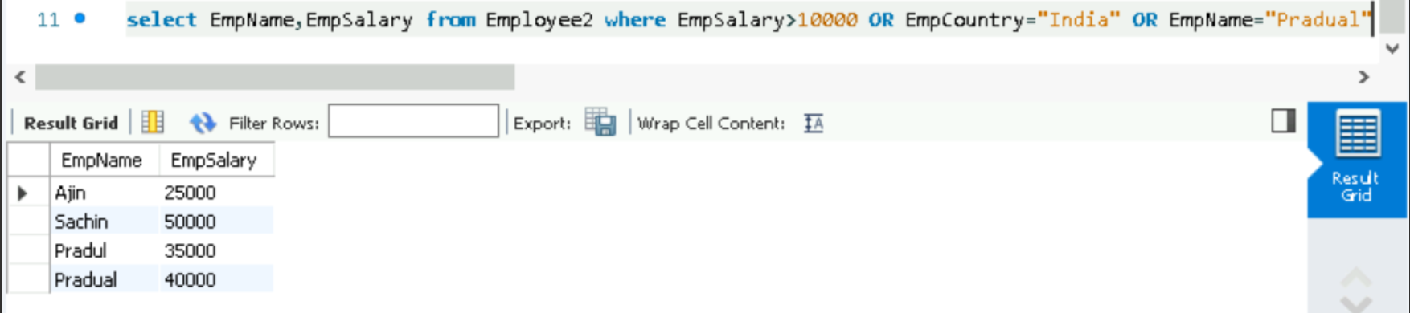 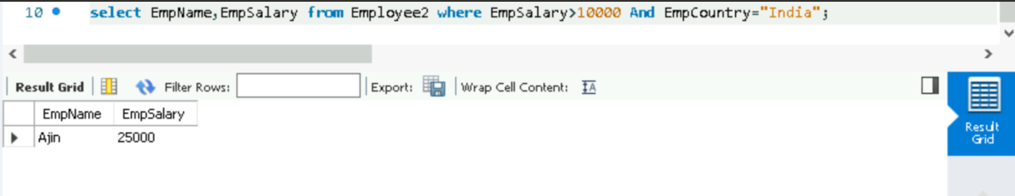

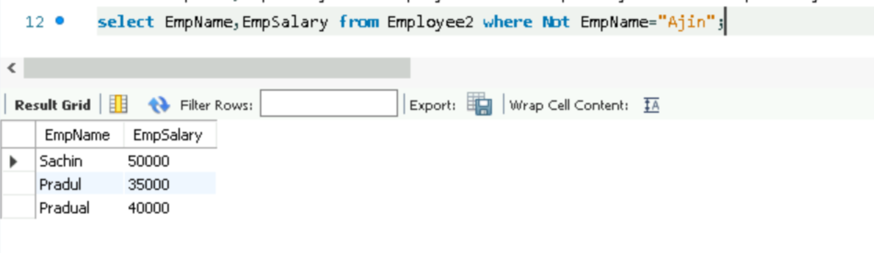

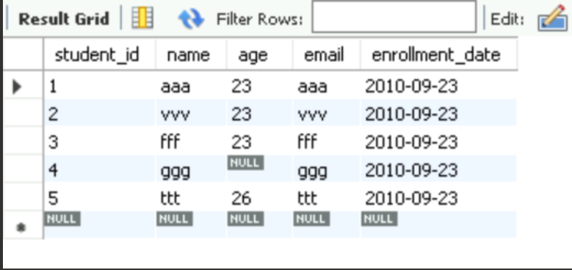

**IS NULL:**

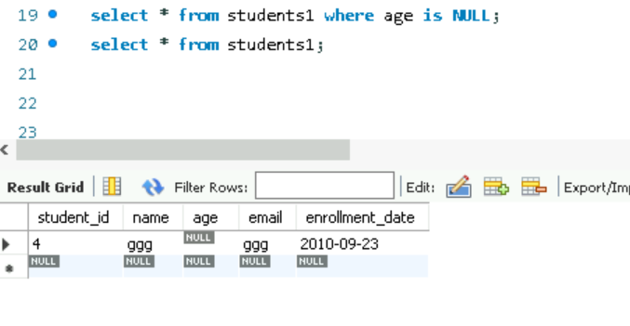

**PRIMARY KEY:**

**Table**

**Table**

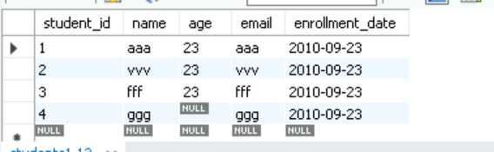

**IS NOT NULL:**

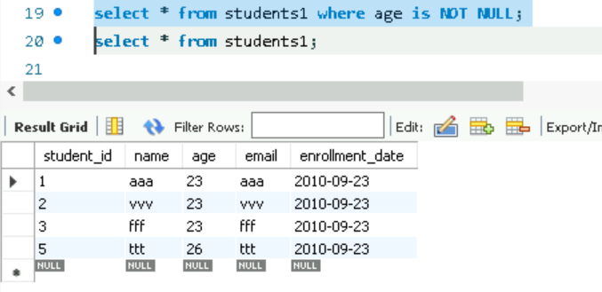

**Auto-increment :**

* Goes in order (Starting from 1)

**Table**

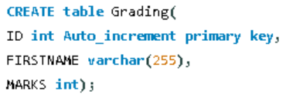 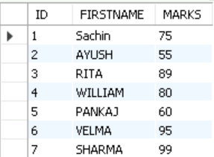

**Min:**



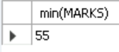

**Max**:





**Count** :

* Select count(MARKS) from Grading WHERE MARKS > 80;



**Avg**:



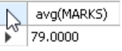

**DISTINCT:**

**Table**

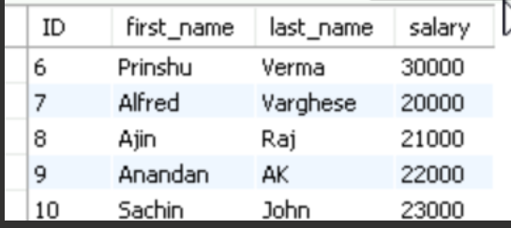

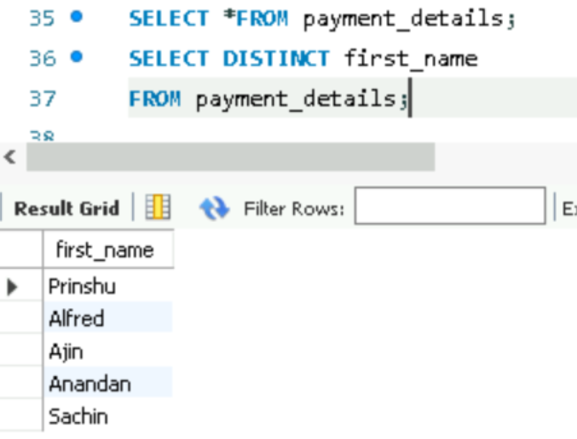

**IN** :

**Table**

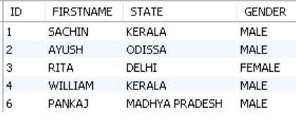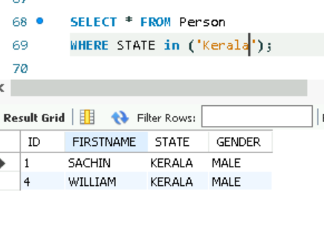

**BETWEEN :**

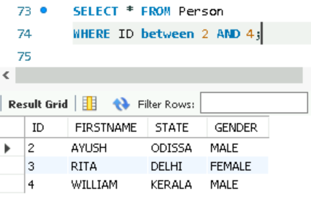

**Column alias:**

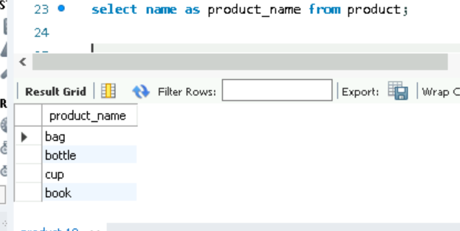

**Table alias**

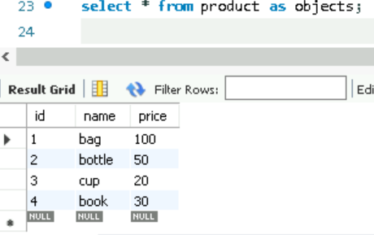

**Wildcards :** 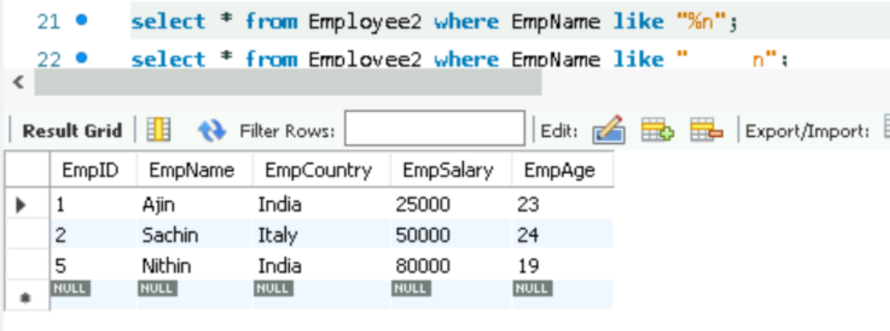

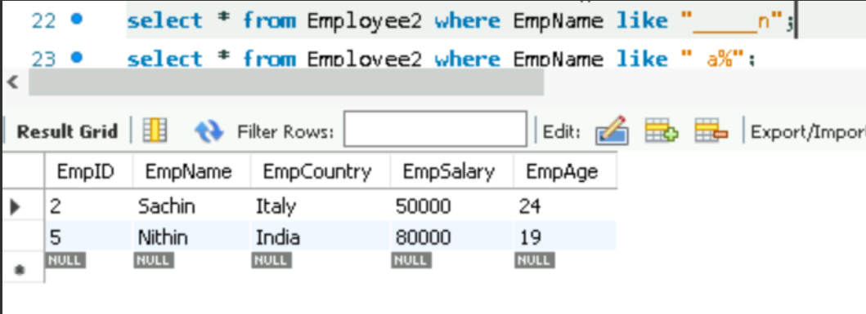

**DESCRIBE :**

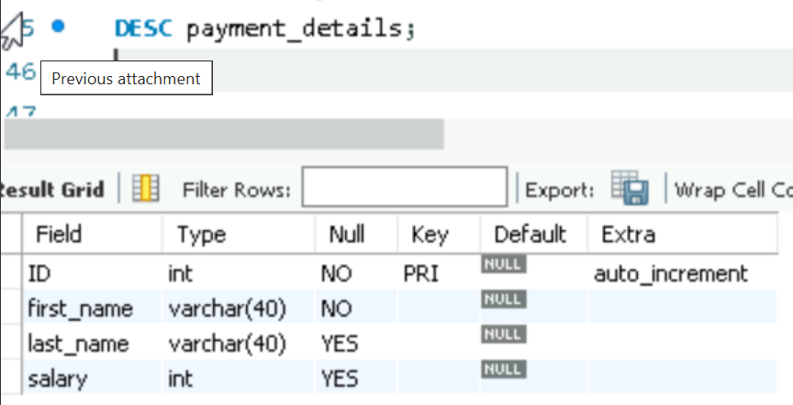

**Table**

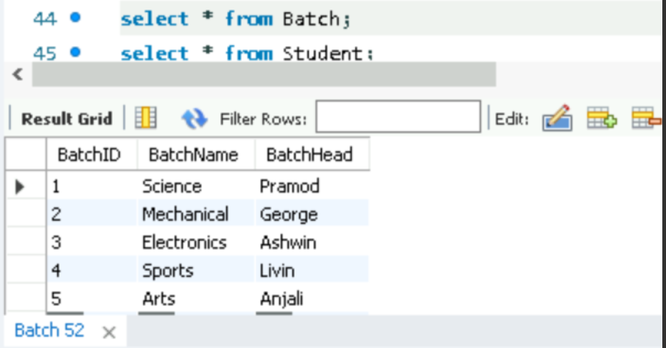

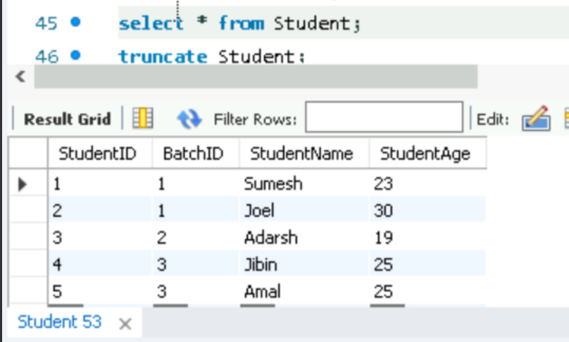

**INNER JOIN :**

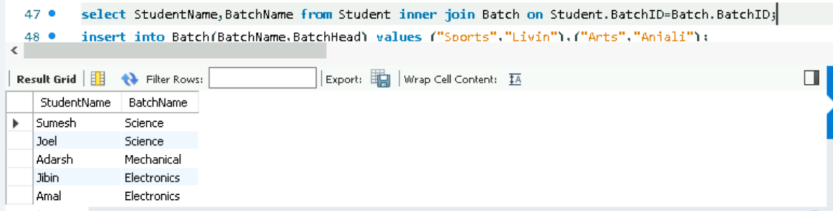

**RIGHT JOIN :**

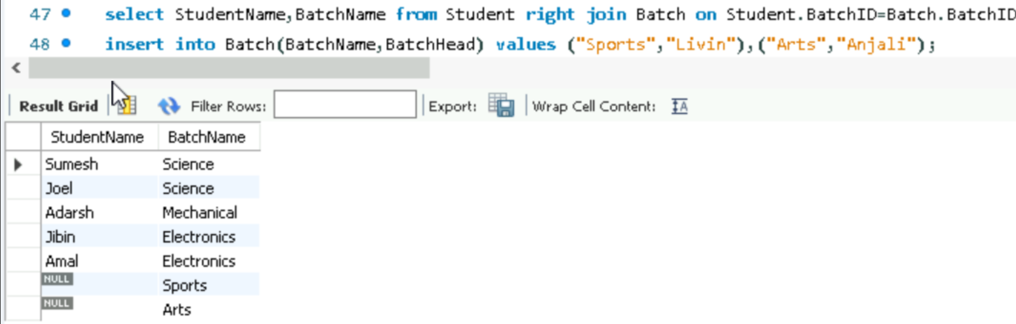

**UNION :**

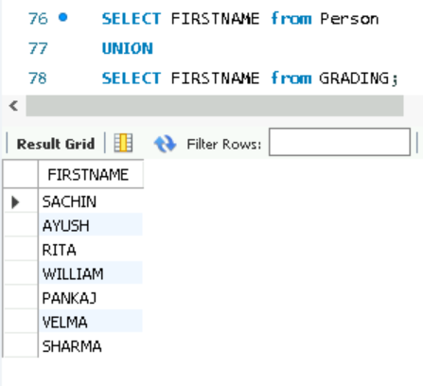

**Table**

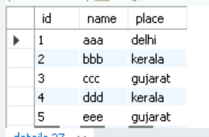

**Group by:**

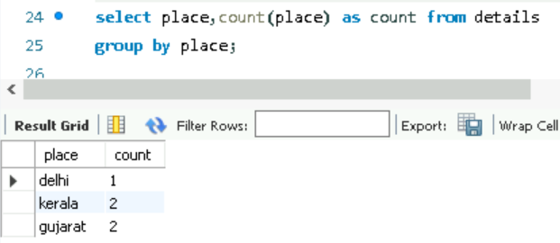

**Having:**

**TROUBLESHOOTING:**

Code #1



1. **Objective** : To display the joined table
2. **Cause :**  Unknown Column error
3. **Solution :**  Specify the required column table

Code #2



1. **Objective** : To select Inner Join
2. **Cause :**  Did not run the database
3. **Solution :**  use database

Code #3

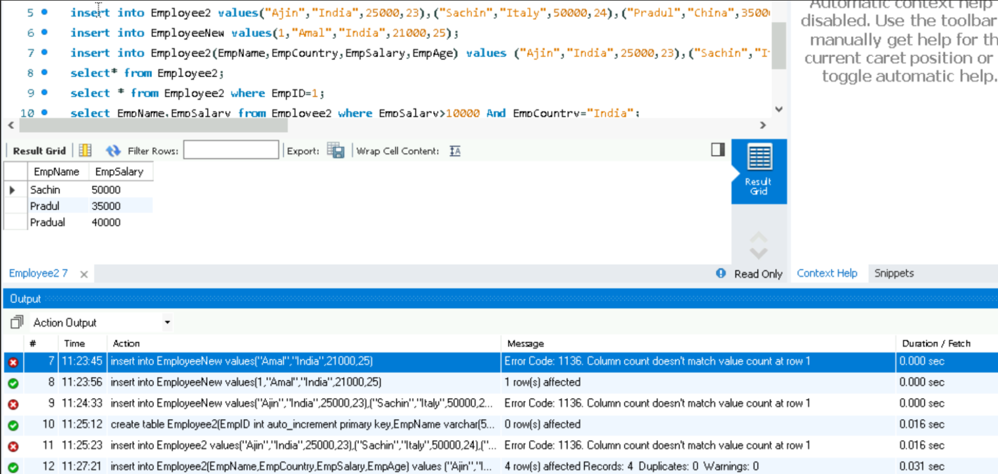

1. **Objective** : To insert values into table
2. **Cause :**  Did not specify column names
3. **Solution :**  insert into Employee(column_name1,column_name2…..)

Code #4

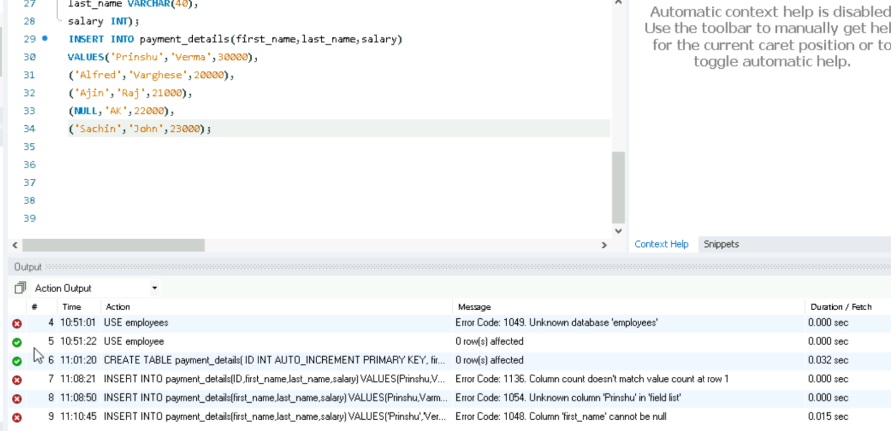

1. **Objective** : Insert values into table
2. **Cause :**  First_name cannot be null since it has been initialized as “NOT NULL”
3. **Solution :** First_name must have values

Code #5

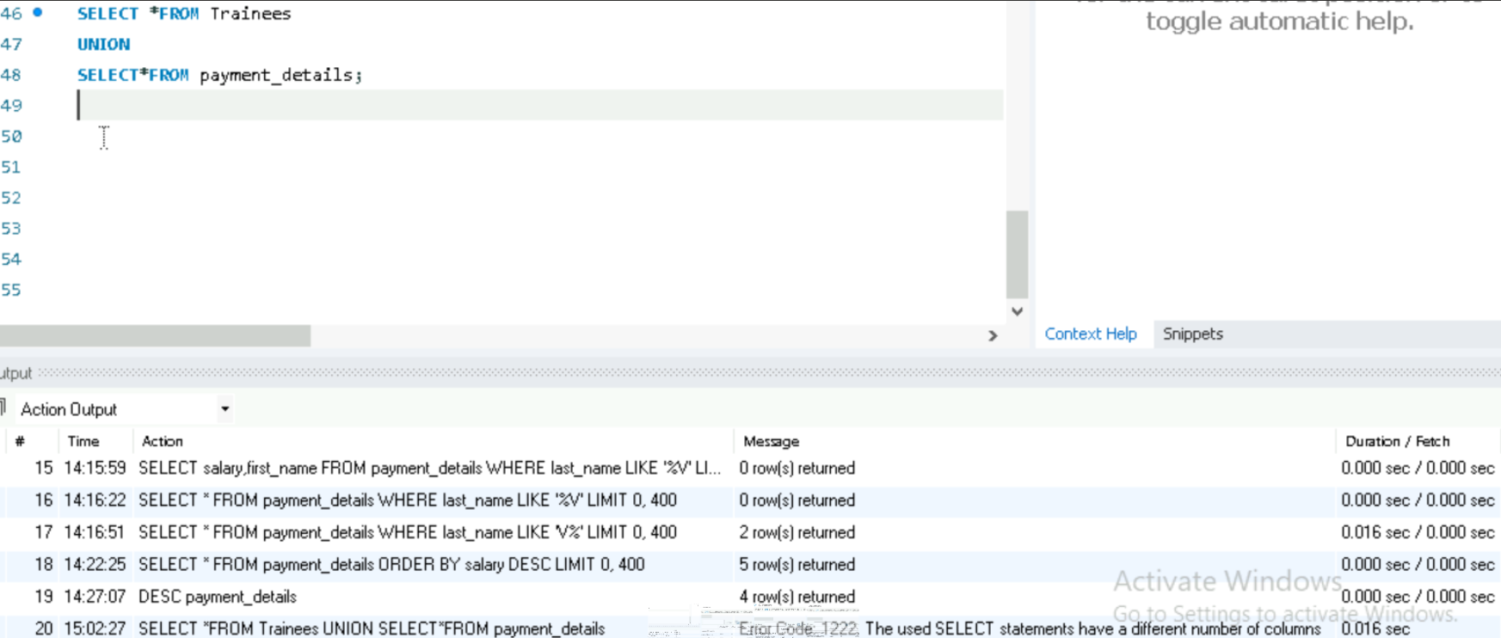

1. **Objective** : Union of two tables
2. **Cause :**  Different number of columns
3. **Solution :** Join with same number of columns / specify each column