Troubleshooting

# Team B

Sachin John Thomas : 6

A.K. Anandan : 4

Alfred Varghese : 4

Ajin Raj : 7

Code #1

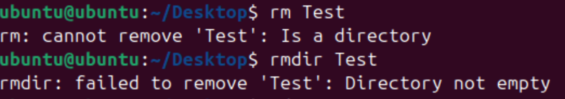

1. **Objective** : To remove a **Directory** ‘Test’
2. **Cause :**  rm is used for removing  **Files**
3. **Solution :**  rmdir Test

Code #2



1. **Objective** : To remove a **Directory**  ‘Test’
2. **Cause :**  Test contains **files**
3. **Solution :**  Empty the files in Test OR rm -r Test

Code #3

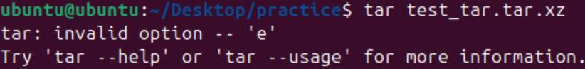

1. **Objective** : To extract a zip file(tar.xz format)
2. **Cause :**  Invalid code/ not enough information
3. **Solution :**  tar -xf test_tar.tar.xz

Code #4

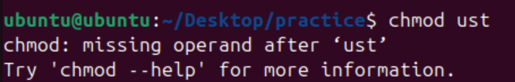

1. **Objective** : To restrict everyone from access(read only)
2. **Cause :**  Invalid code/ not enough information
3. **Solution :**  chmod -R 444 ust

Code #5

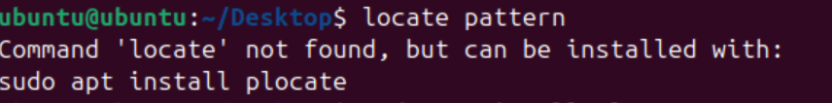

1. **Objective** : To use the command locate pattern
2. **Cause :**  Package not installed
3. **Solution :**  sudo apt install plocate

Code #6

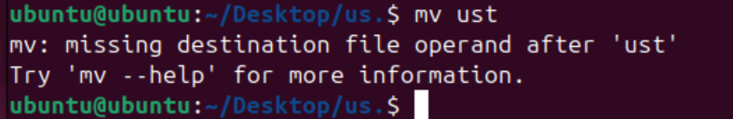

1. **Objective** : To relocate file ‘ust’
2. **Cause :**  Address not defined
3. **Solution :**  mv ~/Desktop/filename ust

Code #7

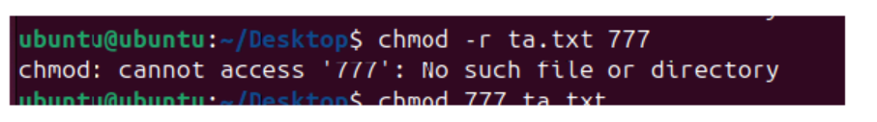

1. **Objective** : To give access to the specified file
2. **Cause :**  Incorrect pattern
3. **Solution :**  chmod -R 777 ta.txt

Code #8



1. **Objective** : To create a directory practice
2. **Cause :**  The file already exist
3. **Solution :** *nil*

Code #9

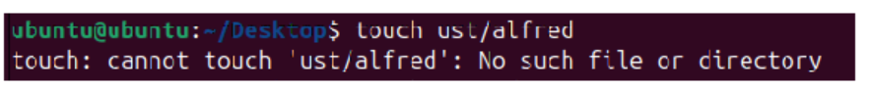

1. **Objective** : To create a file ‘**alfred**’ in the directory ust
2. **Cause :**  Incorrect implementation of address and code
3. **Solution :**  touch ~/Desktop/ust Alfred

Code #10

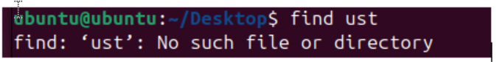

1. **Objective** : To find a file ‘ust’
2. **Cause :**  no such file exist/incorrect spelling
3. **Solution :** Check spelling ( eg : find usa)

Code #11



1. **Objective** : To find a word “this” in the file paragraph
2. **Cause :**  The actual word is “This” . The word is case sensitive.
3. **Solution :**  grep “This” paragraph