Code #1

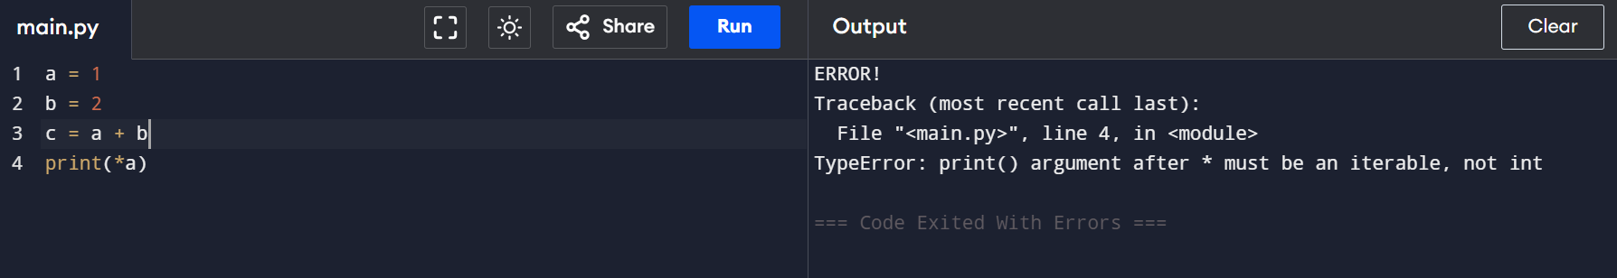

1. **Cause :**  Wrong use case of address
2. **Solution :**  print(id(a))