**1. What are the Boolean data type's two values? How do you go about writing them?**

True

False

When we write it, first letter must be capitalized.

**2. What are the three different types of Boolean operators?**

1. and
2. or
3. **not**

**3. Make a list of each Boolean operator's truth tables (i.e. every possible combination of Boolean values for the operator and what it evaluate )**.

**AND**

|  |  |  |
| --- | --- | --- |
| **Input 1** | **Input 2** | **Output** |
| True | True | True |
| True | False | False |
| False | True | False |
| False | False | False |

**OR**

|  |  |  |
| --- | --- | --- |
| **Input 1** | **Input 2** | **Output** |
| True | True | True |
| True | False | True |
| False | True | True |
| False | False | False |

**NOT**

|  |  |
| --- | --- |
| **Input** | **Output** |
| True | False |
| False | True |

4. What are the values of the following expressions?

(5 > 4) and (3 == 5) **False**

not (5 > 4) **False**

(5 > 4) or (3 == 5) **True**

not ((5 > 4) or (3 == 5)) **False**

(True and True) and (True == False) **False**

(not False) or (not True) **True**

**5. What are the six different types of reference operators?**

==

!=

>

>=

<

<=

**6. How do you tell the difference between the equal to and assignment operators?**

The symbol ‘=’ is assignment operator. It is used to assign the value of right hand side to the variable on left hand side.

The symbol ‘==’ is used for equality checking. i.e, it checks whether the operands on both sides are equal and return True or False accordingly.

**7. Describe a condition and when you would use one.**

When we want to alter the program flow based on certain rules, we use conditions. It branches the flow into two. One branch will get executed if the condition evaluates to True. The other branch will be executed otherwise.

8. Recognize the following three blocks in this code:

spam = 0

if spam == 10:

print('eggs')

if spam > 5:

print('bacon')

else:

print('ham')

print('spam')

print('spam')

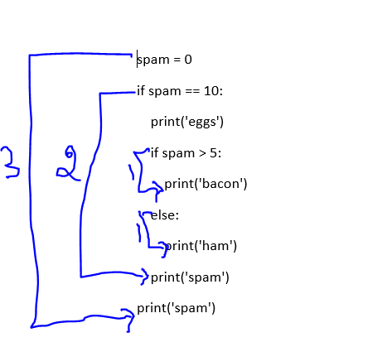

3 – the main program flow

2 – if block

1 – another if and else block within the previous if block.

**9. Create a programme that prints. If 1 is stored in spam, prints Hello; if 2 is stored in spam, prints Howdy; and, prints Salutations! if there's something else in spam.**

spam = int(input("Enter a number"))  
if spam == 1:  
 print("Hello")  
elif spam == 2:  
 print("Howdy")  
else:  
 print("Salutations!")

**10.If your programme is stuck in an endless loop, what keys can you press?**

To exit from endless loop in command line, press CTRL + C

**11. How can you tell the difference between break and continue?**

The break keyword will completely exit the loop. The rest of the code inside loop and the remaining iterations are not executed.

However, continue keyword will only skip the execution of remaining code of current iteration. The execution proceeds from next iteration.

**12. In a for loop, what is the difference between range(10), range(0, 10), and range(0, 10, 1)?**

range(10) has only one argument, which defaults to the stop limit. The resulting range is [0, 1, 2, 3, 4, 5, 6, 7, 8, 9]

range(0, 10) has 2 arguments. 0 is the start index and 10 is the stop index. The resulting range is [0, 1, 2, 3, 4, 5, 6, 7, 8, 9]

range(0,10,1) has 3 arguments. 0 is the start index, 10 is the stop index and 1 is the step value.

13. Using a for loop, write a short programme that prints the numbers 1 to 10 Then, using a while loop, create an identical programme that prints the numbers 1 to 10.

for i in range(1,11):  
 print(i)

i = 1  
while i<=10:  
 print(i)  
 i += 1

**14. If you had a bacon() function within a spam module, how would you call it after importing spam?**

Spam.bacon()