Recruitment Model-Driven App Documentation
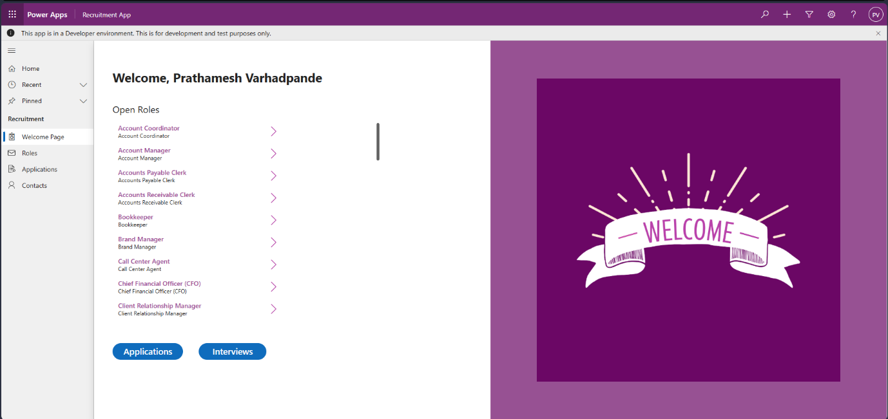
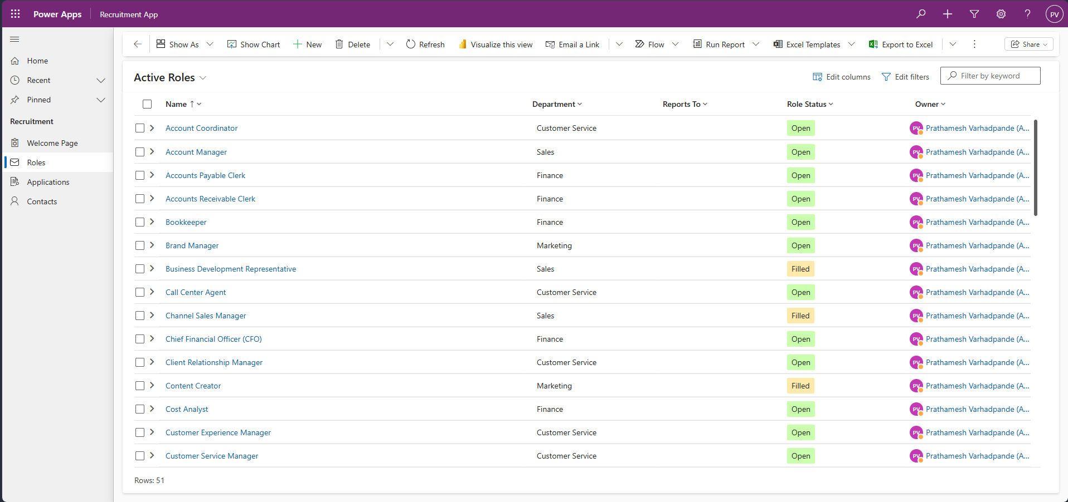
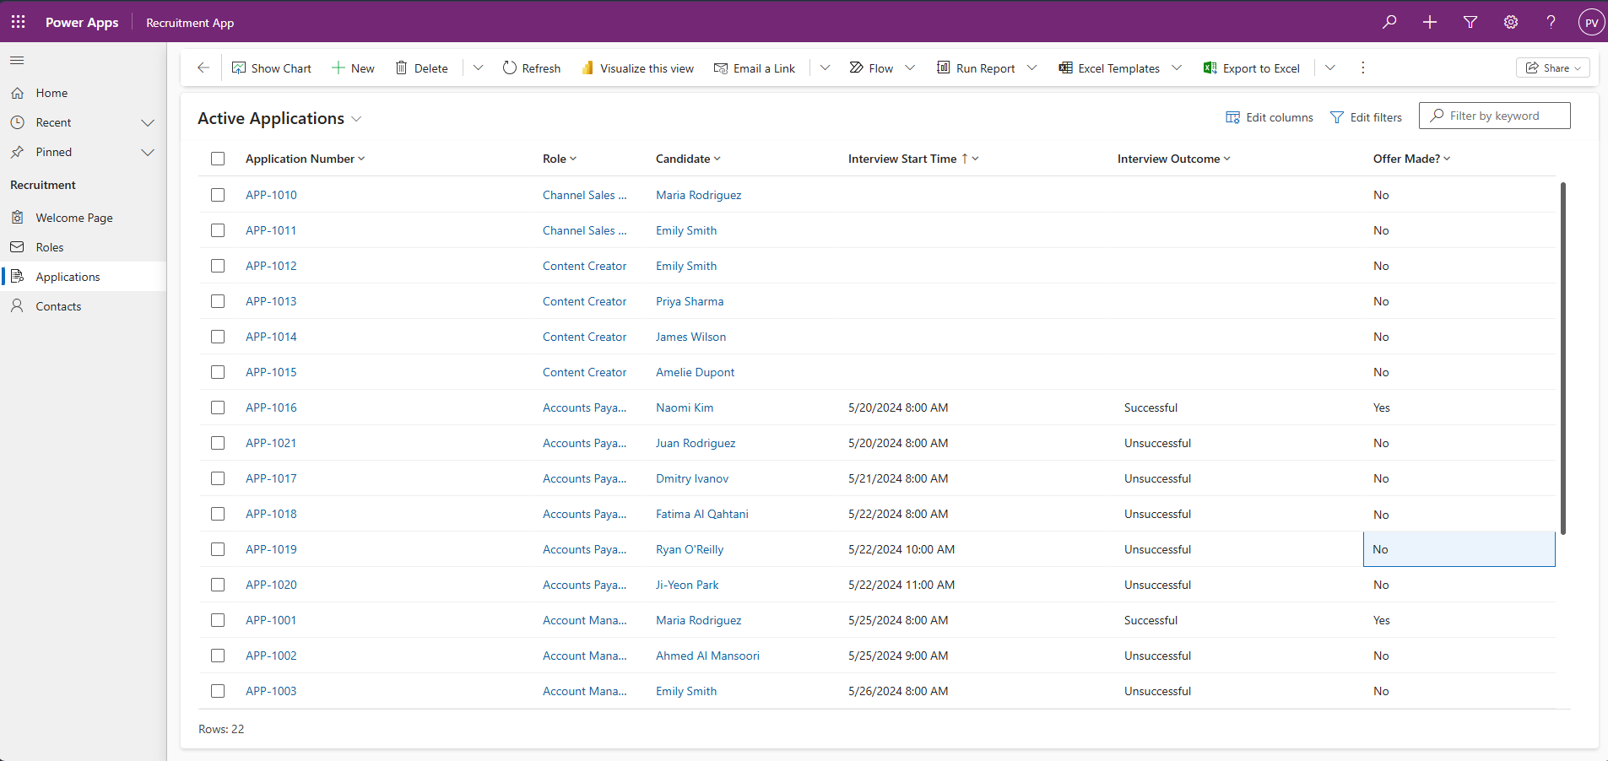
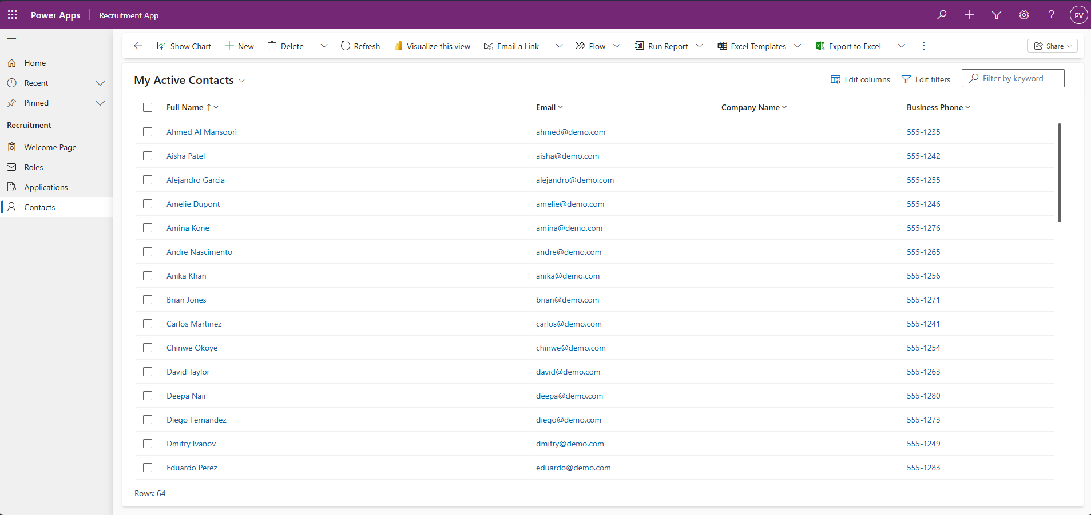
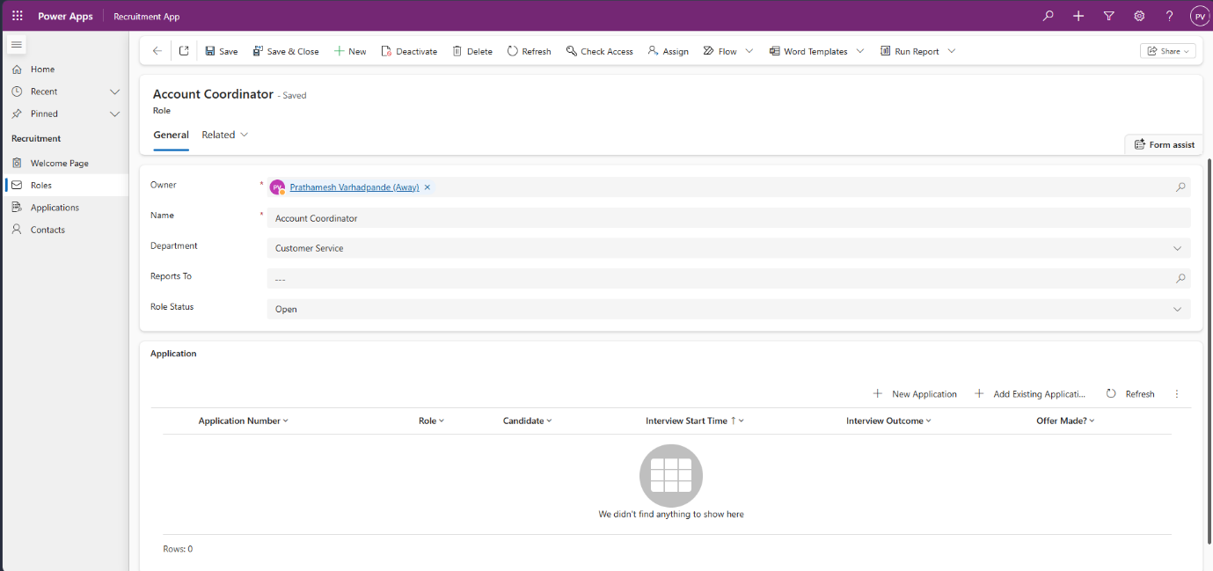
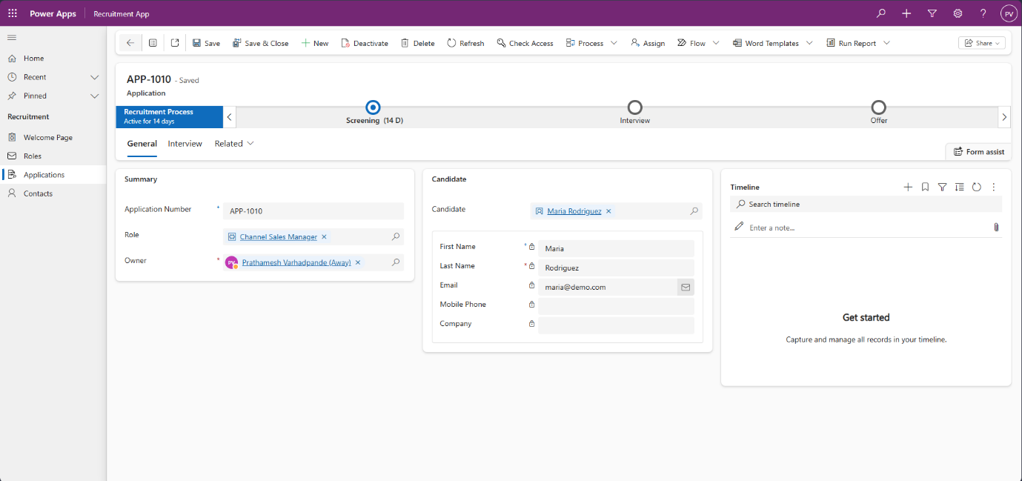

Project Overview
This project is a Model-Driven Power App built on Dataverse to manage a recruitment process from start to finish. The app is designed to handle job roles, candidates, and job applications in one connected system with forms, views, relationships, process tracking, and security.
Purpose
The main purpose of the app is to support recruitment operations in a structured way. It helps teams track open roles, store candidate details, manage applications, move candidates through each hiring stage, and keep all related activity in one place.
Why a Model-Driven App
A model-driven app is used because the project is based on business data, table relationships, and process control rather than custom screen design. It is a good fit for enterprise-style applications that need scalability, security, auditing, search, and a strong Dataverse foundation.
Environment Setup
The project starts by creating or using a Power Apps environment with Dataverse enabled. Important environment settings are also turned on, such as the monthly release channel, Dataverse search, AI-powered chat, and auditing, so the app can use newer features and maintain change history.
Solution Structure
A solution named Recruitment is created to store all project components in one place. This makes it easier to organize tables, processes, forms, views, and the final app, and it also supports moving the solution between environments such as development, testing, and production.
Data Model
The app is built around three main tables: Role, Contact, and Application. The Contact table is reused from Dataverse, while Role and Application are created as custom tables inside the solution.
The Role table stores job opening details, the Contact table stores candidate information, and the Application table connects a candidate to a role. This creates a proper relational structure where one role can have many applications and one candidate can also have many applications.
Role Table
The Role table is created with attachments, auditing, quick create support, and search enabled. It includes columns such as role name, department, role status, and a lookup to the reporting manager using Microsoft Entra ID.
Department and role status are created as choice fields so users select from standard values instead of typing free text. This keeps the data clean and makes filtering and reporting easier.
Application Table
The Application table is the core process table of the app. It includes an auto-number primary name column used as an application number, along with fields for screening call date, interview timing, interview outcome, comments, reference check details, and offer status.
This table also supports activities, which means users can store notes, tasks, phone calls, emails, and other timeline items directly against an application. That gives the recruitment team one place to track both data and follow-up actions.
Relationships
The project uses Dataverse relationships to connect data across the app. Applications are linked to both a role and a candidate through lookup columns, which allows the app to show related information without duplication.
These relationships are also used later in forms, subgrids, and quick view controls. Because of this design, users can open one record and immediately see connected details from other related records.
Views
Custom views are created to show the right records in the app. For example, the Role table includes views like Active Roles and Open Roles, while the Application table includes an Active Applications view sorted by interview timing.
The project also configures Quick Find columns so search works on useful fields only. This improves both usability and search relevance inside the model-driven app and Copilot experience.
Forms
Main forms are designed for both the Role and Application tables. The forms use sections, tabs, and multi-column layouts to make the data easier to read and update.
The Application form includes a general area for summary details, a timeline for related activity, and an interview tab for process-specific fields such as interview dates, outcome, and comments. This structure keeps the form clean even though the process has many fields.
Business Process Flow
A business process flow is added on top of the Application table to guide users through the recruitment stages. The process includes stages such as Screening, Interview, Reference Check, and Offer.
The reference check stage is built with conditional branching. If a reference check is required, the process shows that extra stage; otherwise, the application can move directly to the offer stage.
Model-Driven App Build
After the tables, views, forms, and process are ready, the model-driven app is created by adding the main Dataverse tables into the app. This automatically brings in much of the standard navigation, toolbar behavior, responsive layout, and user interface experience.
The app includes navigation for roles, contacts, and applications, and it uses the forms and views designed earlier. Because it is model-driven, much of the interface behavior is available without extra custom coding.
Data Import and Usage
Sample data is added by importing CSV files into the tables. Data is loaded in the correct order so relationships can be matched properly, starting with roles, then contacts, and then applications.
During import, columns are mapped to Dataverse fields and lookup relationships are matched to existing records. This allows the app to show meaningful data quickly and makes testing much easier.
Extra User Experience Features
The app also includes quick create forms, quick view forms, lookup view improvements, and subgrids. These features help users create records faster, preview related details, and see connected records directly inside forms.
For example, a role form can show all related applications in a subgrid, and an application form can display key candidate details through a quick view form. These additions reduce unnecessary clicks and make the app more useful in daily work.
Search and Copilot
Dataverse search is enabled so users can search across indexed columns in the app. Copilot is also enabled, allowing users to ask natural-language questions about the stored data, such as counts or role distribution by department.
This adds a more modern analytics and discovery layer on top of the recruitment system. It helps users find information faster without manually building every filter or view.
Security
Security roles are an important part of the project because this is an enterprise-style app. Dataverse security controls what users can read, create, update, delete, or manage at the table and record level.
This means different users, such as recruiters, managers, or administrators, can be given different access depending on their responsibilities. The app is not only shared visually; it is secured through the underlying Dataverse model.
Outcome
The final result is a complete recruitment management system built with Power Apps Model-Driven App capabilities and Dataverse. It demonstrates how to design a business application using tables, relationships, views, forms, business process flows, imports, search, and security in a simple but professional way.

