

Noble House CMS System

Meeting Summary

会议议题 | 第二次版本上线（经过SS部门测试后）SS给美国的答复
时间 | 2014年3月6日 | 会议方式 | Email
会议地点
参加会议人员 | David Eike, Mike, Oliver, Mellisa, Bonnie, Lee
会议记录：
Dear Melissa :
Due Mike is ill today , I help this part.
As chat with Jin in morning , about USA feedback point we answer as bellow :
- SKU QTY: It is the online stock , but now has no info, because it will work in Version2 of CMS development(Websites API).
- Product Dimension: need add unit ------------------------ IT will deal with it in next week.
- Cost Module ：Need reconfirm with you the info(in CMS now) as you want and what is the Definitions. Current CMS info is based on last time David confirm and HM ALL items info to design.
- 294903 Pix issue: it is the mark to on behalf of this SKU, --------------------------IT will change another better logo .
- 237526 Freight issue: we based on Webecom freight to get 35, need you give us the right freight or get the data logic , so that we could find the correct freight info .
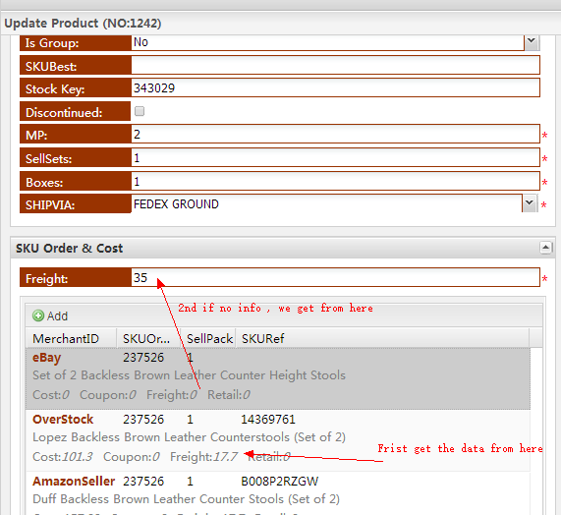
- The Drop-down box function will be add in next week by IT
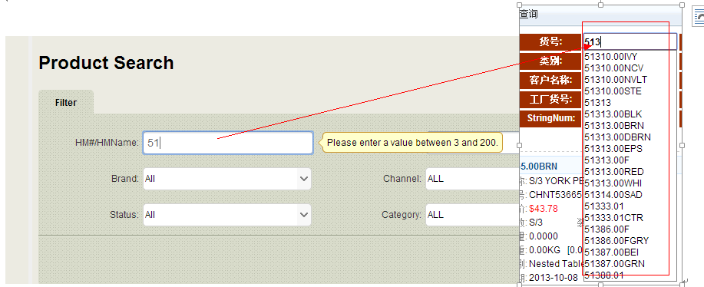
- Modified Time change to：last update
- Question: update CMS , could auto update the WEBECOM?------------------Yes we are doing the function from this week .
- Log: Only log for 2 page Product Configuration / HMNIM Configuration, but no detail in cells. If want to do it , will wait for the last priority.
- UPC: please confirm if get from HM.xls as bellow pix show. Please give the key logic so that we could related to the CMS key
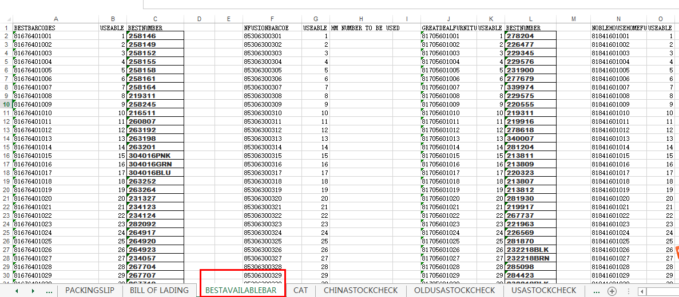
- All the PIX : USA will select . but let you know we have do the related lifestyle path base on sku name and list by the pix size. But we don’t have do the export function , need USA team to suggest which way they will do for uploading the pix for the websites, so that we could base on the requirement to do the export function. Be sure in Version2 –System will do the API , but before it , We think the export function is useful for your work
- First Plan goal： Fix all overstock info 100% in CMS. -------------need share more your details about this part , so that we could prepare.
- Would you like to answer us bellow Email 9 points?
Look forward to your feedback.
Millie

下一步行动计划：

附录：

