**Quadrilateral**

**Time Limit: 2000/1000 MS (Java/Others)    Memory Limit: 65536/32768 K (Java/Others)**

Description

One day the little Jack is playing a game with four crabsticks. The game is simple, he want to make all the four crabsticks to be a quadrilateral, which has the biggest area in all the possible ways. But Jack’s math is so bad, he doesn’t know how to do it, can you help him using your excellent programming skills?

Input

The first line contains an integer N (1 <= N <= 10000) which indicates the number of test cases. The next N lines contain 4 integers a, b, c, d, indicating the length of the crabsticks.(1 <= a, b, c, d <= 1000)

Output

For each test case, please output a line “Case X: Y”. X indicating the number of test cases, and Y indicating the area of the quadrilateral Jack want to make. Accurate to 6 digits after the decimal point. If there is no such quadrilateral, print “-1” instead.

Sample Input

2

1 1 1 1

1 2 3 4

Sample Output

Case 1: 1.000000

Case 2: 4.898979

解题报告：

一道数学题，给定四边形边长，求最大面积。

首先注意，如果最小的三个边加在一起小于等于最大的边，那么此四边形不存在。

下面简证，等且仅当四边形为圆内接四边形时，面积最大，并给出面积公式。

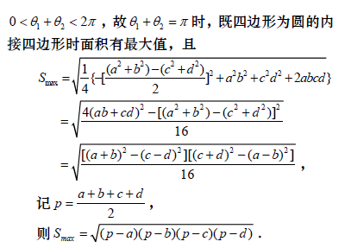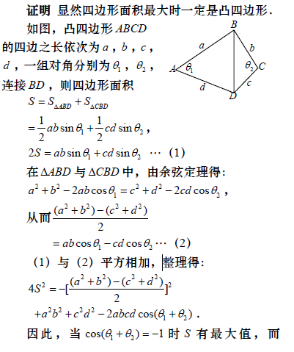

所以只需要令p=(a+b+c+d)/2，输出sqrt((p-a)(p-b)(p-c)(p-d))即可。