

**TABLE OF CONTENTS**

**Brief Description 3**

**Nav Bar Section 4**

**Colour Section 5**

**Typography Section 6**

**Wireframe Section 9**

**Branding Section 10**

**1.Brief Description**

The project is basically a CMS (Content Management System) with a specific area of functionality. This system is made for personal purpose. Few of the tasks which are related to personal purpose are displayed as follows:

* Displaying the work that admin has done.
* Retrieving details of admin.
* Uploading and downloading various assignments and projects from the website.
  1. **Purpose**

The main purpose of this project is that the i can pay attention on my work easily through this project. And any people use the my website and retrieve the information about my work.

* 1. **Scope**

In this section we get ourselves familiarized with the scope of the system. The system is a Content Management System which means it will manage the content of a website. There are also some specifications or in simple terms a verity in the scope of this CMS, this CMS is specifically designed for personal purpose. If we go more specific into the application of the software, it will manage the data of the my work, services that i provide.

**2.Nav Bar Section**



In this project, nav bar is horizontally created. The nav bar is located above the header tag. It has separate section from header tag. There are five lables include in nav bar: HOME PAGE, ABOUT PAGE, PRIJECTS, SERVICES, GIT HUB, CONTACT ME and BUSINESS CONTACTS. Nav bar has its border so that user can identify the portion of nav bar.When user move the cursor on the labels, the labels change its colour from black to grey by using hover function. Each label has its own portions. Also,each lables has its own separate file.Thus,when user click on the lables ,they will go to another page according to the lables.

**3.Colours Section**

In this project, i have used so many colors in different sections. But, each page has same background color.Following is the list of colors ,their hexadecimal numbers, and their location on the website.

|  |  |
| --- | --- |
| **Hexadecimal Value** | Location |
| #d0e4fe | Container tag |
| #9CC5FC | Header , nav and footer tag |
| #000033 | Every h2,h3, nad h4 tag |

**4.Typography Section**

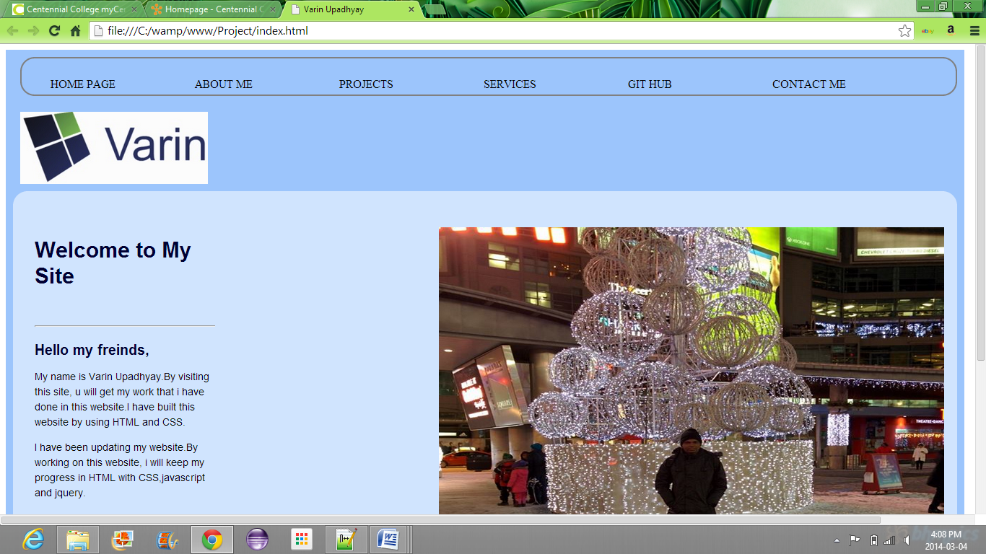[Home Page(header,container)]

21

31

41

51

61

11

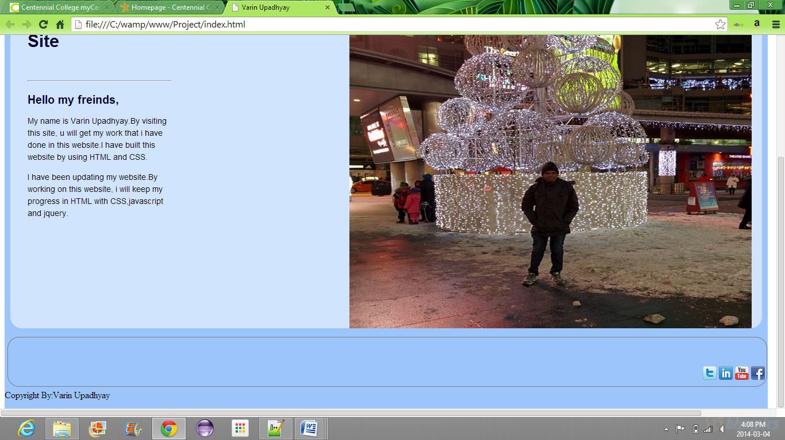[Home Page(container,footer)]

71

|  |  |  |
| --- | --- | --- |
| **Arrow No** | **Tag Name** | **Description** |
| 1 | Nav | * Set the border with grey color. * Font size set to 16px. * Height of line is 02em. |
| 2 | Header |  |
| 3 | h2 | * set the color dark blue(#000033). * Font size set to 30px. * Font family set to Arial. |
| 4 | h3 | * set the color dark blue(#000033). * Font size set to 30px. * Font family set to Arial. |
| 5 | P | * set the color none. * Font size set to 15px. * Font family set to Arial. |
| 6 | Img | * set the height 700px. * set the width 700px. |
| 7 | Copyright | * set the font size 20px. * set the text color dark blue(#000033). |

**5.Wireframes Section**

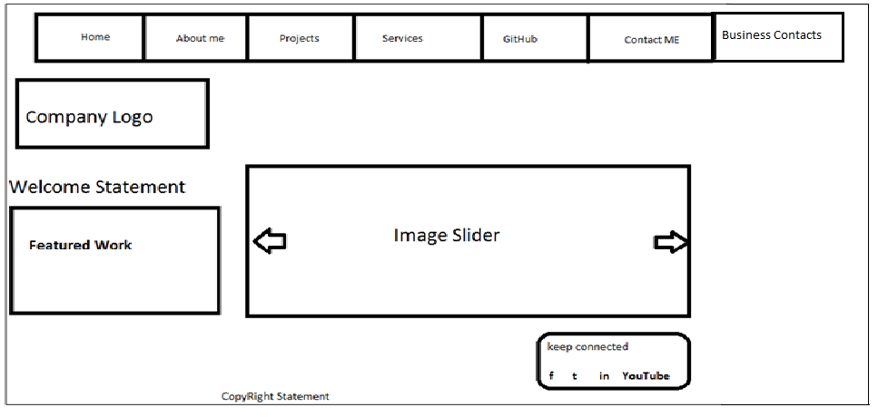

**6.Branding Section**

**Screenshots :-**

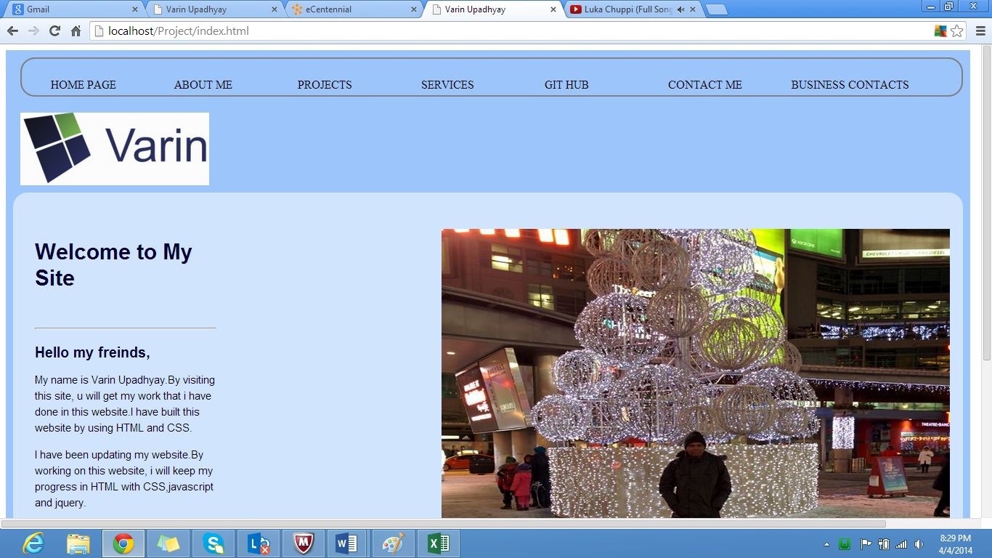 [Home page]

 [About ME page]

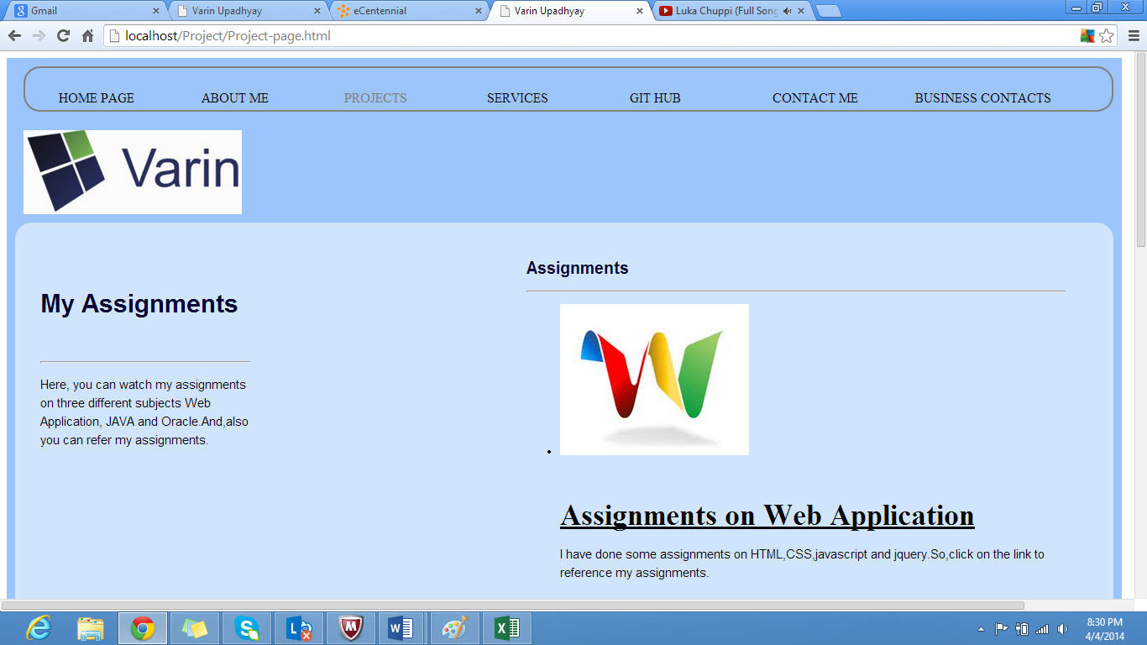 [Project Page]

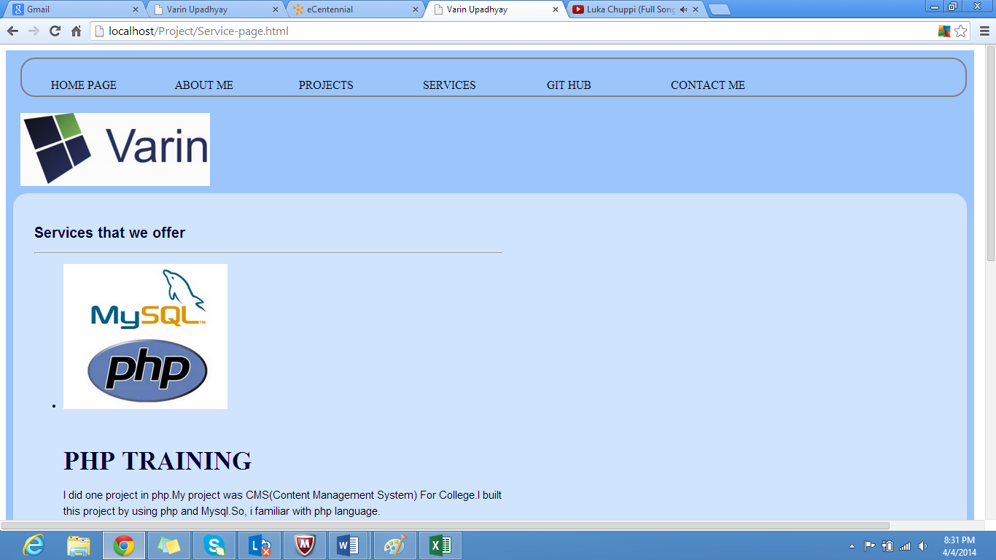 [Services Page]

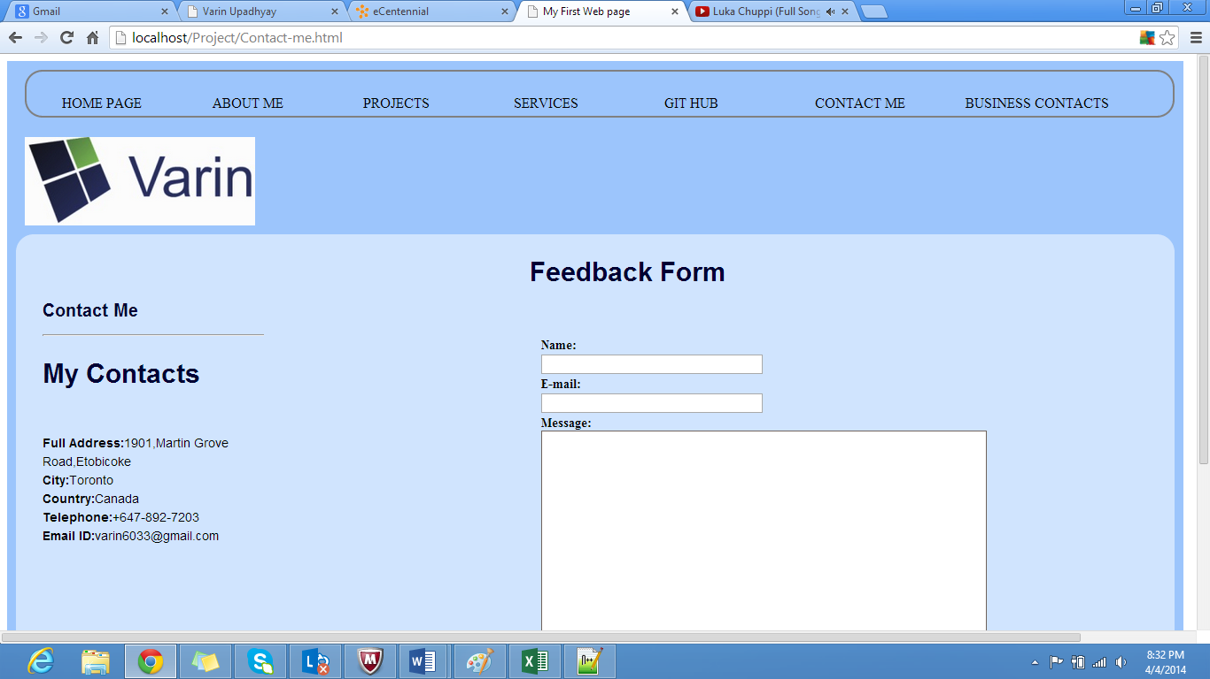 [Contact ME page]

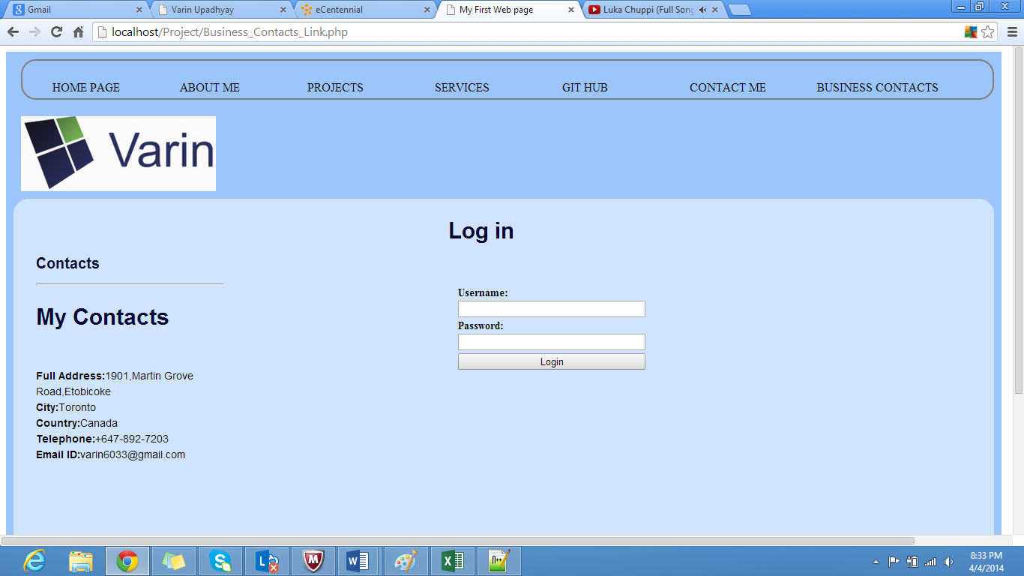

[Business_Contacts_Link.php]

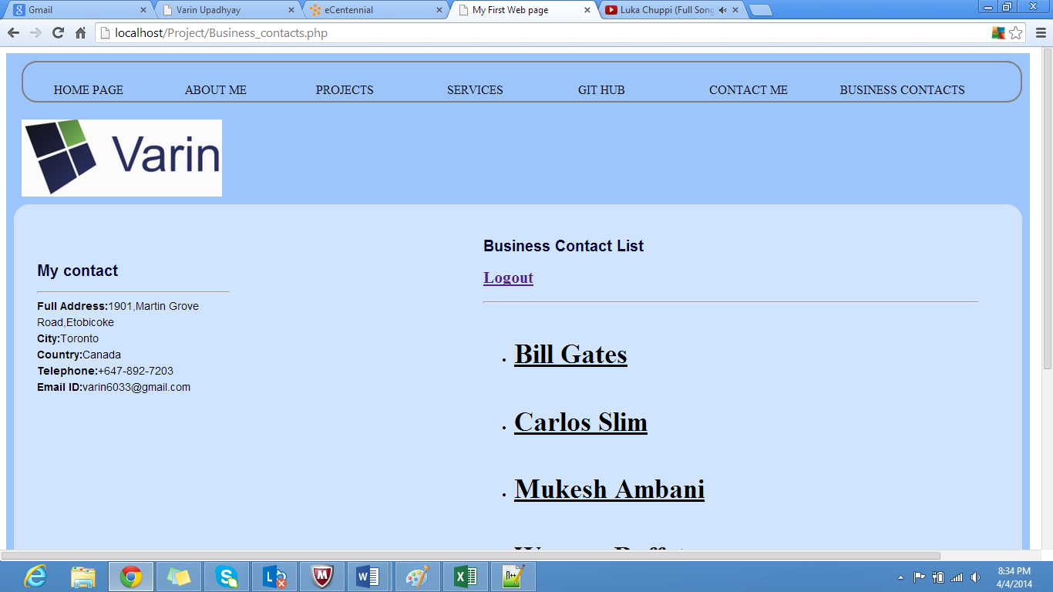

[Business_contacts.php]