 

Pay Slip - Month, Year

Crabroom PayInt LLC

201 Washington Street, Suite 2600, Boston, MA, USA 02108

Date of Joining: **21-10-2023** Employee Name: **Varis Rajak**

Department: **Techinical** Designation: **Full Stack Developer**

Pay Period: **01-02-25 to 28-02-25** Pay Scale: **45,833 Rs**

Total Working Days: **19** Total Working Hours: **152**

Worked Days: **18** Worked Hours: **161**

YTD Earnings: **6,69,450**

|  |  |
| --- | --- |
| Earnings | Amount (RS.) |
| Pay – **302 Rs/hr** * **161** | **48,622** |
| Reimbursement - <<description>> |  |
| Total Earnings | **48,622** |

Employer Signature Employee Signature

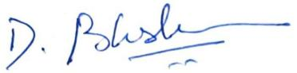

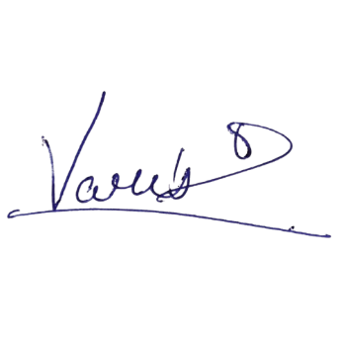

*Crabroom PayInt LLC., One Boston Place, Suite 2600, Boston, MA 02108*