1. Trained Model to Predict--- (In Jupyter)
2. Created a flask app that takes in test file and gives predictions (In Spyder)
3. Using flasgger, created a front end User Interface that works with Flask (Same file in Spyder)
4. Using Docker:

a.Write Docker File- (no extension)

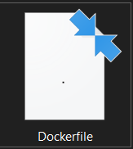

In docker file, following commands:

FROM continuumio/anaconda3:4.4.0 #What Environment I want in docker

COPY . /usr/app/ #Copy from host machine location

EXPOSE 5000 #Will use port number 5000 for networking eg flask app

WORKDIR /usr/app/ #Fix work directory location in docker

RUN pip install -r requirements.txt #Install libraries

CMD python flask_api.pi #Run file with flask app

b. In cmd:

Change directory to workdir of host machine (cd …)

docker build -t money_api . (Build docker image in the location this has been run that is why we changed workdir in previous step; this will get instructions from Docker File (in same workdir) and do all steps inside)

To check which dockers are running: docker ps