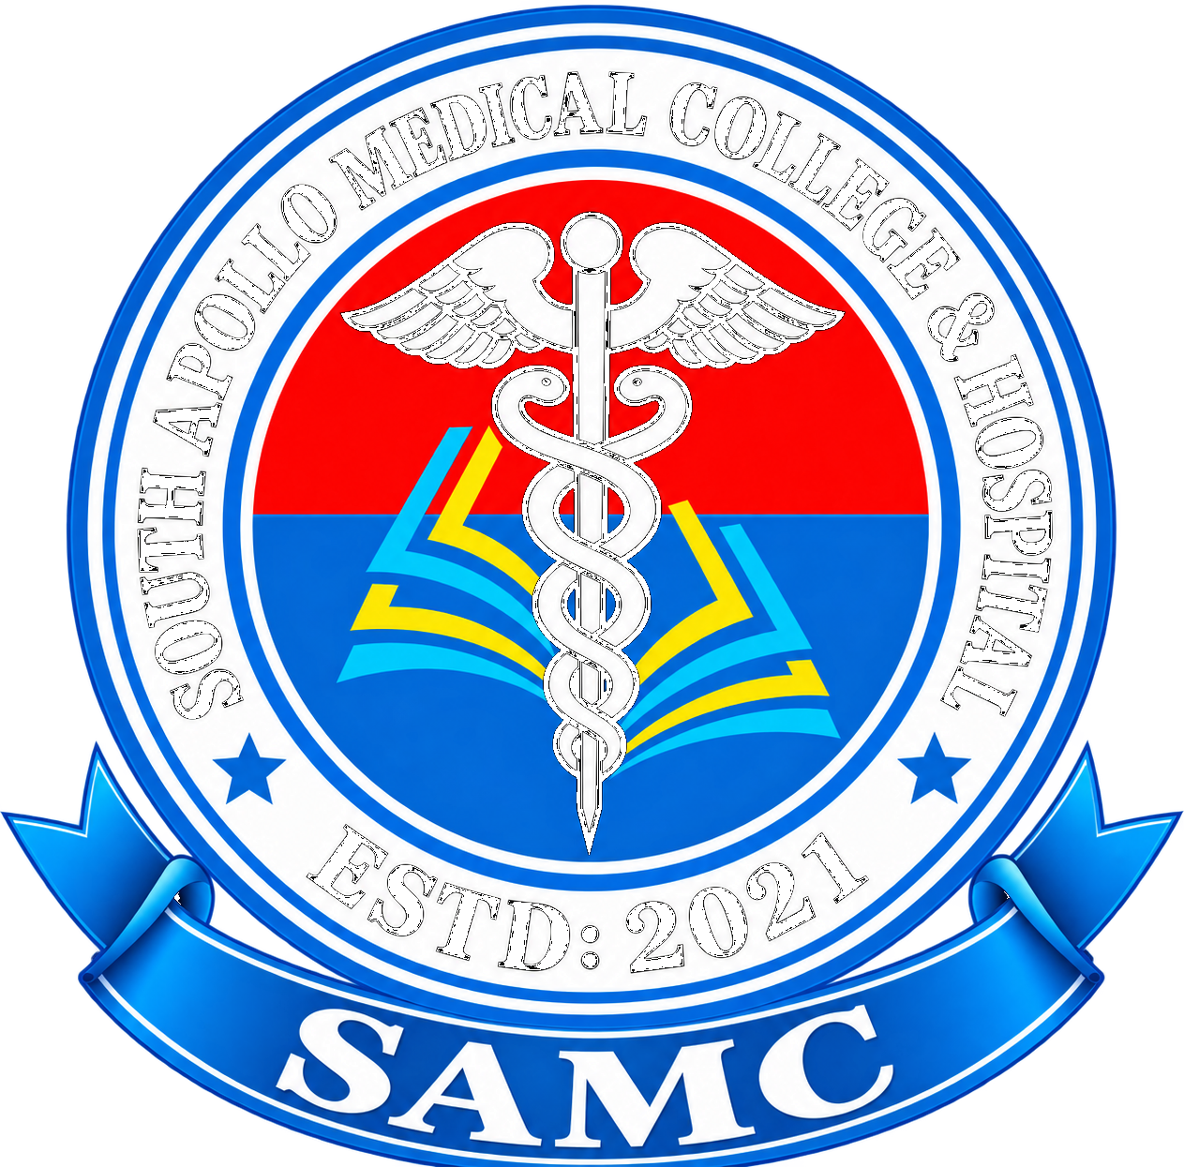
Supplied institutional crest reference · verify master/vector artwork and rights before production

SAMC BRAND GUIDELINES
  - Institutional Crest Edition · v2.2 · EN + বাংলা
Built from the actual SAMC crest supplied by the institution
MASTER IDENTITY
The supplied SAMC crest—not a newly invented symbol—is the primary institutional identity reference.

00 / IDENTITY

The crest is the institution
The supplied crest combines the institutional name, medical emblem, red/blue field, stars, ESTD: 2021 and SAMC ribbon into one formal identity.

Layer | Approved expression | Rule
Master identity | SAMC crest | Primary institutional mark.
Formal name | South Apollo Medical College & Hospital (as supplied) | Verify the current registered college/hospital wording before legal or regulatory use.
Care division | SAMC / Medical Care Services | Descriptor, not a separate logo.
Education division | SAMC / Medical Professional Education | Descriptor, not a separate logo.
Research | SAMC / Research & Innovation | Descriptor, not a separate logo.

NAME CONTROL
The supplied crest reads “SOUTH APOLLO MEDICAL COLLEGE & HOSPITAL.” Some earlier concepts used a different name. Until the legal wording is formally confirmed, the supplied crest and SAMC short form should be treated as the visual reference.

01 / CREST ANATOMY

Preserve the artwork
The crest is a seal. Its individual elements may be explained, but they must not be rearranged, redrawn or independently stylized.

Element | Role | Rule
Outer ring | Institutional name | Do not re-typeset.
Caduceus | Medical identity | Preserve as supplied.
Red field | Clinical/visual emphasis | Part of the crest.
Blue field | Institutional/academic emphasis | Part of the crest.
Cyan + yellow lines | Internal graphic motif | Do not extract casually.
Stars | Formal emblem | Do not move or duplicate.
ESTD: 2021 | Origin marker | Do not alter.
SAMC ribbon | Short name | Do not replace lettering.

MASTER ARTWORK
Use the approved master vector/raster file. Never rebuild the crest manually.

02 / LOGO USE

Clear, formal and consistent

- Use the full-color crest on white or very light backgrounds whenever possible.
- Maintain clear space equal to at least 10% of the crest's overall width on every side, measured from the outermost visible point. Increase space whenever nearby text or edges compete with it.
- Create separate approved print, digital, monochrome and reverse variants from the master asset.
- Provisional minimum full-crest sizes pending physical/user testing: 30mm print, 120px digital, 50mm embroidery. Below these, use only an authorized simplified emblem—not a cropped crest. Signage requires site/viewing-distance calculations.
- Never stretch, compress, rotate, shadow, bevel, outline or recolor the crest.
- Never place the full crest over a busy photograph where its lettering becomes unreadable.
- Do not use the crest as a repeating decorative pattern.

03 / COLOR

Crest-derived institutional palette
The crest is multicolor, but external brand applications should remain disciplined. One site or campaign should use one controlled working set.

Role | HEX | Primary use
Institutional Blue | #0076D7 | Primary actions, links, headings, fields.
Deep Blue | #005AA8 | Formal text accents and strong surfaces.
Clinical Red | #F20D16 | Critical/urgent information and restrained accents.
Crest Cyan | #21B7EA | Secondary highlights.
Crest Yellow | #FFD21A | Small highlights only.
Black | #111111 | Formal text.
White | #FFFFFF | Primary negative space.
Soft Blue | #F2F8FD | Quiet panels and UI surfaces.
ACCESSIBILITY / WCAG 2.2 AA target: 4.5:1 normal text; 3:1 large text and meaningful UI components. White on #0076D7 = 4.59:1; white on #005AA8 = 6.94:1. White on #F20D16 = 4.33:1 (not normal-size text); #21B7EA and #FFD21A require dark text or non-text accent use. #64748B on white = 4.76:1. Do not use color alone for clinical or status meaning.

ONE-SITE RULE
Keep the crest itself intact. Outside the crest, do not scatter all crest colors throughout the interface. Select a controlled working set for the site/campaign and keep it consistent.

04 / TYPOGRAPHY

Academic authority + modern usability
The crest already carries a traditional academic character. Supporting typography should therefore be clean and restrained.

Context | English | Bangla | Rule
Primary web/UI | Aptos | Hind Siliguri | Main institutional system.
Formal print | Approved serif where needed | Approved Bengali serif where needed | Ceremonial exception only.
Clinical/data | Aptos | Hind Siliguri | Clarity first.

MAXIMUM TYPE RULE
For the main digital system, maximum two everyday type families: one English and one Bangla. Do not add fonts simply for decoration.

05 / BILINGUAL

English + বাংলা are equal states
Every public-facing digital experience should be designed as two complete language states.

- Persistent EN / বাংলা switch.
- Every core English page has a corresponding Bangla page and vice versa.
- Recommended /en/... and /bn/... structure.
- Navigation, buttons, forms, validation, errors, confirmations and help are bilingual.
- Patient-facing information uses plain, natural Bangla.
- Accepted medical English may appear in parentheses when clinically useful.
- Bangla is LTR and receives independent responsive QA.
- Literal machine translation is not a final publishing standard.
- Missing critical translation is a release blocker.
QA area | English | বাংলা
Navigation | No truncation | No clipping / overflow
Buttons | Correct width | Correct width
Headlines | Expected hierarchy | Expected hierarchy
Forms | Aligned labels | Aligned labels
Mobile | No overflow | No overflow
Accessibility | Contrast / focus | Contrast / rendering

06 / INSTITUTIONAL ARCHITECTURE

One SAMC · two core divisions
The visual identity should mirror the institution's operating model: medical care and medical professional education under one master SAMC identity.

Master | Division | Descriptor language
SAMC | Medical Care Services | Care · Safety · Service
SAMC | Medical Professional Education | Knowledge · Skills · Excellence
SAMC | Research & Innovation | Evidence · Discovery · Impact

ARCHITECTURE RULE
Do not create separate crests for divisions. Use one SAMC master identity plus a consistent descriptor system.

07 / PHOTOGRAPHY

HD imagery is a core brand asset
The institution should look real, credible and human—not like a generic healthcare startup.

Context | Preferred | Avoid
Medical care | Consultation, nursing, diagnostics, procedures, patient journey | Artificial stock-photo clinical scenes
Education | Teaching rounds, simulation, labs, skills training | Generic classroom stock
Research | Laboratories, imaging, researchers, data, technology | Science-fiction imagery presented as reality
Community | Families, outreach, public health, local people | Exploitative poverty imagery
Campus | Architecture, learning spaces, gardens, wayfinding | Unverified renders shown as current reality

HD PLACEHOLDER STANDARD
Reserve large HD-photo areas on major pages and campaigns. Define crop ratio, focal point, caption and alt-text zones before final photography is inserted.

08 / 77 CREATIVE LIBRARY

One master identity, 77 production surfaces
Every creative type inherits the actual crest, institutional palette, bilingual standard and one-site/one-set discipline.

# | Creative type | Language
01 | Master logo lockup | EN + BN
02 | Horizontal logo lockup | EN + BN
03 | Vertical / stacked lockup | EN + BN
04 | Symbol / emblem mark | Language-neutral
05 | Monochrome positive mark | Language-neutral
06 | Monochrome reverse mark | Language-neutral
07 | Minimum-size logo | Language-neutral
08 | Clear-space diagram | Language-neutral
09 | Incorrect-use sheet | Language-neutral
10 | Co-brand / partner lockup | EN + BN
11 | Division descriptor lockup | EN + BN
12 | Department descriptor lockup | EN + BN
13 | Campus / facility identifier | EN + BN
14 | Bilingual master lockup | EN + BN
15 | Bilingual nameplate | EN + BN
16 | Favicon | Language-neutral
17 | App icon | Language-neutral
18 | Social avatar | Language-neutral
19 | Email signature | EN + BN
20 | Letterhead | EN + BN
21 | Continuation sheet | EN + BN
22 | Envelope | EN + BN
23 | Business card | EN + BN
24 | ID card | EN + BN
25 | Appointment card | EN + BN
26 | Prescription / clinical stationery | EN + BN
27 | Laboratory report | EN + BN
28 | Radiology report | EN + BN
29 | Discharge summary | EN + BN
30 | Medical certificate | EN + BN
31 | Academic certificate | EN + BN
32 | Transcript / marksheet | EN + BN
33 | Admission letter | EN + BN
34 | Student handbook | EN + BN
35 | Faculty handbook | EN + BN
36 | Research paper / journal template | EN + BN
37 | Annual report | EN + BN
38 | Quality / accreditation report | EN + BN
39 | Hospital signage | EN + BN
40 | Wayfinding arrows | EN + BN
41 | Room / department plaques | EN + BN
42 | Emergency signage | EN + BN
43 | Accessibility signage | EN + BN
44 | Parking / arrival signage | EN + BN
45 | Visitor badge | EN + BN
46 | Staff uniform / apparel | EN + BN
47 | Medical coat embroidery | EN + BN
48 | Student apparel | EN + BN
49 | Vehicle livery | EN + BN
50 | Ambulance identity | EN + BN
51 | Outdoor banner | EN + BN
52 | Indoor poster | EN + BN
53 | Roll-up banner | EN + BN
54 | Conference backdrop | EN + BN
55 | Name badge / speaker badge | EN + BN
56 | Presentation master | EN + BN
57 | Infographic system | EN + BN
58 | Data visualization system | EN + BN
59 | Social media post | EN + BN
60 | Social media story | EN + BN
61 | Social media cover | EN + BN
62 | Recruitment campaign | EN + BN
63 | Admissions campaign | EN + BN
64 | Community health campaign | EN + BN
65 | Patient education sheet | EN + BN
66 | Health awareness campaign | EN + BN
67 | Research announcement | EN + BN
68 | CME / CPD campaign | EN + BN
69 | Event invitation | EN + BN
70 | Event ticket / QR pass | EN + BN
71 | Website design system | EN + BN
72 | Digital portal / dashboard | EN + BN
73 | Mobile UI system | EN + BN
74 | Email newsletter | EN + BN
75 | Digital advertising | EN + BN
76 | Merchandise / premium collateral | EN + BN
77 | Environmental / experiential brand | EN + BN

09 / DIGITAL

Website behavior
The website may be contemporary and spacious, but the actual SAMC crest remains the anchor.

Component | Standard
Header | Crest + SAMC identity + EN / বাংলা.
Hero | Large HD photo or institutional visual; concise headline; one primary action.
Navigation | Simple, high contrast, bilingual.
Cards | Consistent spacing and one controlled palette.
Icons | Health Icons outline only; 48-unit source grid; currentColor; English/Bangla labels; CC0 source register; no mixed icon families.
Footer | Institutional identity, contact, legal and language utilities.
Mobile | Independent EN and BN responsive states.

10 / GOVERNANCE

Protect the master identity
A crest-led institution needs one authoritative source of truth.

Area | Owner | Control
Master crest | Institutional brand authority | Single approved master file.
Legal name | Institutional authority | Legal wording overrides design preference.
Color | Brand owner | Version-controlled values.
Bangla terminology | Content/language owner | Approved terminology list.
Clinical communication | Clinical + communications authority | Accuracy before aesthetics.
Academic communication | Academic + communications authority | Accuracy + consistency.
Digital UI | Digital/product owner | EN/BN parity + accessibility.
Photography | Communications + privacy owner | Rights, consent, dignity.

11 / RELEASE CHECKLIST

Nothing ships until it passes

- Correct approved SAMC crest used.
- Correct institutional/legal name used where required.
- No alteration of crest artwork.
- One controlled color set used outside the crest.
- English and Bangla content complete.
- Bangla rendering tested on target devices.
- HD photography approved, licensed and appropriately cropped.
- Patient privacy and dignity protected.
- Accessibility and contrast checked.
- Responsive EN/BN states tested.
- Source files and exports archived.
- Version and approval status recorded.
FINAL RULE
The crest is the identity. Color, typography, photography, UI, signage and campaigns exist to make that identity clearer, more credible and more useful.

APPENDIX

Master asset library
Recommended production structure for the final brand handoff.

Folder | Contents
01_MASTER_CREST | Vector, PNG, monochrome, reverse and minimum-size masters.
02_IDENTITY_RULES | Clear space, sizing and incorrect-use standards.
03_COLOR | Digital and print color specifications.
04_TYPE | English/Bangla fonts, hierarchy and licensing references.
05_BILINGUAL | Approved EN/BN terminology and QA.
06_PHOTOGRAPHY | HD library, rights, consent, crops and alt text.
07_77_CREATIVE | Editable masters for all 77 creative types.
08_DIGITAL | UI components, responsive states and accessibility.
09_PRINT | Print-ready artwork and vendor specifications.
10_ARCHIVE | Superseded versions and approvals.

PRODUCTION NOTES / v2.2 reviewed copy
- The supplied crest reads SOUTH APOLLO MEDICAL COLLEGE & HOSPITAL. Earlier South Asian references in the concept workspace are superseded for this crest edition; legal-name and rights verification remain required.
- The 77-item creative library is a scope checklist, not a claim that all 77 finished assets exist in the supplied package.
- Minimum sizes, contrast, icon geometry and repeated table headers are specified in this reviewed copy. Physical print, embroidery, signage, screen-reader and EN/BN user testing remain release gates.
- Publication requires a named approver, approval date, source master, rights/consent records, font licenses and a change log. This reviewed document is not itself institutional approval.
This document is a design and identity standard. It does not itself establish trademark ownership, legal registration, clinical policy or regulatory approval.

