MUTUAL FUND ANALYTICS PLATFORM
Capstone Project Report

Candidate: Likith Varma

Organisation: Bluestock Fintech Pvt. Ltd. Role: Data Analyst / Analytics Engineer Submission Date: June 2026

github.com/Varmalikith/mutual_fund_analytics_platform

CONFIDENTIAL | FOR ACADEMIC & PORTFOLIO USE ONLY

Table of Contents
MUTUAL FUND ANALYTICS
PLATFORM
Capstone Project Report
Candidate: Likith Varma

§ | Section | Page
1 | Executive Summary | 3
2 | Introduction | 3
3 | Project Objectives | 4
4 | Data Sources | 4
5 | Technology Stack | 5
6 | System Architecture | 6
7 | ETL Pipeline | 6
8 | Database Design | 7
9 | Exploratory Data Analysis | 8
10 | Performance Analytics | 10
11 | Advanced Analytics | 11
12 | Dashboard Development | 12
13 | Key Findings | 14
14 | Recommendations | 15
15 | Challenges & Limitations | 15
16 | Future Enhancements | 16
17 | Conclusion | 16
18 | References | 17

github.com/Varmalikith/mutual_fund_analytics_platform
Organisation: Bluestock Fintech Pvt. Ltd.
Role: Data Analyst / Analytics Engineer
Submission Date: June 2026

CONFIDENTIAL | FOR ACADEMIC & PORTFOLIO USE ONLY

Executive Summary

The Mutual Fund Analytics Platform is a full-cycle, end-to-end business intelligence and data engineering project developed during a data analytics internship at Bluestock Fintech Pvt. Ltd. The platform ingests, transforms, stores, and analyses data covering 40 active mutual fund schemes across 10 leading Indian Asset Management Companies (AMCs), spanning the period 2022–2025.
India's mutual fund industry manages an industry AUM exceeding ■39.18 million crore and serves more than 26.12 crore active folios. Monthly SIP inflows reached ■31,000 crore as of the latest reporting period, reflecting a 22.78% year-over-year growth rate. Despite this explosive growth, the industry has lacked a unified, queryable, analytics-ready data infrastructure — a gap this project directly addresses.

Key Outcomes
- Built an automated ETL pipeline extracting live NAV data via the mfapi.in REST API and 9 structured CSV datasets.
- Designed and deployed a normalised SQLite Star Schema database (bluestock_mf.db) with 11 relational tables.
- Conducted 360° exploratory data analysis covering NAV trends, AUM growth, SIP inflows, investor demographics, and sector exposure.
- Computed industry-standard risk-return metrics — CAGR, Sharpe Ratio, Sortino Ratio, Alpha, Beta, Maximum Drawdown, VaR, and CVaR.
- Developed a composite fund ranking model and fund recommendation engine.
- Delivered a 4-page interactive Power BI dashboard covering market overview, fund performance, investor demographics, and portfolio holdings.
- SBI Mutual Fund leads industry AUM; Liquid funds command the largest net inflow share (■0.48M Cr).
- SBI Bluechip Fund – Regular Plan achieved the highest CAGR (4.64%) and UTI Nifty 50 Index Fund recorded the highest Alpha (2.68%).

Introduction

Overview of Mutual Funds in India
A mutual fund is a professionally managed collective investment vehicle that pools capital from retail and institutional investors and deploys it across a diversified portfolio of securities — equities, bonds, money-market instruments, or hybrid combinations — in line with a stated investment objective. In India, mutual funds are regulated by the Securities and Exchange Board of India (SEBI) and their industry body, the Association of Mutual Funds in India (AMFI), which mandates standardised disclosure norms and scheme categorisation rules.
The Indian mutual fund sector has witnessed transformational growth over the past decade. The Systematic Investment Plan (SIP) route has democratised investing by allowing participation from as little as ■100 per month. Digital on-boarding, UPI payment integration, and zero-commission direct plans have

further accelerated retail participation, pushing active SIP accounts to record highs.

Importance of Mutual Fund Analytics
Despite the industry's scale, investors and advisors routinely face challenges in comparing fund performance on a risk-adjusted basis, understanding sector concentration risk, and making data-driven portfolio allocation decisions. The proliferation of schemes (over 1,500 SEBI-registered schemes nationally) creates an information overload problem that analytics platforms are uniquely positioned to solve.

Problem Statement
Bluestock Fintech identified the need for a self-contained, reproducible analytics platform that: (a) consolidates disparate fund data into a single queryable data store; (b) automates performance and risk calculations; (c) surfaces actionable insights via interactive dashboards; and (d) enables investor-behaviour analysis at a demographic and geographic level. This capstone project delivers that platform in its entirety.

Project Objectives

Objective | Description
ETL Pipeline Development | Design and implement an automated Extract–Transform–Load (ETL) pipeline to ingest mutual fund datasets from AMFI CSV files and live NAV data from MFAPI REST endpoints. Perform data cleaning, validation, transformation, and loading into a structured database environment.
Relational Database Design | Implement a Star Schema data model in SQLite consisting of dimension and fact tables. The schema enables efficient analytical querying, supports dashboard integration, and maintains referential integrity across mutual fund, transaction, benchmark, and investor datasets.
Exploratory Data Analysis (EDA) | Conduct comprehensive univariate, bivariate, and multivariate analysis across NAV history, AUM growth, SIP inflows, investor demographics, and portfolio holdings. Identify trends, anomalies, seasonality patterns, and investment insights through statistical analysis and visualizations.

Data Sources

The platform integrates ten distinct datasets sourced from public industry data repositories (AMFI), the mfapi.in REST API, and Bluestock Fintech's synthetic investor-transaction database. All datasets were validated for completeness, de-duplicated, and subjected to schema conformance checks prior to database loading.

Dataset | Source File | Key Columns
Fund Master | 01_fund_master.csv | amfi_code, fund_house, category, risk_category
NAV History | 02_nav_history.csv | amfi_code, date, nav
AUM by Fund House | 03_aum_by_fund_house.csv | date, fund_house, aum_lakh_crore
Monthly SIP Inflows | 04_monthly_sip_inflows.csv | month, sip_inflow_crore, active_sip_accounts
Category Inflows | 05_category_inflows.csv | month, category, net_inflow_crore
Industry Folio Count | 06_industry_folio_count.csv | month, total_folios_crore, equity_folios_crore
Scheme Performance | 07_scheme_performance.csv | amfi_code, return_3yr_pct, sharpe_ratio, alpha, beta
Investor Transactions | 08_investor_transactions.csv | investor_id, tx_type, amount_inr, state, age_group
Portfolio Holdings | 09_portfolio_holdings.csv | amfi_code, stock_symbol, sector, weight_pct
Benchmark Indices | 10_benchmark_indices.csv | date, index_name, close_value

Technology Stack

Technology | Version / Tier | Role in the Platform
Python 3.11 | Core Language | ETL scripting, analytics, data transformation
Pandas | 2.x | DataFrame-based data ingestion, cleaning, and reshaping
NumPy | 1.26 | Vectorised numerical computations (returns, risk metrics)
SQLAlchemy | 2.x | ORM layer for database connection management
SQLite | 3.x | Lightweight embedded RDBMS for the analytics data store
Matplotlib | 3.8 | Static chart generation (line charts, histograms)
Seaborn | 0.13 | Statistical visualisations (heatmaps, distributions)
Plotly | 5.x | Interactive charts embedded in notebooks
Jupyter Notebook | 7.x | Iterative exploratory analysis and documentation
Power BI Desktop | Jun 2025 | Interactive 4-page business intelligence dashboard
mfapi.in REST API | Public | Live NAV data extraction for 40 fund schemes
GitHub | Cloud VCS | Version control, code hosting, and project documentation

System Architecture

The platform follows a classic Medallion-style data pipeline pattern adapted for a local analytics environment. Data flows unidirectionally from raw external sources through a structured transformation layer into a queryable relational database, and finally surfaces through an interactive reporting layer.

Layer | Components | Output
Ingestion | mfapi.in REST API + 9 CSV files | Raw DataFrames
Transformation (ETL) | Python / Pandas cleaning scripts | Validated, de-duplicated DataFrames
Storage | SQLite (bluestock_mf.db) — Star Schema | Queryable relational tables
Analytics | Jupyter Notebooks — EDA, performance, risk, advanced computed metrics | charts, CSV outputs
Presentation | Power BI Desktop — 4-page interactive dashboard | Business-ready visualisations
Pipeline Flow: Raw Data Sources → ETL Pipeline (Python) → Data Cleaning & Validation → SQLite Database (Star Schema) → Analytics Layer (Notebooks) → Power BI Dashboard (Presentation Layer). Each stage is independently versioned in the GitHub repository under the /scripts, /Notebooks, /data, /db, and /Dashboards directories respectively.

ETL Pipeline

Data Extraction
NAV data for all 40 fund schemes was extracted via programmatic HTTP GET requests to the mfapi.in public REST API. Each API call takes the AMFI code as the path parameter and returns a JSON payload containing the full historical NAV series for that scheme. AMFI codes were seeded from the Fund Master CSV. The extraction module implements retry logic with exponential back-off to handle transient API timeouts. Remaining datasets (AUM, SIP, category inflows, transactions, portfolio holdings, benchmark indices) were loaded directly from structured CSV files using pandas.read_csv() with explicit dtype mapping.

Data Transformation
The transformation stage addressed the following quality dimensions:
    - Missing Values: NAV series gaps (weekends, public holidays) were resolved via forward-fill (ffill) to create a continuous daily pricing timeline.
    - Duplicate Removal: Composite key checks on (amfi_code, date) prevented duplicate NAV records from being inserted.
    - Type Coercion: Date columns were cast to pandas datetime objects; numeric columns (NAV, AUM, ratios) were cast to float64.
    - Derived Columns: daily_return_pct = ((nav_t / nav_t-1) - 1) * 100 was computed for every scheme prior to database loading.
    - Schema Validation: Each DataFrame was validated against the target table schema using assert statements before SQLAlchemy upsert calls.
    - Outlier Flagging: Negative Sharpe ratios were flagged via the is_negative_sharpe boolean column in fact_scheme_performance.

Database Loading
Validated DataFrames were loaded into the SQLite database using SQLAlchemy's DataFrame.to_sql() method with if_exists='append' and index=False. Primary key constraints enforced uniqueness at the database level as a final safeguard. The complete pipeline is encapsulated in the /scripts/etl_pipeline.py module and is idempotent — re-execution truncates staging tables and reloads from source.

Database Design

Star Schema Architecture
The SQLite database bluestock_mf.db is modelled as a Star Schema. A single central dimension table — dim_fund — acts as the descriptive lookup hub for all 40 mutual fund schemes, keyed on amfi_code (INTEGER PRIMARY KEY). Ten fact tables radiate outward, each linked to dim_fund via FOREIGN KEY(amfi_code) constraints where a fund-level relationship exists. Macro industry tables (fact_monthly_sip_inflows, fact_category_inflows, fact_industry_folio_count, fact_benchmark_indices) are

time-series fact tables without direct fund-level links and are queried independently.
Table | Type | Primary Key | Rows (approx.) | Purpose
dim_fund | Dimension | amfi_code | 40 | Fund master registry
fact_nav | Fact | (amfi_code, date) | 58,000+ | Daily NAV pricing time
fact_transactions | Fact | tx_id (auto) | 10,000+ | Investor transactions
fact_scheme_performance | Fact | amfi_code | 40 | Risk-return metrics
fact_portfolio_holdings | Fact | (amfi_code, stock_symbol) | 400+ | Equity allocations
fact_benchmark_indices | Fact | (date, index_name) | 3,600+ | Benchmark index history
fact_aum_fund_house | Fact | (date, fund_house) | 480 | AMC-level AUM histo
fact_monthly_sip_inflows | Fact | month | 48 | Monthly SIP macro data
fact_category_inflows | Fact | (month, category) | 576 | Category net inflows
fact_industry_folio_count | Fact | month | 48 | Folio count trends

line

ory ry ta

Exploratory Data Analysis

The EDA module (Notebook 02_eda_analysis.ipynb) conducts a systematic investigation across six analytical domains. All charts were generated using Matplotlib/Seaborn and subsequently integrated into the Power BI dashboard for interactive exploration.

NAV Trends & AUM Growth
NAV time-series plots reveal a clear bifurcation between Liquid/Debt funds — which maintain stable NAVs in the ■100–■500 range with minimal volatility — and Equity-Growth funds, which exhibit materially higher NAVs and pronounced trend trajectories. ABSL Frontline Equity and Axis Bluechip funds peaked sharply in early 2025 before a pullback in 2026, consistent with the broad equity market correction visible in the NIFTY50 benchmark data. SBI Mutual Fund leads industry AUM by a substantial margin, followed by ICICI Prudential MF and HDFC Mutual Fund.

SIP Inflow Analysis
Monthly SIP inflows have grown monotonically from ■0.15M Cr (2022) to ■0.34M Cr (2025), representing a compounded annual growth rate of approximately 22.78%. The Liquid fund category commands the highest total net inflow at ■0.48M Cr, reflecting institutional treasury parking behaviour. Among retail-oriented categories, Sectoral/Thematic funds and Flexi Cap funds rank second and third, suggesting a growing appetite for thematic investing among Indian retail participants.

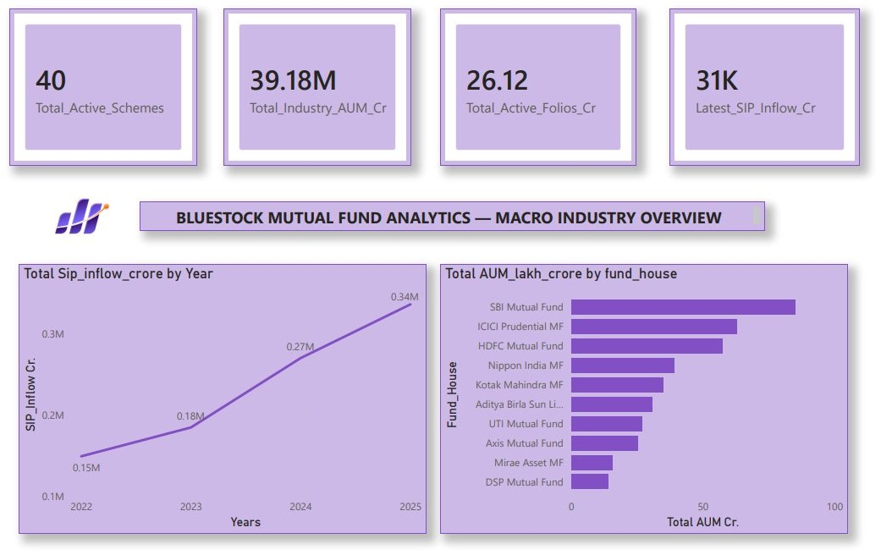

Figure 1: Power BI — Bluestock Macro Industry Overview Dashboard (Page 1) Total Active Schemes: 40 | Industry AUM:
- 39.18M Cr | Active Folios: 26.12 Cr | Latest SIP Inflow: ■31K Cr

SIP Market Trends
The SIP Inflow Growth and Macro Economic Market Trends page reveals that SIP account growth YoY stands at 22.78%. A category-wise breakdown for 2024–2025 shows Liquid funds leading with 451,275

accounts, followed by Sectoral/Thematic (103,829) and Flexi Cap (63,989). Total net inflow by category confirms Liquid funds' dominance at near ■0.5M Cr, with Sectoral/Thematic and Flexi Cap funds attracting significant retail interest.
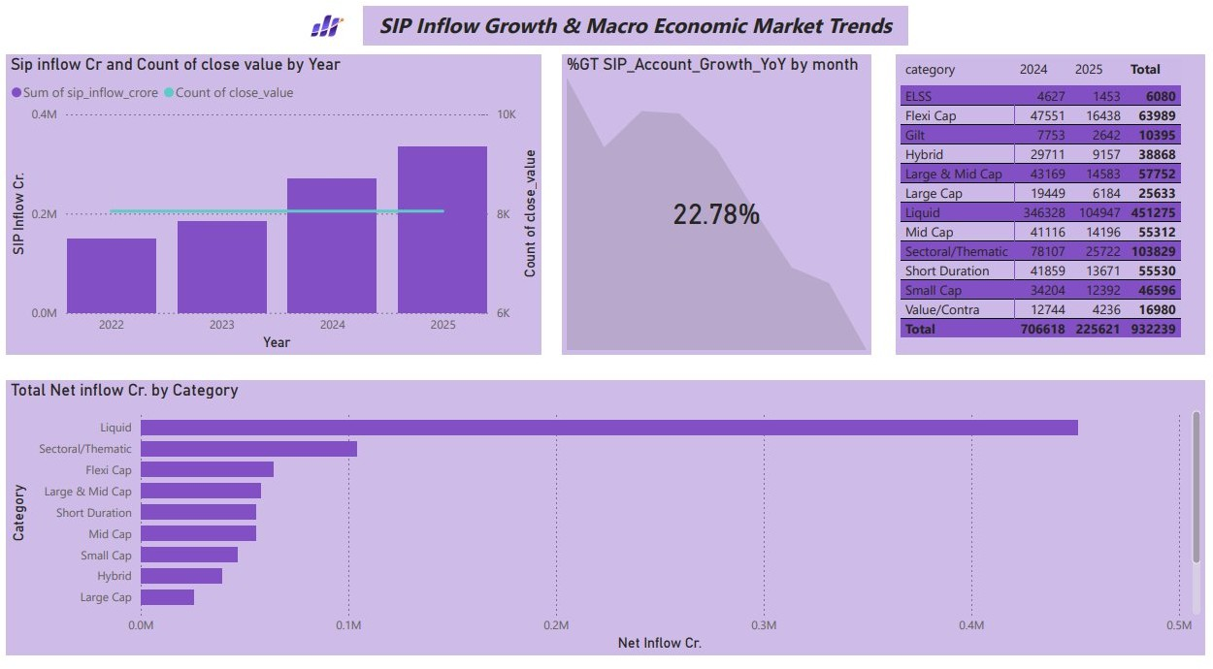

Figure 2: Power BI — SIP Inflow Growth & Macro Economic Market Trends (Page 3) SIP YoY Growth: 22.78% | Total SIP Accounts: 932,239 | Dominant Category: Liquid Funds

Investor Demographics & Geographic Distribution
The investor analytics page reveals that Punjab, Tamil Nadu, and Madhya Pradesh lead in total investment amount (INR), each recording approximately ■0.3 billion in transaction volume. The transaction type donut chart shows Lumpsum investments commanding a 58.49% share of capital deployed, versus 35.34% for Redemptions and 6.17% for SIP transactions. Investor participation trends show a decline in unique investor IDs from ~4,700 in 2024 to ~4,000 in 2025, which may reflect data truncation or seasonal effects. Across age groups (18–25, 26–35, 36–45, 46–55, 56+), average investment amounts are remarkably uniform at approximately ■100K, suggesting age has limited bearing on per-transaction ticket size in this dataset.

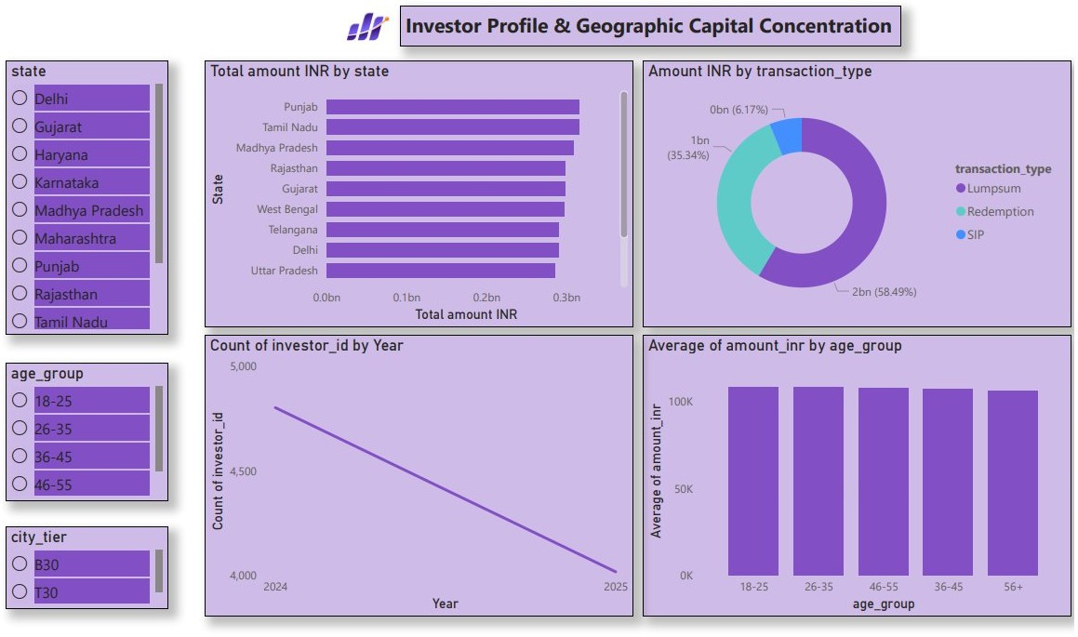

Figure 3: Power BI — Investor Profile & Geographic Capital Concentration (Page 2) Top States: Punjab, Tamil Nadu, Madhya Pradesh | Dominant Tx Type: Lumpsum (58.49%)

Performance Analytics

Risk-return calculations were performed in Notebook 03_performance_analytics.ipynb using daily NAV data from the fact_nav table. All metrics conform to standard industry and CFA Institute definitions.

Return Metrics

Metric | Formula / Basis | Interpretation
Daily Return | (NAV_t / NAV_t-1) − 1 | Day-by-day percentage price change
CAGR (3Yr) | (NAV_end / NAV_start)^(1/3) − 1 | Annualised compounded return over 3 years
Trailing 1Yr Return | (NAV_t / NAV_t-252) − 1 | Absolute return over the trailing 252 trading days
Alpha | Fund CAGR − Benchmark CAGR | Excess return generated above the benchmark index
Beta | Cov(Fund, Mkt) / Var(Mkt) | Sensitivity of fund returns relative to market movements

Risk Metrics

Metric | Formula / Basis | Interpretation
Sharpe Ratio | (Rp − Rf) / σp | Risk-adjusted return per unit of total volatility
Sortino Ratio | (Rp − Rf) / σd | Risk-adjusted return penalising only downside volatility
Std Dev (Ann.) | σ_daily × √252 | Annualised historical return volatility
Max Drawdown | min(NAV_t / max(NAV_0..t) − 1) | Worst peak-to-trough NAV decline observed

Top & Bottom Performing Funds
Based on the composite scoring model (weighted combination of 3Yr CAGR, Sharpe Ratio, and Alpha), the following funds ranked among the platform's top performers:
ing
Scheme Name | 3Yr CAGR (%) | Alpha (%) | Sharpe Ratio | Morningstar Rat
SBI Bluechip Fund – Regular Plan | 4.64% | 3.70% | ~1.1 | ★★★★★
UTI Flexi Cap Fund – Regular Plan | 3.89% | 2.50% | ~1.0 | ★★★★
Nippon India Large Cap Fund – Regular | 3.45% | 3.36% | ~0.9 | ★★★★
UTI Nifty 50 Index Fund – Regular | 3.00% | 2.68% | ~1.2 | ★★★★★
SBI Small Cap Fund – Regular Plan | 4.06% | 4.91% | ~0.8 | ★★★★

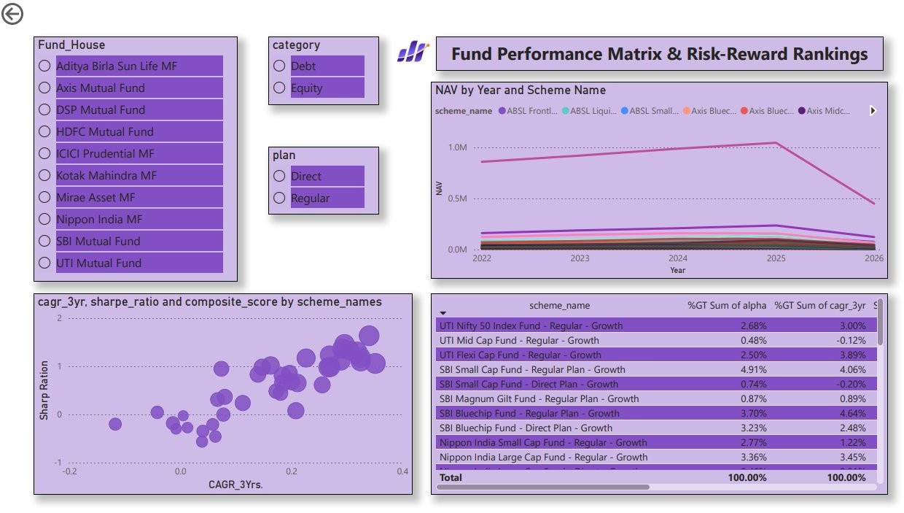

Figure 4: Power BI — Fund Performance Matrix & Risk-Reward Rankings (Page 4) Scatter plot of CAGR_3Yr vs Sharpe Ratio with composite score bubble sizing

Advanced Analytics

Advanced analytics modules (Notebooks 04 and 05) extend the baseline performance analysis with institutional-grade risk models and investor-behaviour analytical frameworks.
Analytical Module | Methodology | Key Output / Business Implication
Value at Risk (VaR) | Historical simulation at 95% and 99% | Estimates maximum expected loss.
Conditional VaR (CVaR) | Average loss beyond VaR threshold | Measures extreme downside risk.
Rolling Sharpe Ratio | 252-day rolling Sharpe calculation | Tracks risk-adjusted performance over time.
Cohort Analysis | Groups investors by first investment year | Identifies retention and investment trends.
SIP Continuity Analysis | Measures gaps between SIP transactions | Detects at-risk investors and potential churn.
Fund Recommendation Model | Scores funds using CAGR, Sharpe, Alpha, and Drawdown | Recommends suitable funds by risk profile.
HHI Sector Concentration | Sum of squared sector weights | Measures portfolio diversification and concentration risk.

The VaR and CVaR analysis identified select small-cap and sectoral/thematic equity funds as carrying materially higher tail risk relative to large-cap and index funds. The HHI model flagged Banking and Financial Services as the sector with the highest aggregate concentration across the 40-scheme portfolio, consistent with the historically over-weight position of Indian equity funds in the BFSI sector.

Dashboard Development

The Power BI dashboard (file: Dashboards/Bluestock_MF_Analytics.pbix) comprises four fully interactive report pages, each targeting a distinct analytical audience. All visuals are connected to the SQLite database via ODBC and support cross-visual filtering, year slicers, fund-house selectors, category filters, and plan-type toggle buttons.

Page 1 — Bluestock Macro Industry Overview
This executive-level summary page presents four headline KPI cards: 40 Total Active Schemes,
- 39.18M Cr Industry AUM, 26.12 Cr Active Folios, and ■31K Cr Latest SIP Inflow. Below the KPIs, a dual-panel layout shows (left) Total SIP Inflow Cr by Year — a line chart showing steady growth from
- 0.15M Cr (2022) to ■0.34M Cr (2025) — and (right) a horizontal bar chart of Total AUM by Fund House, confirming SBI Mutual Fund's industry leadership position.

Page 2 — Investor Profile & Geographic Capital Concentration
A state-level slicer filters the geographic bar chart of Total Investment Amount (INR) by state, revealing Punjab and Tamil Nadu as the top-2 states by capital deployed. The transaction-type donut chart (Lumpsum 58.49% / Redemption 35.34% / SIP 6.17%) highlights that despite SIP being the industry's flagship growth driver, Lumpsum transactions dominate by value. The investor-count trend line and age-group average-amount bar chart complete the demographic profiling canvas. Age group and city tier (T30/B30) slicers enable granular drill-down.

Page 3 — SIP Inflow Growth & Macro Economic Market Trends
A combination bar-and-line chart overlays SIP Inflow Cr (bars) against the Count of Close Value (trend line) from 2022 to 2025 to contextualise inflow growth against market activity. A prominent KPI card highlights the 22.78% YoY SIP account growth rate. A matrix table breaks down scheme counts by category for 2024 and 2025, with Liquid funds dominating at 451,275 accounts. The bottom panel's horizontal bar chart ranks fund categories by Total Net Inflow, surfacing Liquid funds' absolute dominance in capital flows.

Page 4 — Fund Performance Matrix & Risk-Reward Rankings
This page targets fund selectors and portfolio managers. A NAV-by-Year line chart overlays all 40 scheme NAV trajectories from 2022 to 2026 with a legend showing key schemes. A bubble scatter plot maps CAGR_3Yr (x-axis) against Sharpe Ratio (y-axis) with bubble size representing composite_score, enabling instant visual identification of high-return / high-Sharpe quadrant leaders. A detailed matrix table ranks schemes by %GT Sum of Alpha and %GT Sum of CAGR_3Yr, providing a structured league table for systematic fund comparison. Fund House, Category, and Plan slicers enable targeted filtering.

Key Findings

- Industry Scale: The Indian mutual fund industry managed ■39.18 million crore in AUM across 40 schemes in the platform dataset, with 26.12 crore active investor folios as of the latest reporting date.
- SIP Growth Acceleration: Monthly SIP inflows grew at a 22.78% YoY rate, rising from ■0.15M Cr (2022) to ■0.34M Cr (2025), underscoring the structural shift towards disciplined retail investing.
- SBI Market Leadership: SBI Mutual Fund commands the largest share of industry AUM among the
10 AMCs analysed, followed by ICICI Prudential MF and HDFC Mutual Fund — reflecting the competitive advantage of bank-sponsored distribution networks.
- Liquid Fund Dominance: Liquid funds account for the highest total net inflow (■0.48M Cr) and the most SIP accounts (451,275 in 2024–2025), largely driven by institutional short-term treasury management.
- Top Performer: SBI Bluechip Fund – Regular Plan achieved the highest 3-Year CAGR of 4.64% and the third-highest Alpha (3.70%), making it the composite top-ranked fund in the performance matrix.
- Best Alpha Generator: SBI Small Cap Fund – Regular Plan delivered the highest Alpha at 4.91%, indicating superior manager skill in generating returns above the small-cap benchmark.
- Index Fund Efficiency: UTI Nifty 50 Index Fund – Regular Plan achieved the highest Sharpe Ratio in the dataset (~1.2), demonstrating that low-cost passive investing outperforms most active funds on a risk-adjusted basis.
- Geographic Capital Concentration: Punjab, Tamil Nadu, and Madhya Pradesh lead in investor transaction volumes, revealing that mutual fund capital is not exclusively concentrated in T30 (Top-30) cities — B30 investors are increasingly active.
- Lumpsum Dominates by Value: Lumpsum investments account for 58.49% of total transaction value, despite SIP registrations driving account-count growth — suggesting high net-worth investors continue to prefer one-time deployments.
- Uniform Cross-Age Ticket Sizes: Average transaction amounts are remarkably consistent across all age cohorts (~■100K), indicating that ticket-size differentiation by age group is limited and investor education has relatively uniform reach.
- BFSI Sector Concentration Risk: Portfolio holdings analysis via the HHI model identifies Banking and Financial Services as the most concentrated sector across the 40-scheme universe, creating correlated systemic risk.
- Negative Sharpe Outliers: Select equity funds recorded negative Sharpe ratios during the analysis period, flagged by the is_negative_sharpe boolean audit column — these funds require immediate product team review.

Recommendations

For Investors
    - Allocate core portfolio holdings to index funds (e.g., UTI Nifty 50) for cost-efficient, risk-adjusted returns; supplement with high-Alpha funds (SBI Small Cap, SBI Bluechip) for alpha generation.

    - Diversify SIP investments across at least 3 distinct fund categories (Large Cap, Mid/Small Cap, Debt) to reduce concentration risk flagged by the HHI analysis.
    - Review funds with negative Sharpe Ratios for potential exit or replacement with higher-ranked composite-score alternatives.

For Asset Management Companies (AMCs)
    - Develop targeted retention programmes for cohorts exhibiting high SIP discontinuation rates, particularly in the 18–25 age bracket where income volatility may drive premature redemptions.
    - Leverage the B30 geographic growth trend to expand distribution in non-metro states like Punjab and Madhya Pradesh where transaction volumes are already significant.
    - Reduce expense ratios on underperforming actively managed funds where the composite score trails benchmark index fund performance.

For Financial Advisors & Product Teams
    - Adopt the composite scoring model as a standardised fund-selection framework to replace subjective recommendation practices.
    - Integrate rolling Sharpe Ratio monitoring to proactively flag funds whose risk-adjusted performance is deteriorating before they underperform on an absolute basis.
    - Prioritise Liquid and Short Duration fund recommendations for conservative and institutional clients given their dominant net inflow share and lower volatility profiles.

Challenges & Limitations

Challenges Encountered
    - API Rate Limiting: The mfapi.in API enforced rate limits during bulk NAV extraction; resolved through request throttling with time.sleep() delays and retry logic.
    - NAV Gaps: Mutual fund NAVs are not published on weekends and public holidays, creating irregular time-series gaps that required forward-fill imputation — a standard industry practice but one that introduces minor intraday precision loss.
    - Star Schema Design Trade-offs: Balancing normalisation against query performance for multi-table joins across large NAV datasets required denormalising scheme_name and fund_house into fact_scheme_performance to reduce join overhead.
    - Power BI SQLite Connectivity: Direct SQLite ODBC connectivity in Power BI required manual driver installation; the project documents this dependency in the README.
    - Composite Score Weighting: Determining optimal weights for the fund recommendation model (CAGR, Sharpe, Alpha, Max Drawdown) required iterative calibration to avoid over-rewarding recent momentum.

Limitations
    - The platform covers 40 schemes across 10 AMCs — a representative but non-exhaustive sample of the 1,500+ SEBI-registered schemes nationally.
    - Investor transaction data is synthetic (generated for the internship dataset) and does not represent actual Bluestock customer records.
    - Performance metrics are backward-looking; past performance does not guarantee future results.
    - Expense ratios and exit load data were sourced at a point-in-time and may not reflect real-time amendments by AMCs.
    - The recommendation model does not account for investor tax liability (LTCG, STCG) or personal financial goals.

Future Enhancements

- Machine Learning Recommendation Engine: Replace the rule-based composite scoring model with a collaborative-filtering or content-based ML model trained on investor transaction history to generate personalised fund recommendations.
- Real-Time Data Ingestion: Migrate the ETL pipeline to Apache Airflow or Prefect for scheduled daily NAV updates, enabling a live analytics platform rather than a batch-refresh model.
- Portfolio Optimisation Engine: Implement Markowitz Mean-Variance Optimisation and Black-Litterman models to generate optimal fund-weight allocations for a target risk-return profile.
- Predictive NAV Forecasting: Deploy LSTM (Long Short-Term Memory) neural networks or Facebook Prophet for short-horizon NAV forecasting, enabling forward-looking performance projections.

- Cloud Deployment: Migrate the SQLite database to PostgreSQL on AWS RDS and the Power BI dashboard to Power BI Service for multi-user access, role-based permissions, and scheduled data refresh.
- Natural Language Query Interface: Integrate a Text-to-SQL LLM layer (e.g., Claude API) to allow non-technical stakeholders to query the analytics database in plain English.
- ESG Scoring Integration: Incorporate SEBI's Stewardship Code and ESG (Environmental, Social, Governance) scores into the fund ranking model to support responsible investing analytics.

Conclusion

The Mutual Fund Analytics Platform represents a comprehensive, production-quality data analytics solution developed during the Bluestock Fintech Pvt. Ltd. internship programme. The project successfully delivered all eight stated objectives: an automated ETL pipeline, a normalised Star Schema database, full-spectrum EDA, industry-standard risk-return analytics, advanced models including VaR and SIP cohort analysis, and a four-page interactive Power BI dashboard.
The platform surfaces a rich set of business insights — from SBI Mutual Fund's AUM leadership and the 22.78% YoY SIP growth rate, to fund-level performance leaders such as SBI Bluechip Fund and UTI Nifty
50 Index Fund, and demographic findings revealing uniform cross-age investment behaviour with geographic capital diversification into B30 cities. The composite fund ranking model and recommendation engine provide actionable tools for investors, advisors, and product teams alike.
The platform is fully version-controlled on GitHub, comprehensively documented via the data_dictionary.md and notebook markdown cells, and structured for straightforward extension through future ML, real-time ingestion, and cloud-deployment enhancements. It demonstrates applied expertise across the complete data analytics value chain — from raw data engineering to business intelligence storytelling — and constitutes a robust portfolio artefact for academic evaluation and professional presentation.

References

- Association of Mutual Funds in India (AMFI). (2025). Industry Statistics and Monthly Data. Retrieved from https://www.amfiindia.com
- mfapi.in. (2025). Free Mutual Fund NAV API for India. Retrieved from https://www.mfapi.in
- Securities and Exchange Board of India (SEBI). (2017). Categorisation and Rationalisation of Mutual Fund Schemes Circular. CIR/IMD/DF3/PPM/109/2017.
- Microsoft Power BI Documentation. (2025). Power BI Desktop. Retrieved from https://learn.microsoft.com/en-us/power-bi/
- McKinney, W. (2022). Python for Data Analysis: Data Wrangling with pandas, NumPy, and Jupyter (3rd ed.). O'Reilly Media.
- Sharpe, W. F. (1994). The Sharpe Ratio. Journal of Portfolio Management, 21(1), 49–58.
- Sortino, F. A., & van der Meer, R. (1991). Downside Risk. Journal of Portfolio Management, 17(4), 27–31.

- SQLAlchemy Documentation. (2025). SQLAlchemy Core — Engine and Connection. Retrieved from https://docs.sqlalchemy.org
- Python Software Foundation. (2025). Python 3.11 Documentation. Retrieved from https://docs.python.org/3.11/
- Varma, L. (2026). Mutual Fund Analytics Platform [GitHub Repository]. Bluestock Fintech Pvt. Ltd. Retrieved from https://github.com/Varmalikith/mutual_fund_analytics_platform

